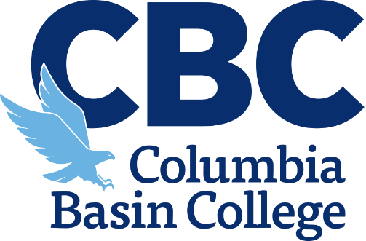

**CTE Dual Credit**

**Evidence of Competency   
Through Distance Instruction**

Due to the continued disruption of COVID-19, CBC’s CTE Dual Credit program will need this form completed for each one-semester or one-trimester CTE Dual Credit approved class affected by the continued remote instruction. The completed signed form should be signed by both the high school CTE Instructor and school district CTE Director by **November 10, 2020**.

|  |  |
| --- | --- |
| High School or  Skill Center Name: |  |
| Teacher  Name: |  |
| High School  Class Name: |  |
| College Course(s) Articulated:  *(Example: AMT 110)* | Will you be able to provide instruction addressing all college course student learning outcomes in accordance to the CTE Dual Credit articulation by the end of this semester/trimester?  *If no, please type “N/A” for the remainder of the form, sign, and submit.*  YES NO |

## For the following questions, please focus on content from your class as outlined in the district framework, which is necessary to facilitate students’ mastery of the learning outcomes outlined in the college course competencies. CTE Dual Credit articulations are based on a high school class covering 100% of the college course competencies, not seat time in class.

|  |
| --- |
| 1. Approximately what percentage of the articulated college course competencies/student learning outcomes have your students completed at this time in the semester/trimester?   % |

1. Briefly list the remaining course objectives/student learning outcomes that still need to be covered.
2. Describe how the remaining course objectives/student learning outcomes will be addressed through continued distance learning by the end of the semester/trimester.

The completed signed form should be signed by both the high school CTE Instructor and school district CTE Director. The signed form should be completed by **November 10, 2020**

High School CTE Instructor Signature:

School District CTE Director Signature: