Finding Your Class

1. Open the Assignments menu. Select Class Roster/Assign Grades.

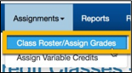

1. The Search screen will open. The current school year will be the default. Complete as much information as needed to locate your course. Only articulations with which you are associated will be returned in the search results. Select the Search button.

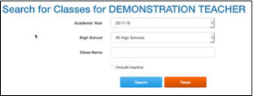

1. Search results will display below the search form. Select the Class Name to update the roster or assign grades.

page12image1667225840

Assigning Grades or Updating Student Status

You cannot modify a student’s grade or status unless the grading window is open. CTE Dual Credit staff establishes the dates for grading windows.

1. Search for the class you want to work with.

2. When the class roster is open, you can update each student’s status or assign a grade. Note that when you assign a grade, the student status is automatically set to Completed, and that the Completed status requires a grade to be assigned.

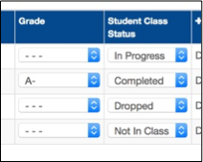

3. When you have completed all of your updates, select Save Changes. If you would like to reset the roster to the state it was in when you opened it, select Discard Changes. Selecting the printer icon above and to the right of the roster will generate a print- friendly version of the roster.

