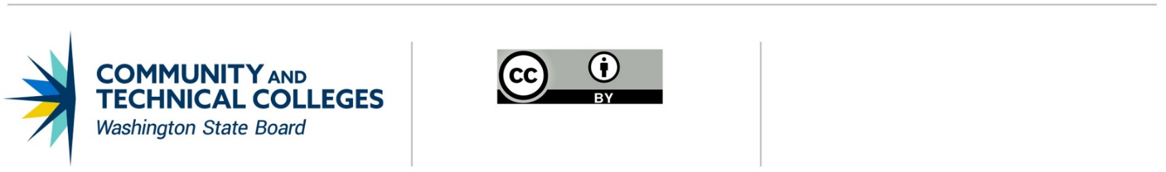

2022-2023 Nursing Programs Healthcare Simulation Lab Equipment

Allocation-Specific Assurances
This assurances document must be signed by the college president or their designee and submitted to Kim Wheeler at kwheeler@sbctc.edu at the time the college completes the associated Program Funding Request (PFR). A signed copy must be kept on file at the educational institution.
This assurances document recognizes SBCTC is expediting nursing programs healthcare simulation lab equipment at the system’s request to allocate resources quickly, to ease administration, and to create uniformity across new funding streams where possible. These allocation-specific assurances encompass both the language that is typically contained in assurances for workforce funding and new language addressing items that would be included in program guidelines typically issued by SBCTC.

It is assured and understood that:
- The nursing programs healthcare simulation lab equipment funding will not be used to replace (supplant) other state funds expended to carry out nursing education and training activities.
- Nursing programs healthcare simulation lab equipment funding is provided solely for nursing programs to purchase or upgrade simulation laboratory equipment.
- If this application includes any facility improvement work, it will be procured using a public work process administered by the Engineering & Architectural Services division of the Department of Enterprise Services (DES), unless it is eligible for self-performance by college staff. DES will charge a project management fee for administering the public work portion of the project. Colleges can self-perform work with qualified staff if the total cost of the work is less than $45,000 and only requires one trade, or up to $90,000 for work requiring multiple trades. (RCW 28B.50.330). The college must submit a Local Capital Expenditure Request to the SBCTC Capital department for expenditure tracking of the facility modifications.
- Colleges who accept funding through this program agree to provide complete and timely program and fiscal reports as outlined in the program guidelines. Reporting will include the itemized disclosure of fund utilization to facilitate the determination of whether funds were utilized in compliance with allowable capital funded expenses and in alignment with programmatic and legislative intent.
- Funds become available by allocation after the request has been approved, and once approved, may be expended from July 1, 2022 through June 30, 2023. Funds may not be expended past the end of the 2023 fiscal year. Work with your college’s business office to access these funds.

Certificate of Assurance
THE APPLICANT AGREES to adhere to the conditions and deliverable requirements outlined above and in the application guidelines.
FURTHERMORE, the applicant agrees to comply with federal and state fiscal control procedures to (1) avoid the commingling of federal and state funds, (2) ensure compliance with IRS regulations for tax-exempt financings, and (3) provide necessary program and financial descriptive and statistical reports.
FURTHERMORE, the above applicant certifies that the information contained in this application is true and correct to the best of its knowledge, and that this application is consistent with the purposes of the 2022 Supplemental Operating Budget Engrossed Substitute Senate Bill 5693 PL Sec. 602.
College President or Designee Name: Date:
Signature:
Email signed form to Kim Wheeler at kwheeler@sbctc.edu.

