TO: Student Services Commission and Councils

FROM: Washington State Board for Community and Technical Colleges, Student Services

RE: 2023 Winter Student Services State Board Report

# Staff Updates – Meet the New Director of Student Services

 **Dr. Lauren Hibbs, Director, Student Services**A longtime Washingtonian, Dr. Lauren Hibbs has served students, institutions, and communities in the K-12, College, and University sectors, with an emphasis on improving access and affordability; advancing racial, social, economic justice; and closing equity gaps over the past 15 years. Lauren has worked in residential life, leadership programs, academic advising, taught classes in Educational Psychology and Leadership Development, and spent nearly a decade in teacher and principal preparation programs. Most recently, Lauren served as the Executive Director of Extended Learning for Central Washington University overseeing 8 university centers and sites, six of which are co-located on college campuses across the state. Her work at CWU focused on transfer, partnerships, student services, social and racial justice, community outreach, and program implementation. Lauren has degrees in Psychology, Student Development, and a doctorate in Education Leadership from UW Tacoma focusing on emotional intelligence and leadership development in WA college leaders. Her most recent accomplishment includes launching a multi-institutional leadership program with the Washington Employers for Racial Equity.

## **2023 Legislative Updates**

**HB 1002** - Increasing the penalty for hazing in the criminal code, elevating some forms of hazing to a felony offense. (Neutral)

**HB 1003** - Creating a dual credit subsidy program to remove out of pocket expenses for eligible students. (Support with concerns)

**HB 1045/SB 5125** - Creating the evergreen basic income pilot program - Bill from the Poverty Reduction efforts. Increases access to public assistance (cash assistance) in the form of guaranteed basic income for low-income populations, to include homelessness under the pilot program. Could result in an increase in referrals to student support programs. (Support)

**HB 1069** - Adopting the mental health counselor compact (Neutral)

**HB 1094/SB 5125** - Creating the WA future fund program - Creates a fund to low-income children to have access to higher education after high school (Support)

**HB 1146** - Notifying high school students and their families about available dual credit programs and any available financial assistance (Support)

**HB 1316** - Dual credit program access - Expanding access to dual credit programs (Support)

**HB 1134** - Behavioral Health Crisis Response and Suicide Prevention (Neutral)

**HB 1156** - College grant eligibility - Extending the terms of eligibility for the Washington college grant program (Support)

**HB 1232** - College bound scholarship - Enhancing the college bound scholarship program (Support)

**SB 0229** - Concerning the date by which tuition operating fees are established (Support)

**SB 1559** - Student basic needs at public postsecondary institutions act

**SB 5048 -** Eliminates college in the high school fees (Support with concerns)

**SB 5079** - Tuition operating fees established - Concerning the date by which tuition operating fees are established (Support)

**SB 5329** - Higher education fees/campuses - Addressing fees at campuses other than the main campus (Pending)

**SB 5513** - Concerning mental health counseling at community and technical colleges - Expanding mental health counseling pilot program (support)

## **SBCTC 2023 Legislative Interns**

The SBCTC is excited to introduce our Legislative Session Interns. During the 2023 Legislative session interns will be working in-person and virtually with the State Board’s Legislative Director and other staff in support of our system’s legislative priorities and goals.

Image of Baydaa Alshatee outside smiling wearing a dark blue Hijab.
  **Baydaa Alshatee - Everett Community College**I am Baydaa Alshatee (She/Her/Hers). I grew up in Washington State and now I am a Journalism  
student at Everett Community College and plan to transfer to Western Washington University  
(major undecided). I have a passion for Diversity, Equity, and Inclusion and I am excited to  
learn more about the legislative process and embark on this new journey!

Image of Shannon Cosgrove taken outside with sunflowers
 **Shannon Cosgrove - Columbia Basin College**

I am currently a student at Columbia Basin College and my home is the Northwest tip of the Olympic Peninsula. I am always looking for reasons to travel, and when I am not on the soccer field, traveling, or studying, I am reading manga in the quietest corner I can find. My chosen discipline of study is environmental science, and I am interested in learning more about law and the policy-making process.

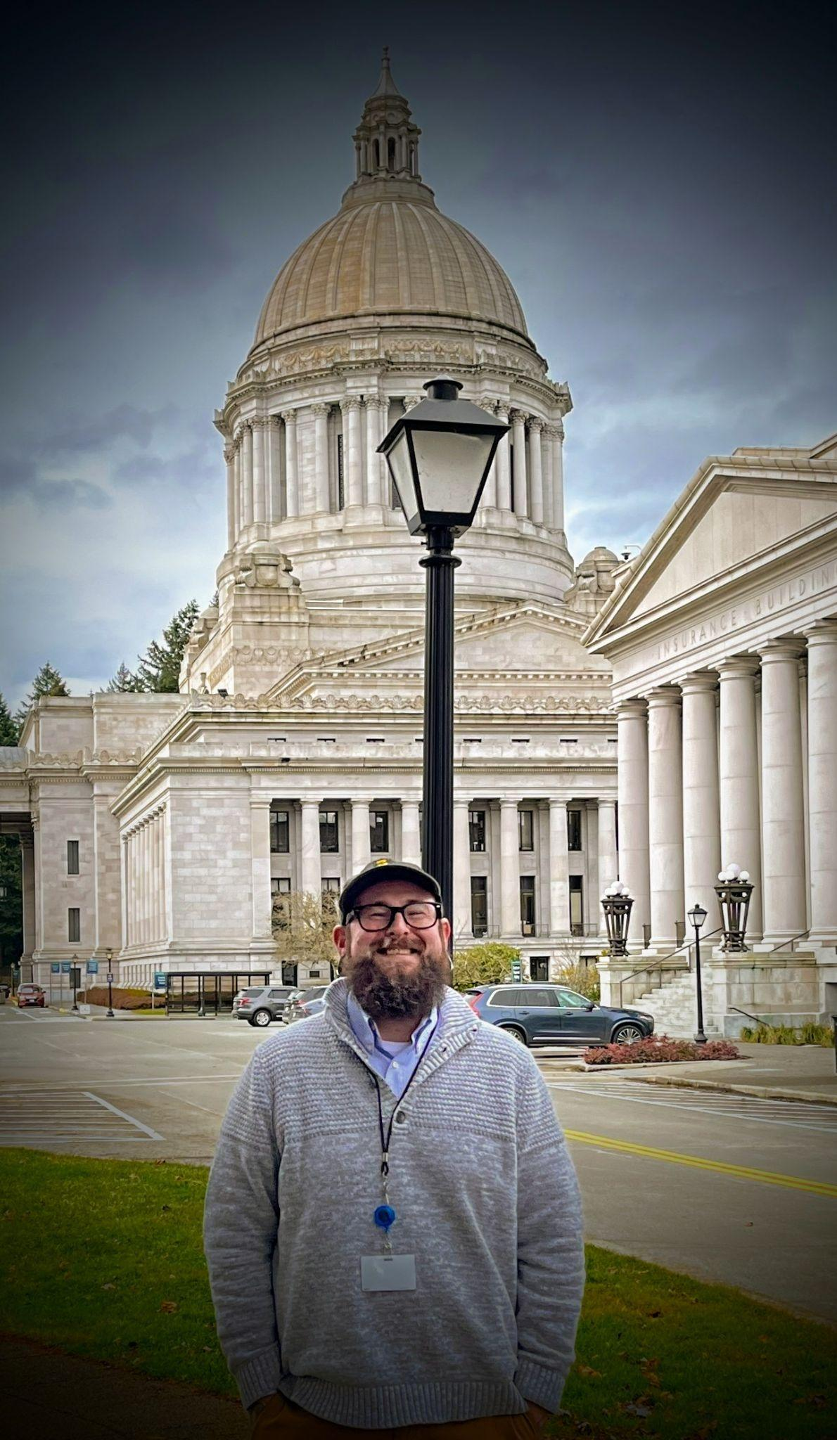 **Jacob Katz - Clover Park Technical College**

After graduating from Manhattan High School in Manhattan, Kansas, I completed schooling in culinary arts and worked in the hospitality industry across the country. Relocating to Washington in 2013, I continued in hospitality until the pandemic paused food service nationwide. Viewing this pause as an opportunity to explore a new career path, I enrolled at Clover Park Technical College to pursue a degree in Human Services. I found a passion for policy work and advocacy through my position as a Student Ambassador at Clover Park and my involvement in the Washington Community and Technical College Student Association, or WACTCSA. After completing my time at Clover Park, I will be pursuing a degree in Political Science at the Evergreen State College in hopes of continuing a career in the legislative field. In my leisure time, I enjoy cooking and baking, music, painting, and spending time in nature with my pup Bubba.

## **Student Support Programs Updates**

### **Statewide Student Basic Needs Survey**

In fall 2022, coordinated through the Washington Student Achievement Council, over 9,700 college and university students participated in a statewide basic needs survey. Twenty-six community and technical colleges participated in the survey with 4,855 students responding to the survey.

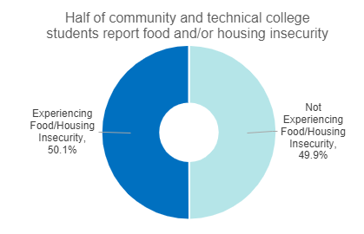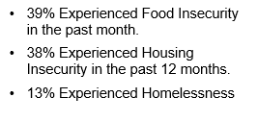

The results show that basic needs insecurity is prevalent among enrolled students.

Among the CTC students who experience food and/or housing insecurity, 60% reported accessing some form of governmental or other public assistance, and only 21% had accessed campus resources to help them address basic needs concerns.

The statewide results revealed that American Indian/Alaska Native and Black/African American students reported the highest rates of basic needs insecurity among the self-reported race/ethnic groups. The report also reveals serious concerns about other dimensions of basic needs, including access to healthcare and affordable childcare. The full 2023 [**Basic Needs Security among Washington College Students**](https://wsac.wa.gov/sites/default/files/2023.BasicNeedsReport.pdf) report is available from WSAC as well as [Executive Summary](https://wsac.wa.gov/sites/default/files/2023.BasicNeedsSummary.pdf) highlights.

### **Integrations**

The Student Support Programs (SSP) Team continues its efforts to integrate across programs, within Student Services, and across the Education Division. We’re pleased to be exploring a spring opportunity for collaboration across the system related to relationship building and closing knowledge gaps between SSP and Corrections. We are also exploring potential connections with state and local partners for colleges supporting students.

Reminder: The State of Washington Secure Email Portal (SEP) officially sunsetted as of December 29, 2022. For handling the transmission of confidential information, the SBCTC has transitioned to using encrypted email through Microsoft 365. CTCs must connect with their institution’s IT teams to ensure knowledge and capacity for sending encrypted emails - check out the *Email Encryption - Sending & Receiving Confidential Information* page under *Student Supports Tools and Websites* in the SSP Canvas Community for more information.

Upcoming Meetings, Trainings, and Forums:

* January 31, 2023 - SEAG/SSEH Collaboration Hub
* March 23, 2023 – Winter SSP System Training

### **Canvas Community Reminder**

The Student Support Programs Canvas Community is your resource hub for WorkFirst, BFET, SSEH, SEAG, Opportunity Grant, and WRT. Important program information, updates, and reminders are communicated solely via this Canvas Community. Take care to enable course notifications in your Canvas account to ensure you are getting the most up-to-date information for your programs! Utilize the Student Supports Canvas Community for:

* Grant Announcements
* Funding Surveys
* Notifications from DSHS
* Program Information
* Recorded Trainings
* Helpful Forms and Links

Katelynn Orellana (korellana@sbctc.edu) can provide technical assistance and manages enrollment in the community.

### **Student Emergency Assistance (SEAG) Program**

The FY22 SEAG report was submitted to the Legislature in December 2022. The report describes student basic needs trends across the state. Strikingly, colleges saw a drastic increase in student emergent need in FY22. Community and technical colleges fielded 15,369 student emergency assistance requests in FY22 and of the total number of requests the system funded 51% (7,762) total student emergency assistance requests. Colleges administered SEAG funding to 62% more students in FY22 although student additional needs in the amount of nearly $50M across the state went unfunded. However, in FY22 90% of SEAG recipients who attempted credits and were able to complete their credits in the quarter after they received SEAG emergency.

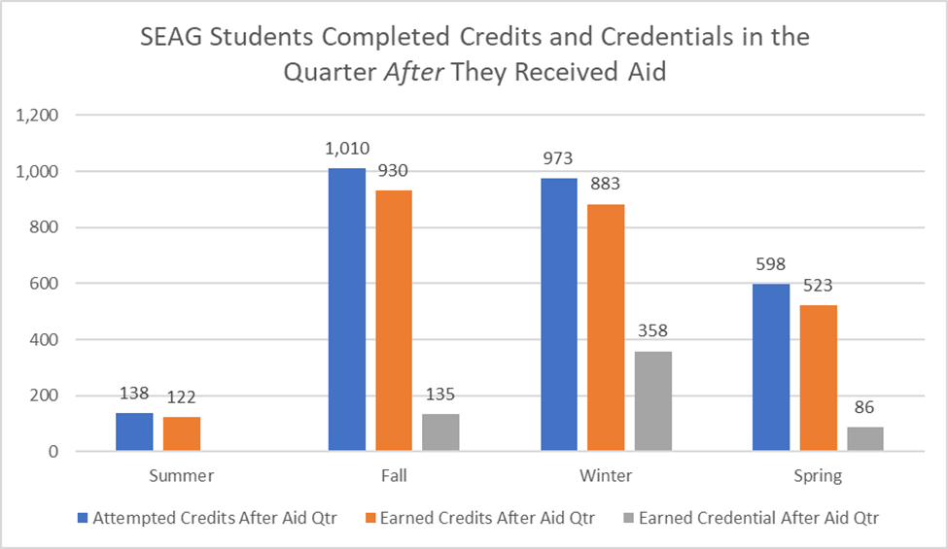

Chart Illustration shows 11 bars on a pivot table chart depicting the number of SEAG students who received funds and completed credits the following quarter of SEAG aid disbursement.

A SEAG/SSEH College Collaboration Hub meeting is scheduled for January 31. Agenda items include a report out on the legislative report, spotlight on SEAG/SSEH college best practices, SSEH update as well as system, state and federal updates.

### **Basic Food Employment and Training (BFET)**

The Student Support Programs team is moving forward hiring a new Program Administrator for the Basic Food Employment and Training Program. We had a robust applicant pool and completed the first and second round of interviews. We hope to provide a system-wide announcement as soon as we have the position filled.

Reminder: The Education Division has approved a new policy for setting the administrative costs for BFET leveraging in ctcLink. This new policy went into effect October 1, 2022. Colleges are now required to use the program code for the administrative funding of the program. For more information, please see the FY23 BFET Grant Guidelines.

All CTC’s will participate in Fiscal and Program monitoring this year. We sincerely appreciate the cooperation of the Business Offices as this is a requirement of our contract.

### **Supporting Students Experiencing Homelessness (SSEH) Pilot Program**

An SSEH Canvas module went live October 17th to help participating colleges access resources and receive system communications. More content is being developed to respond to recurring questions about the pilot program.

The quarterly report which colleges complete to report information about student accommodations provided, expenditures, and formative evaluation updates, was revised and moved into a more user-friendly platform for FY23. Two supporting webinars were provided to help college staff understand the report, and thus far, the new format has been well received.

The statewide SSEH Pilot Learning Community convened virtually on December 1st. This provided an opportunity for participating CTC’s and the state universities to engage with each other. The heart of the convening was a series of breakout groups with presentations by colleges and roundtable discussions on topics of interest.

Year end results from FY22 showed that the 8 participating CTC’s served 1,975 students and provided many accommodations, including substantial case management and referral support. 1,321 students received more than two case management contacts from program staff. Relationships and partnerships with community providers (such as United Way, 211 Washington, DSHS, community food pantries, WorkSource, and Domestic Violence resources) are integral elements of the SSEH program. SSEH made approx. 3,300 student referrals to community partners and resources last year.

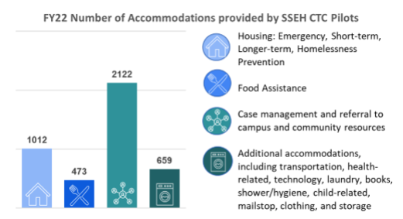

Supporting students when they face housing insecurity and homelessness helps them remain enrolled and working towards their education and training goals. 85% of the students who received SSEH accommodations last year completed the quarter in which they received services.

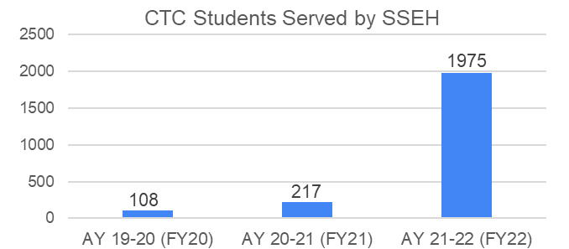

Thanks to a budget proviso in the 2022 legislative session, the pilot has expanded to include 27 CTC’s in FY23 (up from 8 in FY22). The pilot will expire June 30, 2024 unless the legislature takes action to extend the pilot or make it a permanent program.

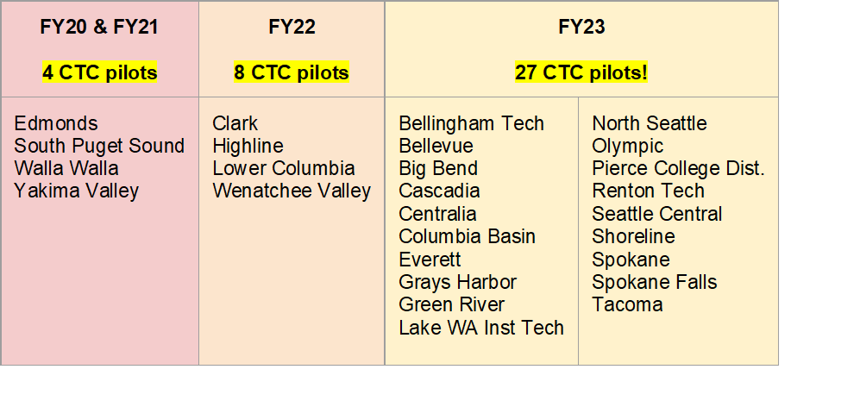

### **WorkFirst Program**

The SBCTC WorkFirst staff provided multiple system-wide training sessions during fall quarter, including Components and Hours Workshop Part 1 & 2, and an Education and Training Worksheet Workshop. This was in addition to providing corresponding written guides and content within the Student Support Programs Canvas Community.

WorkFirst has begun incorporating fiscal monitoring along with program monitoring in FY23.We appreciate the cooperation of the Business Offices as this is a requirement of our contract.

The Winter Funding Survey is scheduled to be released February 13 and is due February 27, 2023.

## **Opportunity Grant Health Care Allocations**

## The Redistribution Form for both standard Opportunity Grant and Opportunity Grant Health is available for winter term. Redistribution will be available in spring as well to provide campuses with maximum flexibility to use the funds.

## **Dual Credit Updates**

### **Running Start Elementary and Secondary Schools Emergency Relief Funds (ESSER) Grant 2022-23** 32 community and technical colleges applied for and received federal funds to cover tuition costs, fees, books, and materials that are not currently covered by the Running Start program for summer, fall, winter, and spring of the 2022-2023 academic year.

Summer 2022  
All Running Start students were able to enroll in courses tuition free at 32 of our community and technical colleges.

Quick Stats:

* 2486 enrolled
* 90% of enrolled students earned college level credit
* 45% of enrolled students were students of color
* 12 students that earned their two-year degree and a diploma from the college in summer

**Upcoming Dual Credit Legislative Updates**  
Join fellow community and technical college colleagues in receiving legislative updates for Running Start, College in the High School, and CTE Dual Credit.

2/2-1:00-2:00pm  
2/16 -1:00-2:00pm  
3/2 -1:00-2:00pm  
3/16-1:00-2:00pm  
3/20-1:00-2:00pm  
4/13 – 1:00-2:00pm

Join Zoom Meeting  
<https://us02web.zoom.us/j/84574356450?pwd=VUNkN1doWWovYVZxMWFqVGJYckVkUT09>

Meeting ID: 845 7435 6450  
Passcode: 641934

## **Mental Health Counseling and Services Pilot Program**

The four pilot colleges (Grays Harbor College, Lake Washington Institute of Technology, North Seattle College, and Wenatchee Valley College) are well into the second year of the grant after wrapping up their first year filled with many achievements. Each college has expanded access to mental health counseling to students, including historically underserved student populations, and all experienced a positive impact on student persistence and well-being.

In November, 2022, the four mental health counseling pilot colleges took part in a [Lessons Learned from the First Year of the Pilot panel discussion](https://sbctc.hosted.panopto.com/Panopto/Pages/Viewer.aspx?id=f1d6c880-6fef-4116-8a3e-af6b01452541&start=13%20). For more information, contact [Christine McMullin](mailto:cmcmullin@sbctc.edu).

## **Health Insurance Outreach Proviso**

Yakima Valley College and South Puget Sound Community College both received $40,000 through a FY 2023 budget proviso pilot to help students, including those enrolled in state registered apprenticeship programs, connect with health coverage.

The Washington Student Achievement Council also received funding to pilot with two public baccalaureate institutions to do similar work and the Office of Financial Management will conduct a statewide survey related to student access to healthcare and insurance.

**Promising Practices Exchange and Webinar Series 2022-23**

The *Promising Practices Exchange* provides an opportunity to highlight “what’s working” within our system. We want to hear from colleges on their latest innovation and strategies to make a difference for students. Please visit the [Promising Practices Exchange](https://www.sbctc.edu/about/task-forces-work-groups/strategic-enrollment/promising-practices.aspx) to view past webinars and to submit current practices for consideration. Upcoming webinars include:

* March 1, 1:00-2:30 pm - Innovative Practices in Dual Credit
* April 5, 1:00-2:30 pm - Innovative Instructional Practices for Adult Reengagement

Information on registering will be distributed through SBCTC listservs.

**Student Success and Strategic Initiatives**

The Peer and Professional Learning Agenda for winter quarter is now available on our website:<https://www.sbctc.edu/colleges-staff/programs-services/student-success-center/learning-agenda.aspx>

Events this Winter will include:

* Professional Developers Community of Practice, third Tuesday of every month, resuming March.
  + Tuesday, March 14, 2023
  + Tuesday, April 11, 2023
* Monthly Lunch and Learn Series (virtual)
  + Entering the Path: Intake processes that help students choose and enter their pathway--Monday, January 30
  + Staying on the Path (Part 1): How Navigators work with individuals to create access and plan for success in college--Monday, February 23, 2023
  + Staying on the Path (Part 2): Ongoing Advising - Monday, April 10, 2023
* Guided Pathways Community of Practice

### **Guided Pathways and ctcLink**

The Student Success Center and the Project Management Office at SBCTC have partnered to interview the colleges to learn more about their successes, needs, challenges, and ideas to support colleges with their ctcLink needs in Guided Pathways. Upon completion of interviews, updates will be made to the Guided Pathways Quick Reference Guides to reflect the information shared by colleges. Further, we will be offering professional development opportunities aligned with what was learned in the interviews. Lastly, a set of targeted Enhancement Requests will be developed and shared out with colleges for collaboration and eventual submission for governance approval.

### **Antiracist Curriculum Initiative**

The Antiracist Curriculum Initiative is a statewide community of practice for faculty teaching ENGL& 101 committed to closing equity gaps and interested in employing more equitable teaching and learning strategies. As participants began the second year of the ACI in the fall quarter by implementing Labor Based Grading practices, participants will take reflections and lessons learned into winter quarter as they continue to refine their practices. Further, faculty participants will form leadership groups in order to begin gathering qualitative and quantitative data, explore additional antiracist assessment practices, and further address problems of practice.

### **Reporting and Analysis**

Washington State Institute of Public Policy (WSIPP) is working closely with the Student Success Center and Policy Research team to gather the data needed to support their reporting on Guided Pathways Implementation to the legislature. Their first report, due December 2022, will draw from quantitative Data from SBCTC and qualitative data from the colleges. In December 2022, WSIPP sent a survey to Guided Pathways leads to learn more about individual college implementation. The survey is due February 24th, 2023.

The Community College Research Center (CCRC) has completed the Scale of Adoption Survey for Washington State, Ohio, and Tennessee as part of a National Science Foundation funded study to examine GP model adoption and effects on one-year student outcomes. An analysis of this data is anticipated soon in a published report from CCRS. Meanwhile, Dr. Debra Bragg, researcher and critical friend to Guided Pathways work in Washington and across the United States, is conducting an analysis using the Scale of Adoption Survey information as well as Guided Pathways Work Plans and data from the First Time Entering College Dashboard for student outcome data. Updates will be sent to the system as they become available.

### **Guided Pathways Coaching**

We are excited to announce that the [Guided Pathways Coach Application](https://docs.google.com/forms/d/e/1FAIpQLSfAv1tSin7wN-y9RJ8UFt3G7wZJkrb2SHW7vg94HprzOH420w/viewform?usp=sharing) is now open for the 2023-2024 year. In order to build our coaching capacity, we are seeking coach candidates to complete the application and consider joining the coaching cadre this spring for possible assignment in the 2023-24 year.

Recruitment priorities: At the end of each year, we contact each College President to obtain feedback about their priorities relative to guided pathways and how coaching has and can support their needs. As we approach recruitment this year, we will want to keep these needs in mind as we continue to build the capacity for the future. The areas listed below are a combination of assets and experiences expressed by the colleges and Coach Advisory Team as priorities for new coach candidates. These areas would help us broaden coach capacity:

1. Direct and successful experience in the development and implementation of guided pathways and achieving measurable results in their own institution. All colleges expressed an interest in coaches who had a deep and practical understanding of how pathways can be implemented in a CTC institution
2. Experience effectively integrating equity into the design, implementation, and evaluation of guided pathways
3. Diversity in terms of race, gender, and cultural background
4. Expertise in Student Services Redesign through an equity-grounded pathways lens
5. Taking effective practice to scale in community colleges
6. Experience with college-wide collaboration in designing pathways meta-majors and program maps
7. Faculty experience in pathways leadership who can assist with meaningful faculty conversations about guided pathways particularly in cases of resistance
8. Experience in areas that challenge colleges such as the integration of accreditation, effective adoption of technology, and ctcLink
9. Training and/or experience as a community or technical college coach focused on pathways or equity-focused student success
10. An approach to coaching that reflects the coach as “motivator not fixer” and respects the institutional role of driving the work
11. Experience and strategic understanding in the design and development of pathways and program maps specific to the technical college

Recruitment Strategy:  The call for coaches will go to all colleges with multiple contacts within each institution and essential list serves within the state. While this is an important dissemination activity, we have found that one of the most effective tools in coach recruitment is personal outreach. To that end, we are asking coaches and Coach Advisory Team members to specifically consider reaching out to those who could be encouraged to apply. We are not limited to Washington state and are interested in a wide range of experiences and roles within the institution.

Delivery of Coaching for 2023-24: While we have been successful in delivering coaching services via virtual delivery over the last 2 years, we will monitor the needs of the colleges to determine how and if the implementation of in-person or hybrid options for colleges will be available.

Recruitment and Selection Timeline:

* Applications should be submitted no later than April 1, 2023 for this round.
* Coach Advisory Team reviews and recommendations for appointment of new coaches: April 1-April 15, 2023
* Notification of new coach trainees by May 1 and New Coach Orientation May 25, 2023, 1-4 p.m.
* Confirm continuing 2022/23 coaches: A check-in will occur in early February to determine the interest and capacity of current coaches. This will be used to determine any changes in assignments as we plan for fall 2023

Training Components and Schedule:

Expectations for training for new team members:

1. National Pathways Collaborative online training through ATD (Selected modules will be assigned to new coaches as basic preparation)
2. New Coach Orientation will be May 25, 1-4 p.m. (New Coach Trainees along with some experienced coach leads)
3. Second New Coach training session on August 3, 2023, 9:00 a.m.-12:00 p.m. (with support from Advisory Committee Members)
4. All-coach Training Sessions (2- total) August 24, 2023, 9:00 a.m.-12:00 p.m. & winter/spring 2023 (date TBD)
5. Coaches will be invited to participate in SBCTC sponsored retreats

At the completion of the training program, coaches will be matched with college needs. Not all coach trainees may be needed as assigned coaches in a given year.

Following is the link to the application that applicants complete and submit on-line. We hope you will share the application with those who you think may be interested.

<https://docs.google.com/forms/d/e/1FAIpQLSfAv1tSin7wN-y9RJ8UFt3G7wZJkrb2SHW7vg94HprzOH420w/viewform?usp=sharing>

### **Guided Pathways Initiative in Equity, Diversity, Antiracism, and Leadership (IDEAL) Fellowship**

A 30-student cohort from Bellevue College, South Puget Sound Community College, and Yakima Valley College were selected in December for cohort four. The cohort begins in February and will commence April 14th with a symposium for fellows to present their findings to campus and system stakeholders. The Community College REsearch Initiative will conduct a qualitative evaluation of this fellowship to understand impact on students and institutional change.

### **Guided Pathways Award for Innovation & Equity: Infusing undergraduate research to close equity gaps**

The Washington Consortium for Undergraduate Research & Equity (WA CURE) is pleased to announce a funding opportunity for faculty groups at Washington Community and Technical Colleges to create course-based undergraduate research experiences (CURES) to improve teaching and learning and increase educational equity in guided pathways.

As a key part of Guided Pathways work, the SBCTC has granted the Washington Consortium for Undergraduate Research and Equity (WA-CURE) funds to support faculty groups that wish to infuse undergraduate research, in the form of course-based undergraduate research experiences, into all or most sections of a course (or a sequence of related courses or set of courses along a Pathway) that ideally reaches or will reach over 200 unduplicated students per year, and/or serves adults in basic education or other particularly diverse student populations, early in their pathways.

This call for proposals is focused on a particular form of undergraduate research, a course-based undergraduate research experience or CURE, because this model has the biggest equity impacts by increasing access to this powerful teaching and learning strategy for all students in a course. All proposals must focus the curriculum development on redesigning existing courses to incorporate CURE modules (at least more than one per course) or a quarter long CURE research project.

* [Pathways Award Guideline Application Packet (Word)](https://docs.google.com/document/d/1shFIJ_9fWu0OPtdZ-N8IfSZ_7tp7pW4l/edit?usp=share_link&ouid=102851043645389371500&rtpof=true&sd=true)
* [Pathways Award Guideline Application Packet (PDF)](https://drive.google.com/file/d/1U1P7ZQ-aujZjkxAjUYRy7lmykITrNT3K/view?usp=share_link)