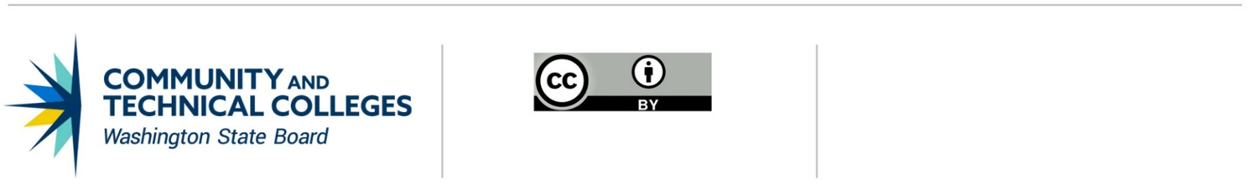 June 21, 2019

# **Professional Technical Common Courses**

# Revising an existing course

If a college offering a Professional/Technical Common Course (P/TCC) wants to modify any part of the course (Prefix, Number, Title, Credits, Description, Student Outcomes), the college must either:

* Convene all the other adopting colleges to initiate discussion about revisions to the course, OR
* Email [SBCTC P/TCC staff](mailto:kgoebel@sbctc.edu?subject=P/TCC%20Revising%20Request) and request the college be removed from the list of colleges offering the P/TCC on the [Common Course Matrix](https://ccn.sbctc.edu/).

## Revision Process

1. The Lead College Contact will invite all colleges that have adopted the P/TCC under consideration to participate in the change discussion.
2. CONSENSUS:
   1. If consensus is reached, the colleges must complete steps 3, 7, 8, 9, and 10 on the Professional/Technical Common Course “[Developing a New Course](https://www.sbctc.edu/resources/documents/colleges-staff/programs-services/professional-technical/developing-a-new-course.docx)” checklist.
   2. If consensus cannot be reached, the Lead College Contact will contact the WEC Chair to facilitate and resolve concerns before any change may be submitted to the Instruction Commission for approval.
   3. If a technology modification or change (for example, new software or equipment) not common to all participating colleges hinders resolution:
      1. The historic P/TCC will be retained by colleges that cannot accommodate the technology modification.
      2. Colleges that are able to accommodate the technology modification are required to develop a unique department/division prefix and/or number and title.   
           
         Colleges must complete steps 1, 3, 6, 7, and 9 on the P/TCC “Developing a New Course” checklist and submit to the WEC Chair. A cover letter briefly describing the reason for the change should be attached.  
           
         The WEC Chair will forward proposals to the P/TCC Subcommittee Chair. The subcommittee with review and notifies the WEC Chair and Lead College Contact of the recommendation. If recommended, colleges will add P/TCC to their college course catalogs.
   4. If the majority of members of the consortium agrees to a change and a member college does not agree with the proposed change, the disagreeing college must drop the P/TCC designation.

## Assurances

I, NAME OF COLLEGE CHIEF INSTRUCTIONAL OFFICER, affirms that NAME OF COLLEGE has approved the following Professional Technical Common Course(s): (Replicate table for each course.)

|  | **PREFIX** | **NUMBER** | **P/T COMMON COURSE TITLE** | **CREDITS** |
| --- | --- | --- | --- | --- |
|  |  |  |  |
| **DESCRIPTION** |  | | | |
| **TOPICS/SKILLS** |  | | | |
| **COURSE OUTCOMES** |  | | | |
| **ADOPTING COLLEGES** |  | | | |

This institution’s established approval process has been followed and the courses listed above have been approved by the college.

This institution acknowledges that once the courses have been adopted, no modifications are permissible without utilizing the established Professions/Technical Revision process or Deactivation process.

Approved By:

_____________________________________________________________________________________

SIGNATURE OF CHIEF INSTRUCTIONAL OFFICER DATE

____________________________________________________________________________________  
PRINTED NAME OF CHIEF INSTRUCTIONAL OFFICER

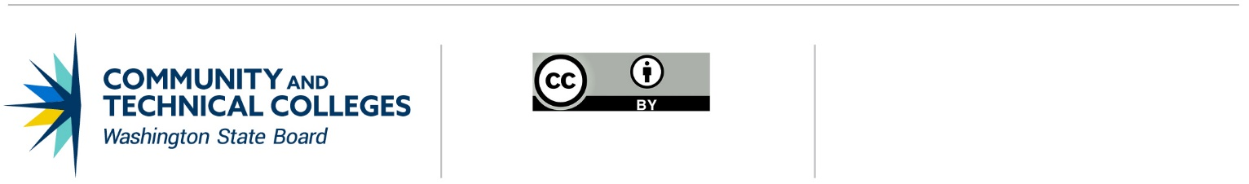

*Note: All material licensed under CC BY.*

CONTACT INFORMATION

Kathy Goebel

Policy Associate, Workforce Education

p: 360-704-4359

e: [kgoebel@sbctc.edu](mailto:kgoebel@sbctc.edu)