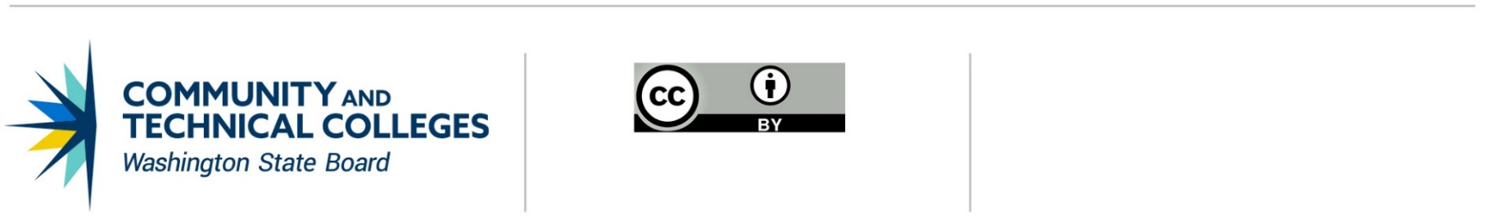 June 21, 2019

# **Professional Technical Common Courses**

# Assurances

I, NAME OF COLLEGE CHIEF INSTRUCTIONAL OFFICER, affirms that NAME OF COLLEGE has approved the following Professional Technical Common Course(s): (Replicate table for each course.)

|  | **PREFIX** | **NUMBER** | **P/T COMMON COURSE TITLE** | **CREDITS** |
| --- | --- | --- | --- | --- |
|  |  |  |  |
| **DESCRIPTION** |  | | | |
| **TOPICS/SKILLS** |  | | | |
| **COURSE OUTCOMES** |  | | | |
| **ADOPTING COLLEGES** |  | | | |

This institution’s established approval process has been followed and the courses listed above have been approved by the college.

This institution acknowledges that once the courses have been adopted, no modifications are permissible without utilizing the established Professions/Technical [Revision process](https://www.sbctc.edu/resources/documents/colleges-staff/programs-services/professional-technical/revising-an-existing-course.docx) or [Deactivation process](https://www.sbctc.edu/resources/documents/colleges-staff/programs-services/professional-technical/deactivation-of-an-existing-course.docx).

Approved By:

_____________________________________________________________________________________

SIGNATURE OF CHIEF INSTRUCTIONAL OFFICER DATE

____________________________________________________________________________________  
PRINTED NAME OF CHIEF INSTRUCTIONAL OFFICER