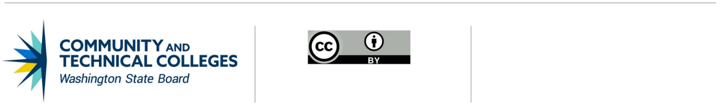 June 21, 2019

# **Professional Technical Common Courses**

# Deactivation of an existing course

## Deactivation Process

To drop a Professional/Technical Common Course (P/TCC) from its inventory, the college:

1. Submits an email to the [SBCTC P/TCC staff](mailto:kgoebel@sbctc.edu?subject=P/TCC%20Deactivation%20Request) to remove the college from the list of colleges offering the P/TCC. The WEC Chair should be copied on the email.
2. Revises the college’s course catalog to reflect the change.

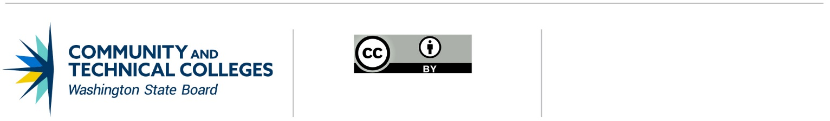

*Note: All material licensed under CC BY.*

CONTACT INFORMATION

Kathy Goebel

Policy Associate, Workforce Education

p: 360-704-4359

e: [kgoebel@sbctc.edu](mailto:kgoebel@sbctc.edu)