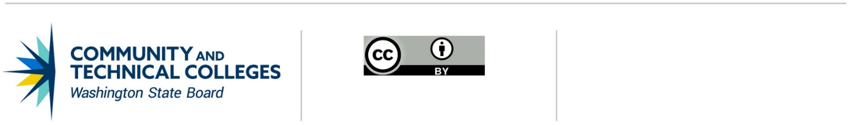 June 21, 2019

# **Professional Technical Common Courses**

# Adopting an existing course

## Colleges may add one or more Professional/Technical Common Courses (P/TCC) at a time.

1. The college reviews existing P/TCC on the [Common Course Matrix](https://ccn.sbctc.edu/).
2. The college contacts the WEC Chair expressing intent to adopt an existing P/TCC. The WEC Chair will forward request to the P/TCC Subcommittee Chair. This is an informational – not a recommendation – step. No recommendation or approval action is required for a college to adopt an existing P/TCC.
3. The college seeks approval to adopt or add the course(s) through its established internal college process. The college will submit a completed Assurance Page to the P/TCC Subcommittee Chair to confirm this. The common elements that constitute the P/T Common Course must not be changed.

**ELEMENTS THAT CONSTITUTE THE PTCCN**

|  | **PREFIX** | **NUMBER** | **P/T COMMON COURSE TITLE** | **CREDITS** |
| --- | --- | --- | --- | --- |
|  |  |  |  |
| **DESCRIPTION** |  | | | |
| **TOPICS/SKILLS** |  | | | |
| **COURSE OUTCOMES** |  | | | |
| **ADOPTING COLLEGES** |  | | | |

1. The colleges will provide a [Program Approval Request (PAR)](http://www.sbctc.edu/resources/documents/colleges-staff/programs-services/professional-technical/2012PAR.docx) when appropriate.   
   [CLICK HERE FOR MORE INFORMATION ON PROF-TECH PROGRAM APPROVAL.](http://www.sbctc.edu/resources/documents/colleges-staff/programs-services/professional-technical/2012ProgramApprovalProcessGuidelines.pdf)
2. The college will inform the WEC Chair of the course adoption.
3. The WEC Chair will notify the P/TCC Subcommittee Chair and State Board of Community and Technical Colleges ([SBCTC](mailto:kgoebel@sbctc.edu?subject=P/TCC%20Adopting%20an%20Exsisting%20Course)) of the new college’s adoption of the P/TCC and it will be added to the [Common Course Matrix](https://ccn.sbctc.edu/).
4. The college will add approved P/TCC(s) to its course catalog.

## Assurances

I, NAME OF COLLEGE CHIEF INSTRUCTIONAL OFFICER, affirms that NAME OF COLLEGE has approved the following Professional Technical Common Course(s): (Replicate table for each course.)

|  | **PREFIX** | **NUMBER** | **P/T COMMON COURSE TITLE** | **CREDITS** |
| --- | --- | --- | --- | --- |
|  |  |  |  |
| **DESCRIPTION** |  | | | |
| **TOPICS/SKILLS** |  | | | |
| **COURSE OUTCOMES** |  | | | |
| **ADOPTING COLLEGES** |  | | | |

This institution’s established approval process has been followed and the courses listed above have been approved by the college.

This institution acknowledges that once the courses have been adopted, no modifications are permissible without utilizing the established Professional/Technical Revision process or Deactivation process.

Approved By:

_____________________________________________________________________________________

SIGNATURE OF CHIEF INSTRUCTIONAL OFFICER DATE

_____________________________________________________________________________________  
PRINTED NAME OF CHIEF INSTRUCTIONAL OFFICER

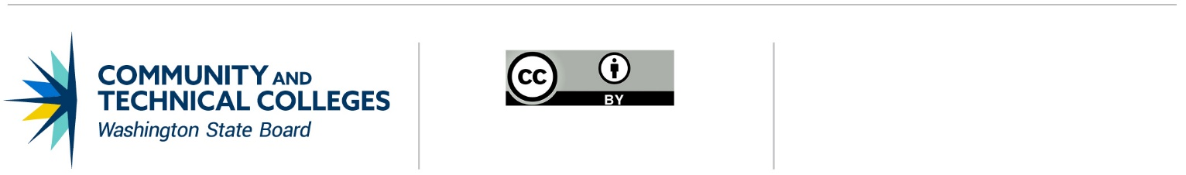

*Note: All material licensed under CC BY.*

CONTACT INFORMATION

Kathy Goebel

Policy Associate, Workforce Education

p: 360-704-4359

e: [kgoebel@sbctc.edu](mailto:kgoebel@sbctc.edu)