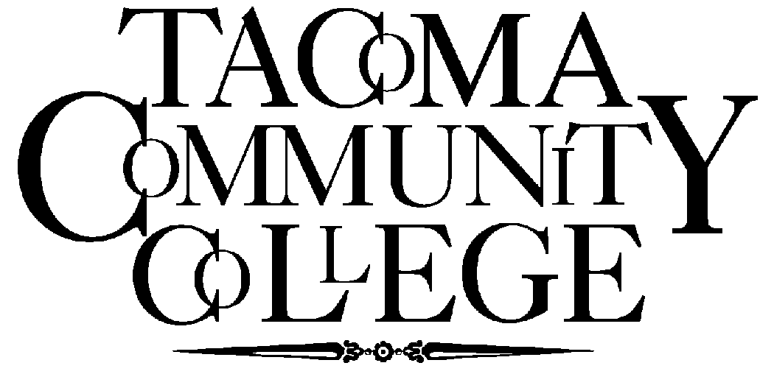
ADVISE
for Action
Your College Logo Here

You've been asked to serve . . .
On a Career and Technical Education Program Advisory Committee

What is a Career and Technical Education Program advisory committee?

Advisory committees for career and technical education programs are appointed by local education agencies or institutions to help improve programs that prepare students to enter and succeed in the workforce. Members, who represent business and labor, have expertise in the skills and competencies needed for specific occupations. Because committee members have extensive knowledge of the area they advise, instructors and administrators take their role seriously. Committees are goal-oriented and achieve results. They promote constructive and necessary change within a program, generate new ideas and serve as advocates for quality career and technical education.

As a member of an advisory committee, you will be asked to:

- Identify and validate academic and occupational competencies
- Develop student performance standards and measures
- Evaluate equipment and facilities against industry grants
- Recommend new technologies to include in the program
- Facilitate student job shadowing, internships, or cooperative work experiences
- Increase community awareness of career and technical education
- Help with student recruitment and job placement
- Provide back-to-industry opportunities for instructors
- Promote efforts of vocational student organizations
- Determine effectiveness of program
- Support state and federal legislation impacting career and technical education

You have been asked to serve because:

Your skills and expertise are valuable to the career and technical education program; your advice, time and energy will improve the instructional efforts; your ideas about education and training are important; your energy will help the committee accomplish a plan of action; your willingness to work as a member of a team; and your commitment to quality education. Your efforts will ensure that students acquire the knowledge, skills, and attitudes that are necessary to enter and succeed in the workforce.

What will I get out of the experience?

The benefits you receive from participating on an advisory committee will depend on your perspective. Some of the advantages include: personal satisfaction of knowing that you have contributed to the education program and the economic growth of your community; satisfaction of knowing you have helped students; personal and company recognition and prestige for having participated; satisfaction of knowing your ideas have been used and that you are making a difference; and, knowledge of having helped spend tax dollars wisely to build a skilled work force.

What expectations do other members have of me?

Participation
To offer advice, opinions, and constructive suggestions about the work of the committee. This includes studying the problem under consideration and helping to reach consensus for appropriate action.

Attendance
To attend the meetings regularly.

Conduct
To place the needs of students before personal interests; also to respect the opinions of others and refrain from public expression of disapproval.

Your participation as a member of the committee will benefit:

Instructional Program --
The education and training process will become more effective as a result of your participation. Programs will be based on current job needs, with a focus on specific skills, competencies, and attitudes.

Students --
Transition from school to work will be smoother due to instructional program ties with business and labor. Most important, students will have the types and level of skill employers' need.

Employment Community --
The employment community will have a trained work force that will help build economic stability.

Schools --
Local schools will receive increased community support. Students completing programs will be adequately prepared and perform effectively on the job thereby enhancing the school's reputation.

Community --
The entire community benefits from citizens who are making contributions to the social and economic well being of others.

Technical Assistance:
State Board for Community and Technical Colleges
Workforce Education
1300 Quince St SE
PO Box 42495
Olympia, WA 98504-2495
(360) 704-4332

