2023-25 MINOR PROJECT REQUEST
Due April 4, 2022

A minor project must cost between $25,000 and $2,000,000 and can be for facility renovation or alteration or site improvement. The SBCTC established a target level of funding for each college. Within that level, a college may develop one or more projects. These projects should be chosen carefully to reflect critical goals of the college and serve to improve the educational environment, better access, deal with childcare, or student support services. The legislature expects these projects to be completed in the biennium they are funded.

Projects should not include development or improvement of support space. Do not include lease payments, Local Improvement District costs, or other costs that are traditionally paid from the operating budget. Do not propose projects that support enterprise activities, increase space, procure property, or have any operating budget impact.

Colleges must answer the questions on the last page to verify eligibility for state funding of the project.

Program Total by College

The system budget target is $35,466,000 for support of minor programmatic projects in the 2023-25 biennium. Each college’s portion of the system target is based on their portion of the system’s fall 2021 student FTEs, owned gross square footage, and owned gross square footage built before 1998.

Submittal

Submit the Minor Program Request Form(s) via e-mail to wdoty@sbctc.edu. In addition to these forms, supporting letters or reports from design consultants may be submitted to provide background on analysis, alternatives, cost estimates, etc. Project numbers will be assigned to each project when it entered into the Office of Financial Management’s Capital Budget System.

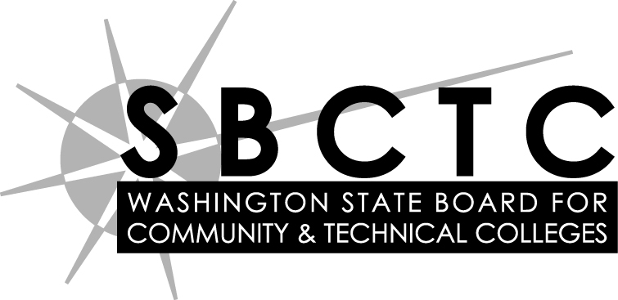
2023-25 MINOR PROGRAM REQUEST
College:
Project title:
Project location:
What is the problem? Why is this project necessary?
What happens if this project is not funded by the State?
What is the desired solution?
Will this project increase access or improve utilization? (Yes/No)
If yes, please specify the Net Change in FTE capacity.
What benefit will this project provide the college?
How does the project relate to the college facilities master plan, the strategic plan, and institutional goals?
Cost Summary:
Construction
Equipment
Contingency
Sales Tax
Design
Total Cost
Funding Summary:
State Appropriation
Local Funding (specify account)
Other (specify source)
Total Funding
Please explain any difference between the Total Cost and Total Funding.
ELIGIBILITY FOR TAX EXEMPT FINANCING

Treasurer’s questions to help ensure compliance with Internal Revenue Service (IRS) regulations for tax-exempt financings.

- Will any portion of the project or asset ever be owned by any entity other than the State or one of its agencies or departments? | Yes No
- Will any portion of the project or asset ever be leased to any entity other than the State or one of its agencies or departments? | Yes No
- Will any portion of the project or asset ever be managed or operated by any entity other than the State or one of its agencies or departments? | Yes No
- Will any portion of the project or asset be used to perform sponsored research under an agreement with a nongovernmental entity*? | Yes No
- Does the project involve a public/private venture, or will any entity other than the State or one of its agencies or departments ever have a special priority or other right to use any portion of the project or asset to purchase or otherwise acquire any output of the project or asset such as electric power or water supply? | Yes No
- Will any portion of the Bond/COP proceeds be granted or transferred to nongovernmental entities or granted or transferred to other governmental entities which will use the grant for nongovernmental purposes? | Yes No
- If you have answered “Yes” to any of the questions above, will your agency or any other State agency receive any payments from any nongovernmental entity, for the use of, or in connection with, the project or asset? | Yes No
- Is any portion of the project or asset, or rights to any portion of the project or asset, expected to be sold to any entity other than the State or one of its agencies or departments? | Yes No
- Will any portion of the Bond/COP proceeds be loaned to nongovernmental entities or loaned to other governmental entities that will use the loan for nongovernmental purposes? | Yes No
- Will any portion of the Bond/COP proceeds be used for staff costs for tasks not directly related to a financed project(s)? | Yes No

*A nongovernmental entity is defined as:
- any person or private entity, such as a corporation, partnership, limited liability company, or association;
- any nonprofit corporation (including any 501(c)(3) organization);
- the federal governmental (including any federal department or agency).

Determining eligibility:

If all of the answers to the questions above are “No”, the project qualifies for tax-exempt funding. If the answer to any of the questions is “Yes”, contact the SBCTC Capital Budget Office for further review.

