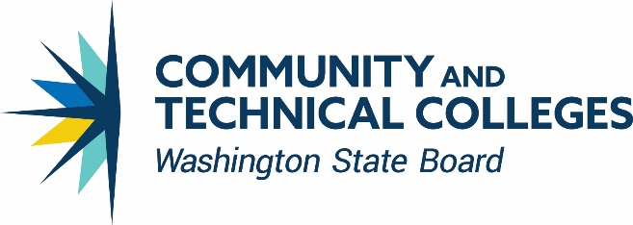

**Basic Education for Adults**

**Staff Areas of Responsibility**

**William Durden** [**wdurden@sbctc.edu**](mailto:wdurden@sbctc.edu) **360-704-4326**

Director

* Strategic Direction Implementation & Management
* Department operations and policy coordination
* WIOA State Plan: Title II

**Christy Lowder** [**clowder@sbctc.edu**](mailto:clowder@sbctc.edu) **360-704-4323**

Assistant to the Director

* Direct support for director
* Department administrative/logistical support
* OGMS support (Kari Kaufmann, [kkauffman@sbctc.edu](mailto:kkauffman@sbctc.edu))
* BEdA website maintenance

**Mandie Tix** [**mtix@sbctc.edu**](mailto:mtix@sbctc.edu) **360-704-4331**

Program Specialist II

* WABERS+ Helpdesk
* Initial I-BEST Approval
* Supports all BEdA I-BEST programs
* Web Resources for I-BEST
* BEdA website maintenance
* Corrections Education Meetings & Conferences

**Troy Goracke** [**tgoracke@sbctc.edu**](mailto:tgoracke@sbctc.edu) **360-704-4361**

Basic Skills – Policy Associate, Accountability &Compliance, Adult High School Completion, Program Approval, and Professional Development

* Adult High School Completion
* Accountability/Compliance/Federal Regulations
* Liaison to OSPI/WTECB-IC/WDC/WorkFirst
* RFA-Master and Leadership Grants, Extensions/Continuations, & Yearend Report
* WIOA Technical Support
* High School Program Review & Technical Assistance

**MarcusAntonio Gunn** [**magunn@sbctc.edu**](mailto:magunn@sbctc.edu) **360-704-4322**

Basic Skills – Policy Associate, Diversity, Equity, and Inclusiveness and Barrier Mitigation

* Diversity, Equity, & Inclusion
* Barrier Mitigation & Closing the Opportunity Gap
* Professional Development & PD Calendar
* AEAC
* CBS
* New Director Training

**Pat Seibert-Love** [**pseibert-love@sbctc.edu**](mailto:pseibert-love@sbctc.edu) **360-704-4358**

Basic Skills – Policy Associate, Corrections Education

* Guided & I-BEST Pathways for CE
* Corrections Education & DOC Liaison
* State Legislation
* Basic Skills for Adults, Workforce Education, AA Degrees, & Reentry

**Hanan Al-Zubaidy** [**hal-zubaidy@sbctc.edu**](mailto:hal-zubaidy@sbctc.edu) **360-704-1052**

Basic Skills – Program Administrator, Corrections Education

* Corrections Education Navigators
* Corrections Education Biennial Conference
* Apprenticeship Work Group
* Corrections Education College Catalogues
* Corrections Education Annual & Quarterly Reports
* Corrections website maintenance

**Nicole Hopkins** [**nhopkins@sbctc.edu**](mailto:nhopkins@sbctc.edu) **360-704-4368**

Basic Skills – Policy Associate, Guided and I-BEST Pathways

* Pathway Development & Implementation, IELCE Grants, & IET
* Prof. Tech., Expansion, Academic I-BEST
* In/out of state I-BEST TA
* Contextualized Instruction/I-BEST at Work
* I-BEST Navigation & TT Cadres
* I-BEST Liaison Councils/Commissions
* I-BEST @ Work Development, Implementation, and Training
* Pathway Navigation

***Vacant* 360-704-4362**

Basic Skills Program Administrator

* Employability Skills
* New faculty Training
* CCR Standards
* Contextualized, integrated, , UDL/LTA/RATS
* Math/English Transition Courses
* BEdA Biennial Conference

**Scott Toscano** [**stoscano@sbctc.edu**](mailto:stoscano@sbctc.edu) **360-704-4381**

Basic Skills Program Administrator

* Assessment Policy & CASAS
* NRS-Data Collection Quality
* Accountability/Compliance/Federal Regulations
* Program Review & Technical Assistance
* Internal & External Data Requests
* WIOA Technical Support

**Jodi Ruback** [**jruback@sbctc.edu**](mailto:jruback@sbctc.edu) **360-704-4306**

Basic Skills Program Administrator

* ELA
* ELA Standards Alignment
* I-DEA-Flipped Instruction & eLearning Liaison
* Distance Learning
* Digital Literacy & Digital Equity
* I-DEA Dissemination
* CBO liaison