## Style Guide for editing Statement of Need and Program Proposal Templates

The information presented here is applicable to the Bachelor of Science (BS), the Bachelor of Applied Science (BAS), and the Bachelor of Science in Nursing (BSN) Statements of Need and Program Proposals. When developing the Statement of Need or Program Proposal, use the State Board for Community and Technical Colleges (SBCTC) template provided on the [Bachelor Program Approval Process](https://www.sbctc.edu/colleges-staff/programs-services/applied-baccalaureates/bachelors-program-approval-application.aspx) page. With the Style Guide in hand, locate the template, and follow these steps:

1. Open the template
2. Go to File> Save as> and rename the document

* Saving the document under a new name, as indicated in step 2 above, will generate the preformatted settings and styles that the college will use when creating new Statements of Need and Program Proposals.

1. To verify that all required criteria have been met, refer to the Style Guide Checklist before submitting documents to the State Board for Community and Technical Colleges (SBCTC).

Contents

Formatting Guidelines 3

Statement of Need Criteria and Standards 7

Program Proposal Criteria and Standards 7

Grammar Guidelines 7

Checklist 8

References 9

Appendix 9

Submission to the State Board for Community and Technical Colleges (SBCTC) 9

## Formatting Guidelines

### Title Page

* Insert college logo into image box on Title page replacing current logo.
  + Limit dimensions of college logo to 5” x 5”
    - Right click in logo, scroll down to Size and Position. Across the top of dialogue box, click the third tab labeled Size. This will open the Size dialogue box. Absolute Position is 5” for vertical and width.
* For accessibility – use Alt Text for your college logo description.
  + Right click in logo, scroll down to Alt Text, add description in window.
* Include the date of State Board meeting when the college will present
* Include the full name, (no acronyms) of the degree title and proposed program
* Write out the full name of the college, without acronyms or shortened titles
  + State Board, Statement of Need, Program: Heading 1
  + College Name: Intense Emphasis

### Margins

* Normal 1” margins
  + Do not alter margins.

### Table of Contents

* The table of contents should be prepared after the full document has been completed. When the Table of Contents is inserted after the title page, the Table of Contents will populate automatically. Following this process will allow for automatic updating of the Table of Contents.
  + To enter Table of Contents, go to Reference tab, click on the Table of Contents icon, in the drop-down menu choose Automatic Table 1 or Table 2.
    - Table of Contents: TOC Heading

### Cover Page

* The cover page contains specific, program-related information, including the [CIP Codes](https://nces.ed.gov/ipeds/cipcode/Default.aspx?y=56). Make sure that the CIP code for the related program is relevant and accurate. Use the CIP Code tool to check accuracy.
* The Chief Academic Officer’s signature is required to verify college approval for submission of Statements of Need and Program Proposals to the State Board for Community and Technical Colleges.
  + Cover Page – Statement of Need: Heading 2
  + Program Information: Heading 3

### Text for Body of Report

* Franklin Gothic Book, font size 11
  + Text – Body heading

### Heading Styles and Formatting

For all Heading Styles used in this document, go to Home tab, Styles dialogue box, and click the down arrow for the Styles in this document.

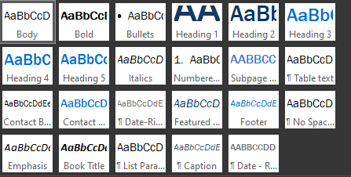

# Heading 1 (font size 30)

## Heading 2 (font size 22)

### Heading 3 (font size 18)

* Bullet list – level 1
  + Bullet list – level 2
    - Bullet list – level 3

### Tables

Dimensions for Tables placed in this document are 6.4 inches wide and centered on page.

* After table is created, place cursor in table, right click, choose table properties
  + Size – 6.4”
  + Alignment – Centered

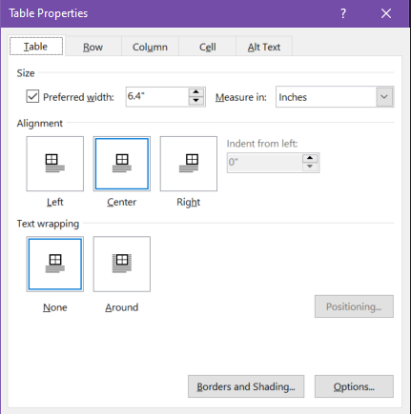

### Shading for Tables

* Blue, accent 1, lighter 80%
  + Go to Home tab, in Paragraph dialogue box, choose the paint can for shading. Shading is 5th column, first color of blue. When you hover over color, the description of Blue, accent 1, lighter 80% should be visible.

### Headings and Text in Tables

* Headings: bold, centered in cell
* Left headings: left-aligned center
* Text in cells: left-aligned, center
* Numbers in cells: middle-aligned, centered
* Money in cells: right-aligned centered, must have dollar sign
  + For Table tools, right click in Table. In the ribbon a Table Tools should appear on the end. Click Layout. The Alignment group gives you control over the alignment, direction, and hyphenation of text within table cells, and control of cell margins.

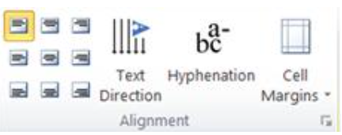

### Accessibility in Tables

* For Accessibility, Tables will need to be captioned. The title will become the caption of your Table.
  + To add captions, highlight Table. Go to Ribbon, Reference Tab, select insert caption. This will open a dialogue box. Insert Caption after Table number.
  + Caption font: Go to Ribbon, Home tab, choose Styles, in the drop down, use the Caption Style.

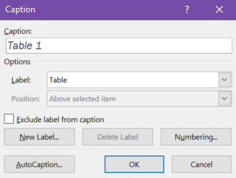

Table 1: Description of how to use Tables in Reports

|  |  |  |
| --- | --- | --- |
| **College** | **2021-2022** | **2022-2023** |
| Your college here | 65 | $ 450.00 |

### Footer

* Place page number on the left and place the college name // program name // date (ex. Fall 2021, right.
* Please adjust the Tab Stop in the ruler located at the top of your document if the college and program title do not fit on one line.
  + Font style for footer: Go to Ribbon, Home, Font Styles, choose Footer style.
    - Font size 9, Franklin Gothic Book
* Your footer will start on the Cover page of the document. The Title Page and Table of Contents will not have footers.

Statement of Need Criteria and Standards

As outlined in the template, use the seven (7) criteria and standards selections to develop the college’s Statement of Need. Please note, to meet accessibility requirements, the information has been removed from the previous Table format. The correct formatting is provided in Statement of Need template. Please remove standard text before listing criteria.

Program Proposal Criteria and Standards

As outlined in the template, use the eight (8) criteria and standards selections to develop the college’s Program Proposal. Please note, to meet accessibility requirements, the information has been removed from the previous Table formatting. The correct formatting is provided in Program Proposal template. Please remove standard text before listing criteria.

## Grammar Guidelines

* Use the college’s official name. (Example: Skagit Valley College, not SVC).
* Refrain from using personal pronouns. (Example: “The college is excited to implement the program” not “Our college is excited to implement the program”).
* Use acronyms sparingly.
* Spell out contractions. (Example: use: could not, rather than: couldn’t).
* Use future tense when discussing the proposed program (Example: “The proposed program will….”)
* Use Fall 2002, not fall of 2002.
* Use Bachelor of Applied Science (upper case) when referencing specific degrees, (Example: Bachelor of Applied Science in Applications Development).
* Use bachelor of applied science (lower case) when referencing nonspecific degrees, (Example: Skagit Valley College offers bachelor of applied science degrees).
* Refrain from beginning sentences with a number or a percentage (Example: Forty percent of students; not 40% of students).

## Checklist

### Title Page

* Insert institution’s logo
* Include date of the state board meeting (ex. October 2021)
* Statement of Need or Program Proposal
* Program full title, do not shorten or use acronyms
* Add institution’s name

### Table of Contents

* Include all sections presented in the document
  + Refer to guidelines on how to insert Table of Contents

### Cover Page

#### Program Information

* Write the full title of the institution
* Provide full title of proposed program. Put related program acronym, if applicable, in parenthesis after the full program title
* Provide accurate [CIP code information](https://nces.ed.gov/ipeds/cipcode/Default.aspx?y=56)
* List the proposed implementation start date for the proposed program
* Provide projected enrollment (FTE) in year one
* Provided enrollments (FTE) by year
* Identify program funding source

### Mode of Delivery

* Identify type of proposed program delivery

### Statement of Need

* Stay within the 20-page limit

### Proposal Program

* Stay within 25-page limit

### Contact Information (Academic Department Representative)

* Provide name, title, address, and phone/email

### Chief Academic Officer Signature

* Signature of chief academic officer (ex. vice president of instruction)

### Criteria and Standards

* Address all criteria (ex. 1-7 for Statement of Need; 1-8 for Program Proposal)
* Check grammar, spelling, and punctuation (see guidelines for specifics)
  + Use acronyms sparingly
  + Do not use personal pronouns
  + Refer to the degree types appropriate (associate not associate’s; bachelors vs bachelor’s)

### Supply and Demand

* Include the supply demand document (Statement of Need)
* Respond to all applicable sections of the supply/demand form

### References

* Provide references in alphabetical order
* Make sure that references are accurate and align with information in the document

### Appendix

* Label appendix headings appropriately (Appendix A, Appendix B, etc.)
* Make sure that appendix reference aligns with references in the criteria sections of the document
* Include letters of support, where applicable

### Submission to the State Board for Community and Technical Colleges (SBCTC)

* Use the [Planning Timeline](https://www.sbctc.edu/resources/documents/colleges-staff/programs-services/applied-baccalaureate/applied-bacc-timeline-2020-21-2021-22.pdf) to determine the submission deadline for Statements of Need and Program Proposals.
* Questions?

Contact: Jamilyn Penn, EdD

director of transfer education

[jpenn@sbctc.edu](mailto:jpenn@sbctc.edu)

253-302-9395