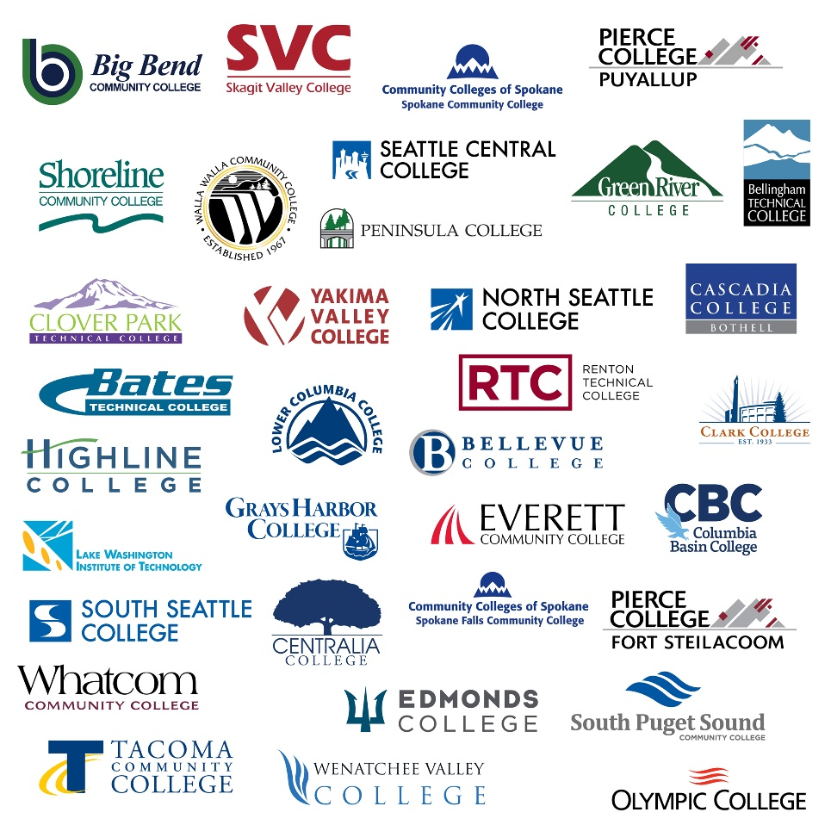

# State Board for Community and technical colleges Insert presentation date Statement of Need Insert degree title insert program name

*Insert college name*

Table of Contents

Cover Page — Statement of Need 3

Program Information 3

Mode of Delivery 3

Statement of Need 3

Contact Information (Academic Department Representative) 4

Chief Academic Officer signature 4

Criteria 1 5

Relationship to institutional role, mission, and program priorities. 5

Criteria 2 5

Support of the statewide strategic plans. 5

Criteria 3 5

Employer/community demand for graduates with baccalaureate level of education proposed in the program. 5

Criteria 4 5

Baccalaureate program builds from existing professional and technical degree program offered by the institution. 5

Criteria 5 5

Student demand for program within the region. 5

Criteria 6 6

Efforts to maximize state resources to serve place-bound students. 6

Criteria 7 6

Promoting equitable opportunities for students, including historically marginalized students. 6

## Cover Page — Statement of Need

### Program Information

Institution Name: Click or tap here to enter text.

Degree Name: Click or tap here to enter text.

CIP Code: Click or tap here to enter text.

Name(s) of existing technical associate degree(s) that will serve as the foundation for this program:

Degree: Click or tap here to enter text.

CIP Code: Click or tap here to enter text.

Year Began: Click or tap here to enter text.

Degree: Click or tap here to enter text.

CIP Code: Click or tap here to enter text.

Year Began: Click or tap here to enter text.

Degree: Click or tap here to enter text.

CIP Code: Click or tap here to enter text.

Year Began: Click or tap here to enter text.

**Proposed Start Implementation Date (i.e. Fall 2014):** Click or tap here to enter text.

Projected Enrollment (FTE) in Year One: Click or tap here to enter text.

Projected Enrollment (FTE) by Year: Click or tap here to enter text.

Funding Source: Choose an item.

### Mode of Delivery

Single Campus Delivery: Click or tap here to enter text.

Off-site: Click or tap here to enter text.

Distance Learning: Click or tap here to enter text.

### Statement of Need

Please see criteria and standard sheet. **Page Limit:** **20 pages**

### Contact Information (Academic Department Representative)

Name: Click or tap here to enter text.

Title: Click or tap here to enter text.

Address: Click or tap here to enter text.

Telephone: Click or tap here to enter text.

Email: Click or tap here to enter text.

### Chief Academic Officer signature

The Statement of Need must be signed. To sign, double click on the signature line below.



Click or tap to enter a date.

## Criteria 1

### Relationship to institutional role, mission, and program priorities.

Describe how the proposed program reflects and support the role and mission of the institution and reflect program priorities.

## Criteria 2

### Support of the statewide strategic plans.

Describe how the program will support the State Board for Community and Technical Colleges (SBCTC) Mission goals outlined in the Mission Study and Washington Student Achievement Council (WSAC) policies and goals for higher education as articulated in the Strategic Master Plan for Higher Education.

## Criteria 3

### Employer/community demand for graduates with baccalaureate level of education proposed in the program.

* Employer demand must exceed regional supply of graduates with relevant degrees.
* Demand must be based on data sources including but not limited to local employer survey, traditional labor market data, industry data, trade associated data, and other transactional data. Please provide evidence of the gap between the numbers of program graduates verses the number of job opening locally and regionally. Refer to attached supply/demand gap rubric for additional guidance.

## Criteria 4

### Baccalaureate program builds from existing professional and technical degree program offered by the institution.

Describe the existing professional and technical degree program that will be used as the foundation for applied baccalaureate program. Include how long the program has been in existence and the enrollment history of the program over the past five years.

## Criteria 5

### Student demand for program within the region.

Evidence of student interest and demand from multiple sources, such as but not limited to: students graduating with technical associate degrees in the region, survey of students within region, demand in excess of opportunity to enroll in related traditional bachelor’s programs, and changes in industry standards. Include enrollment projections for each year over the next five years.

## Criteria 6

### Efforts to maximize state resources to serve place-bound students.

* Describe how program will serve place-bound working adults.
* Identify similar program offered by public or independent institutions in the region.
* Describe options that have been explored for collaboration with other public baccalaureate institutions, businesses, and /or community organizations considered in the development of the proposal and include a brief description of initial conversations.
* Describe collaboration with similar community and technical colleges (CTC) baccalaureate programs and related community and technical colleges Centers of Excellence.
* Describe unique aspects of the proposed program that differentiate it from similar programs and/or describe why expansion would be desirable or necessary.

## Criteria 7

### Promoting equitable opportunities for students, including historically marginalized students.

Create an implementation plan to recruit and support students of color and low-income students into the bachelor degree program. Within the implementation plan, provide data that reflects the college’s student demographics and highlight demographics for students of color and low-income students. Identify barriers/challenges that students of color and low-income students may face at the college, and reflect upon how these barriers/challenges or others may impact students of color and low-income students interested in applying to the bachelor degree program. In the Implementation Plan, describe resources, supports, or other processes to recruit and support students of color and low-income students.