

STATE BOARD FOR COMMUNITY AND TECHNICAL COLLEGES

FEBRUARY 2021 PROGRAM PROPOSAL BACHELOR OF SCIENCE

NURSING

*BELLINGHAM TECHNICAL COLLEGE*

**Contents**

Cover Page — Program Proposal 3

Program Information 3

Mode of Delivery 3

Program Proposal 3

Contact Information (Academic Department Representative) 4

Chief Academic Officer signature 4

Introduction 5

Institutional Overview 5

Program Overview 5

Criteria 1 8

Curriculum demonstrates baccalaureate level rigor. 8

Criteria 2 17

Qualified faculty. 17

Criteria 3 19

Appropriate student services plan. 23

Criteria 5 26

Commitment to build and sustain a high-quality program. 26

Criteria 6 30

Program specific accreditation. 30

Criteria 7 31

Pathway options beyond baccalaureate degree. 31

Criteria 8 31

External expert evaluation of program. 31

APPENDIX A 32

APPENDIX B 35

NURSING PROGRAM RN-BSN APPLICATION 37

REFLECTIVE GOAL STATEMENT 37

# Cover Page — Program Proposal

## Program Information

Institution Name: Click or tap here to enter text. Degree Name: Click or tap here to enter text.

CIP Code: Click or tap here to enter text.

Name(s) of existing technical associate degree(s) that will serve as the foundation for this program: Degree: Click or tap here to enter text.

CIP Code: Click or tap here to enter text. Year Began: Click or tap here to enter text.

Degree: Click or tap here to enter text.

CIP Code: Click or tap here to enter text. Year Began: Click or tap here to enter text.

Degree: Click or tap here to enter text.

CIP Code: Click or tap here to enter text. Year Began: Click or tap here to enter text.

Proposed Start Implementation Date (i.e. Fall 2014): Click or tap here to enter text. Projected Enrollment (FTE) in Year One: Click or tap here to enter text.

Projected Enrollment (FTE) by Year: Click or tap here to enter text. Funding Source: Choose an item.

## Mode of Delivery

Single Campus Delivery: Click or tap here to enter text. Off-site: Click or tap here to enter text.

Distance Learning: Click or tap here to enter text.

## Program Proposal

*Please see criteria and standard sheet. Page Limit: 30 pages*

## Contact Information (Academic Department Representative)

Name: Click or tap here to enter text. Title: Click or tap here to enter text. Address: Click or tap here to enter text. Telephone: Click or tap here to enter text. Email: Click or tap here to enter text.

## Chief Academic Officer signature

The Program Proposal must be signed. To sign, double click on the signature line below.

X

Chief Academic Officer

Date: Click or tap to enter a date.

# Introduction

## Institutional Overview

Bellingham Technical College (BTC) is a two-year technical college located in Whatcom County, a rural area perched on the Pacific Rim and bordered by Canada to the North and the Cascade Mountains to the East. The college has served this region for over 60 years with a combination of professional technical educational programs, direct transfer programs with a workforce focus, basic education for adults, contract training, community programming, and continuing education. As an open-access institution, BTC is a critical resource for students who are economically, socially or educationally disadvantaged,

including students who are low-income or first-generation. 15 percent of the county’s population is below the official U.S. poverty line. In the more rural areas of the county, over 50 percent of K-12 students qualify for free or reduced lunch. The average age of BTC students is 31. Half of BTC’s degree-seeking students are low-income, and approximately one-third are first-generation students.

BTC’s mission is to provide student-centered, high-quality professional technical education for today’s needs and tomorrow’s opportunities. In order to meet current and future workforce needs, BTC has expanded transition, articulation, employment, and continuing education opportunities for the wide variety of students it serves.

## Program Overview

BTC’s nursing pathway development goals include refining existing and designing new part-time nursing programs that foster diverse student retention and success. Pathway courses will be offered at times convenient for incumbent workers—so that their studies won’t affect their attendance at the workplace during times vital to employers. When students can work and support themselves while attending, they are less likely to discontinue studies due to financial circumstances. Helping students continue to earn an income while in school also has a societal benefit, in that such students are less reliant on Federal and state grants and loans.

As part of its mission to meet professional educational needs, BTC proposes the development of a hybrid Registered Nurse to Bachelor of Science in Nursing (RN-BSN) degree. This program will serve at least 30 students per year and fill a gap in RN-BSN opportunities in the state’s northwest region.

BTC’s program will be primarily on-line, with some flexible, face-to-face components, making it more accessible for incumbent workers, student parents, and other adult students with a variety of responsibilities. While Western Washington University, also located in Bellingham, also offers an RN- BSN program, student demand exceeds the number of available program seats. The next closest programs are located at University of Washington-Bothell and Bellevue College, which are 79 and 89 miles south of Bellingham.

By 2021, it is anticipated that BTC, Whatcom Community College, and Skagit Valley College will be preparing close to two hundred Nursing graduates to obtain their Registered Nurse licenses each year. Once employed, however, these RNs will have limited opportunities to obtain the RN-BSN degrees needed to meet regional employer demand and to allow these workers the opportunity to advance in their careers. This lack of access to advancing nursing degrees is widespread:

nationwide, over 75,000 qualified applicants were turned away from Nursing bachelor and graduate programs in the 2018-19 academic year.1 These numbers do not include working RNs who do not apply for educational programs because they are place-bound or lack flexibility due to work or personal time commitments.

The region’s lack of access to further educational opportunities for RNs is creating the potential for a nursing workforce crisis in Northwest Puget Sound: both employers and educational partners in the region (Whatcom, Skagit, Island, and Snohomish counties) agree that an RN-BSN program will complement existing regional training efforts and address a pressing need for BSN-prepared RNs.

The proposed RN-BSN program will be designed not only to help BTC’s nursing students transition seamlessly into an RN-BSN program, but function as the final component of a nursing pathway that provides critical training access to incumbent workers. All BTC training programs listed below will offer hybrid, evening options, forming a pathway that opens up opportunities for advancement on the part of the regional nursing and allied health workforce:

1. Nursing Assistant (CNA)
2. Practical Nursing (PN)
3. Licensed Practical Nursing to Registered Nursing (LPN-RN)
4. Proposed Registered Nursing to Bachelor of Science in Nursing (RN-BSN)

North Puget Sound boasts a high density of nursing and allied health employers demanding highly- qualified nurses who can engage in strategic, critical thinking as well as possessing enhanced care skills. Providing opportunities for current program students, graduates of other two-year Nursing programs, and incumbent workers in the field to earn baccalaureate-level nursing credentials will increase advancement opportunities, address a critical demand among employers, and help answer a strong community need for more baccalaureate options for nurses.

BTC’s Nursing program is nationally accredited. The program also has a 98 percent placement rate for program graduates and a first-time NCLEX licensing exam pass rate of 95 percent in the 2018- 2019 academic year.

Given the long-established and up-to-date nursing curriculum, lab and facilities infrastructure at BTC, the college is well-prepared to offer an RN-BSN program. The college is fully committed to developing this program and will provide substantial support to ensure its success.

BTC’s Dean of Nursing and Allied Health has discussed BTC’s proposed development of the RN-BSN program in group and individual meetings with educational partners from Western Washington University (WWU) in Fall 2019, including in a meeting with Dr. Horacio Walker, Dean of Woodring College of Education, Dr. John Korsmo, Chair of Health and Community Studies at Woodring College of Education, and Dr. Bill Lonneman, Interim RN-BSN Program Director on October 16th, and in discussion with WWU’s RN-BSN program advisory committee meeting on November 13th.

1 American Association of Colleges of Nursing (April 2019). *Nursing Shortage Fact Sheet*. Available at: [https://www.aacnnursing.org/News-Information/Fact-Sheets/Nursing-](https://www.aacnnursing.org/News-Information/Fact-Sheets/Nursing-Shortage) [Shortage](https://www.aacnnursing.org/News-Information/Fact-Sheets/Nursing-Shortage)

In a follow-up conversation with Dr. John Korsmo in December, he reiterated WWU’s support of expanding RN-BSN options in the region and interest in collaborating with BTC. However, WWU has also expressed concern that implementation of a new RN-BSN program option in the region will impact enrollment for their program.

*Table 1: provided by Bill Lonneman, reflects WWU RN-BSN program enrollment patterns:*

|  |  |  |  |  |
| --- | --- | --- | --- | --- |
| **Cohort** | **Started** | **# began**  **program** | **Graduation**  **date** | **# graduated**  **program** |
| 1 | 9/13 | 24 | 12/14 | 24 |
| 2 | 9/14 | 20 | 12/15 | 18 |
| 3 | 9/15 | 26 | 8/16 | 25 |
| 4 | 3/16 | 13 | 3/17 | 12 |
| 5 | 9/16 | 30 | 8/17 | 29 |
| 6 & 7 | 9/17 | 40 | 8/18 | 37 |
| 8 & 9 | 9/18 | 32 | 8/19 | 30 |
| 10 & 11 | 9/19 | 32 | 8/20 | 32 |
| 12 | 9/20 | 20 |  |  |

In a letter dated December 6, 2019, Interim Director Bill Lonneman noted that approximately one- third of their cohort generally comes from BTC’s ADN program. He went on to express mixed feelings about the establishment of an additional option for students in our community, noting that WWU’s program is not state-supported and struggles to attract students due to its higher, self-sustaining program tuition rate. He ended by noting that there was agreement when WWU’s program was founded that there was a great need and that their program was in response to that need. WWU Dean Horacio Walker followed up with a letter dated February 5, 2020, which expressed support for expansion of opportunity in nursing education and acknowledged the quality of BTC’s nursing program options. He also, however, echoed Bill’s concern that enrollment will be impacted because of the higher cost of WWU’s self-supporting RN-BSN program (see Appendix D).

At regional meetings with the Northwest Nursing Clinical Placement Consortium, BTC’s Dean of Nursing and Allied Health discussed proposed development of a BTC RN-BSN program with Grace Kolodychuk, Nursing Director at Whatcom Community College; Shelley Price, Associate Dean of Nursing from Skagit Valley College; Jada Ginnett from Skagit Regional Health; Bill Lonneman; and Jenn Moyes from PeaceHealth St. Joseph Medical Center. BTC’s nursing administrator has also discussed plans for a RN-BSN with nursing coalition representatives statewide as well as with regional partners during Washington Center for Nursing (WCN), Council on Nursing Education in Washington State (CNEWS) meetings, and in its role as co-lead of the statewide Academic Progression Workgroup (part of the APIN initiative), focusing on LPN-BSN progression. BTC will continue to work collaboratively with educational and workforce partners to help ensure that its program will complement regional and statewide training efforts and serve students and industry in the best manner possible.

Whether or not a program thrives in the environment that it was developed for is clearly a multifaceted and complex issue. Not all students are able to afford the cost of a self-supported university program, and/or may not feel comfortable or confident of success in a university environment. Many students from systematically disadvantaged populations do not pursue university

programs for these reasons. BTC serves a high number of low-income, first-generation students in its nursing programs who have developed a sense of belonging and success at the institution, and these students, along with many former graduates, may be more successful in a BTC RN-BSN program.

However, there is also a population of students who will not pursue an RN-BSN program at a technical college because they specifically want to enroll in a university program, and/or they feel the WWU program will be a better fit. The choice of which program to attend is complex, and both institutions have something to offer regional residents who want to continue their nursing education.

WWU’s program was developed to meet a well-established need in Northwest Washington for seamless academic progression for nurses. That need still exists. BTC has partnered with WWU since the inception of WWU’s RN-BSN program in Whatcom County. Students deserve equitable access to higher education programs that can best support their academic progression. The expansion of RN- BSN educational opportunities in our region will serve to increase options for access and success for all populations, including those that are historically underserved. Working together, we believe that both institutions can continue to serve the diverse populations in the Northwest corner of the state as partners who provide different but equally valuable nursing education pathways.

# Criteria 1

## Curriculum demonstrates baccalaureate level rigor.

**BTC Nursing Program: Guiding Principles**

**Mission Statement**

Bellingham Technical College’s Nursing Program delivers high-quality nursing education to benefit the health of our region.

**Vision Statement**

The Nursing Program will be a recognized leader in providing innovative, effective, and progressive nursing education. The Program creates options for career success by developing a high-quality, competitive nursing workforce.

**Philosophy of Nursing**

Nursing is both an art and a science; an art requiring creativity and skill, and a science requiring knowledge and the application of evidence-based practice achieved through observation, study, and research. Nursing is unique in its ability to provide safe, patient-centered care. This requires collaboration with the healthcare team and coordination of available resources, including application of informatics.

**Nursing Pathway Goals**

In accordance with Bellingham Technical College’s goals, the Nursing Program has established the following goals:

* Teaching & Learning [priority goal]: Support student learning by addressing barriers and creating pathways to high quality instruction.
* Student Career Preparation & Achievement: Strengthen student workplace readiness

through partnerships and job placement services so students may achieve their education and career goals.

* Campus Community & Culture: Cultivate a welcoming and accessible learning environment which promotes student success through a commitment to diversity, equity, and inclusiveness.
* Innovation & Responsiveness: Prioritize continuous improvements so the Nursing Pathways will keep pace with workforce needs and emerging industry trends.

1. **RN-BSN Program Learning Outcomes**

The RN-BSN program at BTC will be the culminating degree in nursing education that BTC offers to our diverse student body. The Nursing pathway at BTC is scaffolded into five core learning outcomes that are leveled for each program. This means that all curriculum along the nursing pathways is aligned, and allows students to begin at the most basic level of nursing training (Nursing Assistant), and progress steadily from Nursing Assistant competencies to RN-BSN outcomes. This pathway was carefully designed with accessibility in mind. Students can choose full- or part-time evening education, and all along the pathway, there are options to achieve licensure and obtain work in the healthcare field at increasing levels of responsibility and compensation. The development of this accessible, flexible pathway allows incumbent workers the ability to train in a high demand healthcare field that might otherwise be inaccessible to them.

The RN-BSN Program student learning outcomes are substantially linked to the American Association of Colleges of Nursing (AACN) Essentials1. These essentials are developed nationally to provide a framework for building nursing curriculum. Each essential is specifically designed to outline necessary curriculum content and expected competencies for baccalaureate nursing students. Table

1.2 includes the Nursing program learning outcomes from Nursing Assistant to RN-BSN and ties the RN-BSN outcomes to AACN Essentials to illustrate the scaffolded nature of the existing and proposed BTC programs.

1 American Association of Colleges of Nursing. (2008). The essentials of baccalaureate education for professional nursing practice. Washington, D.C.: American Association of Colleges of Nursing. Available at: <https://www.aacnnursing.org/portals/42/publications/baccessentials08.pdf>

*Table 1.2: BTC Nursing Pathway Learning Outcomes*

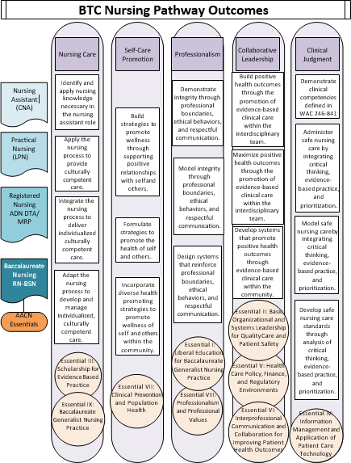

1. **Program Evaluation Criteria and Process**

BTC faculty and staff systematically gather, review, and use instructional program-level data through a long-standing process that involves annual reporting on program student learning outcome (SLO) achievement and program effectiveness in relation to the institutional Key Performance Indicators (KPIs). As part of the college’s ongoing focus on development of effective SLOs and continuous improvement, an updated reporting process was piloted in the 2016-17 academic year, with input and collaboration from faculty members. The SLO report includes program and course-specific student learning outcomes, measures/assessments, and student achievement data. Faculty assess program results and discuss future plans with their deans based on their outcomes data. Over the past few years, faculty and administration have worked together to continue improving SLO assessment processes, combining course- and program- level SLO reports to emphasize the integration of SLOs across the curriculum, improve faculty training, streamline the reporting process, and make the resulting data more accessible for analysis and application to future practice as well as program advisory committee feedback. This improved process for SLO development and assessment ensures that faculty—working in conjunction with the VP of Academic Affairs & Student Learning, deans, and Data & Research staff—will continue to identify specific, measurable SLOs, define effective assessment methods to measure student achievement across each SLO, and engage in meaningful use of assessment results to improve the teaching and learning process.

Each certificate and degree program (degrees and certificates) also develops an annual Instructional Program Effectiveness Report which identifies learning and other outcomes. These reports are used to evaluate each professional technical program and General Education area as compared to pre-determined standards. The Instructional Program Effectiveness Reports include data on annual full-time headcount, annual FTE, retention rates, number of degrees/certificates awarded, student and graduate satisfaction levels, graduate employment and wage results, and employer satisfaction with graduate performance.

Faculty review the reports for their areas, add enrollment and retention data from their own records (optional), and respond to reflective questions. Faculty and deans review the reports together to assess and evaluate each individual instructional program, discuss the effectiveness of prior changes and identify any further changes needed or new areas for improvement.

In addition to college reporting, the Nursing Commission and national accrediting body require all nursing programs to develop and maintain a systematic evaluation plan. This plan must include specific, measurable expected levels of achievement (ELA’s) for each end-of-program student learning outcomes and each program outcome. Program outcomes that must be tracked and evaluated include completion rates and job placement data. These ELA’s must be assessed at regular intervals, used to inform decision making, documented and shared with program stakeholders.

RN-BSN students will complete evaluations for every course they take within the program. Post-graduate surveys will be administered six weeks after graduation, and employer satisfaction surveys will be conducted on an annual basis. The Nursing area has a Curriculum Committee which reviews curriculum at least annually, and the area also administers a faculty satisfaction survey. Results of all assessment and review tools and activities will be reviewed by the Program Director, and RN-BSN program staff and faculty will come together to discuss and work to resolve any program issues that may come to light as a result of these assessments.

1. **Course Preparation Needed by Students Transferring with Technical Associate Degree**

The proposed RN-BSN will provide the education and practice experiences for students who have completed an ADN RN degree, passed the Registered Nurse Licensure Examination, and wish to earn a Bachelor of Science in Nursing (BSN).

BTC has an accredited ADN DTA/MRP program and anticipates that many BTC RN alumni will want to progress to the RN-BSN program after licensure. The ADN curriculum at BTC contains one year of

academic prerequisites and two years of clinical and nursing curriculum and forms a strong foundation for RN to BSN progression.

The prerequisites of the RN-BSN program have been aligned with the statewide Nursing DTA/MRP degree to provide for seamless progression for student who have an ADN DTA/MRP. Students who have graduated from another ADN program that is not aligned with the Washington State DTA/MRP degree will also be eligible to apply but may need to complete additional coursework. See Table 1.3 for comparison of prerequisite foundational courses and degree pathways.

*Table 1.3: Overview of all RN-BSN Degree Pathways*

|  |  |  |  |  |  |  |  |  |
| --- | --- | --- | --- | --- | --- | --- | --- | --- |
| **Prefix** | **#** | **Course Title** | **Credits** | | | | | |
| **PN**  **Cert** Part- time pathw ay | **LPN-ADN** | |  | **RN-BSN**  Full-time and part- time pathway | |
| **DTA/MRP**  Part-time pathway | | **ADN DTA/M RP**  Full- time pathw ay |
| **BTC**  **PN grad** | **Non- BTC PN**  **grad** | **DTA/ MRP**  **grad** | **Non- DTA/ MRP**  **grad** |
| BIOL  & | 16  0 | General Biology w/Lab | 5  credits | Required for PN Cert | 5  credi ts | 5  credits | Included in DTA | 5 credits |
| BIOL  & | 24  1 | Human Anatomy & Physiology 1 | 5  credits | Required for PN  Cert | 5  credi ts | 5  credits | Included in DTA | 5 credits |
| BIOL  & | 24  2 | Human Anatomy & Physiology 2 | 5  credits | Required for PN Cert | 5  credi ts | 5  credits | Included in DTA | 5 credits |
| BIOL  & | 26  0 | Microbiology | n/a | 5 credits | 5  credi ts | 5  credits | Included  in DTA | 5 credits |
| CHEM  & | 12  1 | Intro to Chemistry | 5  credits | Required for PN Cert | 5  credi ts | 5  credits | Included in DTA | 5 credits |
| ENGL  & | 10  1 | English Composition I | 5  credits | Required for PN Cert | 5  credi ts | 5  credits | Included in DTA | 5 credits |
| MATH  & | 14  6 | Introduction to Statistics | 5  credits | Required for PN Cert | 5  credi ts | 5  credits | Included in DTA | 5 credits |
| PSYC  & | 10  0 | General Psychology | 5  credits | Required  for PN Cert | 5  credi | 5  credits | Included  in DTA | 5 credits |

|  |  |  |  |  |  |  |  |  |
| --- | --- | --- | --- | --- | --- | --- | --- | --- |
|  |  |  |  |  | ts |  |  |  |
| PSYC  & | 20  0 | Lifespan Psychology | n/a | 5 credits | 5  credi ts | 5  credits | Included in DTA | 5 credits |
| Nutrition in Healthcare* | | | 3  credits | n/a | 3  credi ts | 5  credits | Included  in DTA | n/a |
| Ethics & Policy in Healthcare* | | | 1  credit | Included in PN Cert | 1  credi t | 5  credits | Included in DTA | n/a |
| Psychosocial Issues in Healthcare* | | | 4  credits | Included in PN Cert | 4  credi ts | 5  credits | Included in DTA | n/a |
| Communication (elective) | | | n/a | 5 credits | 5  credi ts | 5  credits | Included in DTA | 5 credits |
| Humanities (elective) | | | n/a | 10 credits | 10  credit s | 10  credits | Included in DTA | 10 credits |
| Transferred in Nursing Credits (license,  LPN or RN) | | | n/a | n/a | 30  credit s | n/a | Included  in DTA | 60 credits |
| **Total Prerequisite Credits** | | | 3  5 | 25 | 9  0 | 6  0 | 135 | 120 |
| *Integrated into the DTA/MRP over year one and year two, available as supplemental courses for Non-DTA ADN  Graduates. | | | | | | | | |

1. **General Education Component**

In addition to meeting the AACN curricular requirements, the RN-BSN degree meets Washington State Board for Community and Technical Colleges (SBCTC) requirements to include sixty general education credits in the subject areas identified in Table 1.4. Sixty credits are included in the BTC ADN DTA/MRP program by design. For non-DTA/MRP ADN graduates, 45 credits must be completed before beginning RN-BSN coursework. Any remaining credits can be met as part of the baccalaureate program.

BTC’s RN-BSN program will also benefit currently employed nurses as they progress along the nursing continuum towards a BSN, regardless of where they completed their RN. The availability of the general education courses needed for entrance and the flexibility in our RN-BSN electives and courses will support these students in their academic and career goals as well.

*Table 1.4: General Education Requirements for the BTC RN-BSN*

|  |  |  |  |  |  |
| --- | --- | --- | --- | --- | --- |
| SBCTC BAS  Requirements | Cr | Met by WA ADN DTA/MRP | Cr | Additional opportunities to meet requirements (for non-ADN DTA/MRP RNs) | Cr |
| Basic Requirements | | | | | |
| Communication Skills (10 credits) | 10 | English Comp (ENGL& 101) | 5 | Writing in Nursing | 1-3 |
| English elective  (from distribution list) | 5 | Teaching and Learning in Nursing | 3 |
| Quantitative/Symbolic Reasoning Skills  (5 credits) | 5 | College-level statistics (MATH& 146) | 5 |  |  |
| Distribution Requirements | | | | | |
| Humanities (10 credits) | 10 | Humanities electives (from distribution list) | 10 | US Cultural Health | 3 |
| History of Nursing | 3 |
| Nurses in Media | 3 |
| Wellness and Resilience | 3 |
| Social Sciences (10 credits) | 10 | Intro to Psych (PSYC& 100) | 5 | Nursing Anthropology | 3 |
| Lifespan Psych (PSYC&200) | 5 | Contemporary Addiction | 3 |
| Global Health | 3 |
| Natural Sciences (10 credits) | 10 | General Bio (BIOL& 160) | 5 |  |  |
| Chemistry (CHEM& 121) | 5 | Integrative Health | 3 |
| Microbiology (BIOL& 260) | 5 | Nutrition in Healthcare | 5 |
| Anatomy and Physiology, I (BIOL& 241) | 5 |  |  |
| Anatomy and Physiology II (BIOL& 242) | 5 |  |  |
| Additional General Education Courses (15 credits) | 15 | Ethics & Policy in Healthcare | 5 | Ethics & Policy in Healthcare | 5 |
| Psychosocial Issues in Healthcare | 5 | Psychosocial Issues in Healthcare | 5 |
| Nutrition in Healthcare | 5 | Nutrition in Healthcare | 5 |
| Advanced Nutrition Topics | 3 |

1. **Coursework Needed at Junior and Senior Levels** **RN-BSN Course Work**

The Washington State Associate in Nursing DTA/MRP degree prepares students for licensure as a Registered Nurse through Washington State Community and Technical Colleges, as well as for entry into a Bachelor of Science in Nursing completion degree. Students admitted to an RN-BSN program will be conferred senior standing upon passage of the NCLEX-RN2.

This agreement reflects the 3 + 1 nature of the pathway to baccalaureate nursing, where the ADN represents the first three years (135 credits) of coursework, and the RN-BSN represents the final

2 <http://www.wsac.wa.gov/sites/default/files/2016.06.15.NursingDTAMRP.pdf>

year (45 credits) of coursework. Thus, RN-BSN students only complete coursework at the Senior level. See Table 1.5 for credit breakdown for both ADN DTA/MRP graduates and Non-DTA/MRP ADN graduates. Note that the 15 credits of general education that non-DTA/MRP graduates are missing can be taken either prior to starting or during the RN-BSN program.

*Table 1.5: RN-BSN Program Credits for DTA/MRP and Non-DTA/MRP Graduates*

|  |  |
| --- | --- |
| DTA/MRP Graduates | Non-DTA/MRP Graduates |
| 135 credits: Pre-licensure   * 90 credits = ADN Program * 30 credits = RN Licensure as a result of passing the NCLEX-RN * 15 credits = General Education included in the DTA | 120 credits: Pre-licensure   * 90 credits = ADN Program * 30 credits = RN Licensure as a result of passing the NCLEX-RN |
| 45 credits: RN to BSN program   * 30 credits = Nursing Core Courses * 15 credits = Elective Courses | 60 credits: RN to BSN program   * 30 credits = Nursing Core Courses * 15 credits = General Education * 15 credits = Elective Courses |
| 180 credits | 180 credits |

Appendix A contains short course descriptions of the RN-BSN nursing core and elective courses. Nursing Core Courses - 30 Credits

Nursing core courses will be taken sequentially beginning in Fall quarter and run through the summer. See Table 1.6 for RN-BSN Nursing Core Courses. Students can elect to follow a full-time pathway of 12 credits in quarters 1-3 and 9 credits in quarter 4. These students will graduate in four quarters. Students can also elect to follow a part-time pathway of 6 credits per quarter until their final summer quarter which will require 3 credits. These students will graduate in eight quarters.

Nursing courses will be online except where on-ground sessions are necessary to complete practice experience rotations (guided practice hours) as required by the Nursing Care Quality Assurance Commission (NCQAC).

WAC 246-840-5313 outlines practice experience guidelines for RN-BSN programs in Washington State. BTC will have a minimum of 100 hours of faculty planned practice experiences for students based on program outcomes and goals. According to the WAC, these can include, indirect and direct patient care, patient or population teaching, population interventions, student nurse teaching or the teaching of nursing students, leadership and change projects, research, accessing client or population date for the purpose of doing quality assurance or improvement projects, informatics, thesis or dissertation development and defense (WAC 246-840-531 section 2a). These practice experience options are considerably expanded from the direct care requirements for pre-licensure nursing students and reflect the post-licensure experience of RN-BSN students.

3 <https://app.leg.wa.gov/wac/default.aspx?cite=246-840-531>

*Table 1.6: BTC RN-BSN Nursing Core Courses*

|  |  |  |  |  |  |
| --- | --- | --- | --- | --- | --- |
| Course ID | Course Name | Theory Hours | Guided Practice Hours | Field-Based Experience Hours | Credits |
| NURS 301 | Nursing Research | 66 |  |  | 6 |
| NURS 400 | Leadership for Organizational Change | 66 |  |  | 6 |
| NURS 401 | Leadership Practice Experience |  | 66 |  | 3 |
| NURS 402 | Quality and Safety | 66 |  |  | 6 |
| NURS 403 | Community and Public Health | 66 |  |  | 6 |
| NURS 404 | Population Health Practice Experience |  | 66 |  | 3 |

**Elective Courses – 30 Credits Available**

Elective courses will be online, and in-program RN-BSN students will have priority registration for these courses. These electives will also be made available to pre-program, non-matriculated RN-BSN students who are interested in taking electives ahead of their scheduled program start date as space allows. DTA/MRP graduates will need 15 credits of elective courses to complete their RN-BSN coursework. Non-DTA/MRP graduates will need between 15 to 30 credits of elective coursework, depending on their transferrable courses and prior coursework. At least two elective courses will be available each academic quarter. See Table 1.7 for the list of BTC RN-BSN elective courses.

*Table 1.7: BTC RN-BSN Elective Courses*

|  |  |  |  |  |  |
| --- | --- | --- | --- | --- | --- |
| Course ID | Course Name | Theory Hours | Guided Practice  Hours | Field-Based Experience  Hours | Credits |
| NURS 410 | Nurses in Media | 33 |  |  | 3 |
| NURS 412 | US Cultural Health | 33 |  |  | 3 |
| NURS 414 | Global Health | 33 |  |  | 3 |
| NURS 416 | History of Nursing | 33 |  |  | 3 |
| NURS 418 | Nursing Anthropology | 33 |  |  | 3 |
| NURS 420 | Integrative Nursing | 33 |  |  | 3 |
| NURS 422 | Teaching and Learning in Nursing | 33 |  |  | 3 |
| NURS 423 | Writing in Nursing | 11-33 |  |  | 1-3 |
| NURS 424 | Advanced Nutrition Topics | 33 |  |  | 3 |
| NURS 426 | Wellness and Resilience | 33 |  |  | 3 |
| NURS 428 | Contemporary Addiction | 33 |  |  | 3 |

# Criteria 2

## Qualified faculty.

BTC will begin recruiting for program administration and faculty in Winter 2021 as listed in Table 2.1.

*Table 2.1: BTC RN-BSN Faculty and Administrator Profile*

|  |  |  |
| --- | --- | --- |
| Position | FTE | Responsibilities |
| RN-BSN Director | 1.0 full-time exempt (non-  faculty position) | * Administration of the RN-BSN program Creating/maintaining teaching and learning environment Facilitating curriculum * Decision-making * Budget preparation/monitoring Involvement with central administration Faculty development/review * Faculty recruitment Goal development * Assurance of rule compliance * Communication with the Nursing Commission |
| Tenure-Track Faculty Position | 1.0 full-time | * Nursing program outcomes * Curriculum development, implementation, and evaluation Nursing program policies * Academic advising * Evaluating student achievement * Selecting, guiding, and evaluating student learning activities Practice site interaction |
| Adjunct Faculty Positions | part-time as needed | * Nursing program outcomes * Curriculum development, implementation, and evaluation Nursing program policies * Academic advising * Evaluating student achievement * Selecting, guiding, and evaluating student learning activities Practice site interaction |

The first position will be a full-time exempt Nursing Program Director, with full responsibility for management and administration of the RN-BSN program, in compliance with the Washington Administrative Code (WAC 246-840-5174). This position will not include any direct teaching responsibilities. Nursing Directors for RN-BSN programs must hold a minimum of a doctoral degree in nursing or a graduate degree with a major in nursing and a doctoral degree either in nursing or a health or related educational field, all from appropriately accredited colleges or universities. Nursing Directors must also have preparation in education that includes teaching adults, teaching methods, curriculum development, and curriculum evaluation, or two years of teaching experience in nursing education that demonstrates this type of preparation. We will seek a candidate with experience in

4 <https://apps.leg.wa.gov/WAC/default.aspx?cite=246-840-517>

nursing administration or educational administration and at least five years of experience as a Registered Nurse, including two years of experience in nursing education. The current pre-licensure Nursing Director has four years of experience in her role as administrator, 10 years of experience as faculty in the BTC nursing program, and is the direct supervisor and Dean of Nursing and Allied Health programs. The current Nursing Director will help mentor and orient the RN-BSN Director to their role and will continue to oversee the pre-licensure program offerings while the RN-BSN program becomes established and works toward national accreditation. After that time, the administrative structure will be re-evaluated.

The second position is a full-time tenure-track faculty to lead instruction in the RN-BSN program at implementation, in compliance with the requirements for RN-BSN faculty in the Washington Administrative Code (WAC 246-840-5235 and WAC 246-840-5266). Total faculty FTE allocated to the program for the initial cohort will be 1.0 full-time faculty and part-time faculty as needed. All eleven current BTC full-time Nursing faculty members are qualified to teach in the proposed RN-BSN program. It is anticipated that current and/or additional part-time faculty will teach elective courses in their area of expertise, assist with practice experiences for students in the practicum courses, and meet all WAC requirements. Additional adjunct faculty will be hired from the initial recruiting pool and added as need to accommodate program needs and growth. Some of the program’s current pre- licensure faculty have already expressed their interest in adding moonlight contracts to teach elective courses or practice experience rotations in their areas of specialty.

The college will recruit faculty with academic and professional education and experience in their field of specialization. Doctorally-prepared faculty will be preferred candidates. All faculty will be sufficiently qualified according to the WAC regulations above, including holding active, unencumbered Washington State Registered Nurse license. Faculty will also hold the minimum of a graduate degree in nursing from an appropriately accredited college or university and nursing education program, or a bachelor’s degree in nursing from an appropriately accredited college or university, and a graduate degree in a health or education-related field.

Faculty will be provided with both a general college orientation and nursing program faculty orientation, as standardized in both formal orientation processes at BTC. Each new faculty member will also be officially mentored by an existing tenure-track faculty member. Ongoing development opportunities are provided to BTC faculty in the form of professional development support, through contract-guaranteed professional development funds and access to additional funding through BTC Foundation support.

The passage last year of House Bill 2158 provided funding to increase pay for nursing faculty at the community and technical college level. This will allow BTC to recruit faculty and a director for the RN- BSN program with more competitive wage offerings. In the past, it has been difficult to recruit nursing faculty because of the difference between salaries in education and industry. BTC was able to incorporate this new funding into the Faculty Collective Bargaining Agreement quickly and provide the full 26 percent increase for nursing salaries. BTC also offers an additional annual

$4,000 increase for doctorally- prepared faculty.

5 <https://apps.leg.wa.gov/WAC/default.aspx?cite=246-840-523>

6 <https://apps.leg.wa.gov/WAC/default.aspx?cite=246-840-526>

After conducting the RN-BSN needs assessment, the program received inquiries of interest from three prior BTC RN graduates who have since earned their doctoral degrees and have administrative and/or education experience. Recruiting for Director and faculty positions will officially begin in Winter of 2021 with the anticipation of full-time hires beginning in Fall 2021.

# Criteria 3

Selective admissions process, if used for the program, consistent with an open-door institution.

**Admissions Requirements**

BTC will employ the minimum requirements for admission to the RN to BSN program needed to promote student success. Admission requirements are as follows:

* + Associate Degree in Nursing from a nationally-accredited institution with a cumulative GPA of 2.0 or higher;
  + Completion of required prerequisite general education courses with a cumulative GPA of 2.0 or higher;
  + Minimum of 2.0 GPA earned in every nursing course;
  + Unrestricted RN licensure in Washington State;
  + Transcripts from all post-secondary education programs, including ADN program;
  + Professional reference (academic or Supervisor within the last year);
  + Resume and cover letter;
  + Reflective Goal Statement (See Appendix B);
  + Background check.

BTC will use points awarded to offer initial program seats. If there are more applicants than available seats for admission in the program, first consideration will be given to qualified applicants in the order in which they applied.

**Holistic Admissions Process**

To ensure the program will serve a diverse population, admission criteria were designed using holistic admission guidelines from the AACN7. Holistic review considers a broad range of factors in admissions decisions including non-academic and academic measures. These guidelines have the express purpose of diversifying the healthcare workforce and providing opportunities for students from diverse socioeconomic and underserved populations.

The Nursing and Allied Health program areas at BTC have adopted an admissions vision and two core goals that support the college mission to provide student-centered, high quality professional technical education for today’s needs and tomorrow’s opportunities.

*Nursing and Allied Health Selective Admissions Vision*:

BTC Nursing and Allied Health will be recognized leaders in providing innovative admissions processes that promote diversity and equity, maximize student

7 <https://www.aacnnursing.org/Diversity-Inclusion/Holistic-Admissions>

potential, and support the regional economy through development of a diverse and competitive workforce.

*Guiding Goals*:

* + Teaching & Learning [priority goal]: Support student learning by addressing barriers and creating pathways to high quality instruction.
  + Campus Community & Culture: Cultivate a welcoming and accessible learning environment which promotes student success through a commitment to diversity, equity, and inclusiveness.

All of the BTC Nursing pathways are committed to accessibility and equity in admissions procedures and requirements. The BTC ADN DTA/MRP program is one of the few in the state that does not admit students competitively based primarily on GPA. Students are required to meet grade and exam benchmarks and are ranked on several non-academic metrics, including commitment to the college, healthcare training and work experience, veteran status, and prior applications.

BTC Nursing faculty develop admissions criteria for nursing pathways in collaboration with Student Services staff members, industry partners, and the Nursing Student Governance Advisory Committee (NSGAC). The NSGAC is a committee of students who are currently in-program and consult on program needs, changes, and propose systematic improvements. All admissions procedures and criteria are holistically reviewed annually through a collaborative process.

The RN-BSN program will include academic benchmarks as well as non-academic measures when considering applicants for admission to the program. Students will be required to complete and submit a Reflective Goal Statement addressing non-academic measures as listed below.

1. Obtaining a baccalaureate degree requires persistence, hard work, and the ability to focus on the end result. Share with us one long-term goal that RN- BSN education will help you reach. This goal can be academic, personal, or professional.
2. Describe how your life experiences, personal strengths, professional experiences, & aptitude will contribute to your success in an RN-BSN program (community service, leadership experience, healthcare experience, experience working with a diverse underserved population).
3. Explain the academic challenges, success, or obstacles in your life that impacted your ability to achieve your goals.
4. All students can contribute to the creation of a diverse and inclusive environment when diversity is defined most broadly. Whether by a personal attribute, characteristic, culture, experience, or behavior, please tell us how you believe you will contribute to the diversity of BTC and the nursing profession (first-generation college student, multilingual, commitment to work in a medically underserved area, commitment to social justice, etc.).
5. Attach a professional resume to your Reflective Goal Statement.

Reflective Goal Statements will be de-identified and independently reviewed by a faculty representative and a Student Services representative and scored using the rubric in Table 3.1.

*Table: 3.1 Reflective Goal Statement Scoring Rubric*

|  |  |  |  |
| --- | --- | --- | --- |
| **Total Points Possible: 22** | | | |
| **Criteria** | **Ratings** | | |
| **Exceeds Expectations 3 pts** | **Meets Expectations 2 pts** | **Does Not Meet Expectations 1 pt** |
| **Reflective Goal Statement** | | | |
| Goal Orientat ion 3 pts | Goal focuses on diverse levels of interest, ability, or readiness of individual learning needs and is challenging yet achievable through personal  actions. | Goal focuses on learning needs and is achievable through personal actions. | Goal does not focus on learning or is poorly articulated or is dependent on the actions of others. |
| Evaluati on/Self Analysis 3 pts | Independentl y evaluates/an alyzes personal strengths, experiences, &  aptitudes. Demonstrates commitment to ongoing improvement. | Evaluates/anal yzes personal experiences with minimal prompting, primarily major events/decision s.  Demonstrates a desire to improve. | Prompted evaluations are brief, cursory, and not used to improve performance.  Justifies personal decisions/choic es without evaluating them. Is unable to see flaws or need for  improvement. |

|  |  |  |  |  |  |
| --- | --- | --- | --- | --- | --- |
| Format 3 pts | College-level writing used (statements are descriptive, clear, and logical). All required areas are complete and error free.  Consistent and accurate  use of terms. | Some deviation from  college level. All required  areas of the journal entry are complete and error free. Usually and accurately uses terminology. | | | Little or no resemblance to college-level writing.  Areas of the journal entry are incomplete. Rarely uses terms accurately. |
| **Resume** | | | | | |
| 3 pts | Schools are named and listed in chronological order, work experience is thoroughly listed, no personal information is included, 1-2 pages in length, correct spelling and grammar, consistent  font and style. | Schools are named and, work experience is listed, experience is listed, no personal information is included, 1-3 pages in length, mostly correct spelling and grammar, consistent font and style. | | | Elements are missing or format is incorrect, or inconsistent, or personal information is included. |
| **Additional Metrics** | | | | | |
| Community Service - **1pt** | | |  |  | |
| Leadership Experience - **1pt** | | |  |
| Life Experience - **1pt** | | |  |
| Healthcare Experience - **1pt** | | |  |
| Work with Underserved Pops - **1pt** | | |  |
| Overcome Obstacles - **1pt** | | |  |
| Commitment to Diversity - **1pt** | | |  |
| First Generation College Student - **1pt** | | |  |
| Multilingual - **1pt** | | |  |
| Commitment to Social Justice - **1pt** | | |  |

Criteria 4

## Appropriate student services plan.

**Generally Available Student Services**

BTC’s Student Services division is aware and supportive of the proposed RN-BSN program, and is prepared to provide full wrap-around services to potential students, students, and alumni. Students in the RN-BSN program will have access to all of the support, advising, and counseling services generally available to students at BTC. These services include:

* + Admissions & Recruitment
  + Advising & Career Services
  + Accessibility Resources
  + Assessment Center
  + Counseling & Multicultural Services
  + eLearning
  + Financial Aid
  + Registration & Enrollment
  + Workforce Funding &Student Support

BTC also has a Veterans Coordinator and Veterans Club as well as a dedicated Veterans Center. Students in the RN-BSN program will pay the services and activities fee, and benefit from the leadership and services provided by Associated Student Body(ASBTC).

The majority of the RN-BSN courses are online. Only a few of the courses (the Leadership Practice Experience and Population Health Practice Experience courses) will use the hybrid/in-person model due to the need for students to complete face-to-face practice experience hours. Consequently, students will be on-campus for at least some of the time during the duration of their program and will have the same access to services as other BTC students. It is BTC’s policy that all support services are available online as well as face-to-face. More information can be found at <https://www.btc.edu/CurrentStudents/Index.html>

**Program-Specific Services**

**Dedicated Nursing Navigator**

BTC research has shown that students who are members of underrepresented populations often share similar barriers, including uncertainty about their lack of prior education; fear of using online technology; competing demands between work, family and education; and financial pressures.

Feedback from students indicates that a high value is placed on non-academic supports such as coaching and connection to resources. The Nursing Navigator will be integrated into the online learning management system (Canvas) to enhance accessibility to and familiarity with students. The Navigator will combine coaching and advising skills to help students understand the admissions process, support students through individualized coaching services, and provide referrals to additional college and community resources.

The Navigator support model incorporates a proactive response to an individual student’s needs. This staff member is trained in the *InsideTrack* coaching model, will tailor services (using high- or low-touch strategies depending on each student’s cultural or socio-economic needs), and will seek to build rapport and engage with students using coaching techniques. These techniques will help the students build resiliency skills, including self-awareness, confidence, and interpersonal skills. This coaching-

centered support will help guide students through identification of goals and barriers to success, as well as areas of strength, treating the student as a whole person whose academic career is part of— not separate from— their other life circumstances.

BTC’s Nursing Navigator serves all students within the nursing pathway at BTC, which will include RN- BSN students. This consistency allows for strong student advising continuity for all nursing students. All nursing area faculty, administrators and staff work as a team to help support students and resolve issues. This structure has been extremely effective and the existing team is anticipated to be able to absorb the additional RN-BSN student load.

The Nursing Director and Director of the RN-BSN program will assess student advising and support capacity after the first year of the new program to ensure that these resources are sufficient.

BTC initiatives will help RN-BSN nursing faculty use teaching and learning methodologies that support working adults and diverse student populations. BTC is currently implementing a Guided Pathways model on campus, and professional development is a key component of this implementation. As part of this work, faculty leaders are developing BTC’s first Faculty Teaching & Learning Academy (TLA), which is intended to help BTC faculty adapt program content and delivery to remediate student equity gaps. The TLA is also currently piloting a robust peer mentoring program for new faculty. BTC is creating a strong technology training program that will help the RN-BSN employees effectively research, plan and implement system improvements for teaching, learning and student support. Another component of the initiative is focused on helping to improve employee data literacy skills and fostering a culture of data- informed decision-making. This work will include developing and enhancing data dashboards and other tools to enable employees, including RN-BSN faculty and staff, to analyze non-traditional student outcomes in order to identify and respondto barriers and service gaps for student populations.

**Financial Aid**

Although the specific financial aid needs of students in the RN-BSN program may differ in some respects from the needs of students in traditional two-year degree programs, their needs will be handled within the Student Financial Resources office. Student Financial Resources has developed easy-to-use, web-based applications for students, as well as moving the college’s Emergency Funding application online. These changes will enhance the ability of the largely online RN-BSN student population to easily access Financial Aid resources. Student Financial Resources staff will be provided with specialized training as required to help serve these students. We anticipate that current Student Financial Resources staff members will have the capacity to serve this population. However, we will monitor this capacity carefully as student numbers increase over the first two years of the program’s operation.

**Admissions and Advising**

BTC’s Admissions and Advising area will work closely with nursing area employees to promote the new RN-BSN program in a variety of modalities, including through Canvas postings, information on the website, and promotion in internal and external recruitment and outreach events, as well as assist students with their admissions process as needed. Advising is the formal responsibility of Student Services staff. BTC uses a centralized case management system, and RN-BSN students will have the full benefit of this coordinated approach, which is based on nationally-recognized best practices. All students with program intent are enrolled in BTC’s case management system upon admission, and are assigned to

an Academic and Career Advisor specializing in that program. At the request of the advisor, the RN-BSN Program Director and/or faculty teaching in the RN-BSN program will be available to advise students on course choice, discuss student progress, direct students to needed resources, and assist with other program- related issues or problems. If the Program Director is not going to be available, he/she will designate a member of faculty to act in his/her stead. The RN-BSN Program Director and faculty will also work with Student Services staff to establish links with businesses who may hire RN-BSN program graduates. Student support staff across campus, including Admissions and Advising staff members, offer students advising and coaching support via Zoom, through course Canvas pages, and by phone and email.

**Prior Learning Assessment**

Students in the RN-BSN program will be able to apply credit for prior learning in accordance with BTC’s Non-Traditional Credit -Prior Learning Assessment policy8. Assessment of work submitted to gain credit for prior learning will be the responsibility of qualified program faculty.

**Tutoring Center**

BTC’s Tutoring Center is a free service which helps students to achieve success in math, accounting, chemistry, biology, writing, English, and many other courses. Tutoring provides customized small group and individualized academic support for students online, which includes trained tutors using Zoom and a drop-in program on BTC’s Virtual Assistance page. Tutors are recruited to provide support for subjects as requested by BTC students. RN-BSN program faculty will work with the Tutoring Center staff to help them understand the requirements of the program and the standards that students are expected to achieve to be successful –particularly in the area of math. As part of this collaborative approach, program faculty will provide Tutoring Center staff with exemplars of documents (reports, PowerPoint presentations, Excel spreadsheets) so that they can more effectively help students achieve the expected standards. Staff from the Tutoring Center will also provide technology orientations for RN-BSN students during the initial orientation course (NURS 301 Nursing Research), and will be available on request at other times to provide in-person or online academic support as needed.

**eLearning**

Student support will be offered through the eLearning Help Desk (phone and email) and library staff. Library staff develop and maintain online tutorials and videos, which are posted on digital research guides, the BTC website, and through Canvas, and the eLearning department regularly surveys faculty members and students to determine needs and priorities. BTC librarians and paraprofessional staff will offer RN-BSN students reference and research support, directional assistance, circulation assistance, interlibrary loans, and student technology support. Specialized assistance and instruction are available by request. For example, formal library orientations and information literacy sessions are requested and taught regularly for several instructional areas. In addition to orientations and information literacy sessions, librarians offer training on reference tools such as EBSCO eBooks, ProQuest and Credo Reference. The Library has expanded options for remote student contact, including developing a Virtual Info Desk as well as providing support through phone, email and an “Ask the Library” chat function. Wireless internet is available throughout all BTC facilities, and students also have access to the Library’s 30-station open computer lab as well as its technology-rich small group study rooms. The library circulates mobile internet hot-spots, laptops, tablets and other educational technology to support distance learners. eLearning instructional design experts are also available to assist faculty with design and accessibility of online learning.

8 <https://www.btc.edu/FutureStudents/AcademicCreditforPriorLearning.html>

# Criteria 5

## Commitment to build and sustain a high-quality program.

**Assumptions**

BTC’s financial plan for the RN-BSN program assumes the following:

* + Student enrollment projections are based on an assumed attrition rate of 10 percent for each cohort, which is slightly higher than attrition rates for other Nursing program cohorts.
  + The Program Director position will begin Winter 2022.
  + The full-time program faculty position will begin Fall 2022.
  + The adjunct faculty positions will be a 0.16 FTE for the 2022-2023 academic year because there will be no summer cohort. A 0.32 FTE for subsequent years includes a summer cohort.
  + Benefits for faculty and staff are assumed to be 35 percent of gross salary.
  + The per-credit tuition and fees are based on the FY 2020-2021 rate and assume that students are taking full loads (maximum discount) and have Resident status.
  + There will be a student fee of $20 per credit.
  + Teaching will occur in all four quarters.
  + RN-BSN expenses in areas such as Goods & Services will be fully covered or leveraged by the Nursing department’s overallbudget.
  + BTC areas such as the Library and Student Services have their own budgets, which cover program-specific support.

1. **Types of Funds to be Used to Support the Program**

The BTC RN-BSN program will be supported with state funds out of the college operating budget. The Nursing department has been highly successful in obtaining additional private, state and Federal grant resources, and will continue to seek out alternative funding resources in order to continue enhancing the quality of its Nursing programs, including the RN-BSN. Table 5.1 shows the financial plan for program establishment in academic year 2021-2022 and the first 5 full years of the RN-BSN program.

*Table 5.1: Student and Staff FTE, Program Costs and Funding*

|  |  |  |  |  |  |  |
| --- | --- | --- | --- | --- | --- | --- |
|  | AY 21/22 | AY 22/23 | AY 23/24 | AY 24/25 | AY 25/26 | AY 26/27 |
| Student FTE | | | | | | |
| Assumes 10 percent attrition | 0 | 27 | 27 | 27 | 27 | 27 |
| Student Credits | | | | | | |
|  | 0 | 33 | 45 | 45 | 45 | 45 |
| Faculty and Staff FTE | | | | | | |
| Director FTE | 0.5 | 1.0 | 1.0 | 1.0 | 1.0 | 1.0 |
| FT Faculty FTE | 0 | 1.0 | 1.0 | 1.0 | 1.0 | 1.0 |
| PT Faculty FTE | 0 | 0.16 | 0.32 | 0.32 | 0.32 | 0.32 |
| Program Costs | | | | | | |
| Director | $51,500 | $103,000 | $103,000 | $103,000 | $103,000 | $103,000 |
| FT Faculty | $0 | $97,130 | $97,130 | $97,130 | $97,130 | $97,130 |
| PT Faculty | $0 | $10,560 | $21,120 | $21,120 | $21,120 | $21,120 |
| Faculty & Staff Salaries | $51,500 | $210,690 | $221,250 | $221,250 | $221,250 | $221,250 |
| Benefits @ 35  percent | $18,025 | $73,742 | $77,438 | $77,438 | $77,438 | $77,438 |
| TOTAL Faculty &  Staff Costs | $69,525 | $284,432 | $298,688 | $298,688 | $298,688 | $298,688 |
| Other Costs | | | | | | |
| Goods & Services | $500 | $500 | $500 | $500 | $500 | $500 |
| Marketing & Outreach | $5,000 | $1,000 | $1,000 | $1,000 | $1,000 | $1,000 |
| Total Other Costs | $5,500 | $1,500 | $1,500 | $1,500 | $1,500 | $1,500 |
| Program Income | | | | | | |
| Tuition | $0 | $159,335 | $212,447 | $212,447 | $212,447 | $212,447 |
| Student Fees ($20/cr) | $0 | $21,600 | $25,920 | $25,920 | $25,920 | $25,920 |

|  |  |  |  |  |  |  |
| --- | --- | --- | --- | --- | --- | --- |
| State Allocation | $0 | $0 | $0 | $25,778 | $60,929 | $96,080 |
| College Support* | $75,025 | $104,997 | $61,821 | $36,043 | $892 | $0 |
| Total Funding | $75,025 | $285,932 | $300,188 | $300,188 | $300,188 | $334,447 |
| Totals | | | | | | |
| Total Costs | $75,025 | $285,932 | $300,188 | $300,188 | $300,188 | $300,188 |
| Total Funding | $75,025 | $285,932 | $300,188 | $300,188 | $300,188 | $334,447 |
| BALANCE | $0 | $0 | $0 | $0 | $0 | $34,259 |

***\*The College recognizes that the program will need institutional support during the initiation of this new program pathway and while enrollment stabilizes.***

1. **Appropriate Facilities**

Because the RN-BSN degree program will be primarily online, BTC anticipates that no additional facilities and equipment beyond existing classrooms, instructional equipment, and computer laboratories at BTC will be required for this program. Students will be able to use any BTC campus resources, including study areas, food services, and academic or non-academic support services. Faculty will have access to fully-equipped faculty office spaces and all online or on-campus instructional resources.

The BTC Library provides a variety of print, media, and online digital resources to students, faculty, and staff. All digital resources, including specialized online reference databases, a large collection of eBooks, and digital journals, are available from any computer on campus or through remote access. Professional library staff members provide research and reference assistance either in the library or

online. BTC’s Information Commons, the open computer lab on campus, is located in the library and includes over 40 different computer applications, Internet access, and a variety of assistive technologies. The library staff also provides student technical support.

There is overwhelming industry support for BTC’s RN to BSN program in our region. The Associate Degree Program (ADN) program currently has a number of clinical sites in place with active Affiliation Agreements. Table 5.4 outlines facility interest to host RN-BSN students for their practice experiences. See Appendix C for letters of support from industry partners.

*Table 5.4: RN-BSN Clinical Agency Partners*

|  |  |  |
| --- | --- | --- |
| **Industry Partner** | **Unit/Facility** | **Number of Students** |
| PeaceHealth | St. Joseph Hospital – Inpatient Acute Care Case Management | 4 |
| Cancer Center | 2 |
| Whatcom Hospice | 2 |
| Center for Senior Health | 1 |
| Same Day Care Clinic | 1 |
| Allergy and Immunology | 1 |
| Cardiology | 1 |
| Nutrition and Diabetes Clinic | 1 |
| Orthopedics | 1 |
| Pulmonary Medicine | 1 |
| Sleep Disorders Clinic | 1 |
| Skagit Regional Health | Skagit Valley Hospital – Inpatient Acute Care Case Management | 2 |
| Cancer Care Center | 1 |
| Cardiology | 1 |
| Orthopedics | 1 |
| Hospice of the Northwest | 1 |
| Whidbey Health | Whidbey Health Medical Center – Inpatient Acute Care Case Management | 2 |

|  |  |  |
| --- | --- | --- |
| Whidbey Health, cont’d | Cancer Center | 1 |
| Orthopedics | 1 |
| Hospice Care | 1 |
| Behavioral Health | 1 |
| Diabetes Care and Management | 1 |
| Whatcom County Health Department | Communicable Disease | 2 |
| Community Health | 2 |
| Human Services | 2 |
| Christian Health Care Center | Long-Term Care | 2 |
| Therapeutic Rehab | 1 |

1. **Equipment, Technology, and Instructional Resources Needed for the Program**

The program will be primarily online to enhance accessibility for our RN-BSN population. The college will infuse technology into all aspects of instructional delivery for this program, including use of resources such as Assessment Technologies Institute (ATI) to provide online simulations, modules and assessments. Development and implementation will follow the Washington Administrative Code (WAC 246-840-54610) for online nursing education.

All courses will meet established quality and security standards for online and distance learning education: Students are assigned a Student Identification Number (SID) at the time of admission to the College. Information that is unique to the student is linked to the SID and stored in the Student Management System (SMS). Students are enrolled in individual courses through the SMS only, and all programs and courses offered through the online learning management systems require that students log in using their Student Identification Number (SID) and a personalized password. The online course management system used for hosting online classes is a closed and secure system that requires student authentication upon logging in. There are no charges associated with the student verification process at the time of admission or at the time of enrollment in any online course.

BTC online education platforms meet national and regional standards for equal program and service access for users with disabilities and compliance with appropriate federal and state laws such as the Americans with Disabilities Act (ADA). Library and eLearning resources are available for all users and support is readily available for students with access, technology, or equipment needs.

Developed written policies and procedures ensuring quality and security standards for online and distance learning education: The BTC Online Teaching Guide (OTG) was developed in a collaboration between faculty and eLearning in order to meet Department

10 <https://apps.leg.wa.gov/WAC/default.aspx?cite=246-840-546>

*Page 29 Bellingham Technical College // Nursing // Fall 2021*

of Education requirements for teaching online. The guide includes information on federal, state and institutional policies, such as FERPA, Accessibility, Copyright, Regular & Substantive Interaction, privacy & confidentiality, and identity verification. The OTG also provides access to professional development resources, which include BTC materials as well as SBCTC professional development (Quality Matters, Open Educational Resources, Canvas 101, Accessible Course Design, the Washington State Course Design Checklist, etc.). In addition to resources listed in the Online Teaching Guide, the learning management system (Canvas, which is maintained and developed by Instructure) provides 24/7 access to support materials for teaching and learning, including the Canvas Guides (updated every three weeks) and a Help menu for learners and teachers in need of instructional or technological support. The BTC eLearning department responds to support requests during working hours.

Student and faculty evaluations of distance learning courses are conducted institution- wide each quarter. The college subscribes to EvaluationKIT, which is integrated into the LMS, and surveys students quarterly. These anonymous surveys are compiled and reviewed by the nursing faculty group for both quality control and program development.

# Criteria 6

## Program specific accreditation.

The RN-BSN program will seek program approval from the Nursing Care Quality Assurance Commission (NCQAC) before implementation of any nursing education program. This process is already underway: The Nursing Commission is aware and supportive of this program development, and BTC’s submission is currently under review.

BTC will seek national accreditation from the Accreditation Commission for Education in Nursing (ACEN) for the RN-BSN program once approval is finalized and before the first cohort

graduates, per accreditation standards. ACEN is the national accrediting body for the ADN DTA/MRP program at BTC, which received initial accreditation in 2017. National Accreditation is required by the Washington Administrative Code (WAC 246-840-51111) within four years of receiving full commission approval.

Upon SBCTC approval of the RN-BSN degree, BTC will immediately file a Substantive Change Request with the Northwest Commission on Colleges and Universities (NWCCU). BTC is currently approved by NWCCU to offer two applied baccalaureate degrees. NWCCU granted BTC candidacy status at the baccalaureate level in May 2016 for a BAS degree in Operations Management. In August of 2016, NWCCU accepted the college’s second BAS degree proposal for a BAS degree in Engineering Technology. In January 2019, NWCCU accepted BTC’s ad hoc report providing an update on the implementation of its first two BAS programs, and granted accreditation at the baccalaureate level effective September 1, 2017.

11 <https://apps.leg.wa.gov/WAC/default.aspx?cite=246-840-511>

# Criteria 7

## Pathway options beyond baccalaureate degree.

**Master’s and Doctoral Degrees**

A number of potential post-baccalaureate pathways for BSN graduated have been identified in Washington State, including (but not limited to) those shown in Table 7.1. BTC RN-BSN graduates will have a variety of options for advancing their education including out of state and online programs that are not listed here. Common pathways include leadership or education at the Master’s and Doctoral level, clinical practice at the provider level as a Doctor of Nursing Practice (DNP) in a variety of specialty areas, and research development at the PhD level.

*Table 7.1 Post-Baccalaureate Pathways for BSN Graduates*

|  |  |  |
| --- | --- | --- |
| **University** | **Master’s Program** | **Doctoral Program** |
| Gonzaga University | Master of Science in Nursing | Doctor of Nursing Practice (DNP) (various practice areas) |
| Pacific Lutheran University | Master of Science in Nursing | DNP (various practice areas) |
| Seattle Pacific University |  | DNP (various practice areas) |
| Seattle University |  | DNP (various practice areas) |
| University of Washington Bothell | Master of Nursing |  |
| University of Washington Seattle | Master of Science in Nursing | PhD in Nursing Science  DNP (various practice areas) |
| University of Washington  Tacoma | Master of Nursing |  |
| Washington State University Spokane | Master of Nursing | PhD in Nursing  DNP (various practice areas) |
| Washington State University  Tri Cities | Master of Nursing | DNP (various practice areas) |
| Washington State University Vancouver | Master of Nursing | DNP |
| Washington State University Walla Walla | Master of Nursing |  |
| Washington State University Yakima | Master of Nursing |  |
| Western Governors University | Master of Science in Nursing |  |

# Criteria 8

## External expert evaluation of program.

See attached document for external expert evaluation of the program and response to evaluator’s recommendations.

# APPENDIX A

NURS 301 Nursing Research 6 credits

COURSE DESCRIPTION: This course develops the ability to use technology to access and evaluate the credibility of information, weigh the strength of varied perspectives, and develop the skills of academic discourse necessary to produce a written analysis of current issues in nursing research.

This course is the first in the required sequence for the program. COURSE PREREQUISITE(S): Program admission.

NURS 400 Leadership for Organizational Change 6 credits

This course will guide students to develop the leader within and discover the practices that promote meaningful and lasting organizational change through the exploration of nursing history and leadership theory. This course is the second in the required sequence for the program. NURS 401 is the related practice experience component to this course.

COURSE PREREQUISITE(S): NURS 301

NURS 401 Leadership Practice Experience 3 credits

This course utilizes a leadership approach to advocacy for patients, families, communities and healthcare professionals to promote resilience, social justice and equity in our system of care. Demonstrates areas to improve collaboration and coordination in healthcare. This course includes the completion of a practice experience project begun in NURS 400.

COURSE PREREQUISITE(S): NURS 301, NURS 400 must be taken as a prerequisite or corequisite to NURS 401

NURS 402 Quality and Safety 6 credits

This course will examine healthcare systems and evidence-based quality improvement models to develop proficiency leading safety initiatives and improving health outcomes. This course is the third in the required sequence for the program.

COURSE PREREQUISITE(S): NURS 301 & NURS 400

NURS 403 Community and Public Health 6 credits

This course examines the concepts of community health utilizing the population focused nursing process. The student will gain knowledge of the vulnerable and under-served populations as well as how communities are affected by cultural diversity and natural and man-made disasters. Emphasis is on health promotion, risk reduction and disease management in selected community settings. This course is the fourth in the required sequence for the program. This course includes the conception of a practice experience project which will be completed in NURS 404.

COURSE PREREQUISITE(S): NURS 301, NURS 400 & NURS 402

NURS 404 Population Health Practice Experience 3 credits

This course examines the concepts of community health utilizing the population focused nursing

process. Emphasis is on health promotion, risk reduction and disease management in selected community settings. This course includes the completion of a practice experience project begun in NURS 403.

COURSE PREREQUISITE(S): NURS 403 must be taken as a prerequisite or corequisite to NURS 404 NURS 410 Nurses in Media 3 credits

This course will analyze the media’s influence on the nursing profession. An exploration of how nurses are portrayed in the media and the influence and the impact of the public’s perception on the profession of nursing. This course may be taken at any point in the program sequence.

COURSE PREREQUISITE(S): Program admission or faculty permission as a non-matriculated student. NURS 412 US Cultural Health 3 credits

This course explores the relationship between various components of healthcare in the US, the dynamics of health and illness, as well as population differences within the US. This course may be taken at any point in the program sequence.

COURSE PREREQUISITE(S): Program admission or faculty permission as a non-matriculated student. NURS 414 Global Health 3 credits

This course will examine key principles of global public health used to improve population health at all levels. Investigate global health challenges using critical and creative thinking to understand global health needs. This course may be taken at any point in the program sequence.

COURSE PREREQUISITE(S): Program admission or faculty permission as a non-matriculated student. NURS 416 History of Nursing 3 credits

This course will explore the history of nursing from the early years to the current century. Students will explore historical events and persons while considering the impact on today’s professional nursing practice. This course may be taken at any point in the program sequence.

COURSE PREREQUISITE(S): Program admission or faculty permission as a non-matriculated student. NURS 418 Nursing Anthropology 3 credits

This course explores transcultural nursing theory to identify the impacts of culture on healthcare and implements these strategies to promote health and resilience. This course may be taken at any point in the program sequence.

COURSE PREREQUISITE(S): Program admission or faculty permission as a non-matriculated student. NURS 420 Integrative Health 3 credits

This course explores complementary and alternative approaches to healing and the strategies nurses can use to help patients integrate these with conventional health care. This course may be taken at any point in the program sequence.

COURSE PREREQUISITE(S): Program admission or faculty permission as a non-matriculated student.

NURS 422 Teaching and Learning in Nursing 3 credits

This course explores evidence-based methods used in nursing to motivate patients in making healthcare decisions and changing lifestyle behaviors. Develop the skills needed to help patients identify their intrinsic motivation for making changes. This course may be taken at any point in the program sequence.

COURSE PREREQUISITE(S): Program admission or faculty permission as a non-matriculated student.

NURS 423 Writing in Nursing 1-3 credits

This course emphasizes the development of research skills, the ability to evaluate and summarize scholarly sources of information, as well as expand skills with varied methods of communication about research findings. This course may be taken more than once and may be linked to another course.

COURSE PREREQUISITE(S): NURS 301 and faculty permission. NURS 424 Advanced Nutrition Topics 3 credits

This course will explore in depth a specific topic related to advanced nutrition in nursing to gain insight into the topic and the ways in which this knowledge can be implemented to improve self-care, patient care and the nursing profession.

COURSE PREREQUISITE(S): Program admission or faculty permission as a non-matriculated student. NURS 426 Wellness and Resilience 3 credits

This course will Explore of the ability of individuals and communities to recover and heal from stressors, and the promotion of factors that nurses can utilize to increase this resilience. This course may be taken at any point in the program sequence.

COURSE PREREQUISITE(S): Program admission or faculty permission as a non-matriculated student. NURS 428 Contemporary Addiction 3 credits

This course investigates a broad range of addictions including psychoactive substances and process addictions. Also explores the disease process of addiction and addiction theory. The course will draw on current evidenced- based research in the field of addiction treatment. This course may be taken at any point in the program sequence.

COURSE PREREQUISITE(S): Program admission or faculty permission as a non-matriculated student.

# APPENDIX B

Reflection, or thinking about our experiences, is the key to learning. Reflection allows us to analyze our experiences, make changes based on our mistakes, keep doing what is successful, and build upon or modify past knowledge based on new knowledge. Reflection also allows us to make connections between theoretical concepts and experiential learning. Learning how to reflect on your own experience, both personal and professional, will assist you to improve your professional nursing practice now and in the future.

Purpose: The purpose of the reflective goal statement is to: (1) articulate your professional goals in pursuing a baccalaureate degree and (2) address the diversity of experience that students bring to an RN- BSN program (3) prepare students for continuous quality improvement as nursing professionals.

Criteria: Follow the prompts closely and refer to the rubric to make sure that all elements have been included in your statement. Statement length should be 1500 words or less, not including headings and prompts.

There are five (5) elements to this reflective goal statement. Please format your responses to include the prompt that you are replying to. You may use the *Reflective Goal Statement Template* at the end of this document to format your responses.

* 1. Obtaining a baccalaureate degree requires persistence, hard work, and the ability to focus on the end result. Share with us one long-term goal that BSN education will help you reach. This goal can be academic, personal, or professional.
  2. Describe how your life experiences, personal strengths, professional experiences, & aptitude will contribute to your success in an RN-BSN program (community service, leadership experience, healthcare experience, experience working with a diverse underserved population).
  3. Explain the academic challenges, success, or obstacles in your life that impacted your ability to achieve your goals.
  4. All students can contribute to the creation of a diverse and inclusive environment when diversity is defined most broadly. Whether by a personal attribute, characteristic, culture, experience, or behavior, please tell us how you believe you will contribute to the diversity of BTC and the nursing profession (first generation college student, multilingual, commitment to work in a medically underserved area, commitment to social justice).
  5. Attach a professional resume to your Reflective Goal Statement.

*Table 8.1: Reflective Goal Statement Grading Rubric*

|  |  |  |  |  |  |  |  |  |  |
| --- | --- | --- | --- | --- | --- | --- | --- | --- | --- |
| **Total Points Possible: 22** | | | | | | | | | |
| **Criteria** | **Ratings** | | | | | | | | |
| **Exceeds Expectations 3 pts** | | **Meets Expectations 2 pts** | | | **Does Expect** | **Not M ations** | **eet 1 pt** | |
| **Reflective Goal Statement** | | | | | | | | | |
| Goal Orientatio n 3 pts | Goal focuses on diverse levels of interest, ability, or readiness of individual learning needs and is challenging yet achievable through personal actions. | | Goal focuses on learning needs and is achievable through personal actions. | | | Goal does not focus on learning or is poorly articulated or is dependent on the actions of others. | | | |
| Evaluation  / Self Analysis 3 pts | Independently evaluates/analyzes personal strengths, experiences, & aptitudes. Demonstrates commitment to ongoing improvement. | | Evaluates/analyzes personal experiences with minimal prompting, primarily major events/decisions.  Demonstrates a desire to improve. | | | Prompted evaluations are brief, cursory, and not used to improve performance.  Justifies personal decisions/choices without evaluating them. Is unable to see flaws or need for  improvement. | | | |
| Format 3 pts | College level writing used (statements are descriptive, clear, and logical). Proper grammar and spelling displayed. All required areas are complete and error free. Consistent and accurate use  of terms. | | Some deviation from college level. Proper grammar and spelling displayed. All required areas of the journal entry are complete and error free.  Usually and accurately uses terminology. | | | Little or no resemblance to college level writing. More than 6 grammar or spelling errors. Areas of the journal entry are incomplete.  Rarely uses terms accurately. | | | |
| **Resume** | | | | | | | | | |
| 3 pts | Schools are named and listed in chronological order, work experience is thoroughly listed, no personal information is included, 1-2 pages in length, correct spelling and grammar, consistent font and style. | | Schools are named and, work experience is listed, experience is listed, no personal information is included, 1-3 pages in length, mostly correct spelling and grammar, consistent font and style. | | | Elements are missing or format is incorrect, or inconsistent, or personal information is included. | | | |
| **Additional Metrics** | | | | | | | | | |
| Community Service | | 1pt |  |  | First Generation College Student | | 1pt | |  |
| Leadership Experience | | 1pt |  |  | Commitment to Diversity | | 1pt | |
| Life Experience | | 1pt |  |  | Multilingual | | 1pt | |  |
| Healthcare Experience | | 1pt |  |  | Commitment to Social Justice | | 1pt | |
| Work with Underserved Pops | | 1pt |  |  |  | | | |  |
| Overcome Obstacles | | 1pt |  |  |



### NURSING PROGRAM RN-BSN APPLICATION

### REFLECTIVE GOAL STATEMENT

*Template*

Applicant Name: Date:

1. Describe one long-term goal related to baccalaureate education. Obtaining a baccalaureate degree requires persistence, hard work, and the ability to focus on the end result. Share with us one long-term goal that BSN education will help you reach. This goal can be academic, personal, or professional.
2. Describe one long-term goal related to baccalaureate education. Obtaining a baccalaureate degree requires persistence, hard work, and the ability to focus on the end result. Share with us one long-term goal that BSN education will help you reach. This goal can be academic, personal, or professional.
3. Explain the academic challenges, success, or obstacles in your life that impacted your ability to achieve your goals.
4. All students can contribute to the creation of a diverse and inclusive environment when diversity is defined most broadly. Whether by a personal attribute, characteristic, culture, experience, or behavior, please tell us how you believe you will contribute to the diversity of BTC and the nursing profession (first generation college student, multilingual, commitment to work in a medically underserved area, commitment to socialjustice).
5. Attach a professionalresume to your Reflective GoalStatement.

#### APPENDIX C

Letters of support from industry partners

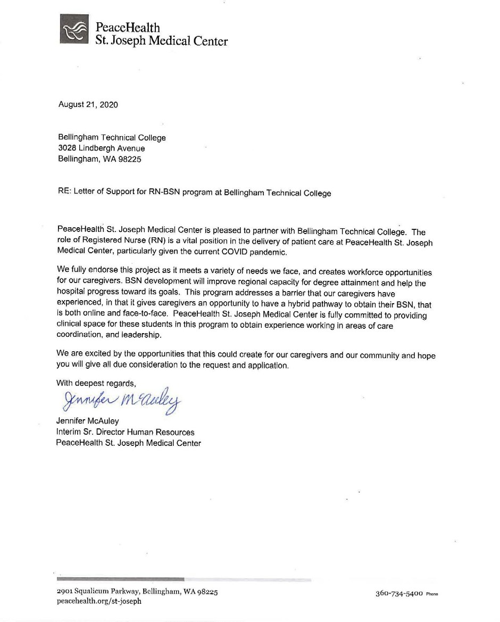

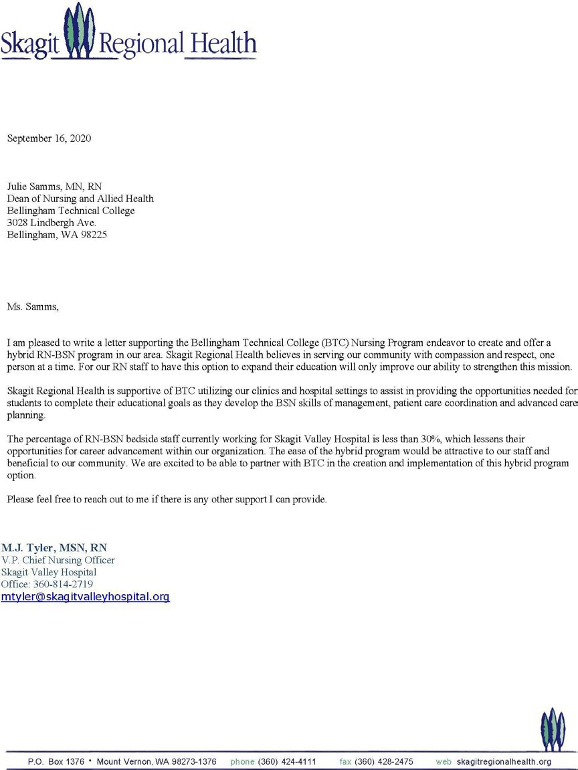

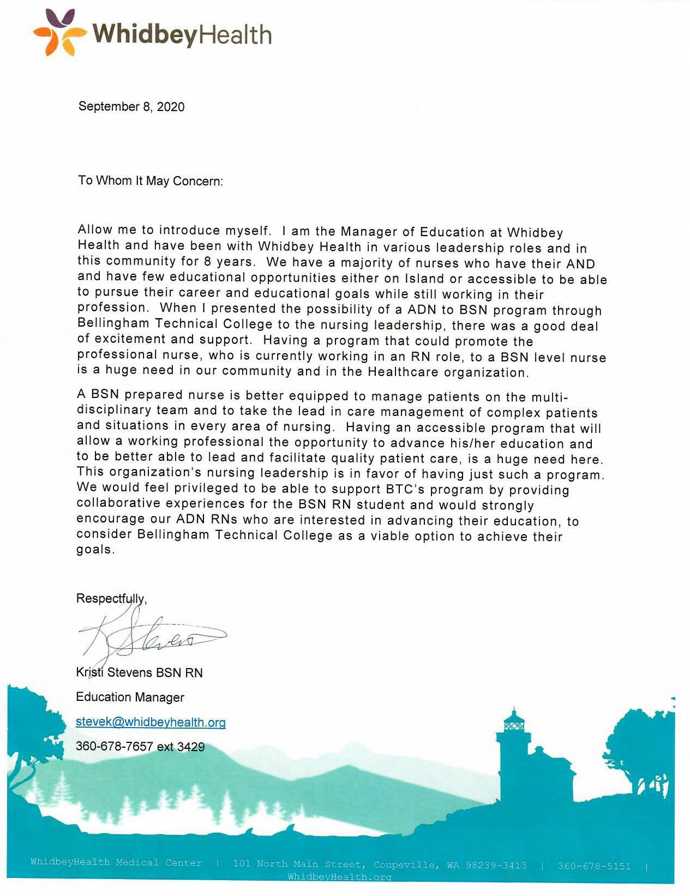

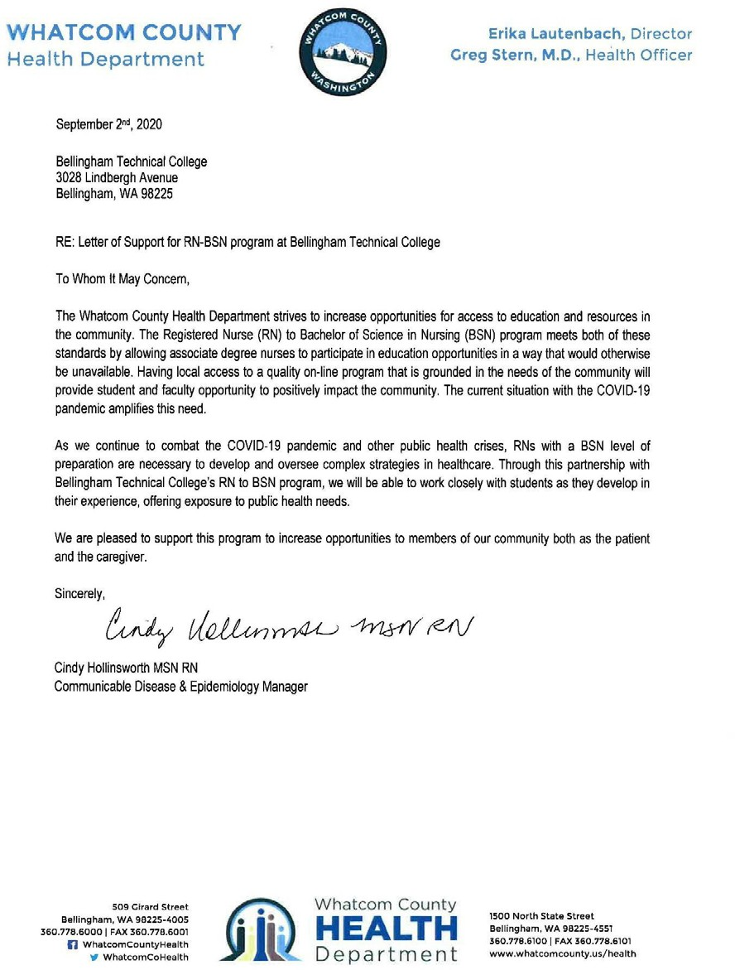

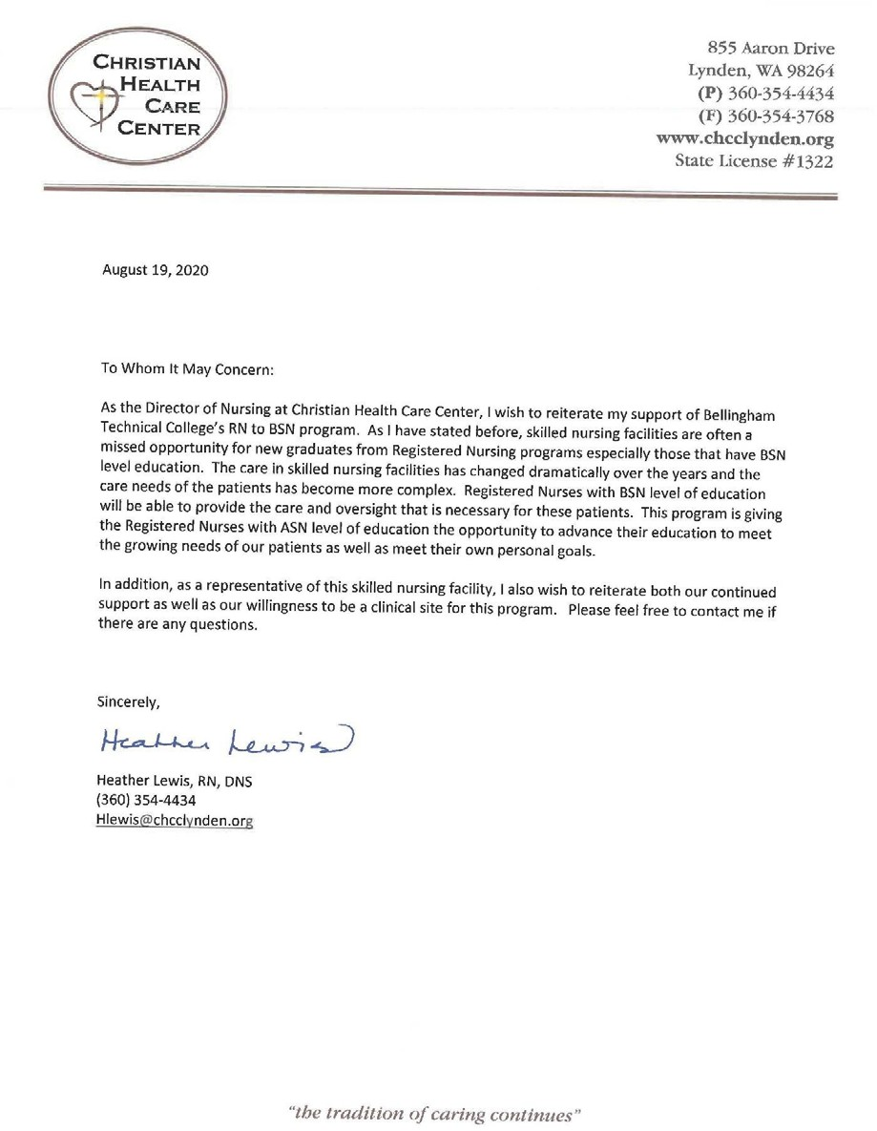

#### APPENDIX

**WESTERN**

WASHI N G T O N

U N I V E R S I T Y

R N - T O - B S N PROGRAM

William Lonneman DNP, RN Interim Program Director RN-to -B SN Progra m a m

Miller Hall 416A - MS 9188 516 High Street, Bellingham, Washington 98225

(360) 650-3882

william[.lonneman@wwu.edu](mailto:.lonneman@wwu.edu)

December 6, 2019

To the members of the Washington State Board for Community and Technical Colleges:

I am writing in regards to the application of Bellingham Technical College (BTC) to open an RN-to-BSN nursing program. BTC is one of two Associate Degree Nursing programs in our city and is located just a few miles from our campus.

Western's RN-to-BSN program began in 2013 and averages about 30 students per year. We usually receive about ten students each year directly from BTC, so about one-third of our cohort. BTC does a wonderful job in educating their ADN students and our program has benefited from the support and counsel of the Dean there, Julie Samms, since our founding. I also fully support the idea of expanded opportunities for BSN education.

So, I have very mixed feelings about their application to open their own RN-to-BSN program. I understand that they mean for their program to be all on-line, and so it is different from ours, which is a hybrid, blended program that meets face-to-face some weeks and on-line for other weeks. Nevertheless, I am sure that the number of students coming to our program will be impacted by this decision. Our program is not state-

supported, and so we already struggle a bit to attract students, due to our higher, self-sustaining program tuition rate.

When our program was founded, everyone agreed on the great need for an RN-to-BSN program in this corner of the state. Western's programwas the response to that need. Thank you for receiving this letter and for Julie's openness in asking me to draft: it. I would be happy to talk further about this if you would like.

Bill Lonneman DNP, RN

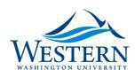

|  |  |
| --- | --- |
| ***WOODRING COLLEGE OF EDUCATION***  **Horacio Walker, Dean** | 516 High Street  Bellingham, Washington 9 822 5 -9088  360-650-3319 FAX 360-650-4845 |

February 5, 2020

Julie Samms

Dean of Nursing and Allied Health Bellingham Technical College

Dear Julie,

I am writing in regards to Bellingham Technical College’s (BTC) application to open an all on- line RN-to-BSN nursing program. The University will always support and stand for

collaboration with BTC when new opportunities are opened to students. I believe that BTC will do a highly professional job putting together an RN-to-BSN nursing program. There is ample evidence that speaks of the high quality of your ADN program. In fact, many of our best students come from BTC.

At the same time, I am very concerned with the impact on enrollment that this will have on our own RN-to-BSN program due to the proximity of BTC to Western and the lower cost of an all on- line program. As you know, since we matriculated the first cohort in 2013 the University has invested a significant amount of resources to support the program, maintaining its high quality, which was

recently confirmed by the CCNE Evaluation Team Report on the Accreditation Review of our RN- to-BSN nursing program. The University remains committed to continued offering of this program.

Sincerely,

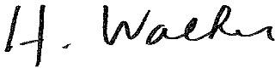

Horacio Walker

Dean, Woodring College of Education Western Washington University