**Wisconsin Payroll Taxes**

**WI State Income Tax Withholding**

Wisconsin Department of Revenue Withholding Tax website: <https://www.revenue.wi.gov/Pages/Withholding/home.aspx>

Wisconsin DOR Withholding Tax Guide: <https://www.revenue.wi.gov/DOR%20Publications/pb166.pdf>

**Who Must Withhold WI State Income Taxes**

An employer that pays wages or other compensation to employees for services performed within WI State is required to register with the Wisconsin Department of Revenue for a Wisconsin withholding tax account number. You may register online at My Tax Account <https://tap.revenue.wi.gov/BTR/_/> (1 – 2 business days for processing) or complete an Application for Wisconsin Business Tax Registration form <https://www.revenue.wi.gov/TaxForms2017through2019/btr-101.pdf> (15 business days for processing).

*Note: There is no application fee if you are only applying for a Wisconsin withholding tax number **and** you are an out-of-state employer who is not engaged in business in Wisconsin.

Wisconsin income taxes are to be withheld from employees and remitted based on the filing frequency assigned to you by the department. Withholding liability is incurred when wages are paid to employees, not when wages are earned. Quarterly, monthly, and semi-monthly filers with an active Wisconsin withholding account must file an electronic deposit report (Form WT-6) even if no tax is withheld during the period covered. An annual reconciliation (Form WT-7) must be filed by January 31, the last day of the month following the calendar year. Withholding deposit reports and the annual withholding reconciliation must be submitted electronically unless you've been granted a department waiver from electronic filing. Submitting deposits and reports through My Tax Account satisfies the electronic filing requirement.

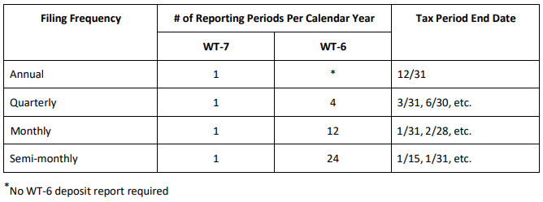

**WI W-4 Requirements**

The Wisconsin Withholding Exemption Certificate (Form WT-4) <https://www.revenue.wi.gov/Pages/Form/with-home.aspx> is used to determine the amount of Wisconsin income tax to be withheld from employee wages. Every Wisconsin employee must give Form WT-4 to their employer. Employers may also use this form to comply with new hire reporting requirements.

**WI State Unemployment Insurance**

In general, workers are covered by the unemployment law of the state in which the work is performed. Wisconsin-based Government Employers have mandatory coverage in WI.

**Per Special Investigator with Wisconsin’s Unemployment Insurance Division, Washington State Government employees are ineligible for UI coverage by their agency and should cover Wisconsin-based employees under Washington State’s Unemployment Insurance program.**

**WI State Workers’ Compensation**

Out-of-state employers must have worker's compensation insurance if they have employees working in Wisconsin. The policy must be with an insurance company licensed to write in Wisconsin and endorsed to name Wisconsin as a covered state in Section 3-A of the policy.

Washington State Department of Enterprise Services (DES) administers a Workers' Compensation Insurance program for state workers. If your employee works outside of Washington in a single other state for more than 30 days (240 hours) per year, **your agency must work with DES** to insure your out-of-state employee. For more information, contact Kimberly Haggard [kimberly.haggard@des.wa.gov](mailto:kimberly.haggard@des.wa.gov) at DES Risk Management.

**WI State Paid Family / Medical Leave**

Wisconsin does not have a paid family and medical leave program as of 06/27/2024.

**Helpful resources for Wisconsin**

Wisconsin Department of Revenue General Withholding Tax Questions: <https://www.revenue.wi.gov/Pages/FAQS/pcs-with.aspx#with2>

Wisconsin withholding tax questions may be answered by emailing [DORWithholdingTax@wisconsin.gov](mailto:DORWithholdingTax@wisconsin.gov) or calling the DOR at (608) 266-2776.

Wisconsin Employer Unemployment Resources: <https://dwd.wisconsin.gov/uitax/>

Wisconsin Department of Workforce Development Worker’s Compensation and Out-of-State Employer Requirements: <https://dwd.wisconsin.gov/wc/employers/oos-employers.htm>