**Oregon Payroll Taxes**

**OR State Income Tax**

Withholding is required on all wages paid by employers for services performed by any employee within Oregon.

Employers may register for an Oregon Business Identification Number (BIN) by filing a Combined Employer’s Registration form with Oregon Secretary of State <https://secure.sos.state.or.us/cbrmanager/index#stay>. The BIN is used when reporting, paying, or making inquiries about your withholding, unemployment insurance, transit taxes, Workers’ Benefit Fund assessment, and the statewide transit taxes. It is important that you include your BIN on all correspondence, returns, and payments that you file with the OR Department of Revenue, Employment Department, and the Department of Consumer and Business Services.

The OR Department of Revenue administers the following types of income taxes:

* OR State Income Tax Withholding (employee-paid taxes on services performed within OR);
* OR Transit District Excise Taxes (employer-paid taxes on services performed in the TriMet or LTD districts, including the homes of OR resident employees who telecommute); and
* OR Statewide Transit Taxes (employee-paid taxes on wages of OR residents, regardless of where the work is performed).

All employers, including nonresident employers, who are paying wages earned in the TriMet or LTD districts must register and file with Oregon Department of Revenue. City, county, and local government units are subject to TriMet payroll taxes, if employees are located or performing services within the TriMet boundaries. If you are subject to transit payroll taxes, complete the transit payroll tax section of the Combined Employer’s Registration form. This is the same form used to register as an employer for withholding and unemployment insurance tax purposes.

To determine if your OR employee’s work location is within the TriMet District boundary, you may either

Check the interactive map: [https://maps.trimet.org/?district=true&zoom=10&tool=search&_gl=1*hq3r4n*_ga*NzQ5NjY2MDEwLjE3MDM3MDQ3Nzk.*_ga_B1DBJM7NST*MTcwMzcxNTYyNC4yLjAuMTcwMzcxNTYyNC4wLjAuMA](https://maps.trimet.org/?district=true&zoom=10&tool=search&_gl=1*hq3r4n*_ga*NzQ5NjY2MDEwLjE3MDM3MDQ3Nzk.*_ga_B1DBJM7NST*MTcwMzcxNTYyNC4yLjAuMTcwMzcxNTYyNC4wLjAuMA); or

Refer to the District Boundary Map and list of ZIP codes on OR Dept of Revenue’s TriMet tax website: <https://www.trimet.org/taxinfo/>.

To determine if your OR employee’s work location is within the LTD district boundary, consult the list of ZIP codes on OR Dept of Revenue’s LTD tax website: <https://www.ltd.org/payroll-self-employment-tax-information/> or contact LTD at 541-687-5555.

Due dates for paying OR withholding taxes are the same as due dates for depositing your federal tax liability.

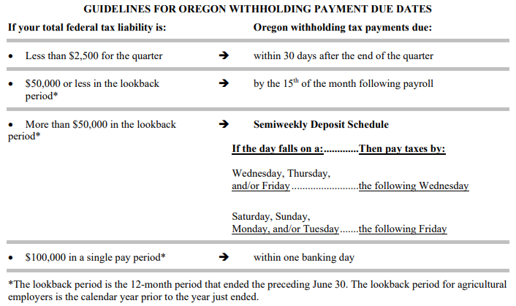

You must file Oregon combined payroll taxes by the due date for as long as you maintain an account (have an active BIN) as an employer with the Oregon Department of Revenue, Employment Department, or Department of Consumer and Business Services, even if you had no payroll for the reporting period. Payroll reports must be filed if you had payroll, even though there may not have been any tax withheld.

How to determine which filing requirement applies to your situation:

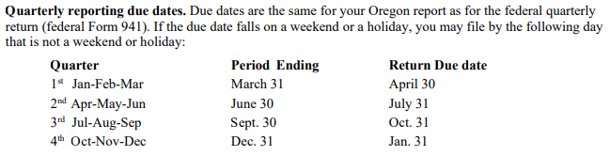

Employers may register for online access to manage accounts, remit payments, and file returns electronically through Frances Online: <https://frances.oregon.gov/Employer/_/>.

All Oregon employers must electronically file an Oregon Annual Withholding Reconciliation Report (Form ORWR). This report is due by the last day of January after the tax year. If you stop doing business during the year, this report is due within 30 days of your final payroll.

Employers must prepare the annual wage and tax statement (Form W-2) on the combined six-part federal-state form or an approved substitute form. Employers must give each employee three copies of the W-2 Form no later than January 31 of the next year.

Oregon requires that **all** employers submit W-2 and 1099 information electronically with the Oregon Department of Revenue. There are currently three submission options available in the Income and Wage Information Return e-Services system (iWire) through OR’s Revenue Online portal at <https://revenueonline.dor.oregon.gov/tap/_/>.

**OR W-4 Requirements**

When figuring OR withholding tax, use the number of allowances claimed by an employee on Form OR-W-4. Current OR W-4 forms and instructions are available by searching here: <https://www.oregon.gov/dor/forms/pages/default.aspx>.

**OR Local Payroll Taxes**

Apart from OR Transit District, Tri-County, and Lane Transit District, certain districts in Oregon impose local payroll taxes. These taxes apply to all wages earned for work performed within these areas, including remote work. Employers must register, withhold (where necessary), and submit these taxes to the appropriate agencies. Employers should assess the relevance of the local taxes listed below based on where their employees work:

Canby Area Transit Tax: <https://www.canbyoregon.gov/transit-tax>

Eugene Payroll Tax: <https://www.eugene-or.gov/4281/Community-Safety-Payroll-Tax>

Sandy Transit Tax: <https://www.ci.sandy.or.us/transit/page/transit-tax>

South Clackamas Transit Tax: <https://www.sctd.org/transit-tax>

Wilsonville Transit Tax: <https://www.ci.wilsonville.or.us/finance/page/transit-payroll-tax-information>

**OR State Unemployment Insurance**

In general, workers are covered by the unemployment law of the state in which the work is performed. OR employers must pay into the Unemployment Insurance Trust Fund if they:

* Have one or more employees in each of 18 weeks during a calendar year; or
* Have total payroll of $1,000 or more in a calendar quarter (after January 1, 2008).

OR allows certain nonprofit organizations and governmental entities to elect to reimburse the Employment Department for any benefits paid to former employees instead of paying unemployment insurance contributions. For additional information regarding these options, please call the Employment Department at 503-947-1488.

In addition to the Oregon Combined Payroll Tax report, employers subject to the Unemployment Insurance contributions must report employee wage detail information. Reports are due by the last day of the month following the end of each calendar quarter and may also be filed via Frances Online.

OR has adopted the Interstate Reciprocal Coverage Arrangement for unemployment insurance. Under this arrangement, if an employee works in more than one state, an employer may elect to cover all the services of such a worker in any state in which: (1) any part of the worker's service is performed, (2) the worker has his or her residence, or (3) the employer maintains a place of business. The agreement should be initiated through the state where the employer wants to report the payroll. A Washington employer may request to elect reciprocal coverage with another state by following the filing process outlined by Washington Administrative Code 192-300-150: <https://app.leg.wa.gov/wac/default.aspx?cite=192-300-150>.

**OR State Workers’ Compensation**

Oregon requires almost all employers to carry workers’ compensation insurance for their employees. If you are an employer with one or more subject workers, you must purchase an Oregon workers’ compensation policy. The insurer will file proof of coverage on your behalf.

Washington State Department of Enterprise Services (DES) administers a Workers' Compensation Insurance program for state workers. If your employee works outside of Washington in a single other state for more than 30 days (240 hours) per year, **your agency must work with DES** to insure your out-of-state employee. For more information, contact Kimberly Haggard [kimberly.haggard@des.wa.gov](mailto:kimberly.haggard@des.wa.gov) at DES Risk Management.

All employers who are required by law or elect to carry Oregon workers’ compensation insurance are required to report and pay the Workers’ Benefit Fund assessment. Report and pay this assessment using Oregon combined payroll tax forms (Form OQ and Form OTC), along with other State payroll taxes administered by the Oregon Department of Revenue and Employment Department.

**OR State Paid Family / Medical Leave**

In 2019 the Oregon State Legislature established the OR Paid Family and Medical Leave Insurance (PFMLI) program, developed and administered by the OR Employment Department. If your employee is living in and performing all of their work in OR, then your agency should withhold contributions from that employees’ wages. Submit them, along with employer contributions, on your OR Combined Payroll Tax Report each quarter via Frances Online.

**Helpful resources for Oregon**

OR Start a Business Guide: <https://sos.oregon.gov/business/Documents/business-guides/start-business-guide.pdf>

OR Employer’s Guide: <https://sos.oregon.gov/business/Documents/business-guides/employer-guide.pdf>

OR Transit Payroll Taxes for Employers Guide: <https://www.oregon.gov/DOR/forms/FormsPubs/transit-payroll-taxes_211-503.pdf>

OR Employment Department (Unemployment Insurance) FAQs: <https://www.oregon.gov/employ/Businesses/Tax/Pages/Frequently-Asked-Questions.aspx>

OR Workers’ Compensation Insurance website: <https://wcd.oregon.gov/employer/pages/compensation-insurance-overview.aspx>

Paid Leave Oregon: <https://paidleave.oregon.gov/>

Paid Leave Oregon Employer Guidebook: <https://d1o0i0v5q5lp8h.cloudfront.net/paidleave/live/assets/resources/Paid-Leave-Oregon-Employer-Guidebook-EN.pdf>