**New Jersey Payroll Taxes**

**Register Your Business for Tax and/or Employer Purposes**

An out-of-state business that does not conduct business operations in New Jersey but needs to withhold payroll taxes for an employee who works in New Jersey must file a paper Form NJ-REG <https://www.wpunj.edu/dotAsset/310281.pdf> in order to obtain a Business Registration Certificate (BRC). Out-of-state business entities that file form NJ-REG only will be subject to a nexus review, initiated and conducted by the Division of Taxation.

Application Requirements

* Entity Federal ID Number
* NAICS code
* Estimated start date in New Jersey
* Description of your business activity
* Estimated number of employees
* Anticipated first payroll withholding date for employees
* Owner, partner, or responsible corporate officer information
* Mailing address
* Business addresses

Once an employer registers with the State of New Jersey for tax purposes, they will receive a welcome letter by mail. This letter will contain the employer's NJ Taxpayer Identification Number along with a Personal Identification Number (PIN) necessary for online filing.

**Prepare for Employees in New Jersey**

Employers must comply with New Jersey's labor laws, including but not limited to:

* Minimum wage and overtime wage rates
* Earned sick leave
* Family leave
* Unpaid or withheld wages
* Fringe benefits
* Workers’ compensation insurance
* Disability insurance
* Health or life insurance
* Unemployment insurance
* Required workplace notices

**NJ W-4 Requirements**

New Jersey employers must furnish an Employee’s Withholding Allowance Certificate [Form NJ-W4](https://www.nj.gov/treasury/taxation/pdf/current/njw4.pdf) to their employees and withhold New Jersey Income Tax at the rate selected.

**NJ State Income Tax Withholding**

<https://www.nj.gov/treasury/taxation/freqqite.shtml>

<https://www.nj.gov/treasury/taxation/njit30.shtml>

New Jersey Income Tax withheld from employees' wages or from other payments must be remitted **electronically**on a weekly, monthly/quarterly, or annual basis. Electronic payment can be made by e-check, credit card, or electronic funds transfer (ACH debit or ACH credit). The related returns also must be filed electronically on a monthly, quarterly, or annual basis.

**NJ Withholding Compliance Calendar**

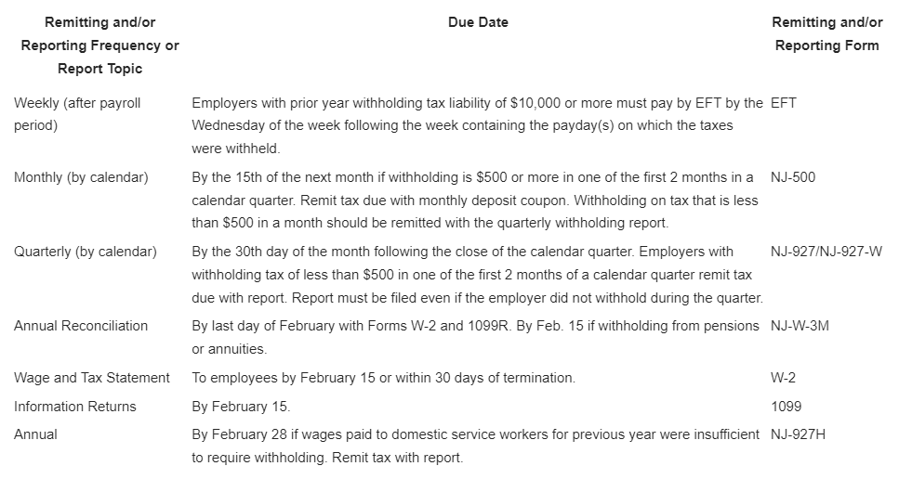

Year-end filings and statements (Forms NJ-W-3, W-2, W-2G, 1099-MISC, 1099-R, 1094/1095, etc.) must also be submitted electronically.

**NJ State Unemployment Insurance**

In general, workers are covered by the unemployment law of the state in which the work is performed. Per the NJ Dept of Labor (written determination provided 09/19/24), governmental entities and instrumentalities located outside the State of New Jersey that hire remote workers or workers localized to perform services in New Jersey are subject employers to the NJ UI/DI law per section 19H1. These employers must participate in NJ State public insurance programs, deduct payroll taxes for employees working in NJ, and report employees’ quarterly earnings to the state.

Once your company employs one or more NJ workers *and* pays wages of $1,000 or more in a calendar year, you must provide quarterly wage reporting via form WR-30, and pay applicable Unemployment (UI), Workforce Development (WF), Temporary Disability (DI) and Family Leave Insurance (FLI) contributions quarterly via form NJ-927. Forms are required to be filed electronically within 30 days of the end of each calendar quarter even if there are no wages paid in the quarter. Information required includes (1) employee Social Security number, (2) employee name, (3) gross wages paid, and (4) base weeks earned.

You may register for an account and file the forms online by following this link: <https://www1.state.nj.us/TYTR_BusinessFilings/jsp/common/Login.jsp?taxcode=45>.

Per the NJ Dept of Labor (written determination provided 09/19/24), governmental entities

and instrumentalities located outside the State of New Jersey do not qualify for the reimbursable method to finance the unemployment fund.

NJ has adopted the Interstate Reciprocal Coverage Arrangement for unemployment insurance. Under this arrangement, if an employee works in more than one state, an employer may elect to cover all the services of such a worker in any state in which: (1) any part of the worker's service is performed, (2) the worker has his or her residence, or (3) the

employer maintains a place of business. The agreement should be initiated through the state where the employer wants to report the payroll. A Washington employer may request to elect reciprocal coverage with another state by following the filing process outlined by Washington Administrative Code 192-300-150: <https://app.leg.wa.gov/wac/default.aspx?cite=192-300-150>.

**NJ State Paid Family / Medical Leave**

The New Jersey Family Leave Insurance (FLI) program provides paid family leave to an eligible employee for a qualifying reason up to 12 consecutive weeks in a 12-month period, or up to 8 weeks in a non-continuous manner in a 12-month period. Employers and employees subject to the state unemployment compensation law are covered under the disability law that includes the FLI program.

The Family Leave program is financed 100% by worker payroll deductions. Employers do not contribute to the program.

Per the NJ Dept of Labor (written determination provided 09/19/24), governmental entities and instrumentalities located outside the State of New Jersey that hire remote workers or workers localized to perform services in New Jersey must participate in the State Family Leave Insurance plan or provide coverage through a private plan insurer.

**NJ State Workers’ Compensation**

The State of New Jersey requires that employers obtain Workers’ Compensation insurance if they have NJ employees.

Washington State Department of Enterprise Services (DES) administers a [Workers' Compensation Insurance program](https://des.wa.gov/sites/default/files/2023-08/Out-Of-State-Workers-Compensation-FAQs.pdf) for state workers. If your employee works outside of Washington in a single other state for more than 30 days (240 hours) per year, **your agency must work with DES** to insure your out-of-state employee. For more information, contact

Kimberly Haggard [kimberly.haggard@des.wa.gov](mailto:kimberly.haggard@des.wa.gov) at DES Risk Management.

**Helpful resources for New Jersey**

NJ Treasury Division of Taxation Employer Payroll Tax website: <https://www.nj.gov/treasury/taxation/businesses/payroll/index.shtml>

NJ Treasury Division of Taxation Income Tax Withholding Instructions: <https://www.nj.gov/treasury/taxation/pdf/current/njwt.pdf>

NJ Department of Labor and Workforce Development Unemployment Insurance Employer Handbook: <https://www.nj.gov/labor/ea/help/employer_handbook/>

NJ Department of Labor and Workforce Development Unemployment Insurance FAQs website: <https://www.nj.gov/labor/ea/help/faqs/faq_general.shtml>

NJ Division of Temporary Disability and Family Leave Insurance FAQ’s website: <https://www.nj.gov/labor/myleavebenefits/help/faq/fli.shtml#:~:text=Claimants%20are%20paid%2085%25%20of,rate%20is%20%241%2C025%20per%20week>