**Missouri Payroll Taxes**

**MO State Income Tax Withholding**

The Missouri Employer’s Tax Guide is available for download from the MO Employer Withholding website: <https://dor.mo.gov/taxation/business/tax-types/withholding/>

**Who Must Withhold MO State Income Taxes**

Every employer paying wages to an employee working in Missouri must register with the MODOR. Employers may register electronically at [https://mytax.mo.gov/rptp/portal/business/register-new-business/](https://mytax.mo.gov/rptp/portal/business/register-new-business/!ut/p/z1/04_Sj9CPykssy0xPLMnMz0vMAfIjo8zijS0MnN09DIy8DFxDDA0cjfx9vd08wgwM3E30w8EKDHAARwP9KGL041EQhd_4cP0oVCvcQ4ONDBz9HUNNwhy9jAzMzKAK8JhRkBsaYZDpqAgAiwV9cA!!/dz/d5/L2dBISEvZ0FBIS9nQSEh/). If you have additional registration questions or concerns, you may contact Business Tax Registration by email at [businesstaxregister@dor.mo.gov](mailto:businesstaxregister@dor.mo.gov) or call 573-751-5860.

MO State Income Tax Withholding Filing and Payment Options

Withholding tax returns may be filed on a quarter-monthly (weekly), monthly, quarterly, or annual basis. Your filing frequency is determined by the amount of income tax that is withheld from the wages you pay.

* Employers withholding over $9,000 per month must file and pay using the quarter-monthly (weekly) frequency. Quarter-monthly filers are also required to pay electronically.
* Employers withholding $500 to $9,000 per month must file and pay on a monthly basis.
* Employers withholding $100 per quarter to $499 per month must file and pay on a quarterly basis.
* Employers withholding less than $100 per quarter will file and pay on an annual basis.

Your filing frequency is reviewed by the Department of Revenue on an annual basis. If this review indicates that your filing frequency should be changed, the change will be made, and a notification will be sent to you.

Employers may file and pay Employer’s Return of Income Taxes Withheld (Form MO-941), online using a Credit Card or E-Check (Electronic Bank Draft), through their MyTax Missouri Portal account or by paper. If you do not have a pre-printed voucher booklet, obtain a blank Form MO-941 here: <https://dor.mo.gov/forms/MO-941.pdf>.

Every employer with an active account is required to file returns (Form MO-941) even if there is no tax to report.

Annually, each employer must file copies of all withholding statements, Form W‑2, or Form 1099-R, Copy 1, for the year, along with the Transmittal of Tax Statements (Form MO W-3). Employers with 250 or more employees are required to submit these items electronically by the last day of January.

Paper filers are required to submit copies of all withholding statements by the last day of February. Paper filers must also be accompanied by a list, preferably an adding machine tape or a computer printout, of the total amount of the income tax withheld as shown on all “Copy 1s” of Form W‑2 and Form 1099-R.

**MO Local / Municipal Income Taxes**

Both Kansas City, MO and St. Louis, MO impose an earnings tax on wages earned within their city limits. If your employee resides in either of these cities, you must register, withhold, report, and remit the taxes to the respective agencies.

[Quick Tax](https://quicktax.gentax.net/KCP/TAP/_/) is the online system Kansas City taxpayers may use to file tax returns, make payments, register a business, view and make changes to their accounts with the City, and view notices and letters sent by the City.

Visit the [St. Louis Earnings Tax Department website](https://www.stlouis-mo.gov/government/departments/collector/earnings-tax/index.cfm) to open an earnings tax account, file business earnings tax forms, and pay earnings taxes for St. Louis employees.

The City of St. Louis also imposes an employer payroll tax; however educational institutions, federal and state governments, and their agencies are exempt from this tax.

**MO W-4 Requirements**

Obtain a completed Form MO W-4 from each Missouri employee. Form MO W-4 is available for download from the Employer Withholding website at: <https://dor.mo.gov/taxation/business/tax-types/withholding/>.

**MO State Unemployment Insurance**

In general, workers are covered by the unemployment law of the state in which the work is performed. A governmental entity becomes liable for MO UI when it employs a worker, regardless of the amount of wages paid or number of weeks the worker is employed.

Employers may register with the Missouri Division of Employment Security (DES) for a State Unemployment Tax Account online via Missouri’s Online Unemployment System, Uinteract: <https://uinteract.labor.mo.gov/tax/home.do>. If you meet the criteria to be liable for state unemployment tax, the DES will send you an official written determination letter.

Only nonprofit organizations as described in Section 501(c)(3) or Missouri Governmental Entities may elect to reimburse the Missouri Unemployment Compensation Fund for the amount of UI benefits paid instead of paying a quarterly tax (Reimbursable Employers). Such an election must be made in writing either:

1. Within 30 days of the date the original notice of liability is mailed
2. At least 30 days prior to January 1st of a calendar year for which such election shall be effective. A contributing employer who chooses to change to the reimbursable method must stay reimbursable for two calendar years.

Employers must report individual workers’ wages each quarter for the Division of Employment Security (DES) wage record files. You may file UI reports electronically via UInteract: <https://uinteract.labor.mo.gov/tax/home.do>.

*** It is required that all employers with 50 or more employees file unemployment insurance reports electronically. Filing the report by magnetic media or using UInteract will meet this requirement. ***

The following chart shows the due dates for all 4 quarters.

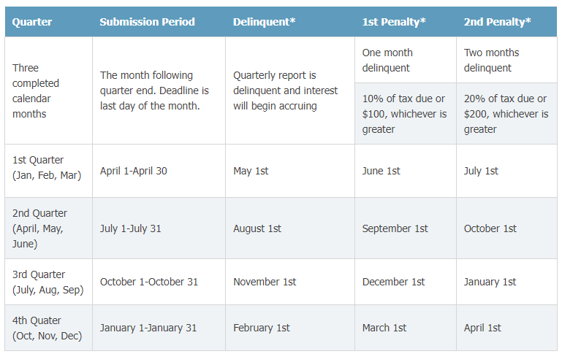

When the date falls on a Saturday, Sunday, or holiday, the first working date following is considered timely.

Missouri has adopted the Interstate Reciprocal Coverage Arrangement for unemployment insurance. Under this arrangement, if an employee works in more than one state, an employer may elect to cover all the services of such a worker in any state in which: (1) any part of the worker's service is performed, (2) the worker has his or her residence, or (3) the employer maintains a place of business. The agreement should be initiated through the state where the employer wants to report the payroll. A Washington employer may request to elect reciprocal coverage with another state by following the filing process outlined by Washington Administrative Code 192-300-150: <https://app.leg.wa.gov/wac/default.aspx?cite=192-300-150>.

**MO State Workers’ Compensation**

Missouri employers are required to carry workers’ compensation insurance if they have five or more employees. Those subject to providing workers’ compensation insurance for their employees must either go through an insurance carrier or may choose to be self-insured upon approval from the MO Division of Workers’ Compensation.

Washington State Department of Enterprise Services (DES) administers a Workers' Compensation Insurance program for state workers. If your employee works outside of Washington in a single other state for more than 30 days (240 hours) per year, **your agency must work with DES** to insure your out-of-state employee. For more information, contact Kimberly Haggard [kimberly.haggard@des.wa.gov](mailto:kimberly.haggard@des.wa.gov) at DES Risk Management.

**MO State Paid Family / Medical Leave**

Missouri does not have a paid family and medical leave program as of 04/15/2024.

**Helpful resources for Missouri**

MO Department of Revenue Taxation Division

P.O. Box 999

Jefferson City, MO 65105-0999

Phone: 573-751-7200

Fax: 573-522-6816

Email: [withholding@dor.mo.gov](mailto:withholding@dor.mo.gov)

MO State Withholding Tax FAQs: <https://dor.mo.gov/faq/taxation/business/withholding.html>

MO DOR Online Withholding Tax Calculator: <https://mytax.mo.gov/rptp/portal/home/withholding-calculator>

For vendor setup, the MO employer withholding tax mailing address is:

MO Department of Revenue

PO Box 3375

Jefferson City, MO 65105-3375

MO DOL Unemployment Insurance Tax information: <https://labor.mo.gov/des/employers>

For vendor setup, the MO unemployment insurance mailing address is:

MO Division of Employment Security

PO Box 888

Jefferson City, MO 65102-0888

MO Remote Work Resources website: <https://dor.mo.gov/taxation/business/remote.html>

MO Division of Workers’ Compensation website: <https://labor.mo.gov/dwc>