**Massachusetts Payroll Taxes**

**MA State Income Tax Withholding**

<https://www.mass.gov/guides/withholding-taxes-on-wages>

**Who Must Withhold MA State Income Taxes**

An employer that pays wages or other compensation to employees for services performed within MA State is required to register with the Massachusetts Department of Revenue (DOR). Employers may register, file reports, and pay wage withholding online via MassTaxConnect at: <https://www.mass.gov/info-details/register-your-business-with-masstaxconnect>.

Filing and Paying Withholding

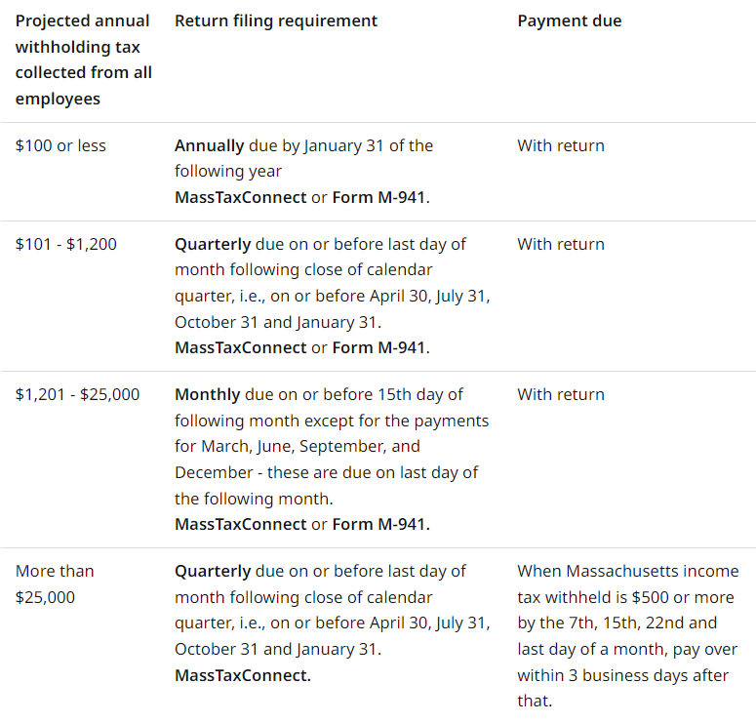

New businesses or existing businesses applying for MA wage withholding are required to file returns and pay withholding taxes electronically, regardless of the amount of annual tax liability.

Employers must file Forms W-2 in a machine-readable format by the last day of March for the preceding year.

**MA W-4 Requirements**

Employees must complete Form M-4 - Employee's Withholding Exemption Certificate: <https://www.mass.gov/doc/form-m-4-massachusetts-employees-withholding-exemption-certificate/download>.

**MA State Unemployment Insurance**

In general, workers are covered by the unemployment law of the state in which the work is performed. The Department of Unemployment Assistance (DUA) is the agency that administers unemployment insurance in Massachusetts. Out-of-state employers are subject to UI once a Massachusetts payroll amount of $200 or more has been reached in a calendar quarter. To register for an employer account number (EAN), visit the DUA’s website at [www.mass.gov/dua](http://www.mass.gov/dua) and select Unemployment Insurance (UI) for Employers.

Government and non-profit employers (organizations holding 501(c)(3) status) may choose to reimburse DUA dollar-for-dollar for all regular UI benefits paid to their workers via the reimbursable method instead of paying quarterly contributions. Governmental employers are asked to choose a financing method when the organization becomes subject to the Unemployment Insurance Law.

*\*Note*: Quarterly employment and wage detail reports must still be filed.

All employers required to participate in the UI system (also referred to as subject employers) must file an Employment and Wage Detail report online at [www.mass.gov/uima](http://www.mass.gov/uima) each calendar quarter. Due dates are as follows:

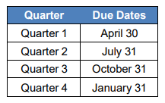

MA has adopted the Interstate Reciprocal Coverage Arrangement for unemployment insurance. Under this arrangement, if an employee works in more than one state, an employer may elect to cover all the services of such a worker in any state in which: (1) any part of the worker's service is performed, (2) the worker has his or her residence, or (3) the employer maintains a place of business. Consent is required from each state that would

have a reasonable claim to cover the service of an individual and also from the employee for whom coverage is sought. An agreement should be initiated through the state where the employer wants to report the payroll. A Washington employer may request to elect reciprocal coverage with another state by following the filing process outlined by Washington Administrative Code 192-300-150: <https://app.leg.wa.gov/wac/default.aspx?cite=192-300-150>.

**MA State Workers’ Compensation**

All employers operating in Massachusetts are required to carry workers’ compensation insurance for their employees. The requirement applies no matter the number of hours worked or the number of employees. The Department of Industrial Accidents (DIA) oversees the Massachusetts workers’ compensation system. For questions, email DIA at [Info2@mass.gov](mailto:Info2@mass.gov).

Out-of-state employers operating in Massachusetts must provide workers’ compensation coverage for all employees working in the Commonwealth.

Employers whose existing workers’ compensation insurance policies list Massachusetts in section 3A of the policy’s information page satisfy this requirement.

Employers whose workers’ compensation policies list Massachusetts in section 3C regarding all states coverage (with or without certain state exclusions) must get proof from their insurance carrier that coverage is provided in Massachusetts by having their workers' compensation insurer submit Form 154 - Verification of Workers' Compensation Coverage for Out-of-State Employers Operating in Massachusetts (<https://www.mass.gov/doc/form-154-verification-of-workers-compensation-coverage-by-out-of-state-employers-operating-in/download>).

Washington State Department of Enterprise Services (DES) administers a Workers' Compensation Insurance program for state workers. If your employee works outside of Washington in a single other state for more than 30 days (240 hours) per year, **your agency must work with DES** to insure your out-of-state employee. For more information, contact Kimberly Haggard [kimberly.haggard@des.wa.gov](mailto:kimberly.haggard@des.wa.gov) at DES Risk Management.

**MA State Paid Family / Medical Leave**

Beginning in 2021, Massachusetts established a paid family and medical leave program that offers up to 26 weeks of paid leave for family or medical reasons to eligible employees in Massachusetts. MA State PFML is funded through employee and employer contributions. The program is administered by the Department of Family and Medical Leave (DFML). You may contact DFML for questions by telephone at (833) 344-7365.

If your employee is living in and performing all of their work in MA, then your agency should report to MA and have the employee pay in to MA’s PFML program to ensure the employee is eligible for benefits if they need them. Use your MassTaxConnect account to manage leave for the MA employees in your organization. Every three months, you will need to log on to MassTaxConnect to complete a quarterly return and remit contributions for your covered individuals for the previous three months.

Washington Paid Family & Medical Leave (PFML) and Washington Cares benefits are not available to employees who are physically working in Massachusetts. If your college has policy questions you may email Washington Employment Security Department at [esddlpfmlpolicy@esd.wa.gov](mailto:esddlpfmlpolicy@esd.wa.gov).

**Helpful resources for Massachusetts**

Massachusetts Department of Revenue withholding tax forms: <https://www.mass.gov/lists/dor-withholding-tax-forms>

Massachusetts Employer’s Guide to Unemployment Insurance: <https://www.mass.gov/doc/the-employers-guide-to-unemployment-insurance/download>

MA Workers’ Compensation for Employers website: <https://www.mass.gov/workers-compensation-for-employers>

MA Department of Family and Medical Leave Employer’s Info websites: <https://www.mass.gov/paid-family-and-medical-leave-information-for-massachusetts-employers>

<https://www.mass.gov/guides/employers-introduction-to-paid-family-and-medical-leave>

<https://www.mass.gov/doc/employer-toolkit-for-paid-family-and-medical-leave/download>

<https://www.mass.gov/info-details/pfml-frequently-asked-questions-for-employers>