**Hawaii Payroll Taxes**

**HI State Income Tax Withholding**

State of Hawaii Department of Taxation Withholding Tax For Employers website: <https://tax.hawaii.gov/geninfo/a2_b2_4empl_whhold/>

**Who Must Withhold HI State Income Taxes**

An employer making payment of wages to employees for services performed within the State of Hawaii must deduct and withhold from such wages an amount of tax as provided by the Hawaii Withholding Law.

Periodic withholding tax returns, including amended returns, may be electronically filed (e-filed) and payments can be made through Hawaii Tax Online. To register for a withholding account, visit [www.hitax.hawaii.gov](http://www.hitax.hawaii.gov).

Withholding tax payment due dates depend on your withholding tax liability. Due dates are as follows:

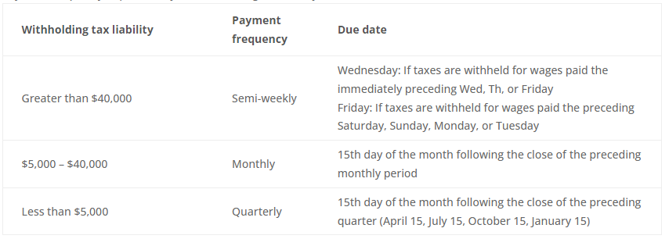

All withholding taxpayers need to file returns quarterly (due April 15, July 15, October 15, and January 15) using Form HW-14.

Form W-2/HW-2 must be filed with the Department of Taxation and furnished to the employee no later than January 31st following the close of the calendar year.

**HI W-4 Requirements**

Before an employee starts work, the employee must give a completed Form HW-4 to the employer. Download Form HW-4 from the Hawaii Tax Forms and Publications website: <https://tax.hawaii.gov/forms/>

**HI State Unemployment Insurance**

In general, workers are covered by the unemployment law of the state in which the work is

performed. To register with the State of Hawaii for an Unemployment Insurance (UI) account number, go to [http://uiclaims.ha](http://uiclaims.hawaii.gov/)[waii.gov](http://huiclaims.hawaii.gov/).  Employers are required to complete the online application before a UI account number will be issued. **Note: Future hire dates are not accepted.**

The employer online website is an easy way to access your Unemployment Insurance account. You can:

* Check your tax rate
* Maintain accounts
* File reports
* Pay taxes
* Authorize a Service Company to act on your behalf
* Add sub-user(s)
* File Low Earning Report
* File or View Appeals
* Register for SIDES E-Response
* View Notices

Non-profit organizations (religious, charitable, and educational) qualifying for income tax exemption under the Internal Revenue Code may apply for exemption from paying contributions by requesting self-financing status. Interested employers should log into their account at [http://uiclaims.hawaii.gov](http://uiclaims.hawaii.gov/) and click on “Forms” to file a notice of election on Form UC-175, “Application for Self-Financing — Non Profit Organization” with the Unemployment Insurance Division. Each self-financed employer must pay a security deposit of .2% of the total wages of the preceding calendar year, which will be held in escrow until the employer withdraws from the self-financing plan and total liability under the self-financing election is terminated. The security deposit will be returned less any deductions provided by law.

All subject employers, including self-financed such as government and nonprofit organizations and contributory employers with a 0.00% tax rate are required to submit Form UC-B6, Quarterly Wage, Contribution and Employment and Training Assessment Report, on or before the last day of the month following the close of the calendar quarter as follows:

First quarter ends March 31:               due no later than April 30

Second quarter ends June 30:             due no later than July 31

Third quarter ends September 30:    due no later than October 31

Fourth quarter ends December 31:   due no later than January 31

Form UC-B6 must be filed each quarter even if wages were not paid during the quarter.

HI has adopted the Interstate Reciprocal Coverage Arrangement for unemployment insurance. Under this arrangement, if an employee works in more than one state, an employer may elect to cover all the services of such a worker in any state in which: (1) any part of the worker's service is performed, (2) the worker has his or her residence, or (3) the

employer maintains a place of business. A Washington employer may request to elect reciprocal coverage with another state by following the filing process outlined by Washington Administrative Code 192-300-150: <https://app.leg.wa.gov/wac/default.aspx?cite=192-300-150>.

**HI State Workers’ Compensation**

The Hawaii Workers’ Compensation (WC) law was enacted in 1915, and its purpose was to provide wage loss compensation and medical care to those employees who suffer a work-related injury. The WC law in essence requires the employer to provide certain benefits without regard to the fault of the employer and prohibits an employee from filing civil action against the employer for work-related injuries or illnesses. Any employer, other than those excluded (section 386-1), having one or more employees, full-time or part-time, permanent or temporary, is required to provide WC coverage for its employees.

Washington State Department of Enterprise Services (DES) administers a Workers' Compensation Insurance program for state workers. If your employee works outside of Washington in a single other state for more than 30 days (240 hours) per year, **your agency must work with DES** to insure your out-of-state employee. For more information, contact Kimberly Haggard [kimberly.haggard@des.wa.gov](mailto:kimberly.haggard@des.wa.gov) at DES Risk Management.

**HI State Paid Family / Medical Leave**

Hawaii does not have a paid family and medical leave program as of 02/21/2024.

**Helpful resources for Hawaii**

Download the ‘*Outline of the Hawaii Tax System’* or the ‘*Employer’s Tax Guide’* from the Hawaii Tax Forms and Publications website: <https://tax.hawaii.gov/forms/>

Visit the State of Hawaii Unemployment Insurance Department Handbook for Employers website at: <https://labor.hawaii.gov/ui/test-handbook-for-employers/>

Visit the State of Hawaii Disability Compensation Division’s website for Workers’ Compensation information by following this link: <https://labor.hawaii.gov/dcd/home/aboutwc/>