**Georgia Payroll Taxes**

**GA State Income Tax Withholding**

Georgia Department of Revenue (GDOR) withholding tax website: <https://dor.georgia.gov/withholding>

Additional withholding tax information: <https://dor.georgia.gov/taxes/business-taxes/withholding-tax-information>

GDOR Employer’s Tax Guide may be downloaded at: <https://dor.georgia.gov/tax-guides>.

**Who Must Withhold GA State Income Taxes**

An employer that pays wages or other compensation to employees for services performed within Georgia is required to register with the Georgia Department of Revenue to obtain a valid withholding number. Register by going to: [https://gtc.dor.ga.gov/_/#](https://gtc.dor.ga.gov/_/) and selecting ‘Register a New Georgia Business’.

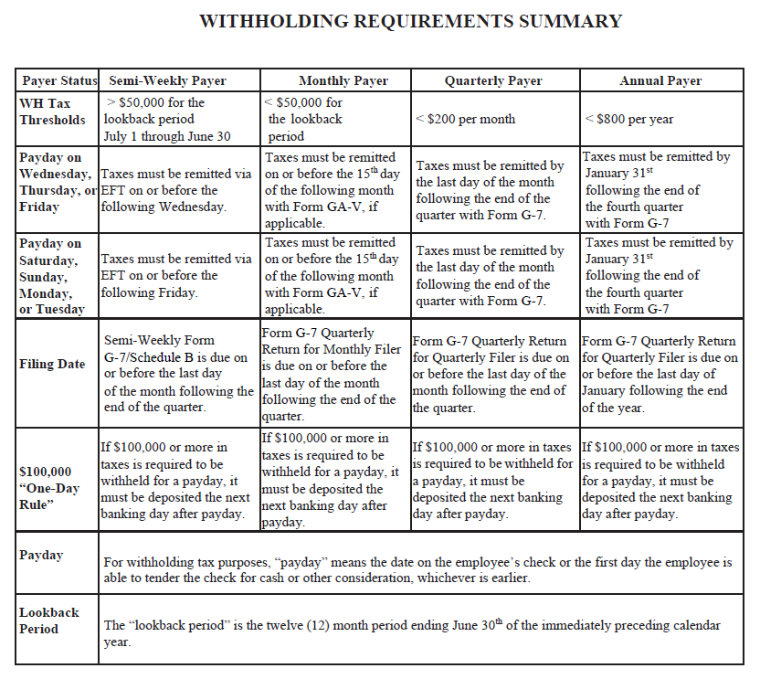

If the total tax withheld or required to be withheld on Form G-7 exceeds $500.00, the amount must be remitted via electronic funds transfer on any payment and return thereafter. All employers who are required to pay the tax withheld or required to be withheld via electronic funds transfer must file all applicable withholding tax returns electronically.

The Georgia Tax Center (GTC) allows business customers to file returns and pay taxes electronically. Employers can file withholding tax returns and make payments using this system. Access the GTC by going to: <https://gtc.dor.ga.gov/>.

Employers are required to submit copies of W-2, 1099, and other income statements with Form G-1003 reflecting payments that are subject to Georgia income tax withholding on or before January 31 of the following year. <https://dor.georgia.gov/document/form/tsdwithholdingincomestatementtransmittalformg1003pdf/download>

For additional information regarding Georgia withholding tax reporting and payment requirements, you may contact the Taxpayer Services Division at 1-877-423-6711.

**GA W-4 Requirements**

The amount of tax to withhold is based on wages, number of allowances, and additional withholding amounts as indicated on Form G-4 Employee’s Withholding Allowance Certificate: <https://dor.georgia.gov/document/form/tsdemployeeswithholdingallowancecertificateg-4pdf/download>

**GA State Unemployment Insurance**

Per Georgia Department of Labor Unemployment Insurance Adjudication Employer Liability Division, an out-of-state government agency is not liable for reporting to Georgia. Instead, the agency should report to the state in which the agency maintains its place of business. Reference OCGA Code § 34-8-35(h) for further information.

**GA State Workers’ Compensation**

In Georgia, employers obtain worker's compensation coverage through private insurers or programs of self-insurance. The rights granted an employee under the workers’ compensation law preclude any other legal remedies against an employer by an employee due to a work-related injury.

The law is applicable to all employers, including public corporations and nonprofit organizations that have at least three full-time or part-time employees. The Georgia State Board of Workers’ Compensation does not sell workers’ compensation insurance.

Washington State Department of Enterprise Services (DES) administers a Workers' Compensation Insurance program for state workers. If your employee works outside of Washington in a single other state for more than 30 days (240 hours) per year, **your agency must work with DES** to insure your out-of-state employee. For more information, contact Kimberly Haggard [kimberly.haggard@des.wa.gov](mailto:kimberly.haggard@des.wa.gov) at DES Risk Management.

**GA State Paid Family / Medical Leave**

Georgia does not have a paid family and medical leave program as of 05/22/2024.

**Helpful resources for Georgia**

G-1003 filing instructional videos:

<https://dor.georgia.gov/file-g-1003-using-gtc-online-entry-video>

<https://dor.georgia.gov/how-create-g-1003-csv-file-video>

Georgia Department of Labor Taxes & Unemployment Insurance Claims website: <https://dol.georgia.gov/employers/taxes-unemployment-insurance-claims>

Georgia Department of Labor Unemployment Insurance FAQs: <https://dol.georgia.gov/faqs-employers/employers-faqs-unemployment-insurance>

Georgia State Board of Workers’ Compensation Insurance FAQs: <https://sbwc.georgia.gov/frequently-asked-questions/workers-compensation-insurance-faqs>