**California Payroll Taxes**

**Who Must Withhold CA State Payroll Taxes**

California Employer’s Guide: <https://edd.ca.gov/siteassets/files/pdf_pub_ctr/de44.pdf>

An employer that hires one or more employees and pays wages in excess of $100 in a calendar quarter for services performed in California must register with the California Employment Development Department (EDD) within 15 days. Register online via the EDD's e-Services for Businesses: [edd.ca.gov/en/Payroll_Taxes/e-Services_for_Business](https://edd.ca.gov/en/Payroll_Taxes/e-Services_for_Business).

Once you have registered, the EDD will assign you an employer payroll tax account number. This account number should be used whenever you contact the EDD and be noted on all EDD payroll tax documents.

The EDD administers the following CA payroll tax programs:

* CA Personal Income Tax (PIT) Withholding
* Unemployment Insurance Tax (UI)
* Employment Training Tax (ETT)
* State Disability Insurance Tax (SDI)

*\*Note:* Paid Family Leave (PFL) is a component of the SDI program.

PIT and SDI are withheld from employee wages. UI and ETT are employer paid contributions. Wages are generally subject to all four payroll taxes unless otherwise stated by law.

**CA W-4 Requirements**

California employees must complete the state form Employee’s Withholding Allowance Certificate (DE 4) for the appropriate personal income tax (PIT) withholding. You can download a DE 4 form from the EDD payroll tax forms & publications website: <https://edd.ca.gov/en/payroll_taxes/forms_and_publications/>.

**CA Payroll Tax Deposits**

California Personal Income Tax (PIT) and State Disability Insurance (SDI) deposit due dates are based on each employer’s federal deposit schedule/requirement and the amount of accumulated PIT the employer has withheld. Employers use e-Services for Business to submit Payroll Tax Deposits (Form DE 88) electronically. Deposit requirements are provided in the chart below.

*\*Note:* California state law requires all employers to electronically submit payroll tax deposits, wage reports, and employment tax returns to the EDD. You may file and pay online with e‑Services for Business to meet this requirement.

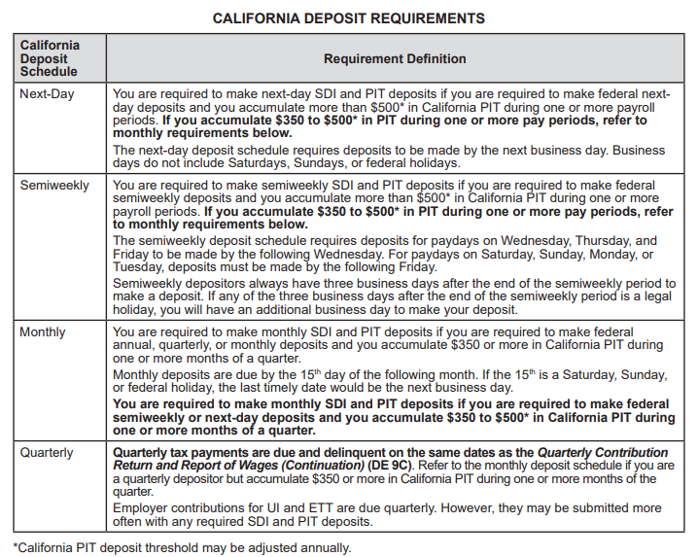

**Filing CA State Payroll Tax Returns**

Employers use the Quarterly Contribution Return and Report of Wages (DE 9) to reconcile payroll tax payments and total subject wages reported for the quarter. You must electronically file a DE 9 and a Quarterly Contribution Return and Report of Wages (Continuation) (DE 9C) each quarter. As an active employer, you must file a DE 9 each quarter even if you paid no wages during the quarter.

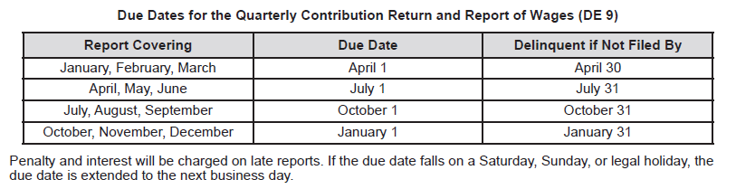

Wages are reported when they are paid to the employee, not when the employee earns the wages.

Employers are required to annually prepare a federal *Wage and Tax Statement* (Form W-2) for each employee by January 31 of the following year. In addition to required federal information, employers must include PIT wages, PIT withheld, and SDI tax withheld on Form W-2. **Do not** send a copy of Form W-2 to the State of California Employment Development Department (EDD) or the Franchise Tax Board (FTB). The Forms W-2 are not filed with the state because you should already be reporting wage and withholding information to the EDD on the *Quarterly Contribution Return and Report of Wages (Continuation)* (DE 9C). However, you must send Forms W-2 to your employees and the Social Security Administration.

**CA State Unemployment Insurance**

In general, workers are covered by the unemployment law of the state in which the work is performed. California’s UI program is funded through payroll taxes paid by the employer. Tax-rated employers pay a percentage on the **first $7,000** in wages paid to each employee in a calendar year.

Public employers and certain nonprofit employers have the option of becoming “reimbursable” employers. Employers electing the reimbursable method (also known as the cost-of-benefits method) are required to reimburse the UI Fund on a dollar-for-dollar basis for all benefits paid to their former employees and charged to their account.

Guidance from the California Employment Development Department’s (EDD) Tax Processing and Accounting Division Analysis Resolution and Correspondence Organization via email on 09/08/23 states that, “Per the California Unemployment Insurance Code (CUIC) Section 632, out of state government agencies are not subject to unemployment insurance and state disability insurance. However, per the California Unemployment Insurance Code (CUIC) Section 709, the agency may elect state disability insurance.” If your agency wishes to elect CA state disability insurance coverage, you must submit Form DE 1378N with board/resolution meeting minutes to CA EDD. Form DE 1378N is available for download here: <https://edd.ca.gov/siteassets/files/pdf_pub_ctr/de1378n.pdf>.

California has adopted the Interstate Reciprocal Coverage Arrangement for unemployment insurance. Under this arrangement, if an employee works in more than one state, an employer may elect to cover all the services of such a worker in any state in which: (1) any part of the worker's service is performed, (2) the worker has his or her residence, or (3) the employer maintains a place of business. The agreement should be initiated through the state where the employer wants to report the payroll. A Washington employer may request to elect reciprocal coverage with another state by following the filing process outlined by Washington Administrative Code 192-300-150: <https://app.leg.wa.gov/wac/default.aspx?cite=192-300-150>.

**CA State Paid Family / Medical Leave**

California’s Paid Family Leave (PFL) is a component of the SDI program. If your agency elects CA state disability insurance coverage, you are required to collect contributions, send them to the EDD, and respond to employee claims for PFL. For more information, visit the EDD’s Employer Requirements website at: <https://edd.ca.gov/en/disability/employer_requirements/>.

Washington Paid Family & Medical Leave (PFML) and Washington Cares benefits are not available to employees who are physically working in California. If agencies have WA PFML or WA Cares policy questions, they are asked to email Washington Employment Security Department at [esddlpfmlpolicy@esd.wa.gov](mailto:esddlpfmlpolicy@esd.wa.gov).

**CA State Workers’ Compensation**

Workers’ compensation insurance is an employer-paid insurance that provides benefits to eligible workers experiencing a loss of wages when they are unable to perform their regular or customary work due to an occupational illness or injury. If you have **any** employees, you are required by law to have workers’ compensation insurance.

Washington State Department of Enterprise Services (DES) administers a Workers' Compensation Insurance program for state workers. If your employee works outside of Washington in a single other state for more than 30 days (240 hours) per year, **your agency must work with DES** to insure your out-of-state employee. For more information, contact Kimberly Haggard [kimberly.haggard@des.wa.gov](mailto:kimberly.haggard@des.wa.gov) at DES Risk Management.

**Helpful resources for California**

California Employment Development Department (EDD): <https://edd.ca.gov/>

Contact information for EDD: <https://edd.ca.gov/en/about_edd/contact_edd>

California e-Services for Business User Guide: <https://edd.ca.gov/pdf_pub_ctr/de160.pdf>

CA e-Services for Business video tutorials: <https://edd.ca.gov/en/payroll_taxes/e-Services_for_Business_tutorials>.

California e-Services for Business frequently asked questions (FAQs): <https://edd.ca.gov/en/payroll_taxes/FAQ_-_e-Services_for_Business>

California EDD Payroll Taxes Fact Sheet: <https://edd.ca.gov/siteassets/files/pdf_pub_ctr/de8714e.pdf>

California payroll tax forms and publications: <https://edd.ca.gov/en/payroll_taxes/forms_and_publications/>

California Workers’ Compensation Employer Information Website: <https://www.dir.ca.gov/dwc/Employer.htm>