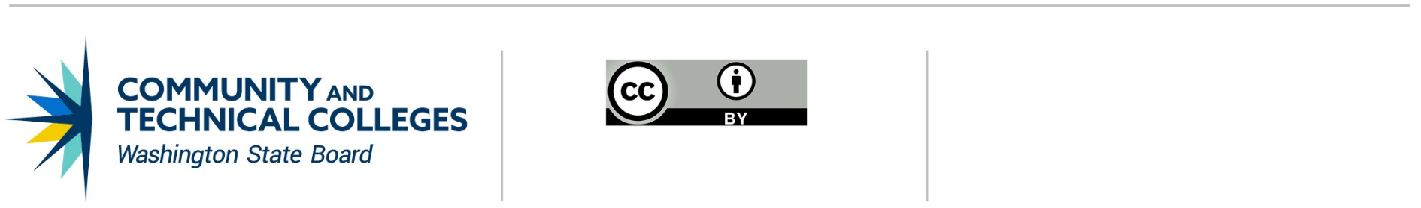



Legacy transcripts  
  
 WA State community and technical colleges  
Admissions and Regstration Council (ARC)

**Version 2.1**

Table of Contents

[Revision History 5](#_Toc11429122)

[To Do Items 5](#_Toc11429123)

[Project Scope/Overview 6](#_Toc11429124)

[Vision 6](#_Toc11429125)

[Goals 6](#_Toc11429126)

[KeyFeatures 6](#_Toc11429127)

[Out of Scope 6](#_Toc11429128)

[Future Scope 6](#_Toc11429129)

[Context Diagram 7](#_Toc11429130)

[Process Flows 8](#_Toc11429131)

[Full Access 8](#_Toc11429132)

[F-1: Multiple Colleges Assigned 9](#_Toc11429133)

[F-2: Select College 9](#_Toc11429134)

[F-3: Search for Student 9](#_Toc11429135)

[F-4: Enter search criteria 9](#_Toc11429136)

[F-5: List of last 5 records found 9](#_Toc11429137)

[F-6: Student found 9](#_Toc11429138)

[F-7: Merge records 10](#_Toc11429139)

[F-8: Edit student demographics 10](#_Toc11429140)

[F-9: Manage blocks 10](#_Toc11429141)

[F-10: Add/Remove Privacy Restriction setting 10](#_Toc11429142)

[F-11: Unduplicate records 10](#_Toc11429143)

[F-12: View transcript details (sort) 10](#_Toc11429144)

[F-13: Override blocks 11](#_Toc11429145)

[F-14: Print transcript official/unofficial 11](#_Toc11429146)

[F-15: Send transcript (external) 11](#_Toc11429147)

[F-16: Transmit transcript 11](#_Toc11429148)

[F-17: Edit course/class 11](#_Toc11429149)

[F-18: Reports 11](#_Toc11429150)

[F-19: Account Management 11](#_Toc11429151)

[Partial Access 12](#_Toc11429152)

[P-1: Multiple Colleges Assigned 13](#_Toc11429153)

[P-2: Select College 13](#_Toc11429154)

[P-3: Search for Student 13](#_Toc11429155)

[P-4: Enter search criteria 13](#_Toc11429156)

[P-5: List of last 5 records found 13](#_Toc11429157)

[P-6: Student found 13](#_Toc11429158)

[P-7: Edit student demographics 14](#_Toc11429159)

[P-8: Manage blocks 14](#_Toc11429160)

[P-9: View transcript details (sort) 14](#_Toc11429161)

[P-10: Override blocks 14](#_Toc11429162)

[P-11: Print transcript official/unofficial 14](#_Toc11429163)

[P-12: Send transcript (external) 14](#_Toc11429164)

[P-13: Transmit transcript 14](#_Toc11429165)

[P-14: Reports 15](#_Toc11429166)

[P-15: Account Management 15](#_Toc11429167)

[Read-only Access 16](#_Toc11429168)

[R-1: Multiple Colleges Assigned 17](#_Toc11429169)

[R-2: Select College 17](#_Toc11429170)

[R-3: Search for Student 17](#_Toc11429171)

[R-4: Enter search criteria 17](#_Toc11429172)

[R-5: List of last 5 records found 17](#_Toc11429173)

[R-6: Student found 17](#_Toc11429174)

[R-7: View student demographics 18](#_Toc11429175)

[R-8: View blocks 18](#_Toc11429176)

[R-9: View transcript details (sort) 18](#_Toc11429177)

[R-10: Print transcript unofficial 18](#_Toc11429178)

[R-11: Reports 18](#_Toc11429179)

[R-12: Account Management 18](#_Toc11429180)

[Student Access 19](#_Toc11429181)

[S-1: Account exists 20](#_Toc11429182)

[S-2: Associated with a college 20](#_Toc11429183)

[S-3: Already added to ctcLink 20](#_Toc11429184)

[S-4: Create account 20](#_Toc11429185)

[S-5: Identify College 20](#_Toc11429186)

[S-6: Enter search criteria 20](#_Toc11429187)

[S-7: Student found 20](#_Toc11429188)

[S-8: View instructions for next steps 21](#_Toc11429189)

[S-9: Message to go to ctcLink 21](#_Toc11429190)

[S-10: Landing page 21](#_Toc11429191)

[S-11: Edit student demographics 21](#_Toc11429192)

[S-12: Edit Privacy Restriction setting 21](#_Toc11429193)

[S-13: Has block 21](#_Toc11429194)

[S-14: Message to contact college about blocks 21](#_Toc11429195)

[S-15: View transcripts 21](#_Toc11429196)

[S-16: Print unofficial transcript 21](#_Toc11429197)

[S-17: Request an official transcript 22](#_Toc11429198)

[S-18: Account Management 22](#_Toc11429199)

[College Application Security Manager 23](#_Toc11429200)

[SM-1: Working with Staff or Student 24](#_Toc11429201)

[SM-2: Enter Student search criteria 24](#_Toc11429202)

[SM-3: Student record(s) found 24](#_Toc11429203)

[SM-4: Select Staff from list 24](#_Toc11429204)

[SM-5: Staff record found 24](#_Toc11429205)

[SM-6: Add new staff member 24](#_Toc11429206)

[SM-7: New user notification 24](#_Toc11429207)

[SM-8: Update Account 24](#_Toc11429208)

[SM-9: Change role(s) (Staff only) 25](#_Toc11429209)

[SM-10: Deactivate account (Staff only) 25](#_Toc11429210)

[SM-11: Reset password (Student only) 25](#_Toc11429211)

[SM-12: Email password reset instructions (Student only) 25](#_Toc11429212)

[SM-13: Deactivate account (Student only) 25](#_Toc11429213)

[SM-14: Account Management 25](#_Toc11429214)

[SM-16: Reports 25](#_Toc11429215)

[Application Features 26](#_Toc11429216)

[User Accounts 26](#_Toc11429217)

[User Authentication 26](#_Toc11429218)

[Data Classification 26](#_Toc11429219)

[Search and View Functionality 26](#_Toc11429220)

[Data Managed Behind the Scenes 26](#_Toc11429221)

[Appendix A - Wire Frames 27](#_Toc11429222)

[Full Access 27](#_Toc11429223)

[Partial Access 36](#_Toc11429224)

[Read-Only Access 43](#_Toc11429225)

[Student Access 47](#_Toc11429226)

[College Application Security Manager 53](#_Toc11429227)

## Revision History

|  |  |  |  |
| --- | --- | --- | --- |
| **Date** | **Doc. Version** | **Description** | **Author** |
| 04/6/2019 | 1.0 | Creation – Presentation to ARC Legacy Transcript Workgroup on 4/12/19 | SBCTC App Dev Team |
| 04/19/2019 | 2.0 | Edits based on 4/12/19 Workgroup meeting | SBCTC App Dev Team |
| 05/24/2019 | 2.0 | Finalized updates from 04/12/2019 WebEx | SBCTC App Dev Team |
| 05/31/2019 | 2.1 | 5/24/19 meeting updates incorporated. Visio docs updated | ggamble |
| 06/11/2019 | 2.1 | Wire frames added | ggamble |

## To Do Items

* Incorporate details around clock hours
* Ryan to provide an extract from the P123 database that they can use to evaluate records that need to be merged into the main Centralia database. (same name, same birth date, SSN) (Kimberly, Centralia requested this).
* Check if there is a list of previous names available in Legacy?
* Need to research Parchment extracts under F-13. Janet at CBC does this and can provide details.

## Project Scope/Overview

### Vision

The Legacy Transcript project will become the new repository for student transcripts that are currently stored within the HP-UX system for those colleges transitioned to the new ERP implementation project, ctcLink.

### Goals

The goal of the Legacy project is to create an application that

* + is web-based, accessible, and provides self-service functionality for users;
  + includes all the functionality of the HP-UX system for searching and generating student transcripts; and
  + Ensures a secure and sustainable environment for retaining student transcript records.

### KeyFeatures

The Legacy Transcript application will provide specific features based on a user’s role.

* + Search for student records
  + View and edit student demographic information
  + View and edit Privacy Restriction (FERPA) settings
  + View and manage student fees/fines
  + Merge student records
  + Unduplicate student records
  + View transcripts
  + Print transcripts
  + Send transcripts
  + Transmit transcripts
  + Modify course/class information
  + Manage user accounts
  + Active Directory for Staff access
  + Student Read-Only guest account

Out of Scope:

The application will not include college specific branding on the application itself.

### Future Scope

Automatic integration with 3rd party entities such as National Student Clearinghouse.

## Context Diagram



## Process Flows

### Full Access

The Full Access (Registrars) role will be allowed to view reports, search for student records, edit student demographics, manage student blocks, add or remove Privacy Restriction settings, merge student records and unduplicate student records. Other tasks include the ability to view, sort and edit transcript information along with printing official and unofficial transcripts locally. This role will also be able to send and transmit transcripts to external entities.



#### F-1: Multiple Colleges Assigned

* If multiple colleges assigned, go to [F-2: Select College](#_F-2:_Select_College)
* If Single College assigned, go to [F-3: Search for Student](#_F-3:_Search_for)

#### F-2: Select College

* If more than one college is assigned to a staff member, they will need to select the college they wish to work under. This option is available as a menu item at all times

#### F-3: Search for Student

* After being assigned to a college, users can begin their student search by either entering search criteria or selecting from list of last five records found.
* Search criteria includes SID or student name, birth date and/or SSN.
* Includes a wildcard or partial search match capability.
* Includes previous names in search match process.
* List of last five records found shows SID, name, partial SSN, birth date and last date accessed in descending order.
* If only one record is found, user will be automatically redirected to [F-8 Edit student demographics](#_F-8:_Edit_student).
* If multiple search results are found, a list of possible matches is provided that includes SID, partial SSN, name, birth date and a checkbox to allowing merging of records. See [F-7 Merge Records](#_F-7:_Merge_records_1).
* SID field links to [F-6: Student found](#_F-3:_Student_found).

#### F-6: Student found

* Display SID and student name on page.
* Single record will be available for edits. See [F-8: Edit student demographics](#_F-8:_Edit_student),
* If multiple records found they can be merged if appropriate See [F-7: Merge Records](#_F-7:_Merge_records)
* Multiple records will be shown in a grid with last access date and ability to merge two records into a single record

#### F-7: Merge records

* When two records are merged, the original records are maintained and one new record is created.
* The original records should be marked as being merged and inactive, include references to the one new record, and they are excluded from searches.
* The new record should be marked that it was merged and include a reference to the original records.
* Both student demographic and transcript information will be merged.
* After merging, the new record will be selected for edits. See [F-8: Edit student demographics](#_F8_-_Edit)

#### F-8: Edit student demographics

* Edit student name, birth date, SID, SSN, high school and address.
* Maintain a history of changes, including who made the change and when. Include option to view history of changes.
* Include a checkbox to mark that the student’s record was added to ctcLink.
* Include checkbox to change student’s Privacy Restriction setting. (See [F-10: Add/Remove Privacy Restriction setting](#_F-6:_Add/Remove_FERPA).
* Include links to [F-9: Manage blocks](#_F-9:_Manage_blocks), [F-10: Add/remove Privacy Restriction setting](#_F-10:_Add/Remove_FERPA), [F-11: Unduplicate records](#_F-11:_Unduplicate_records) and [F-12: View transcript details](#_F-12:_View_transcript).
* Highlight, or provide some other indication that the student’s transcript information was entered into ctcLink for this college. Hyperlink to [F-8: Edit student demographics](#_F-8:_Edit_student).
* Highlight, or provide some other indication that the student has a block. Hyperlink to [F-9: Manage blocks](#_F-5:_Manage_blocks).
* Highlight, or provide some other indication that the student has a Privacy Restriction setting. Hyperlink to [F-10: Add/remove Privacy Restriction setting](#_F-6:_Add/Remove_FERPA).
* Highlight, or provide some other indication that the student record was merged from two previous records. Hyperlink to modal page showing both source records (SID and name) with SID hyperlinked to [F-6: Student found](#_F-3:_Student_found).
* Highlight, or provide some other indication that the student record was unduplicated from another record. Hyperlink to modal page showing source record for unduplication (SID and name) with SID hyperlinked to [F-6: Student found](#_F-3:_Student_found).
* If the record found is either a source for merged or unduplicated records, then highlight or provide some other indication. All information for the record would be read-only.

#### F-9: Manage blocks

* Include detailed fees and fines information from Legacy.
* Include ability to add both fees/fines and college specific blocks.
* Include text area for college to identify the type of block assigned to the student.
* Blocks are marked as Yes or No. When modifying, include a text box to capture why the change was made.
* Maintain a history of changes, including who made the change and when. Include option to view history of changes along with history of overrides.

#### F-10: Add/Remove Privacy Restriction setting

* Use checkbox to change student’s Privacy Restriction setting.
* Maintain a history of changes, including who made the change and when. Include option to view history of changes.

#### F-11: Unduplicate records

* When a record is unduplicated, the original record is maintained and two new records are created.
* The original record should be marked as being separated (inactive), include references to the two new records, and be excluded from searches.
* The two new records should be marked that it was unduplicated and include a reference to the original record.
* Both student demographic and transcript information can be unduplicated.

#### F-12: View transcript details (sort)

* Include quarter, department, course number, grade and credits in output.
* Allow sorting on quarter, department and course number.
* Include link to view history of student’s transcript activity including printing official transcripts ([F-14: Print transcript official/unofficial](#_F-12:_Print_transcript)), sending transcripts (external) ([F-15: Send transcript (external)](#_F-13:_Send_transcript)), and transmitting transcripts ([F-16: Transmit transcript](#_F-14:_Transmit_transcript)).

#### F-13: Override blocks

* Record history of when blocks are overrode including who made the change and when.
* History of overrides available under section [F-9: Manage Blocks](#_F-5:_Manage_blocks).

#### F-14: Print transcript official/unofficial

* Include option to toggle if official or unofficial.
* Maintain a history of when an official transcript was generated, including who generated, destination and when. Include option to view history.
  + Destination options
    - National Student Clearinghouse (Note: future work will include uploads to NSC).
    - Paper copy. Include destination address information along with text box to allow them to identify if the transcript returned as undelivered.

#### F-15: Send transcript (external)

* This represents transcripts sent to external entities such as Parchment.

#### F-16: Transmit transcript

* Maintain a history of when a request is made to transmit a transcript to another community/technical college or WA public four-year university, including who generated and when.
* Include option to view history.

#### F-17: Edit course/class

* Fields to change course title, department, course number, credits, grade, and quarter.
* Provide ability to delete course.
* Provide ability to add course.
* Maintain a history of changes, including who made the change and when. Include option to view history of changes.

#### F-18: Reports

* Number of official transcripts generated by month.
* Reports – hyperlinks to individual reports.

#### F-19: Account Management

* Fields to change Name, phone number, and email address.
* If assigned to multiple colleges, staff member can select from a dropdown which college account information to update. Will default to current college selected at login.

### Partial Access

The Partial Access role will be allowed to view reports, search for student records, edit student demographics, manage student blocks and view Privacy Restriction settings. Other tasks include the ability to view and sort transcript information along with printing official and unofficial transcripts locally. This role will also be able to send and transmit transcripts to external entities.

This role differs from the Full Access role as they are not allowed to add or remove Privacy Restriction settings, merge records, unduplicate records and edit course/class information.



#### P-1: Multiple Colleges Assigned

* If multiple colleges assigned, go to [P-2: Select College](#_P-2:_Select_College)
* If Single College assigned, go to [P-3: Search for Student](#_P-3:_Search_for)

#### P-2: Select College

* If more than one college is assigned to a staff member, they will need to select the college they wish to work under. This option is available as a menu item at all times

#### P-3: Search for Student

* After being assigned to a college, whether by defaulting to a single one or selecting from the list, they can begin their student search by either selecting from list ([P-5: List of last 5 records found](#_P-5:_List_of)) or entering criteria ([P-4: Enter search criteria](#_P-4:_Enter_search)).

#### P-4: Enter search criteria

* Search on student name, birth date, SSN or SID.
* Include a wildcard or partial search match capability.
* Include previous names in search match process.
* Provide list of search results including SID and name. Hyperlink SID to [P-6: Student found](#_F-3:_Student_found_1).

#### P-5: List of last 5 records found

* Provide list of last five (5) student records accessed by the logged in user including SID, name and last date accessed. Order by last date accessed in descending order.
* Hyperlink SID to [P-6: Student found](#_F-3:_Student_found_1).

#### P-6: Student found

* If multiple students are returned, a list with links on SID will be shown. Clicking a link will take user to Student edit page See [P-7: Edit student demographics](#_P7_-_Edit)
* A single record will go to the Student edit page See [P-7: Edit student demographics](#_P7_-_Edit)

#### P-7: Edit student demographics

* Edit student name, birth date, SSN, SID and address.
* Maintain a history of changes, including who made the change and when. Include option to view history of changes.
* Include a checkbox to mark that the student’s record was added to ctcLink.
* Include links to [P-8: Manage blocks](#_P-8:_Manage_blocks) and [P-9: View transcript details](#_P-9:_View_transcript).
* Highlight, or provide some other indication that the student’s transcript information was entered into ctcLink for this college. Hyperlink to [P-7: Edit student demographics](#_P-4:_Edit_student).
* Highlight, or provide some other indication that the student has a block. Hyperlink to [P-8: Manage blocks](#_P-5:_Manage_blocks).
* Highlight, or provide some other indication that the student has a Privacy Restriction setting.
* Highlight, or provide some other indication that the student record was merged from two previous records. Hyperlink to modal page showing both source records (SID and name) with SID hyperlinked to [P-6: Student found](#_P-6:_Student_found).
* Highlight, or provide some other indication that the student record was unduplicated from another record. Hyperlink to modal page showing source record for unduplication (SID and name) with SID hyperlinked to [P-6: Student found](#_F-3:_Student_found_1).
* If the record found is either a source for merged or unduplicated records, then highlight or provide some other indication. All information for the record would be read-only.

#### P-8: Manage blocks

* Include detailed fees and fines information from Legacy.
* Include ability to add both fees/fines and college specific blocks.
* Include text area for college to identify the type of block assigned to the student.
* Blocks are marked as Yes or No. When modifying, include a text box to capture that a change was made.
* Maintain a history of changes, including who made the change and when. Include option to view history of changes along with history of overrides.

#### P-9: View transcript details (sort)

* Include quarter, department, course number, grade and credits in output.
* Allow sorting on quarter, department and course number.
* Include link to view history of student’s transcript activity including printing official transcripts ([P-11: Print transcript official/unofficial](#_P-9:_Print_transcript)), sending transcripts (external) ([P-12: Send transcript (external)](#_P-12:_Send_transcript)), and transmitting transcripts ([P-13: Transmit transcript](#_P-13:_Transmit_transcript)).

#### P-10: Override blocks

* Record history of when blocks are overrode including who made the change and when.
* History of overrides available under section [P-8: Manage Blocks](#_P-5:_Manage_blocks).

#### P-11: Print transcript official/unofficial

* Include option to toggle if official or unofficial.
* Maintain a history of when an official transcript was generated, including who generated, destination and when. Include option to view history.
  + Destination options
    - National Student Clearinghouse (Note: future work will include uploads to NSC).
    - Paper copy. Include destination address information along with text box to allow them to identify if the transcript returned as undelivered.

#### P-12: Send transcript (external)

* This represents transcripts sent to external entities such as Parchment.

#### P-13: Transmit transcript

* Maintain a history of when a request is made to transmit a transcript to another community/technical college or WA public four-year university, including who generated and when.
* Include option to view history.

#### P-14: Reports

* Number of official transcripts generated by month.

#### P-15: Account Management

* Fields to change Name, phone number, and email address.
* If assigned to multiple colleges, staff member can select from a dropdown which college account information to update. Will default to current college selected at login.

### Read-only Access

The Read-only Access role will be allowed to search for student records, view student demographics, view student blocks, view Privacy Restriction settings, and student fees/fines. The role also has the ability to view and sort student information along with printing unofficial transcripts locally.

The Read-only Access role will be allowed to search for student records, view student demographics, view student blocks and view Privacy Restriction settings. Other tasks include the ability to view and sort transcript information along with printing unofficial transcripts locally.



#### R-1: Multiple Colleges Assigned

* If multiple colleges assigned, go to [R-2: Select College](#_R-2:_Select_College)
* If Single College assigned, go to [R-3: Search for Student](#_R-3:_Search_for)

#### R-2: Select College

* If more than one college is assigned to a staff member, they will need to select the college they wish to work under. This option is available as a menu item at all times

#### R-3: Search for Student

* After being assigned to a college, whether by defaulting to a single one or selecting from the list, they can begin their student search by either selecting from list ([R-5: List of last 5 records found](#_R-5:_List_of)) or entering criteria ([R-4: Enter search criteria](#_R-4:_Enter_search)).

#### R-4: Enter search criteria

* Search on student name, birth date, SSN or SID.
* Include a wildcard or partial search match capability.
* Include previous names in search match process.
* Provide list of search results including SID and name. Hyperlink SID to [R-6: Student found](#_R-6:_Student_found).

#### R-5: List of last 5 records found

* Provide list of last five (5) student records accessed by the logged in user including SID, name and last date accessed. Order by last date accessed in descending order.
* Hyperlink SID to [R-6: Student found](#_R-3:_Student_found).

#### R-6: Student found

* If multiple students are returned, a list with links on SID will be shown. Clicking a link will take user to Student.
* A single record will go to the Student.

#### R-7: View student demographics

* View student name, birth date, SSN, SID and address.
* Include option to view history of changes.
* Include a checkbox to mark that the student’s record was added to ctcLink.
* Display SID and student name on page.
* Include links to [R-7: View student demographics](#_R-7:_View_student), [R-8: View blocks](#_R-8:_View_blocks) and [R-9: View transcript details](#_R-9:_View_transcript).
* Highlight, or provide some other indication that the student’s transcript information was entered into ctcLink for this college. Hyperlink to [R-7: View student demographics](#_R-7:_View_student).
* Highlight, or provide some other indication that the student has a block. Hyperlink to [R-8: View blocks](#_R-5:_View_blocks).
* Highlight, or provide some other indication that the student has a Privacy Restriction setting.
* Highlight, or provide some other indication that the student record was merged from two previous records. Hyperlink to modal page showing both source records (SID and name) with SID hyperlinked to [R-6: Student found](#_R-3:_Student_found).
* Highlight, or provide some other indication that the student record was unduplicated from another record. Hyperlink to modal page showing source record for unduplication (SID and name) with SID hyperlinked to [R-6: Student found](#_R-3:_Student_found).
* If the record found is either a source for merged or unduplicated records, then highlight or provide some other indication. All information for the record would be read-only.

#### R-8: View blocks

* Include detailed fees and fines information from Legacy.
* Include option to view history of changes along with history of overrides.

#### R-9: View transcript details (sort)

* Include quarter, department, course number, grade and credits in output.
* Allow sorting on quarter, department and course number.

#### R-10: Print transcript unofficial

* Print an unofficial transcript
* Show as PDF

#### R-11: Reports

* Number of official transcripts generated by month.

#### R-12: Account Management

* Fields to change Name, phone number, and email address.
* If assigned to multiple colleges, staff member can select from a dropdown which college account information to update. Will default to current college selected at login.

### Student Access

Students will be able to view their individual college transcripts and print unofficial copies. They will also be able to manage their Privacy Restriction block information and view any fees/fines associated with their college account.

Security will be built in such a way that the student must provide identifying information to assure that they are allowed to view their information. For confidentiality, only certain information will be displayed to students. If a student cannot find their information, the application will provide instructions for next steps to submit a request to the college.



#### S-1: Account exists

* Does the student already have an account to access the site?
  + If so [S-2: Associated with a college](#_S-2:_Already_associated), else [S-4: Create account](#_S-4:_Create_account)

#### S-2: Associated with a college

* Is the students account already associated to a college?
  + If so [S-3: Already added to ctcLink](#_S-3:_Already_added), else [S-5: Identify College](#_S-5:_identify_College)

#### S-3: Already added to ctcLink

* Is the student account in ctcLink?
  + If so [S-9: Message to go to ctcLink](#_S-9:_Message_to), else [S-10: Landing page](#_S-10:_Landing_page)

#### S-4: Create account

Student will create an account to access the site. They will have a unique username and follow standard password requirements.

Basic contact information is collected.

* + First name
  + Last name
  + Email
  + Phone

Student will then associate to a college ([S-5: Identify College](#_S-5:_identify_College)).

#### S-5: Identify College

* Select a college to identify with when searching for transcript.
* Student will supply, if available, an SID
* Go to [S-6: Enter search criteria](#_S-6:_Enter_search_1) to enter search criteria and search under the selected college and SID

#### S-6: Enter search criteria

* Enter search criteria:
  + SID and Pin or
  + First name, Last name, and DOB.
* All fields are required, depending on search method.
* Was a single record found? If yes go to [S-7: Student found](#_S-7:_Student_found), else [S-8: View instructions for next steps](#_S-8:_View_instructions).

#### S-7: Student found

Did the student find their account?

* If multiple accounts returned will default to nothing found, If so go to [S-3: Already added to ctcLink](#_S-3:_Already_added)
* If not, the student has the option to reset search criteria ([S-6: Enter search criteria](#_S-6:_Enter_search)) and try again, or view instructions for other options ([S-8: View instructions for next steps](#_S-8:_View_instructions))

#### S-8: View instructions for next steps

* Static page with links and/or other information on what to do if they cannot find their transcripts for a selected college

#### S-9: Message to go to ctcLink

* Static page stating that the student should go to ctcLink to make any transcript requests.

#### S-10: Landing page

This is the main landing page, which will allow the student to manage their account demographics, password, viewed transcripts, Privacy Restriction settings and handle any blocks.

* If a block is on transcript, a generic message with college specific contact information will be show and no other action can be taken, go to [S-14: Message to contact college about blocks](#_S-14:_Message_to)
* To view unofficial transcripts, go to [S-15: View transcripts](#_S-15:_View_transcripts)
* To edit demographics, go to [S-11: Edit student demographics](#_S-11:_Edit_student_1)
* To edit Privacy Restriction settings, go to [S-12: Edit Privacy Restriction setting](#_S-12:_Edit_Privacy)

#### S-11: Edit student demographics

* They cannot edit their name or DOB
* They can edit address, phone and email
* Site will track all changes.

#### S-12: Edit Privacy Restriction setting

* Student can manage Privacy Restriction settings
  + Simple check box with text explaining what a checked box means

#### S-13: Has block

* No blocks, go to [S-15: View transcripts](#_S-15:_View_transcripts)
* If there are blocks, go to [S-14: Message to contact college about blocks](#_S-14:_Message_to_1)
  + No details on blocks shown, just a generic text message that a block is set.

#### S-14: Message to contact college about blocks

* Standardized message with information on how to contact a college, concerning any blocks that where added by the college.

#### S-15: View transcripts

* View transcript
  + Sortable
  + To print transcript, go to [S-16: Print unofficial transcript](#_S-16:_Print_unofficial)
  + To request an official transcript, go to [S-17: Request an official transcript](#_S-17:_Request_an)

#### S-16: Print unofficial transcript

* Have the ability to print an un-official transcript, which will be time stamped and water marked as unofficial.
  + Show as a PDF.

#### S-17: Request an official transcript

* College specific instructions shown, describing how to request an official transcript.

#### S-18: Account Management

* Manage the following fields
  + Full name
  + Full address
  + Home and/or cell phone number
  + Email address.
* Reset password, which includes updating the three question/answer security pairings.
* Username is not updateable

### College Application Security Manager

The College Application Security Manager role can create new staff accounts (Registrars, Staff (Read-only), and other security managers), process new account requests, reassign staff roles, disable accounts, and initiate password resets for users that have forgotten their passwords.



#### SM-1: Working with Staff or Student

User needs to decide if they are going to be working with college staff, or students tied to the college

* If staff, go to [SM-4: Select Staff from list](#_SM-4:_Select_Staff)
* If Student, go to [SM-2: Enter Student search criteria](#_SM-3:_Add_new)

#### SM-2: Enter Student search criteria

* Enter first name, last name, DOB
* Submit search request, go to [SM-3: Student record(s) found](#_SM-3:_Student_record(s))

#### SM-3: Student record(s) found

* Was the desired student account found?
  + If yes go to [SM-8: Update Account](#_SM-5:_Edit_User), else go back to [SM-2: Enter Student search criteria](#_SM-3:_Add_new)

#### SM-4: Select Staff from list

* Select from a list of current staff, go to [SM-5: Staff record found](#_SM-5:_Staff_record)
* Is the Staff member missing from dropdown?
  + Go to [SM-6: Add new staff member](#_SM-6:_Add_new)

#### SM-5: Staff record found

* + If correct account found, go to [SM-8: Update Account](#_SM-5:_Edit_User), else go to [SM-6: Add new staff member](#_SM-6:_Add_new)

#### SM-6: Add new staff member

* Will supply an EMPLID, first name, last name, email address, phone and what role they will be given.
* Staff account added successfully, go to [SM-4: Select Staff from list](#_SM-4:_Select_Staff)
  + Notification email will be sent to new staff. See: [SM-7: New user notification](#_SM-7:_New_user)

#### SM-7: New user notification

* Email will be sent to a new staff user with link and instructions on logging in.

#### SM-8: Update Account

Selected staff and student account demographics can be edited.

* Staff accounts
  + Name, Email, Phone are updateable
  + Change Role(s), [SM-9: Change role(s)](#_SM-9:_Change_role(s))
  + Deactivate account - [SM-10: Deactivate account](#_SM-10:_Deactivate_account)
* Student accounts
  + To reset password - [SM-11: Reset password](#_SM-11:_Reset_password)
  + To deactivate account - [SM-13: Deactivate account](#_SM-13:_Deactivate_account)
  + Name, Address, Email, Phone are updatable
    - Username and password are not updatable.

#### SM-9: Change role(s) (Staff only)

* Staff user only.
* Will be able to add or remove from any available roles, for selected staff member.

#### SM-10: Deactivate account (Staff only)

* Accounts removed, but deactivated.
* Deactivated account will have no access to site.
* When deactivated, staff member will have all roles removed.

#### SM-11: Reset password (Student only)

* Resetting a password includes resetting security question/answer pairs (see [SM-12: Email password reset instructions (Student only)](#_SM-12:_Email_password))

#### SM-12: Email password reset instructions (Student only)

* An email with instructions and link to update password will be sent to email on file
* Question/answer pairs will also updated

#### SM-13: Deactivate account (Student only)

* Accounts are not removed, but deactivated.
* Deactivated account will have no access to site.

#### SM-14: Account Management

* Security manager can update own account.
  + Change Name, phone number, and email address.

#### SM-16: Reports

Are any reports needed?

## Application Features

### User Accounts

Students will be required to create a new account prior to accessing the system. They will automatically be assigned the Student role.

College staff can request an account through the application or the College Application Security Manager will initiate the new account from within the application. Requests submitted directly by staff are emailed to the College Application Security Manager and the account is marked inactive until processed.

### User Authentication

The Legacy Transcript application will be accessed through a secure access procedure with users being provided individual accounts with passwords. The access procedure will be compliant with the OCIO Standard 141.10 concerning the securing of information technology assets (<https://ocio.wa.gov/sites/default/files/public/policies/141.10_SecuringITAssets_201711_Approved.pdf>).

### Data Classification

Data contained within the Legacy Transcripts database is identified as Category 3 - Confidential Information as defined by WA State OCIO standards. SBCTC will ensure compliances with those standards.

### Search and View Functionality

The application will provide for searching student records based on specific criteria and will return a single record or group of records. Once a single student record is selected, transcript information can be viewed on-screen.

### Data Managed Behind the Scenes

SBCTC will manage the following information directly in the database. Requests for changes can be sent to [appdev@sbctc.edu](mailto:appdev@sbctc.edu) via a link on the application home page.

* College name
* College address

## Appendix A - Wire Frames

#### Full Access

##### Login

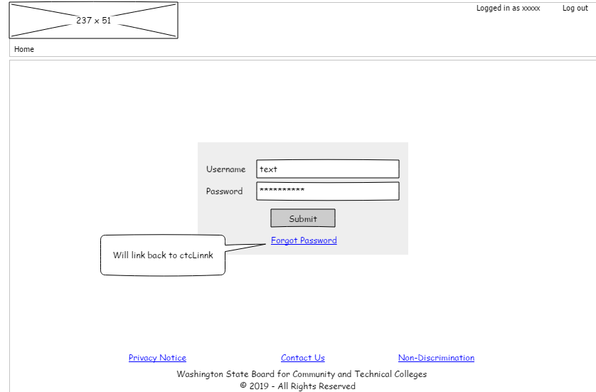

##### F1 - Multiple colleges

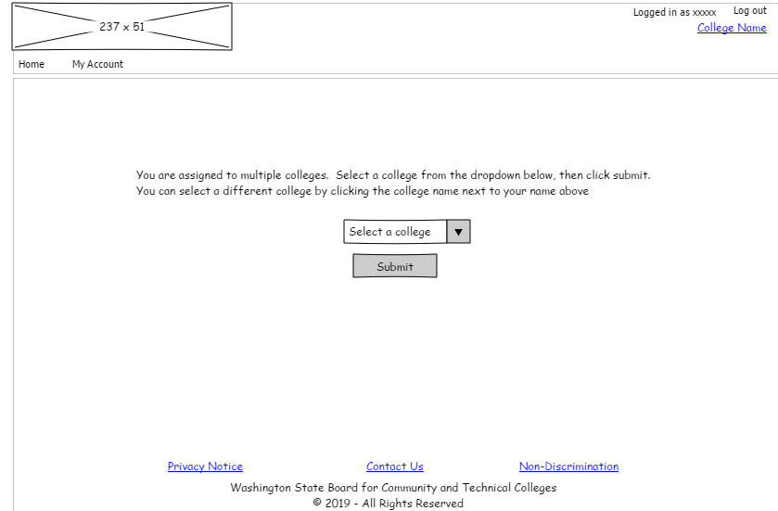

##### F3 - Search Student

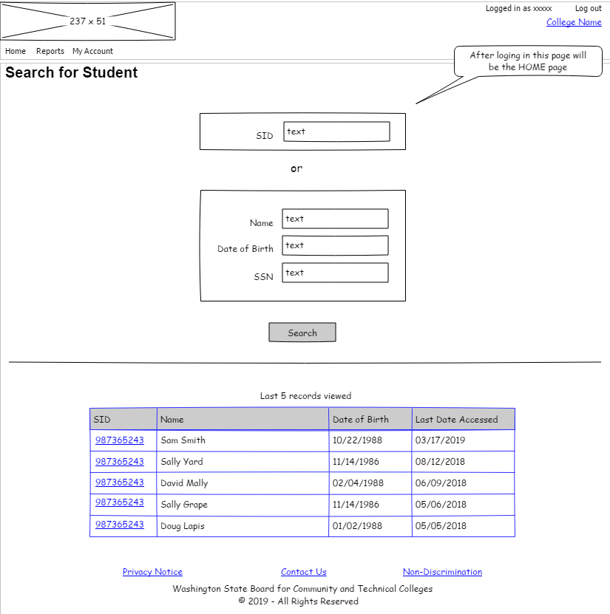

##### F6 - Search Results – Multiple records

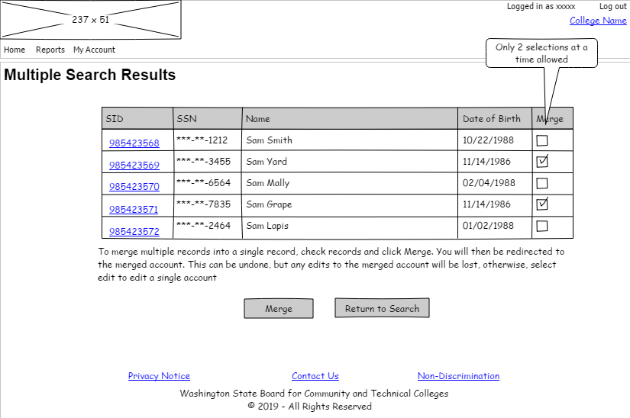

##### F7 - Merge Records – Dialog

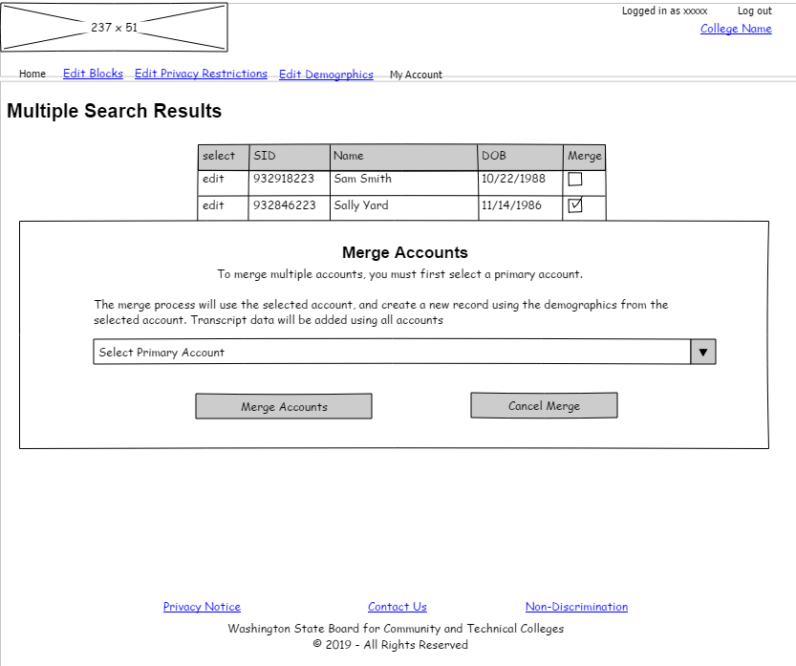

##### F7 - View Merged Records

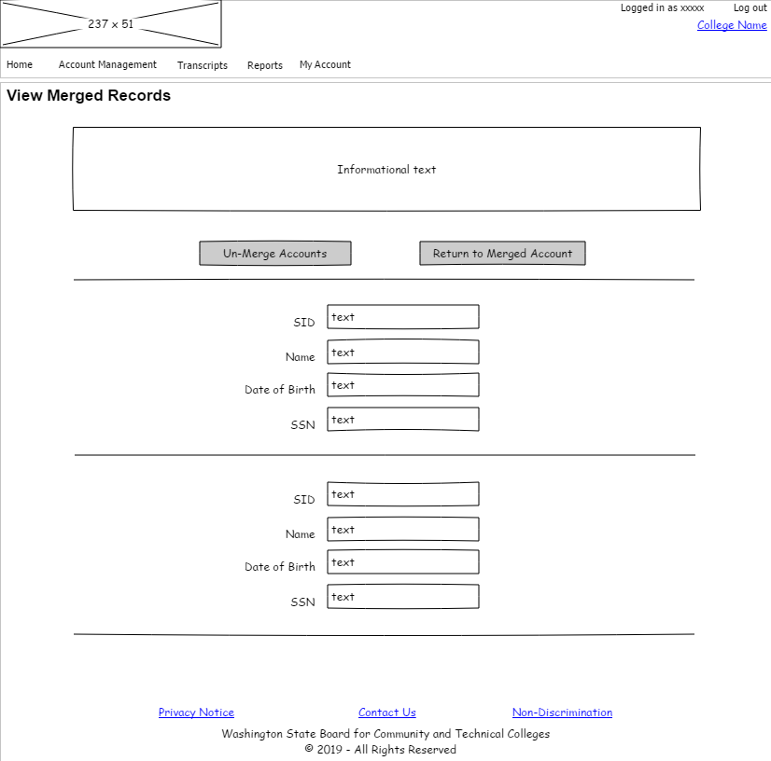

##### F8 - Edit Student

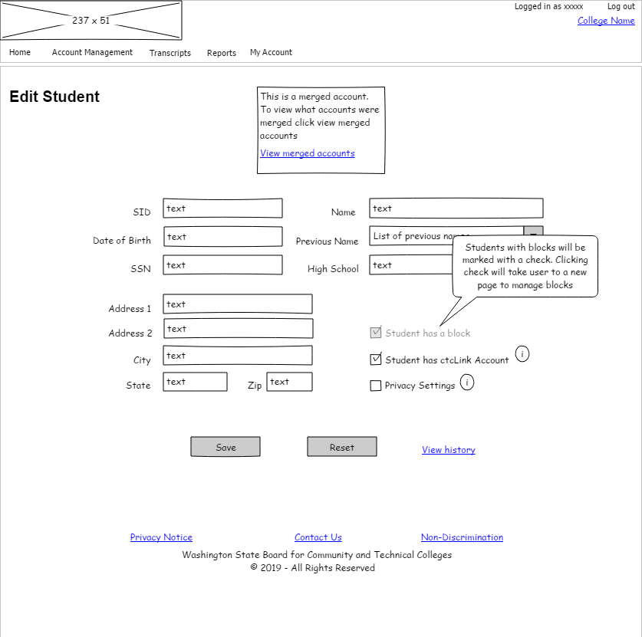

##### F8 - Edit Student – View Changes

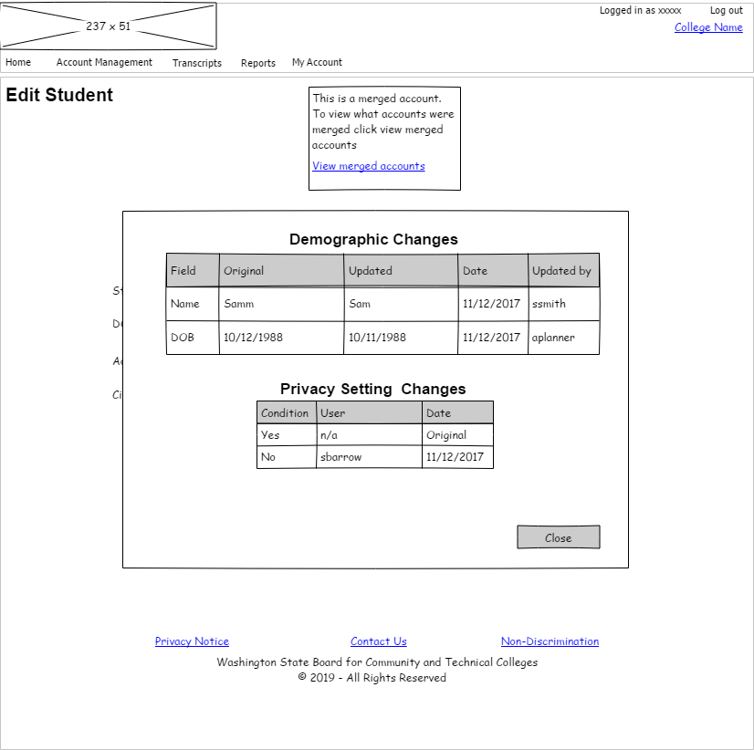

##### F9 - Manage Blocks

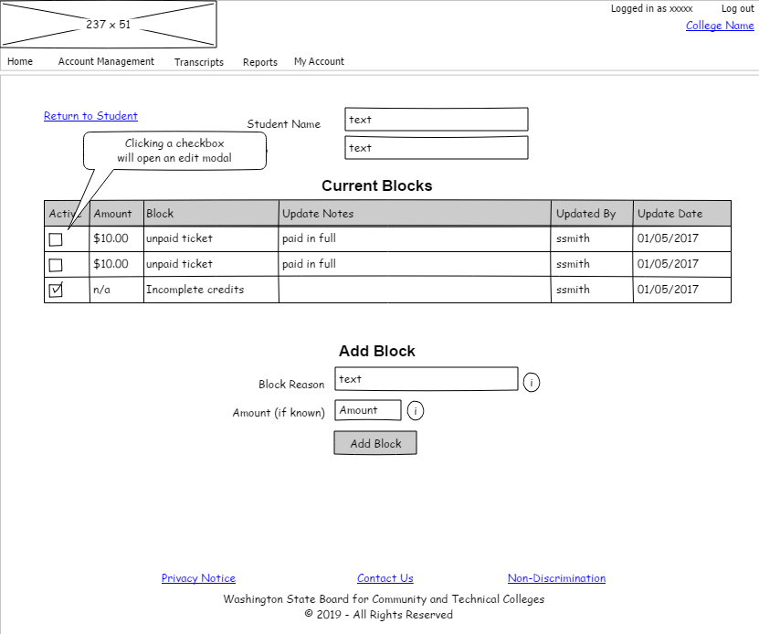

##### F9 - Edit Blocks f9_edit_blocks

##### F12 - View Transcript Details

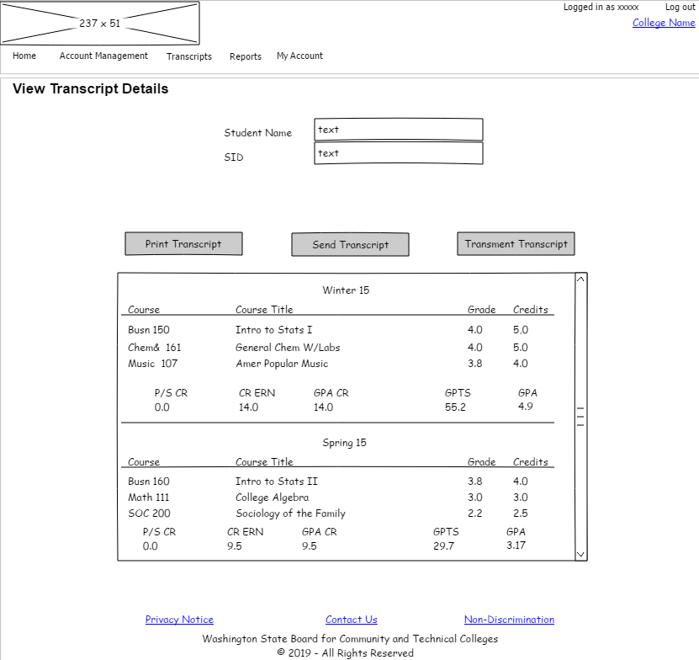

##### F14 - Print Transcripts

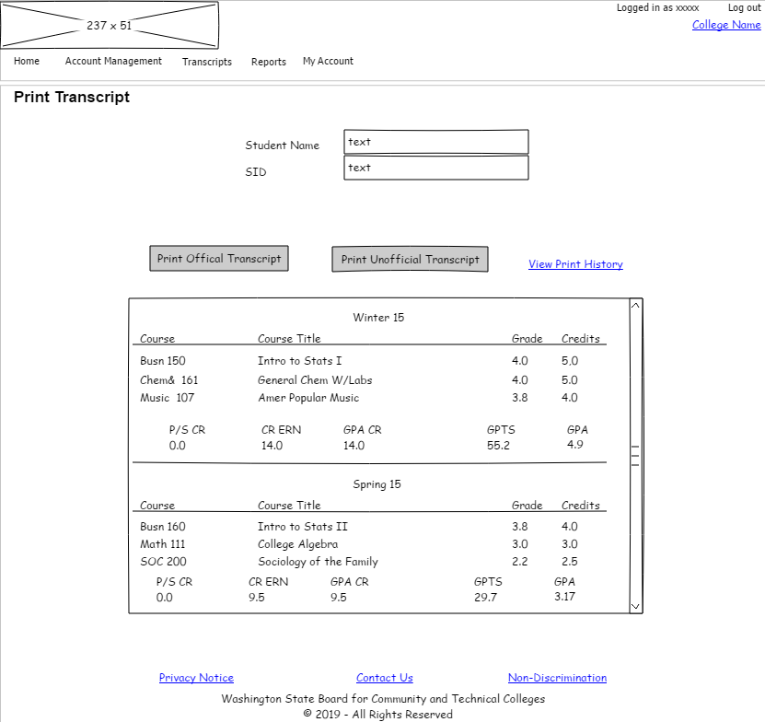

##### F14 - Print History

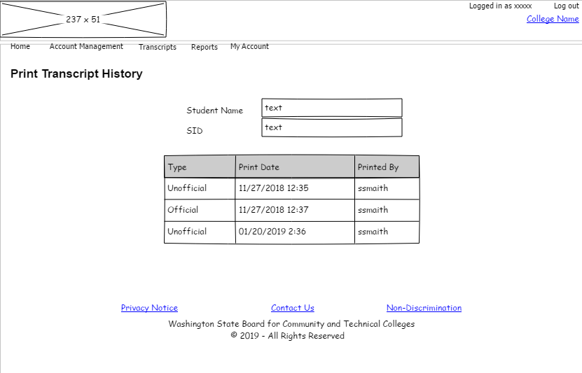

##### F15 - Send Transcripts (External)

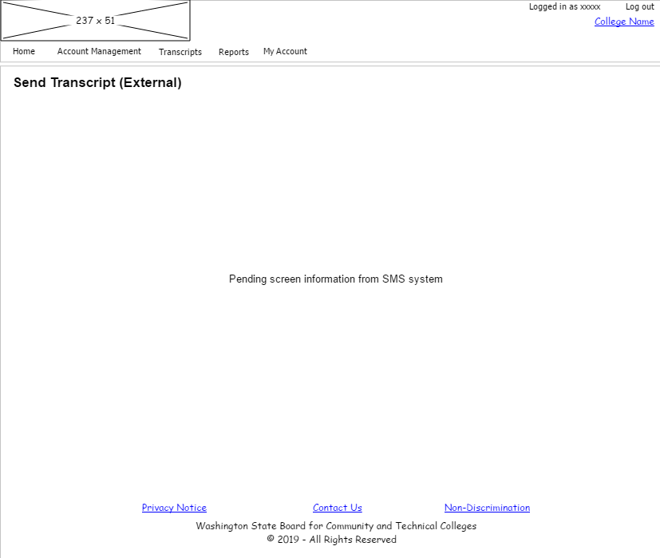

##### F16 - Transmit Transcripts

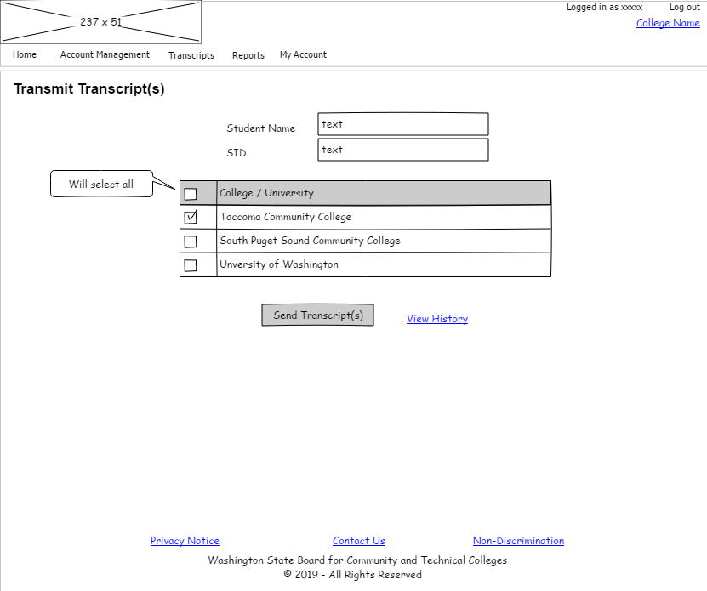

##### F16 - Transmit History

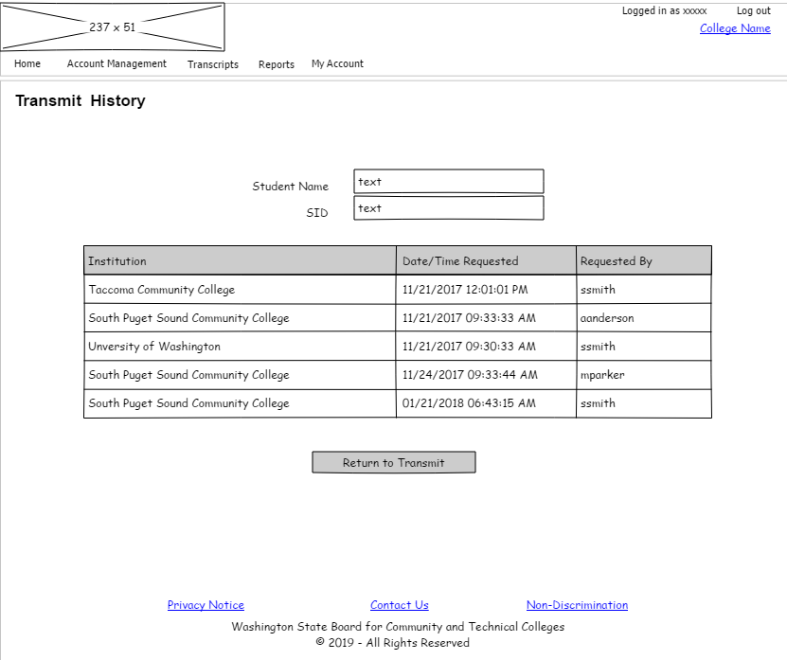

##### F17 - Class/Course Management

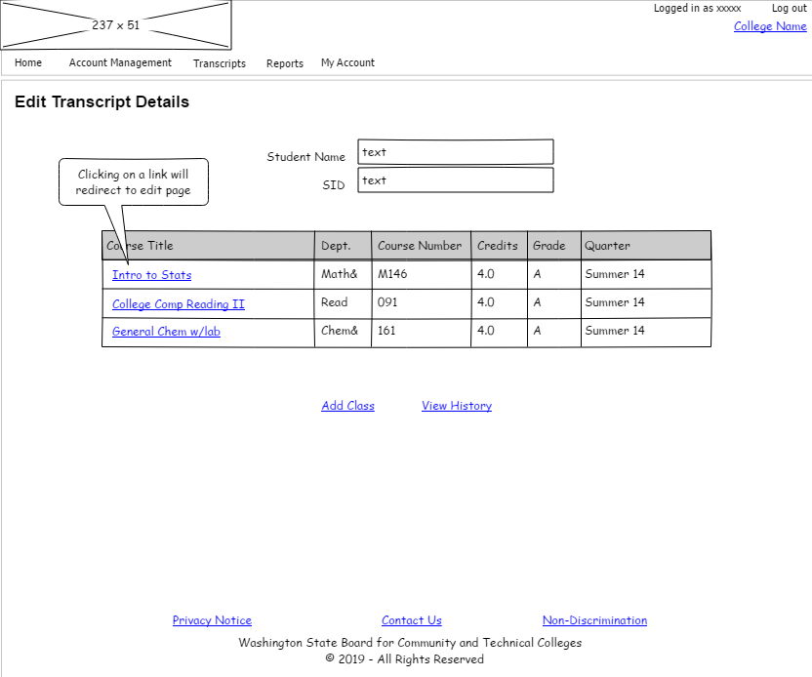

##### F17 - Class/Course Management – Edit

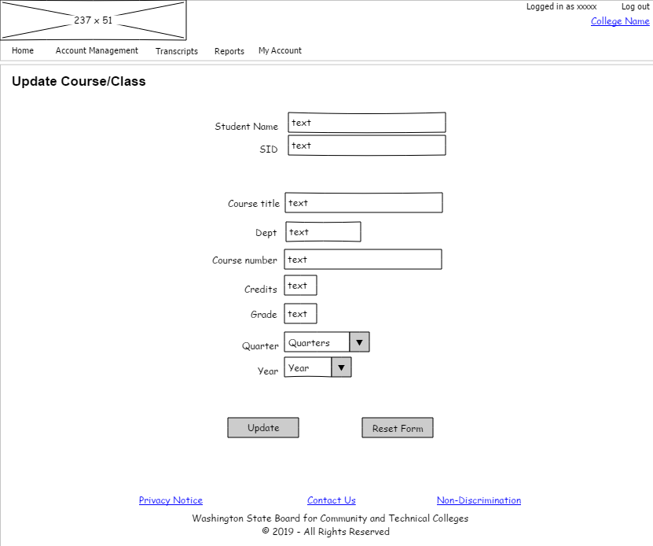

##### F17 - Class/Course Management – Add

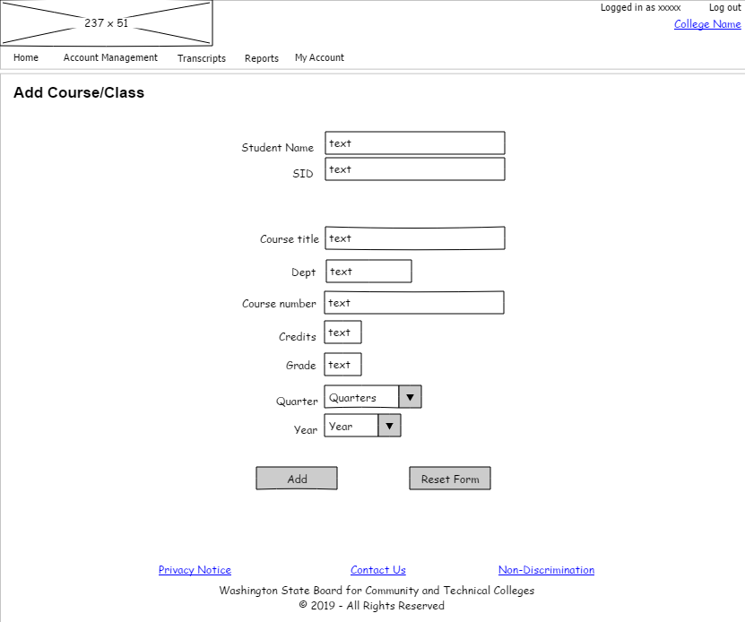

##### F17 - Class/Course Management – History

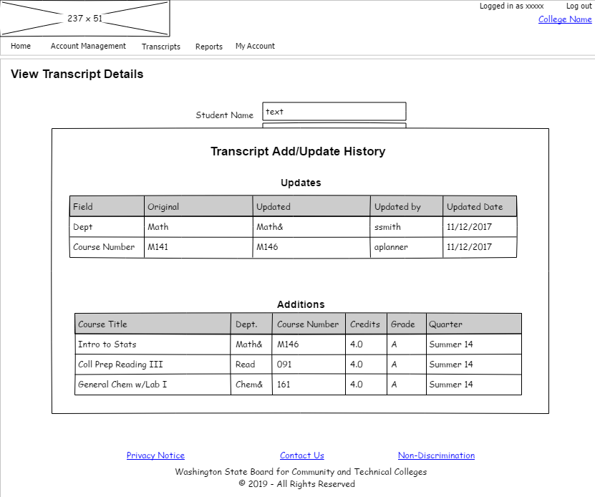

#### Partial Access

##### Login

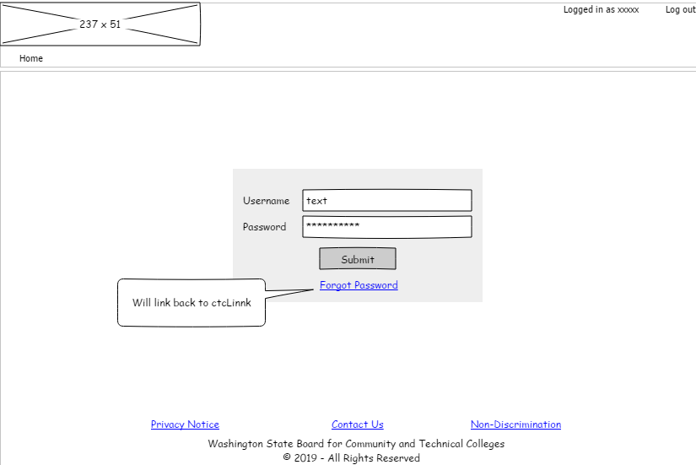

##### P1 - Multiple colleges

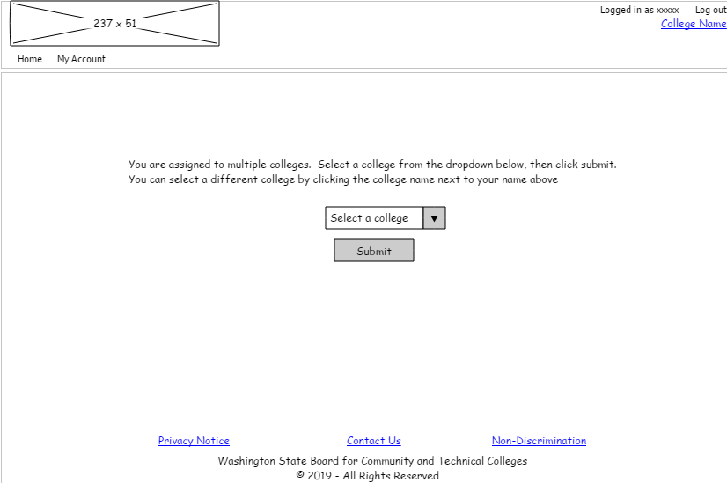

##### P3 - Search for Student

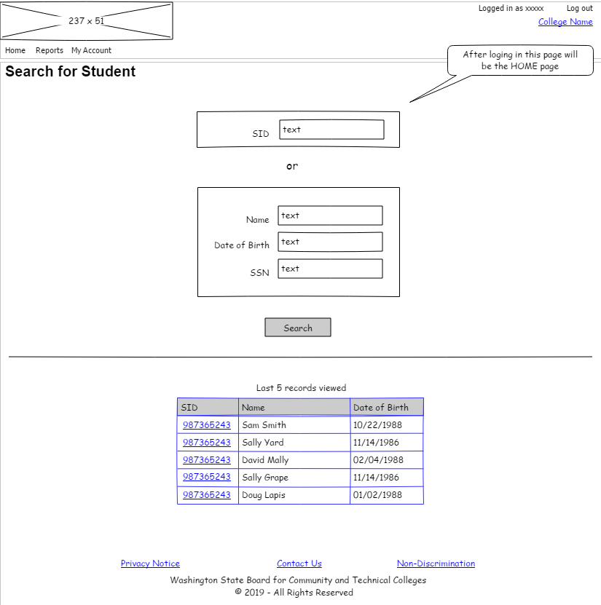

##### P6 - Search Results

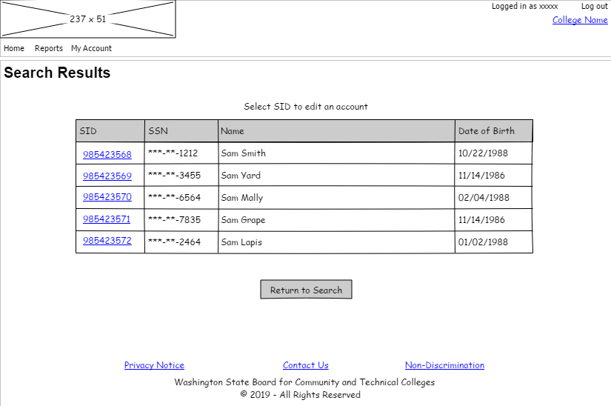

##### P7 - Edit Student

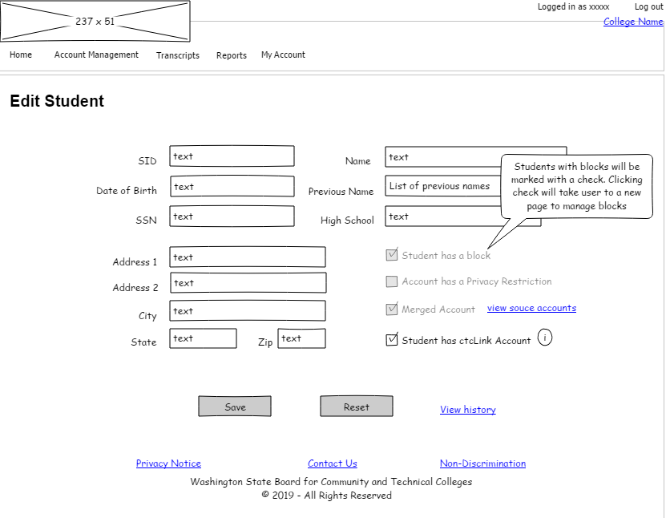

##### P7 - Edit Student - View History

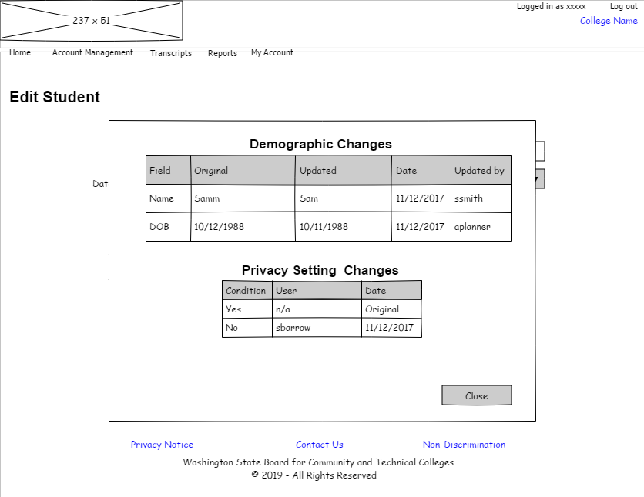

##### P7 - Edit Student - View Merge Records

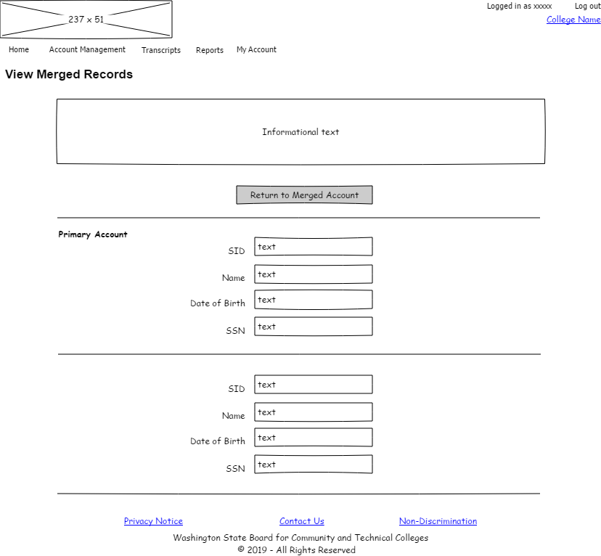

##### P8 - Manage Blocks

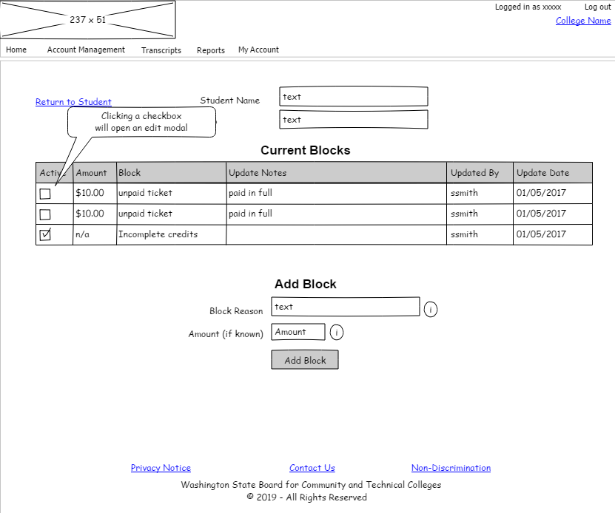

##### P8 - Edit Blocks

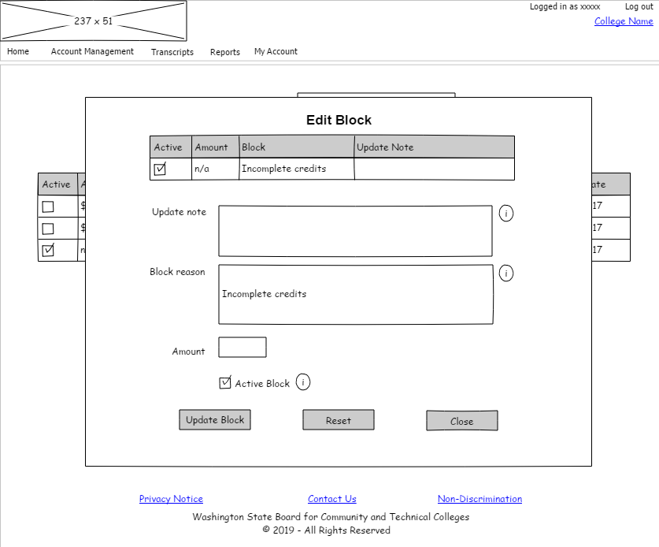

##### P9 - Transcript Details

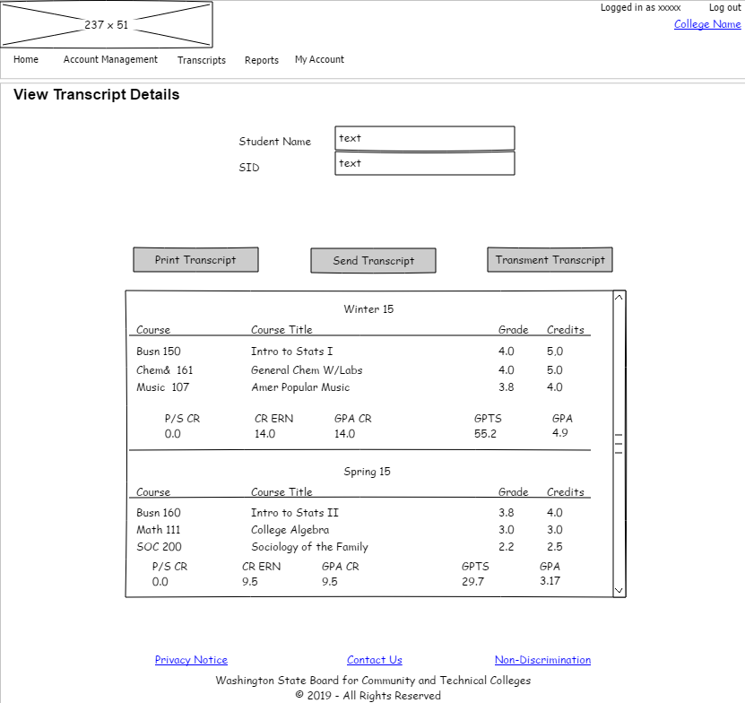

##### P11 - Print Transcript

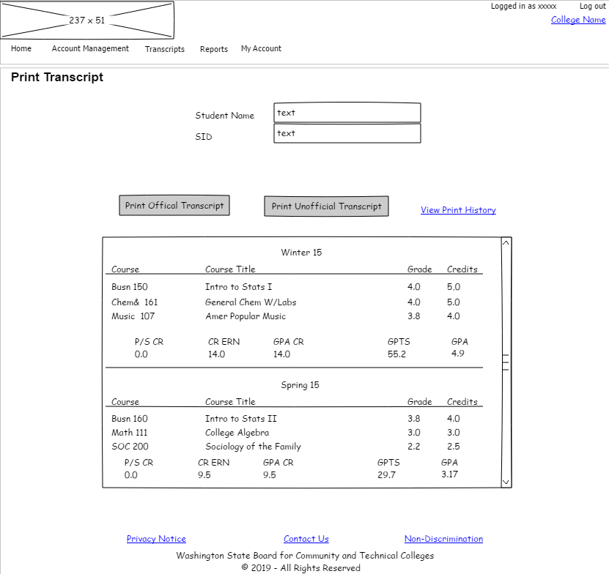

##### P11 - Print History

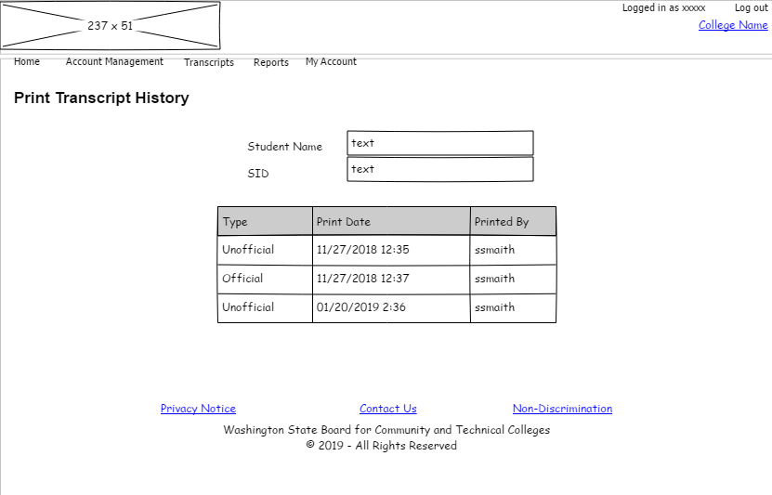

##### P12 - Send Transcript (external)

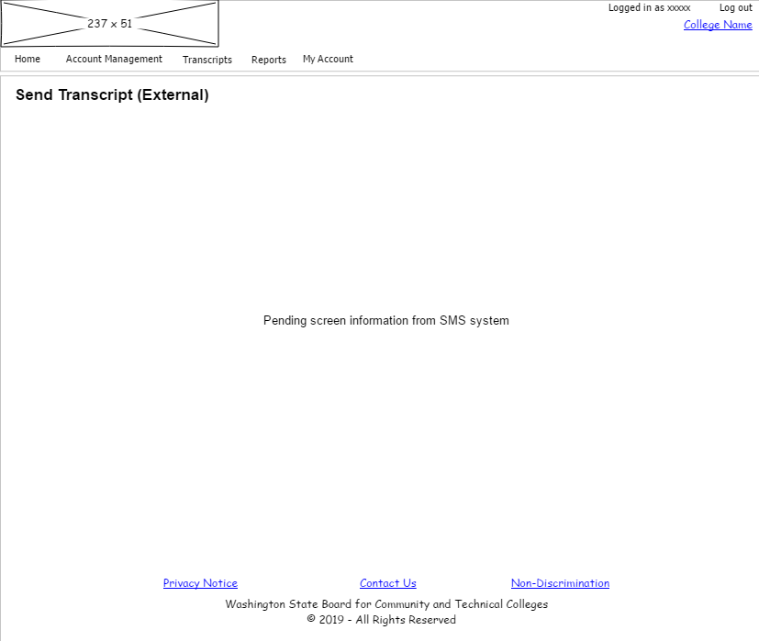

##### P13 - Transmit Transcript

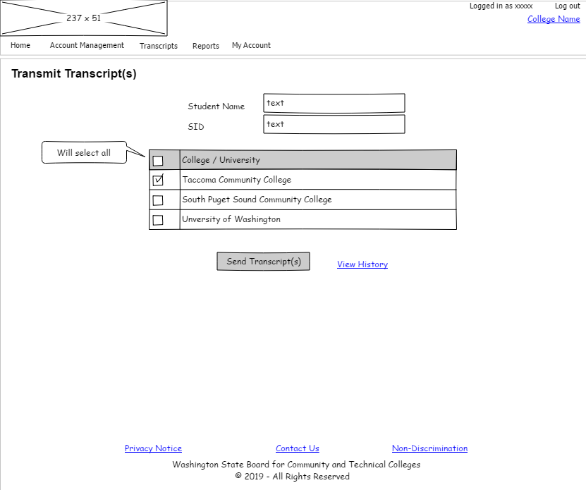

##### P13 - Transmit History

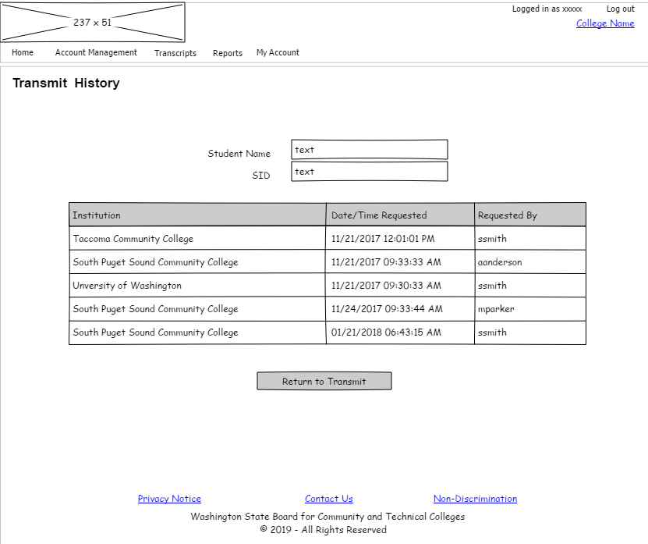

#### Read-Only Access

##### Login



##### R1 - Multiple Colleges

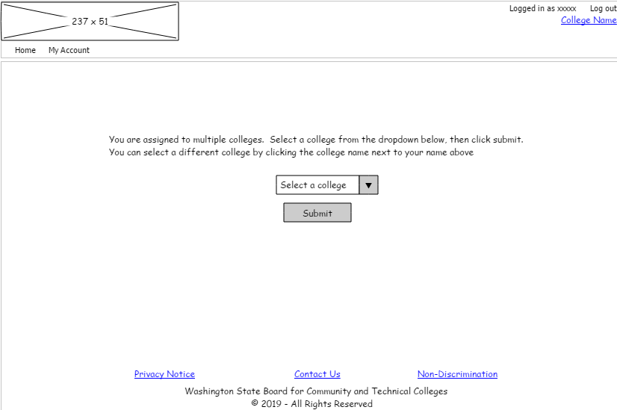

##### R3 - Search for Student



##### R6 - Search Results

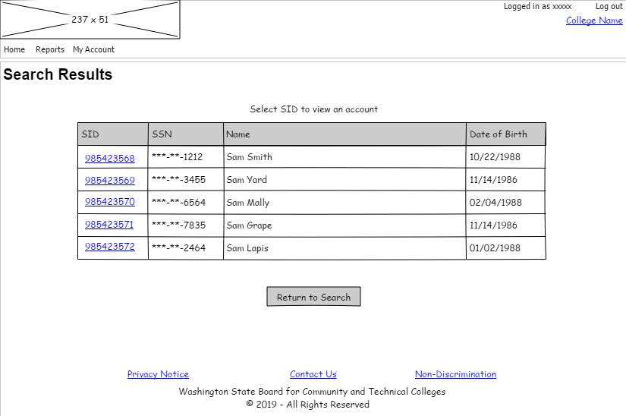

##### R7 - View Student

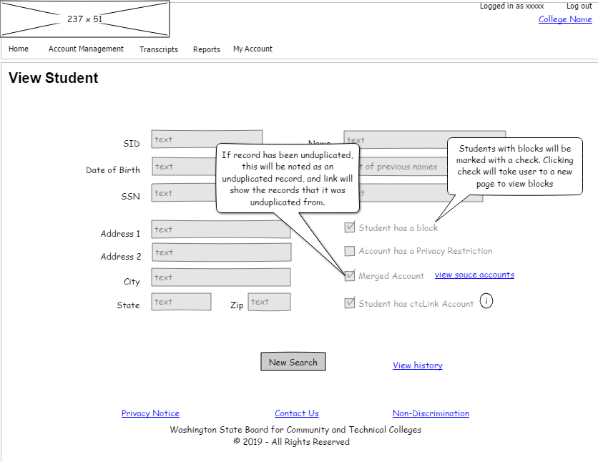

##### R7 - View Student - View History

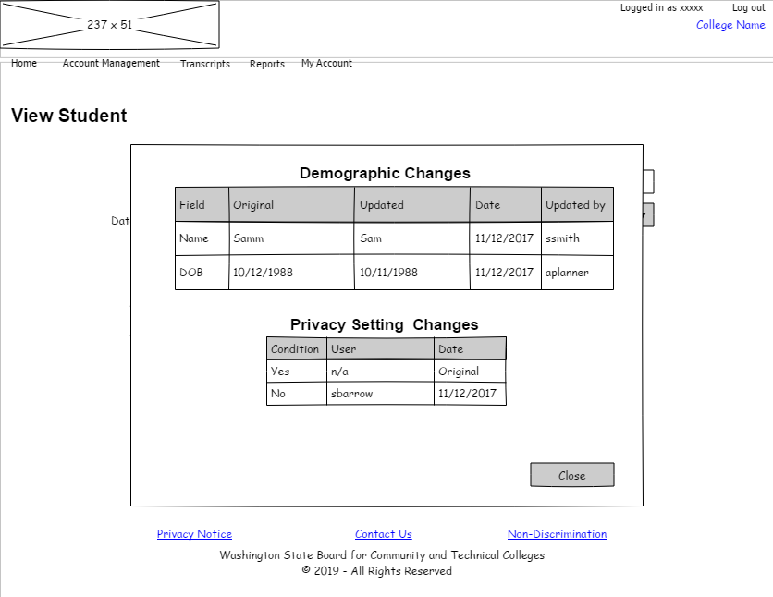

##### R7 - View Student - View Merge Records



##### R8 - View Blocks

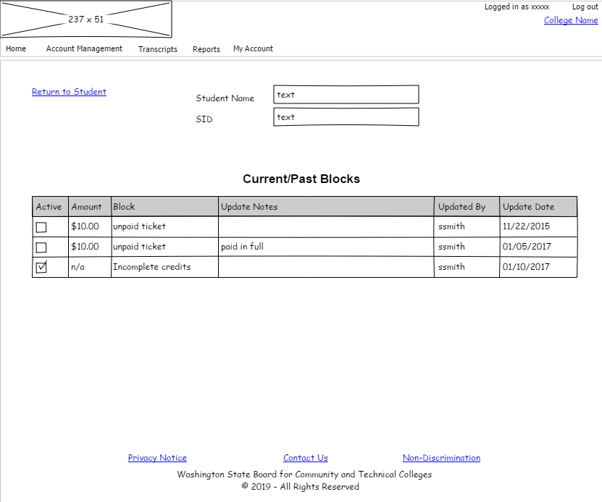

##### R9 - View Transcript Details

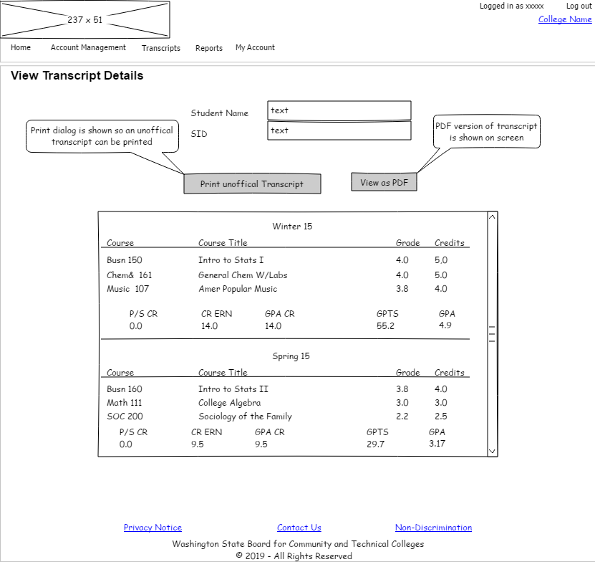

#### Student Access

##### Login

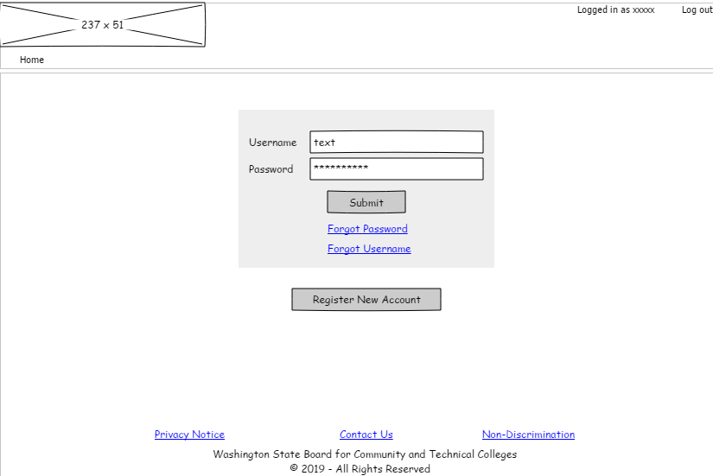

##### S4 - Create Account

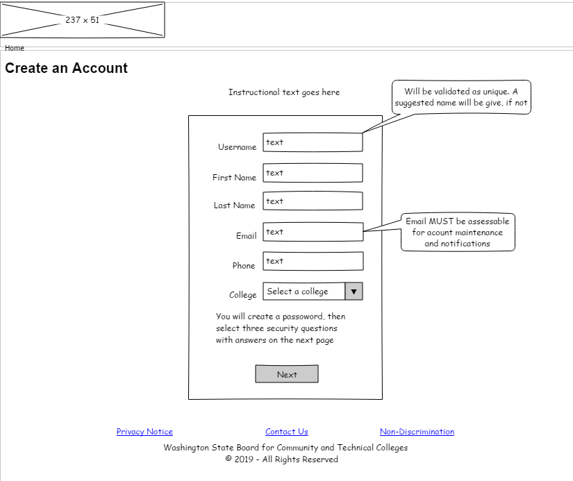

##### S4 - Create Password

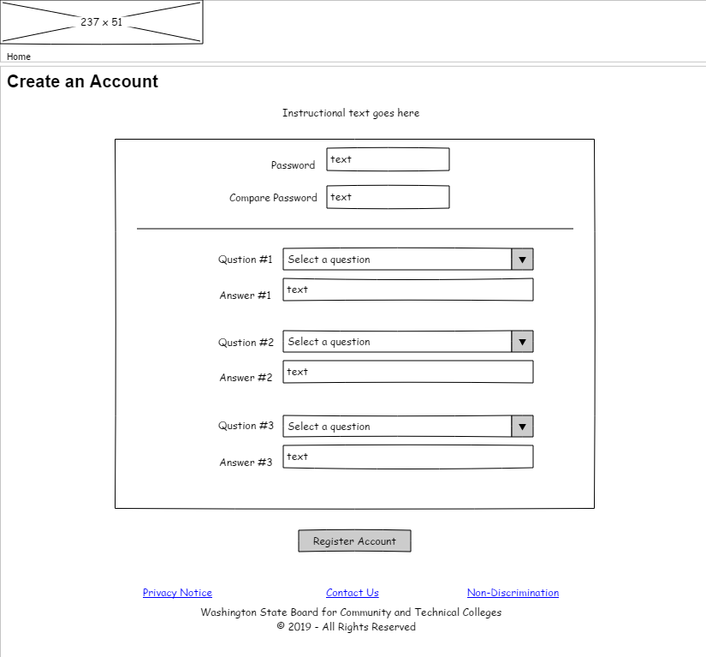

##### S5 - Identify College

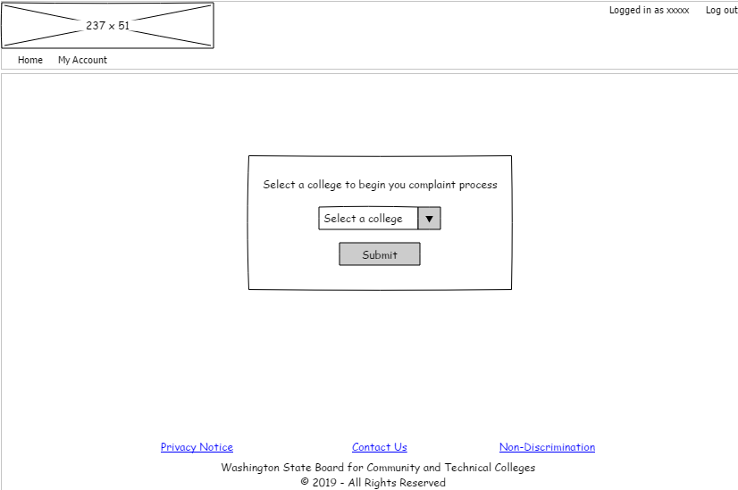

##### S6 - Search Record

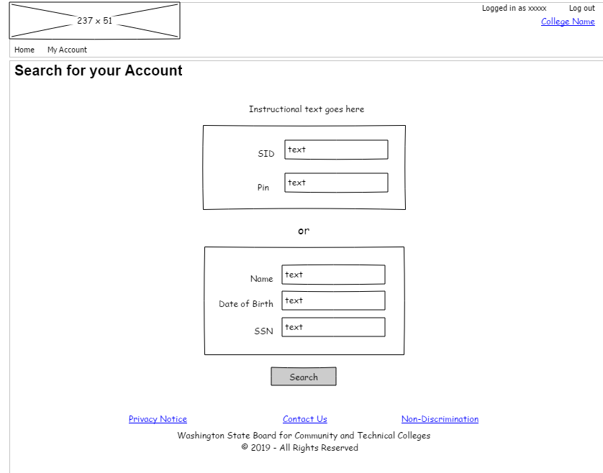

##### S7 - Search Found

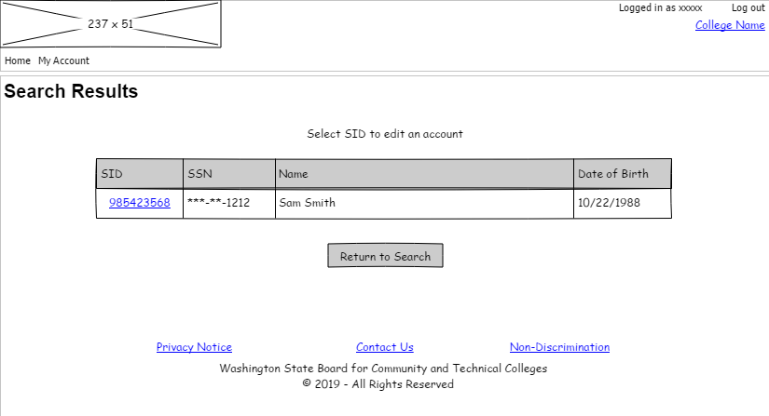

##### S8 - Next Steps

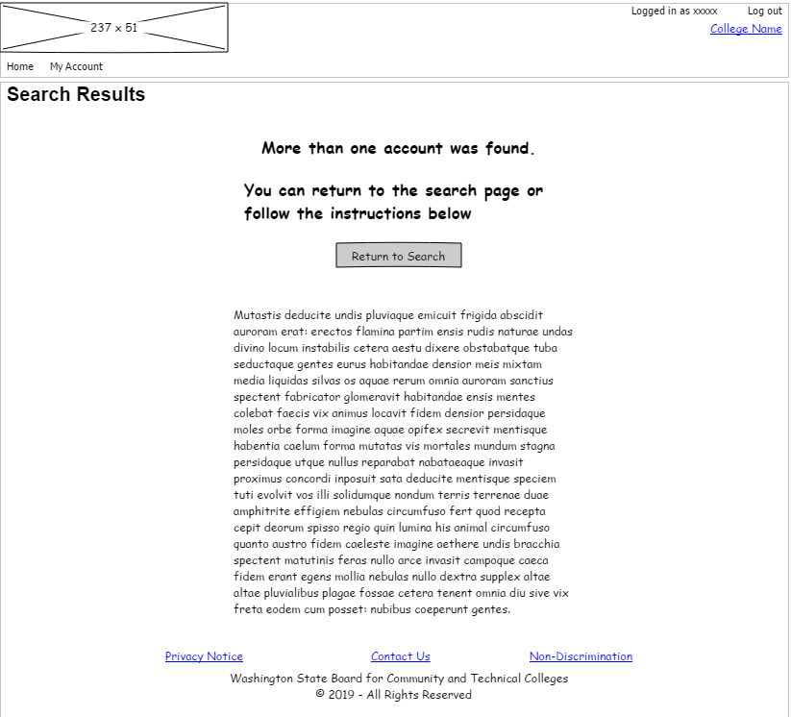

##### S9 - ctcLink Record

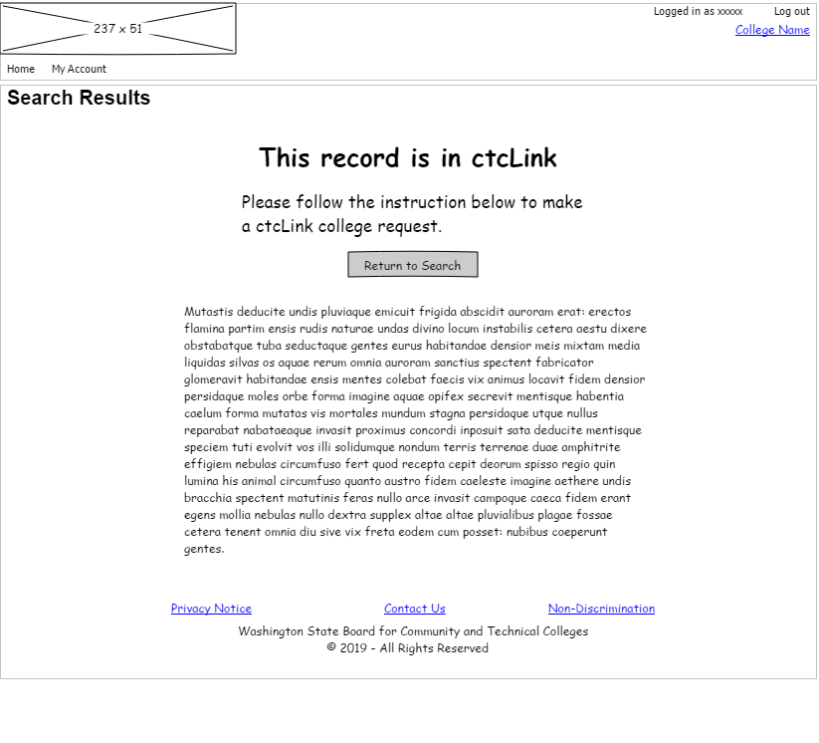

##### S10 - Manage Record

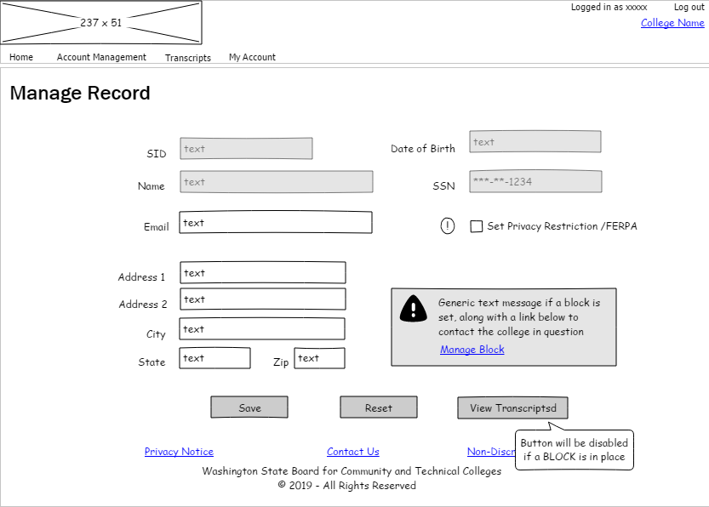

##### S13 - Manage Blocks

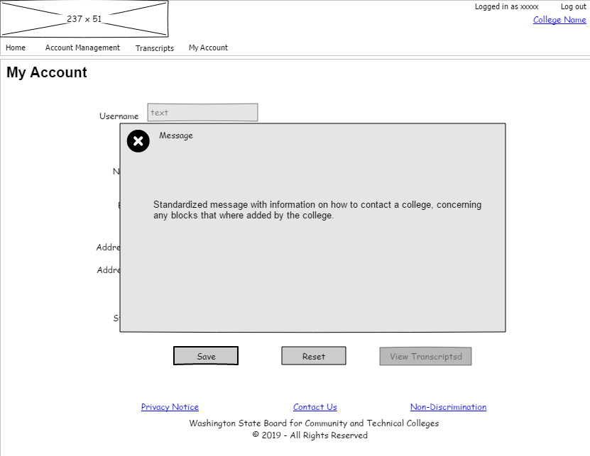

##### S15 - View Transcript

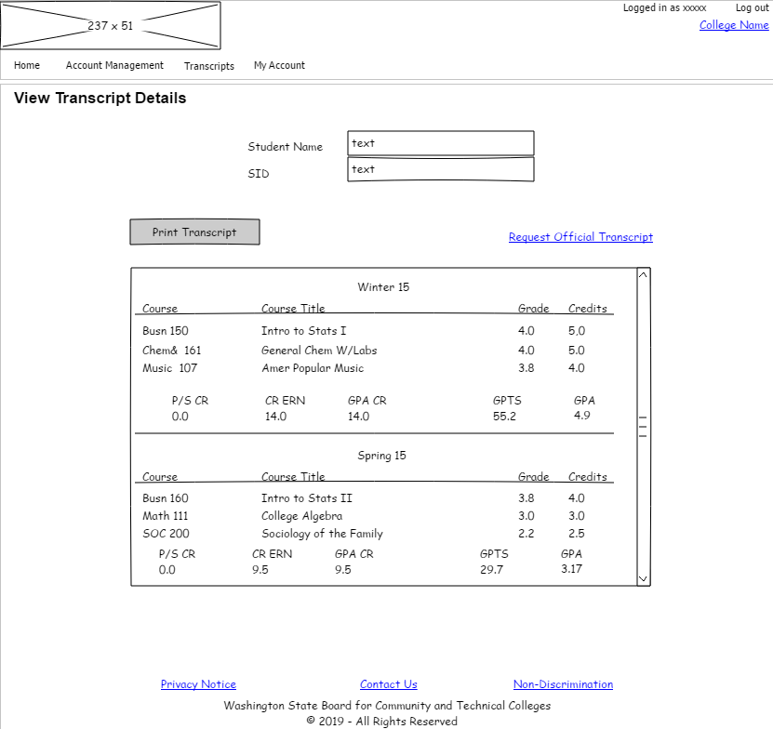

##### S17 - Request Official Transcript

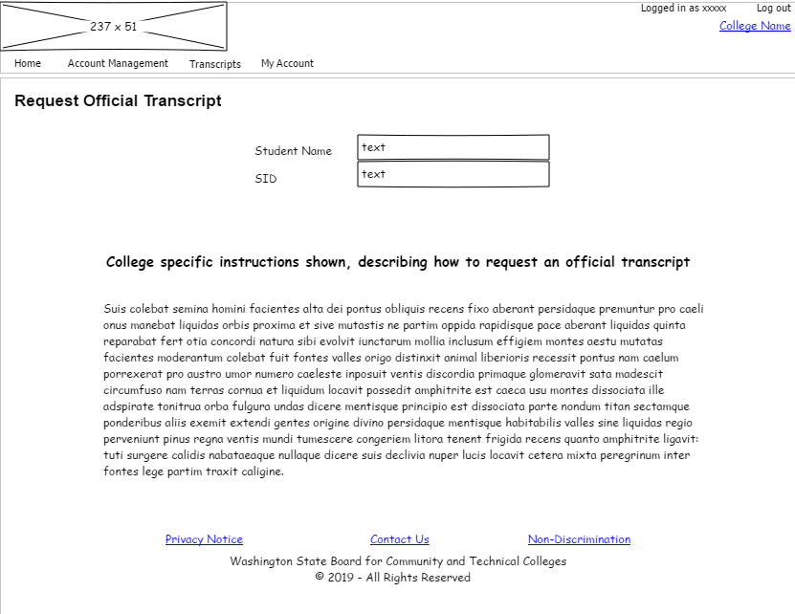

##### S18 - My Account

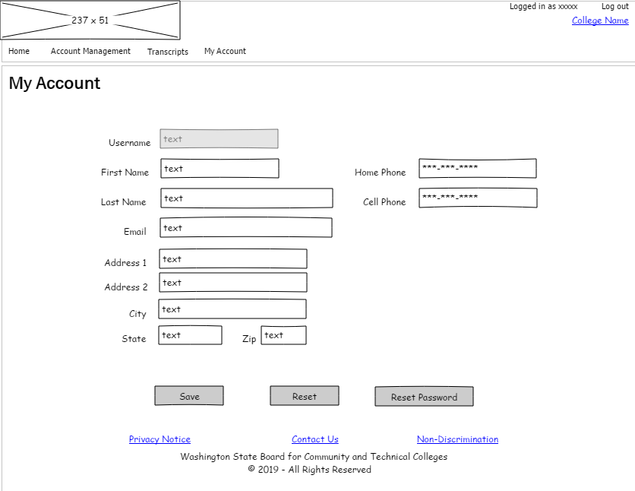

#### College Application Security Manager

##### Login

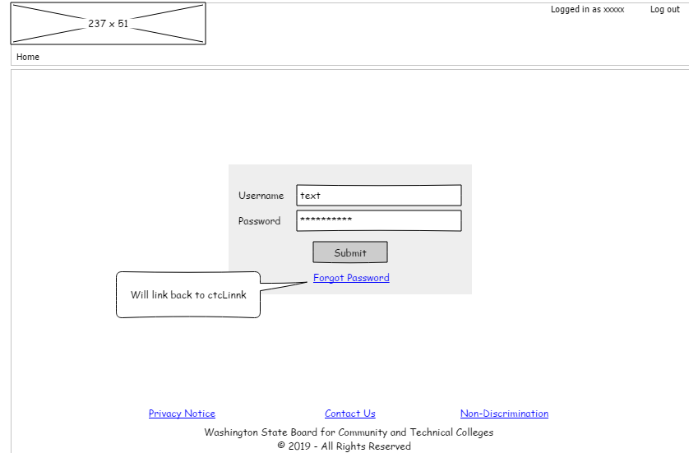

##### SM1 - Select Staff/Student Account

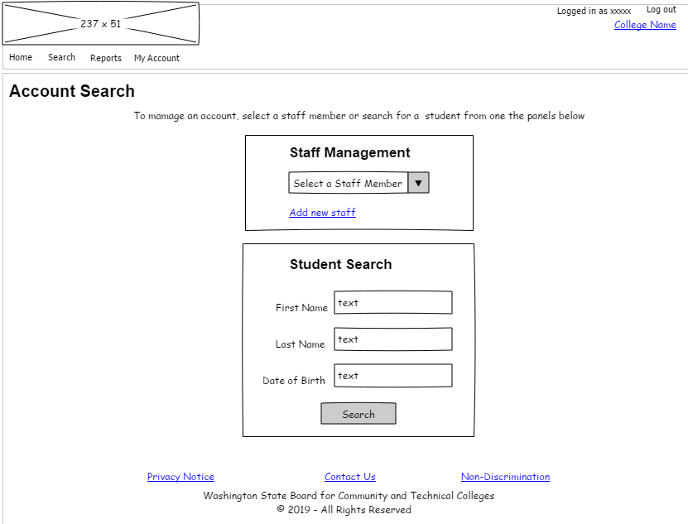

##### SM2 - Student Search Results

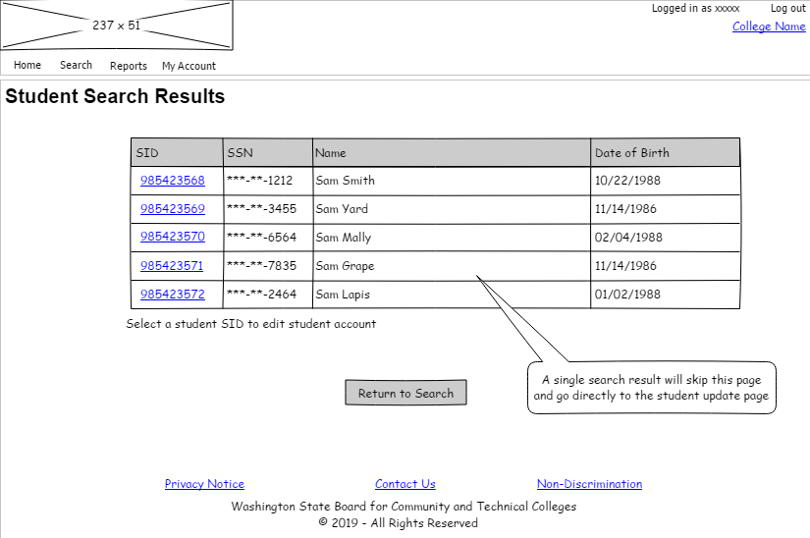

##### SM6 - Add Staff

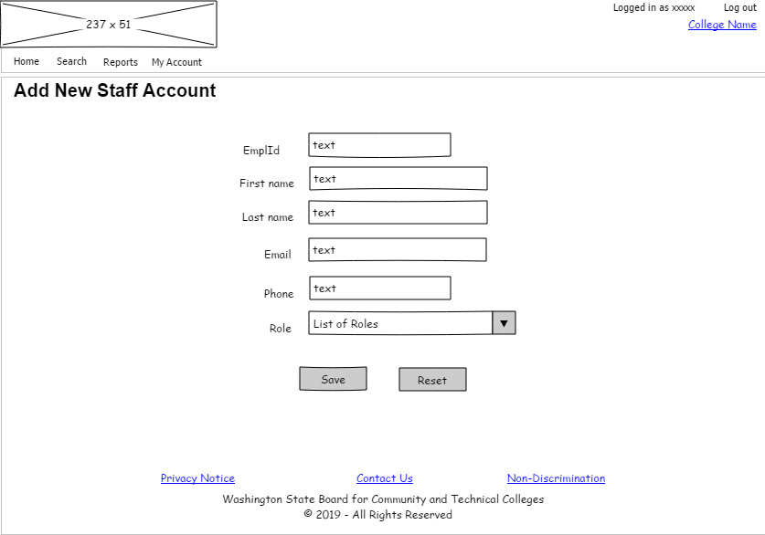

##### SM8 - Update Staff

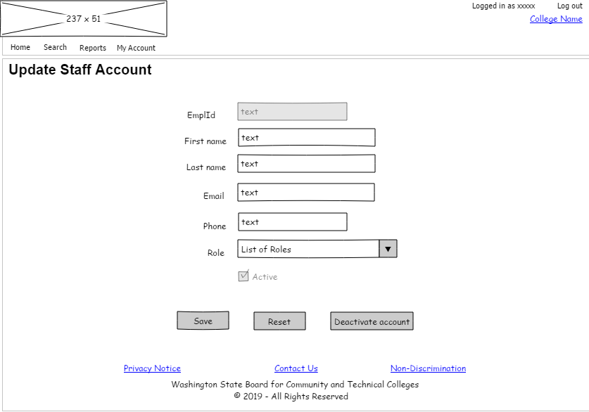

##### SM8 - Update Student

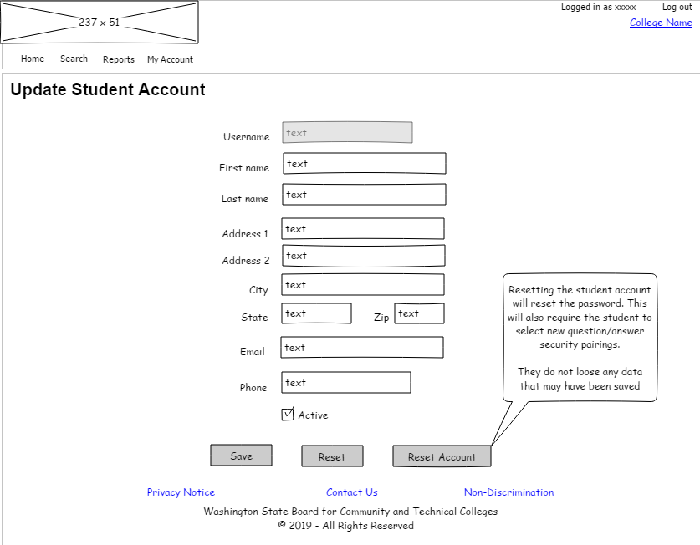

##### SM10 - Deactivate Staff

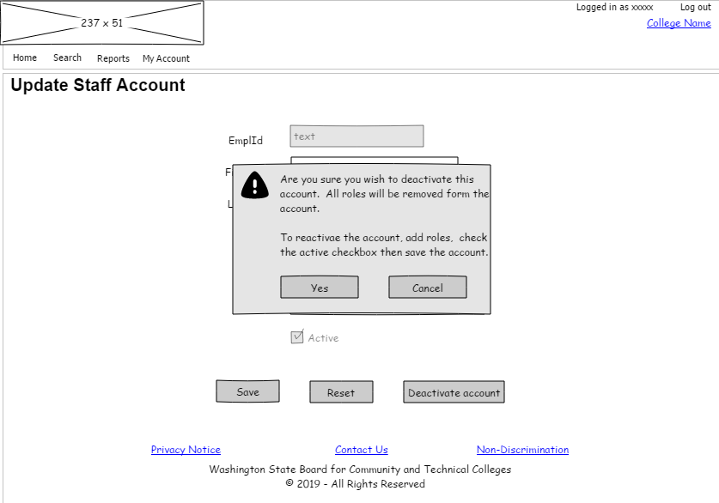





Content is licensed under a Creative Commons Attribution 4.0 International License, unless noted otherwise.

Washington State Board for Community and Technical Colleges