





**Financials and Supply Change Management Image 37 Overview**

Table of Contents

**Contents**

Contents

Introduction 5

Customer Contracts 5

CA_BI_INFTC Run Control 5

Grants 8

Award Profile 8

Modify End Dates 8

General Ledger 10

General Ledger WorkCenter 10

Journals 10

Commitment Control 11

Budget Expiration Report 12

Purchasing 13

Procurement Card Active/Inactive Status 13

Procurement Card – Attachment Requirement (Optional) 13

Procurement Card Purchase Details - Item and Description fields added 16

Procurement Card - New parameters for the Load Voucher Stage Process 17

Purchase Orders - Approval Priority on PO Header 18

Procurement Cards – Add Proxy by Role work around 19

Accounts Payable 22

Single Payment Vouchers – New functionality 22

1099-NeC IRS Reporting Requirements for 2020 Reporting 24

Travel and Expense 25

Expense Report 25

Accessibility 26

Asset Management – Search for an Asset 26

Asset Management – Interface Transactions Review Page 27

Billing – Express Bill Page 28

Billing – Choose Accounting – AR Offset Page 29

Billing – Correct Budget Check Errors 30

Travel and Expenses –Expense Report 31

Travel and Expense – Copy Expense Report 34

Travel and Expenses – Expense Report History 35

Travel and Expenses – Travel Authorizations 36

Grants – Maintain Proposal 37

Purchasing – Procurement Contracts 38

## Introduction

The Image/Upgrade Overview Document is intended to provide ctcLink users with a summary of the changes that will be made in the system as a result of the upcoming image or PeopleTools upgrade implementation. Oracle releases multiple PeopleSoft updates, called images, for each pillar every year. Each Image contains bug fixes and features that are important for PeopleSoft to work well. PeopleTools upgrades update the underlying framework of the system. There are minimal changes that are noticeable to the end users. Below is an overview of the changes that you can expect to see as part of this upgrade.

## Customer Contracts

### CA_BI_INFTC Run Control

The CA_BI_INTFC Run Control page has the following newly added fields: Master Contract Number, LOC Document ID, and several new date options. The date options allow the user to save their run control with the option of Specify Date or Current Date. It may be useful to save the run control with Current Date in the Event Date Option and Invoice Date Option fields. However, the Specify Date option requires the user to enter a date just as the user had to do prior to this change.

#### Navigation

Main Menu > Customer Contracts > Schedule and Process Billing > Process As Incurred Billing

#### Image: Process As Incurred Billing

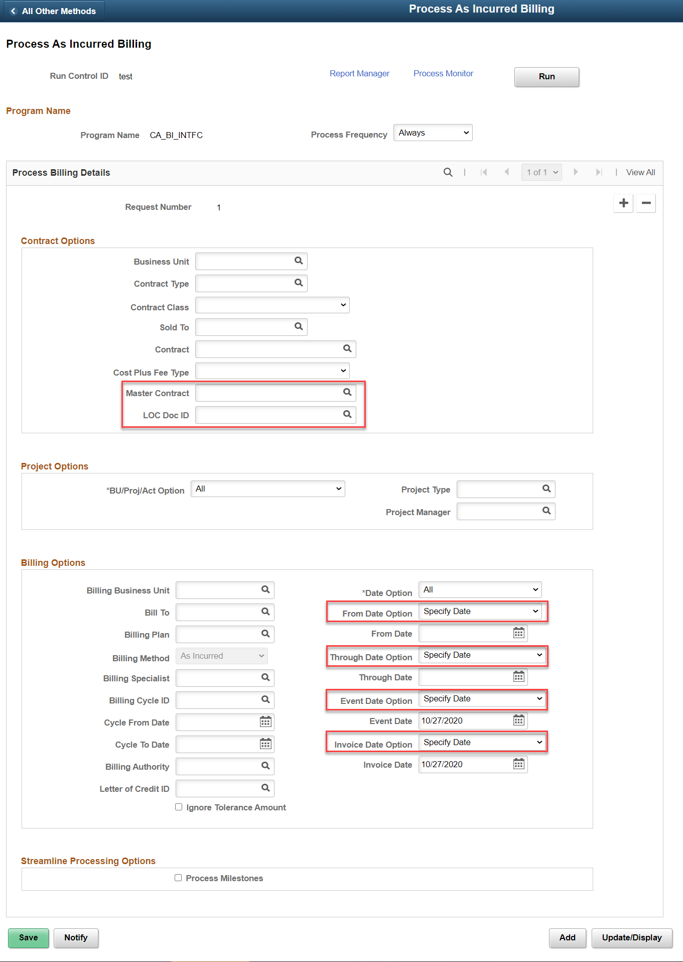

#### QRG

[9.2 Process As Incurred Billing](http://ctclinkreferencecenter.ctclink.us/m/79734/l/1073617-9-2-process-as-incurred-billing)

#### Navigation

Main Menu > Customer Contracts > Schedule and Process Billing > Process Other Billing Methods

#### Image: Process Other Billing Methods (for Fixed Price Contracts)

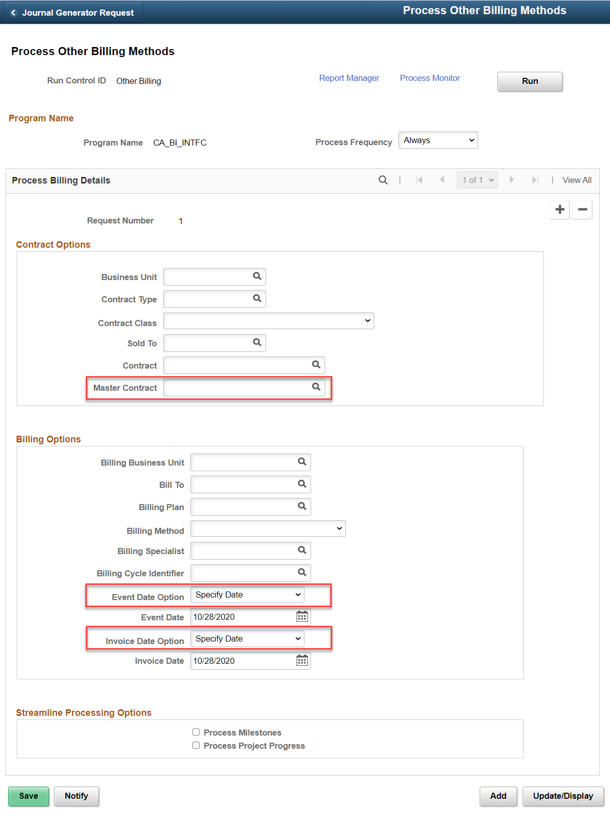

#### QRG

[9.2 Fixed Price Billing](http://ctclinkreferencecenter.ctclink.us/m/79734/l/1073617-9-2-process-as-incurred-billing)

## Grants

### Award Profile

The Award Profile page now displays the commitment control begin and end dates for the grant.

#### Navigation

Main Menu > Grants > Awards > Award Profile

#### Image: Award Profile

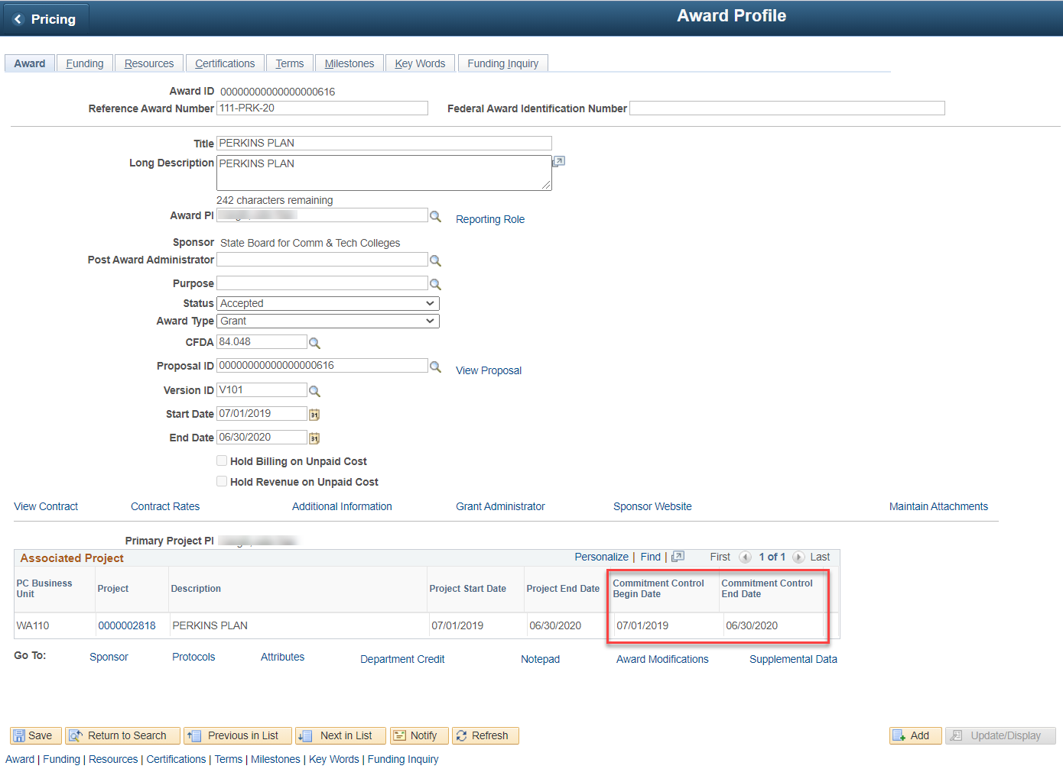

#### QRG

[9.2 Managing an Award](http://ctclinkreferencecenter.ctclink.us/m/79740/l/928894-9-2-managing-an-award)

### Modify End Dates

The Modify End Dates page now displays the commitment control dates for the grant. These dates are viewable but not editable. *The college must still submit a ticket to have SBCTC adjust the commitment control end date.*

Additionally, a section has been added to allow the user to adjust the dates of project team members, which eliminates the need for the user to navigate to the Project Team page.

#### Navigation

Main Menu > Grants > Awards > Modify End Dates

#### Image: Modify End Dates

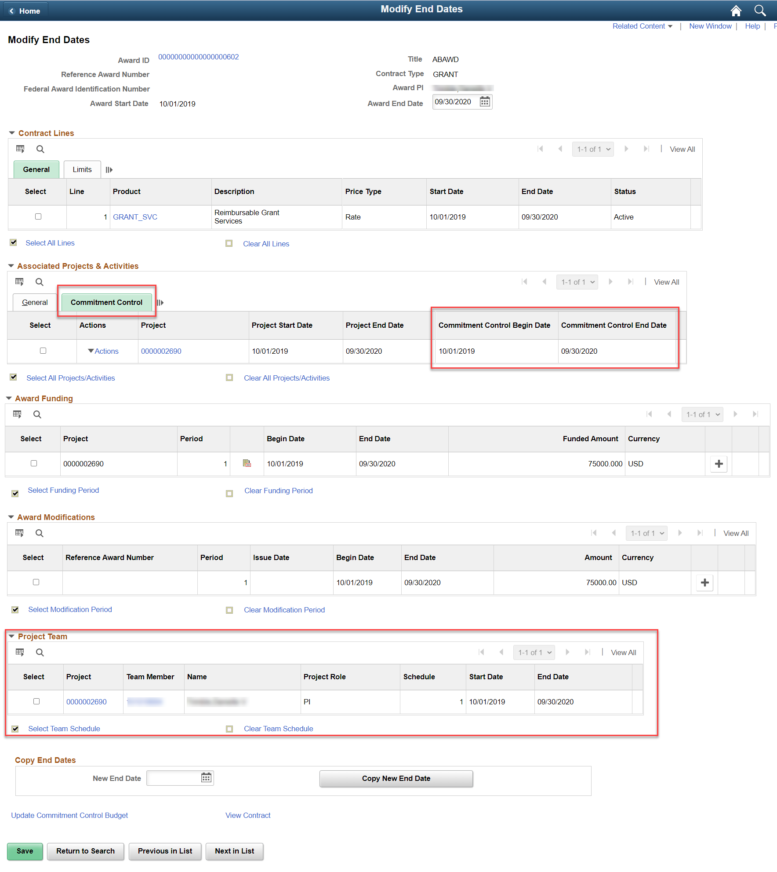

#### QRG

[9.2 Modifying CRC Grant Award End Dates](http://ctclinkreferencecenter.ctclink.us/m/79740/l/1229116-9-2-modifying-crc-grant-award-end-dates)

## General Ledger

### General Ledger WorkCenter

The General Ledger WorkCenter has two new Current Work Links; “Journals Approaching Period End” and Journals Not posted in Closed Period”. Both of these can assist with monthly closing to identify what journals still need to be processed.

#### Navigation

Main Menu> General ledger> General Ledger WorkCenter

#### Image: General Ledger WorkCenter

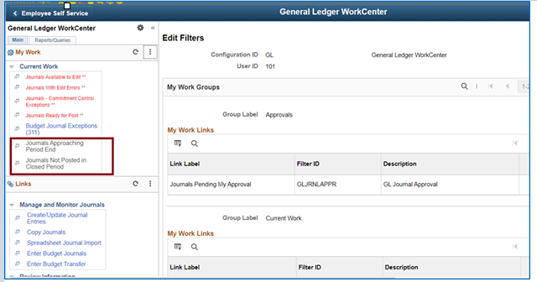

**QRG**

[9.2 Using the GL WorkCenter](http://ctclinkreferencecenter.ctclink.us/m/79739/l/928850-9-2-using-the-gl-workcenter)

### Journals

The personalizing of the users view of a journal has a different access icon; and a slightly different look. The Title “Column 13” was removed.

#### Navigation

General ledger> Journals> Journal Entry > Create/Update Journal Entries (find an existing journal)

#### Image: Journal Lines

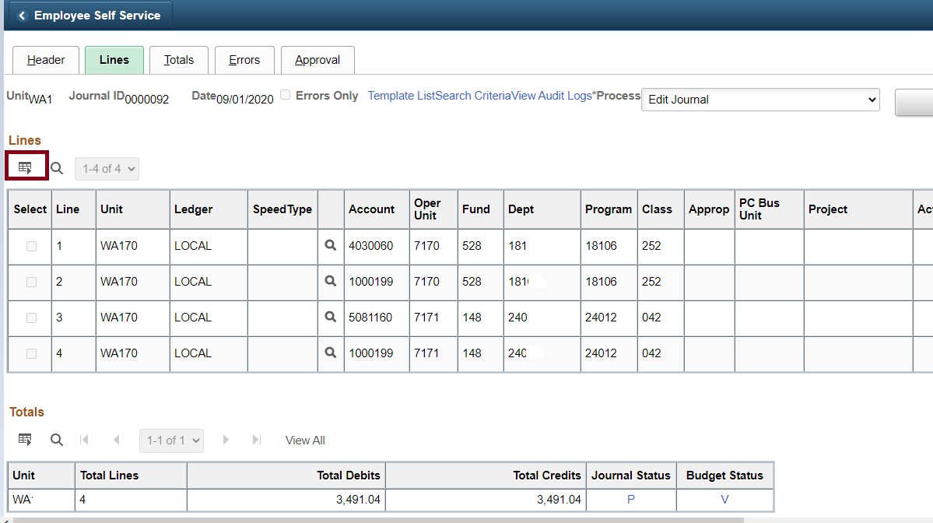

#### Image: Personalize Column and Sort Order

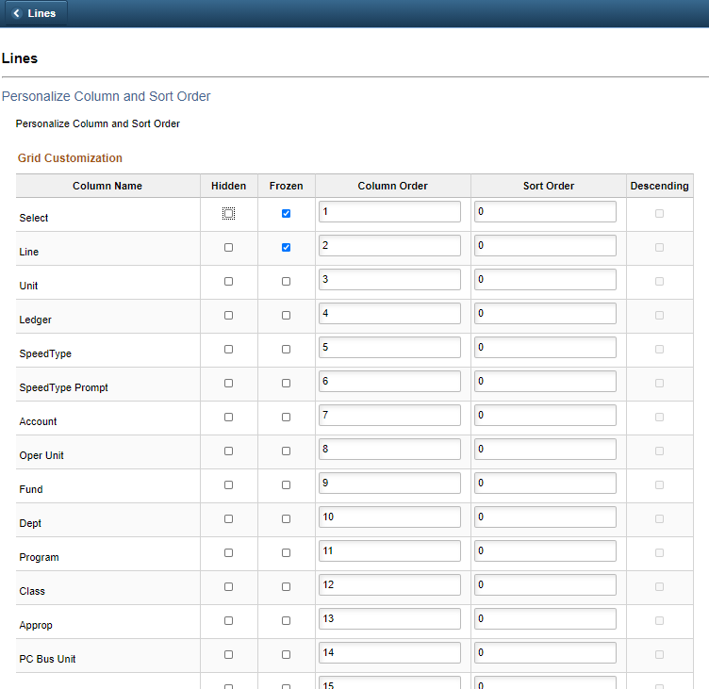

#### QRG

[9.2 Personalize Journal Pages](http://ctclinkreferencecenter.ctclink.us/m/79739/l/1332277-9-2-personalize-journal-pages)

## Commitment Control

### Budget Expiration Report

The following report lists the expiration dates of projects. Use the Ledger Group PROJECT_KK.

#### Navigation

Main menu> Commitment Control> Budget Reports> Project Expiration

#### Image: Commitment Control Project Expiration Report Run Controls

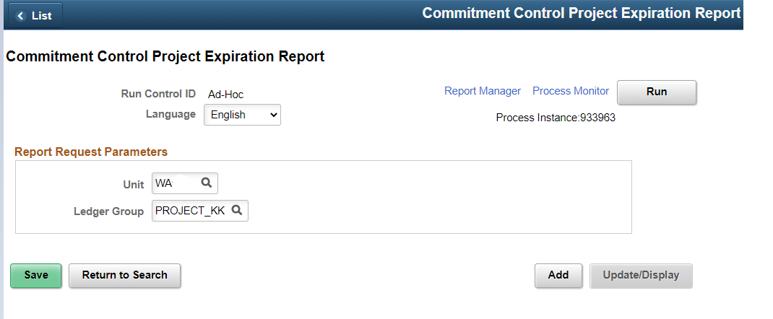

#### Image: Commitment Control Project Expiration Report Example

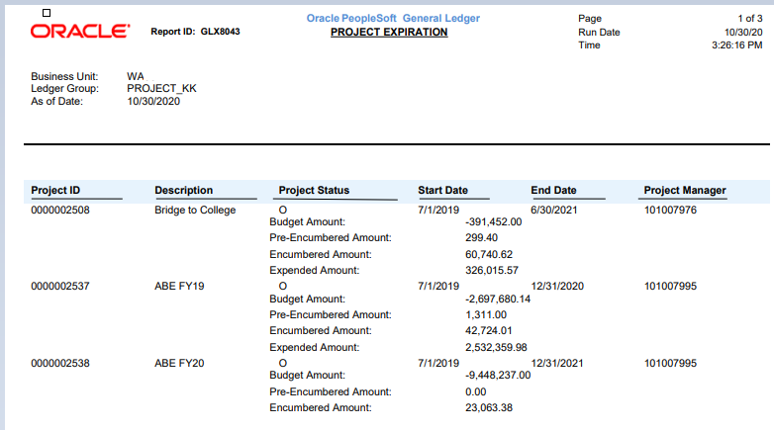

#### QRG

[9.2 Review Project Expiration Report](http://ctclinkreferencecenter.ctclink.us/m/79735/l/1324549-9-2-review-project-expiration-report)

## Purchasing

### Procurement Card Active/Inactive Status

When multiple cardholders possess the same card number, the card usage is managed by setting its status as Active or Inactive in the Cardholder’s Profile. If the Inactive box is checked, the Status field will change to “Inactive” and the Status Date defaults to the current date. The procurement card can then be assigned as an active card to another Cardholder.

#### Navigation

NavBar > Navigator > Purchasing > Procurement Cards>Definitions>Cardholder Profile, Card Data tab – Credit Card tab

#### Image: Card Data tab – Credit Card tab

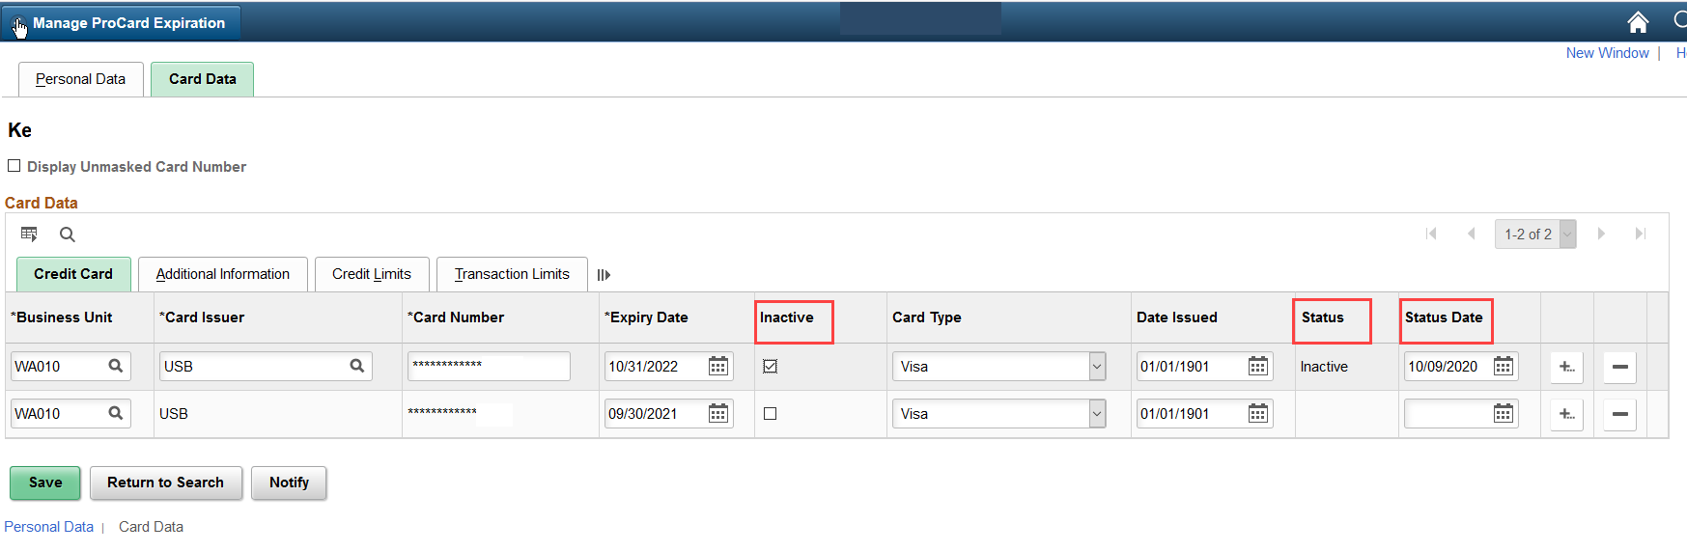

#### QRG

[Adding a New Card to ctcLink](http://ctclinkreferencecenter.ctclink.us/m/79744/l/929034-9-2-resolving-a-missing-card-in-staged-visa-transaction)

### Procurement Card – Attachment Requirement (Optional)

If Business Units have defined a receipt threshold on the Purchasing Business Unit Definition page, cardholders with a transaction at or above the threshold amount are required to attach a receipt during the reconciliation process.

#### Navigation

Set Up Financials/Supply Chain>Business Unit Related>Purchasing>Purchasing Definition>Business Unit Definition, Business Unit Options tab, Procurement Card Controls section

#### Image: Purchasing Definition Page

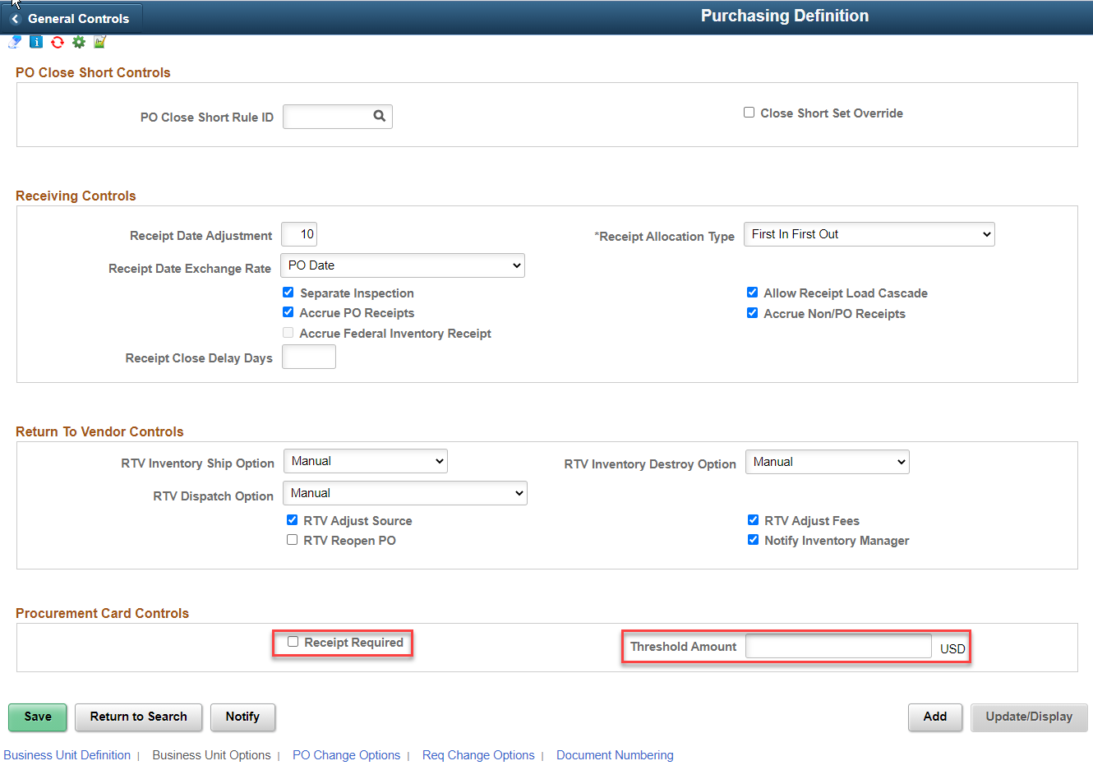

#### Navigation

NavBar > Navigator > Purchasing > Procurement Cards>Reconcile>Reconcile Statement

#### Image: Reconcile Statement Page

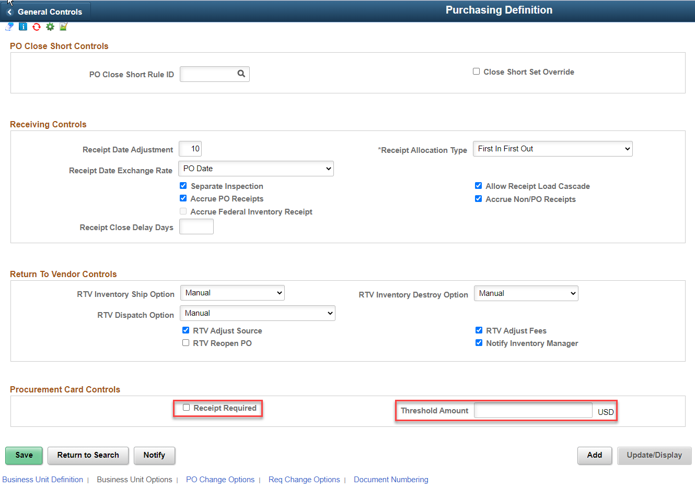

#### Image: Reconcile Statement Page Receipt Required

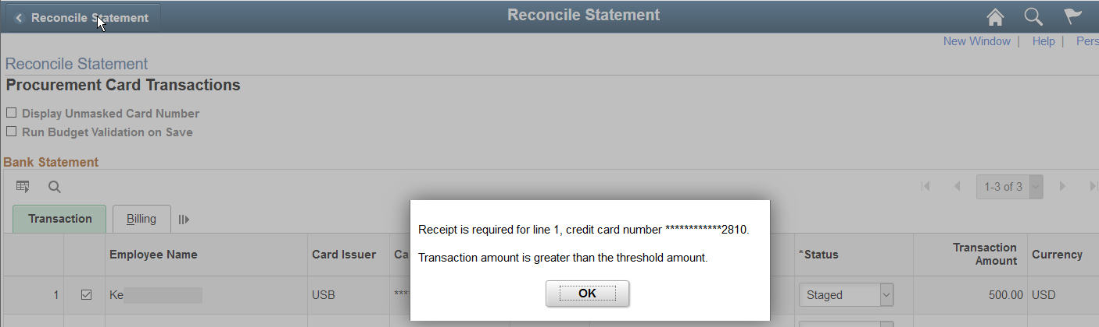

#### Image: Add Attachment

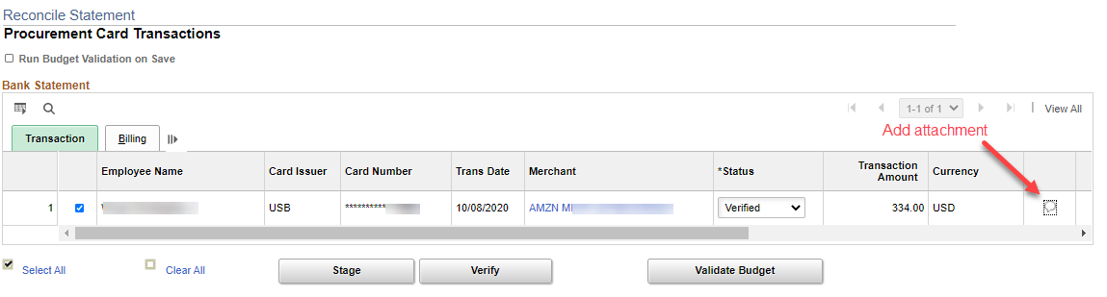

#### QRG

[9.2 Reconciling P-Card Transactions/Statements Manually](http://ctclinkreferencecenter.ctclink.us/m/79744/l/929031-9-2-reconciling-p-card-transactions-statements-manually)

### Procurement Card Purchase Details - Item and Description fields added

On the Reconcile Statement Purchase Details page, item and description fields are available in the search results. This allows users to easily identify and select the correct purchase order line. When a purchase order line is selected on the Lookup Purchase Order Line page, the corresponding line details are automatically populated.

#### Navigation

NavBar > Navigator > Purchasing > Procurement Cards>Reconcile>Reconcile Statement>Purchase Details link

#### Image: Look Up PO Line Search Results

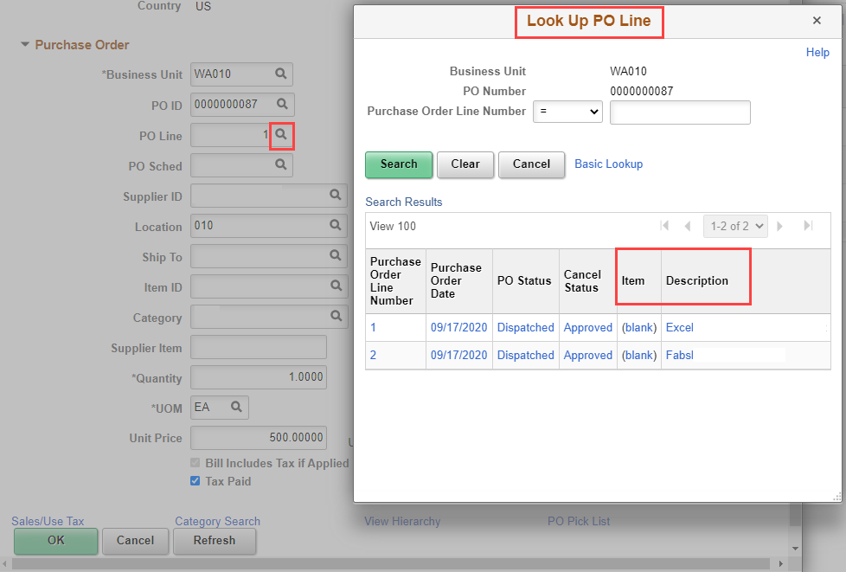

#### QRG

[9.2 Reconciling P-Card Transactions/Statements Manually](http://ctclinkreferencecenter.ctclink.us/m/79744/l/929031-9-2-reconciling-p-card-transactions-statements-manually)

### Procurement Card - New parameters for the Load Voucher Stage Process

A new **Invoice Date to Use** field has been added to determine the voucher’s **Invoice Date**. The dropdown displays three values to choose from:

* Billing Date
* Enter Date
* Today

#### Navigation

NavBar > Navigator Purchasing > Procurement Cards > Process Statements > Load Voucher Stage

#### Image: Load Voucher State Page

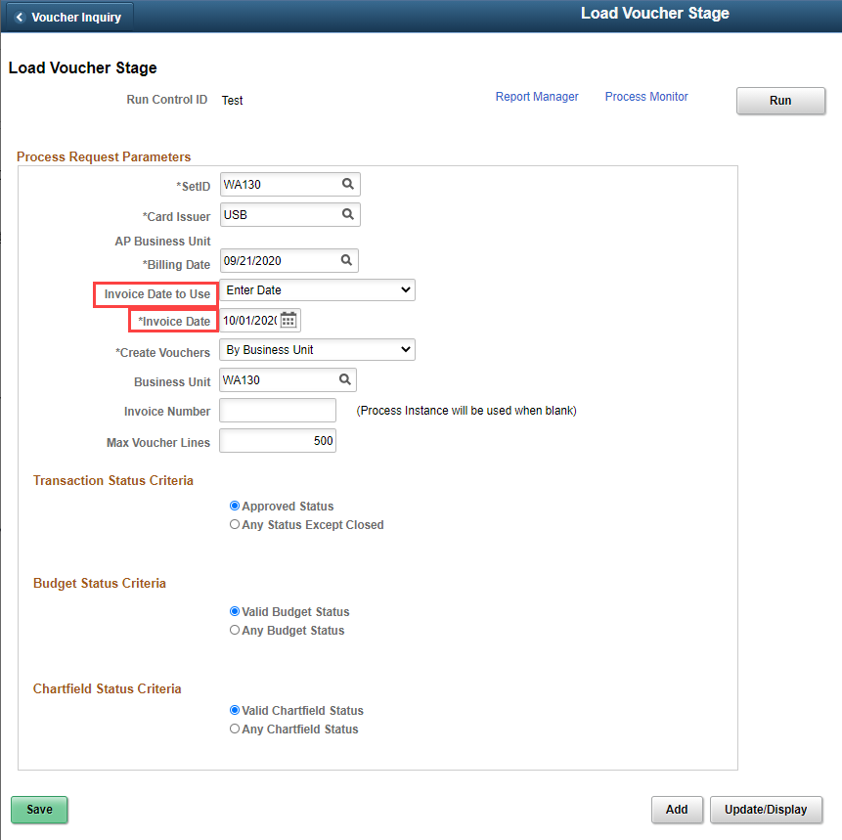

#### QRG

[9.2 Run Load Voucher Stage Process](http://ctclinkreferencecenter.ctclink.us/m/79744/l/1052350-9-2-run-load-voucher-stage-process)

### Purchase Orders - Approval Priority on PO Header

This new feature allows users prioritize Requisitions and Purchase Orders based on urgency. Available priority levels are high, medium and low, with the default level as medium. When creating Requisitions, Requesters can assign a Priority which carries forward to Purchase Orders. Buyers can also assign a Priority level when creating a Purchase Order. The system displays the priority of purchase orders on the approval pages. While approving purchase orders, Approvers can filter and select purchase orders based on priority.

#### Navigation

NavBar > Navigator > Purchasing>Purchase Orders>Add/Update POs

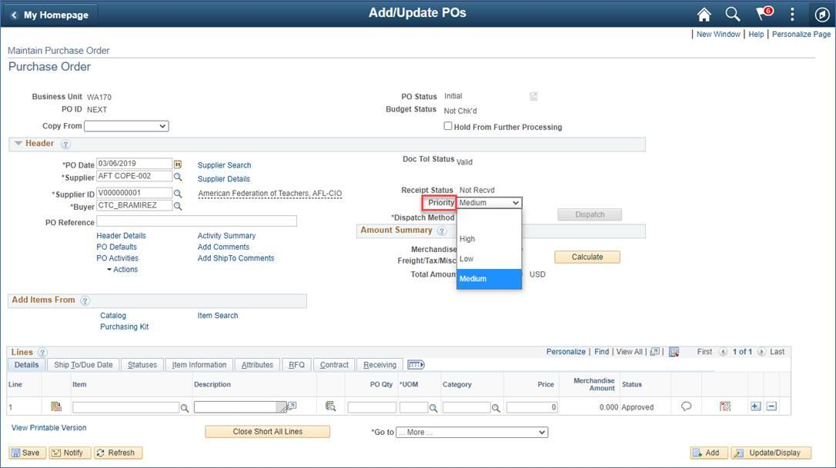

#### QRG

[9.2 Creating Purchase Orders Online](http://ctclinkreferencecenter.ctclink.us/m/79744/l/1064465-9-2-creating-purchase-orders-online)

[9.2 Viewing Purchase Orders](http://ctclinkreferencecenter.ctclink.us/m/79744/l/966953-9-2-viewing-purchase-orders)

### Procurement Cards – Add Proxy by Role work around

Administrators can manage proxy users by role. When proxies are selected by their specific role, the system retrieves the list of all users (from all BU’s) assigned to that role and lists them in a proxy grid. The user should review the proxies listed, removing proxies if needed, before saving.

#### Navigation

NavBar > Navigator > Purchasing>Procurement Cards>Definitions>Cardholder Profile, Card Data tab – Additional Information tab

#### Image: Add Proxy by Role Button

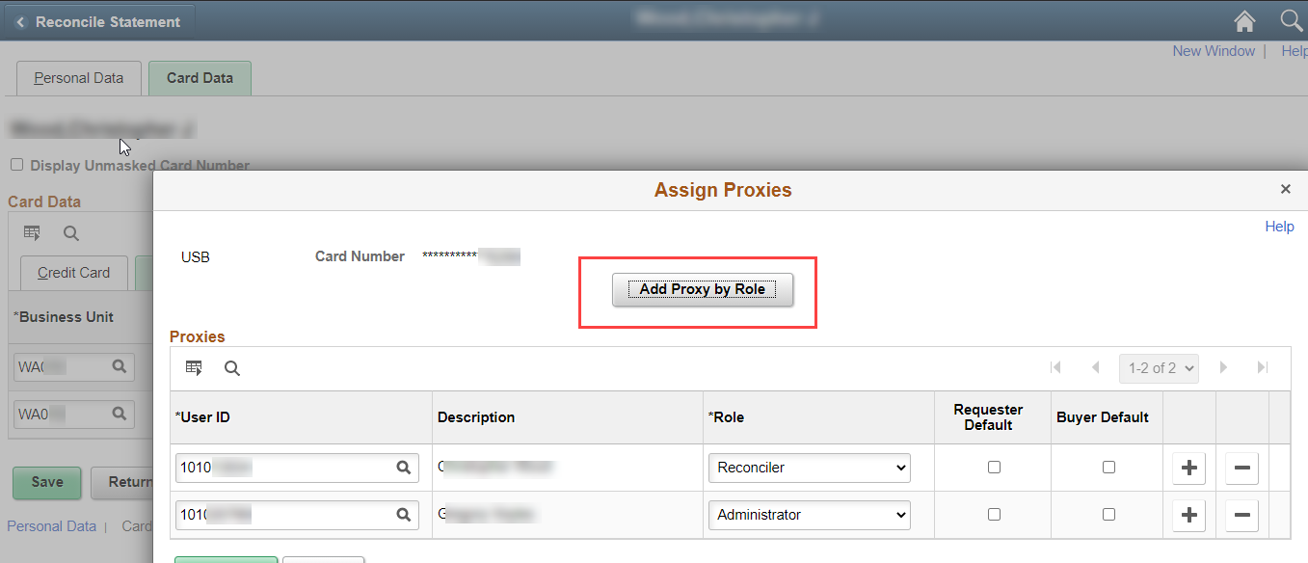

#### Image: Role Name Selection

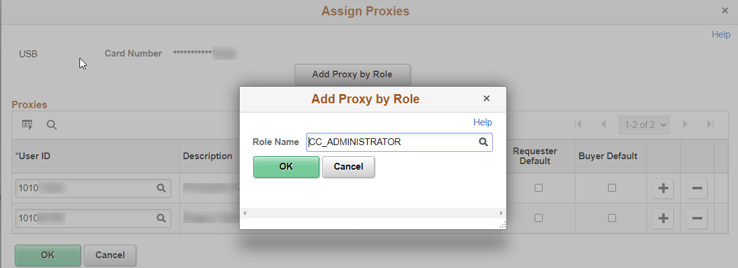

#### Image: Assign Proxies - Workaround

Remove all incorrect rows by clicking on the minus sign at the end of each row, then click OK to save changes.

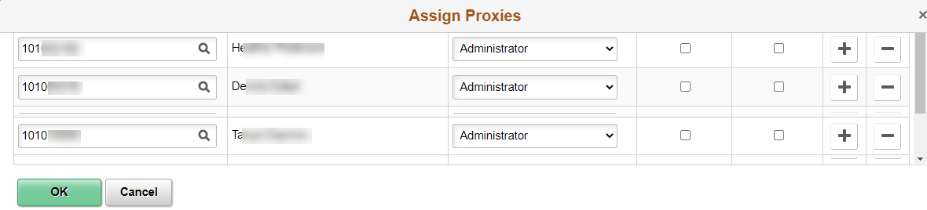

#### QRG

[Adding a New Card to ctcLink](http://ctclinkreferencecenter.ctclink.us/m/79744/l/929034-9-2-resolving-a-missing-card-in-staged-visa-transaction)

## Accounts Payable

### Single Payment Vouchers – New functionality

Enhanced capability to bulk load Single Payment Vouchers to the Voucher Staging table using the ExcelToCI utility. Use the ExcelToCI workbook to stage single payment vouchers that will be loaded into the system.

#### Image: Excel to CI Utility

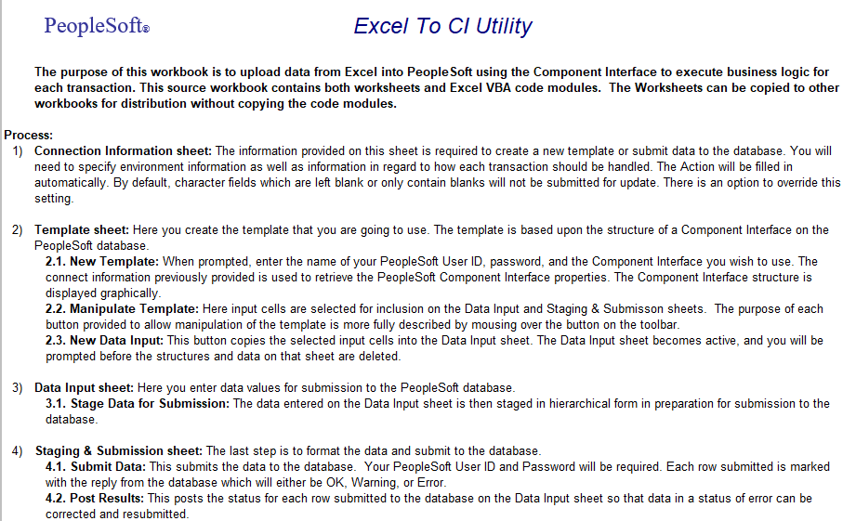

#### Image: Template Sheet

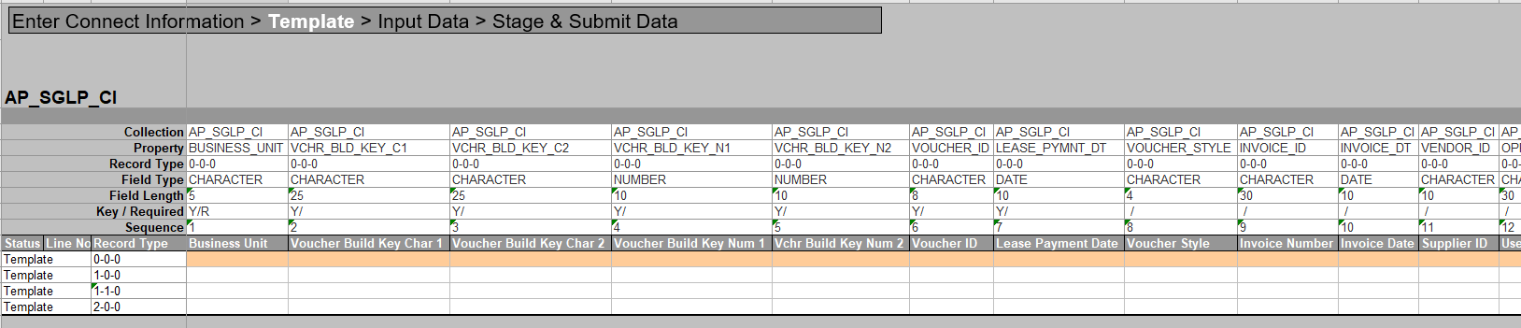

#### Image: Data Input Sheet

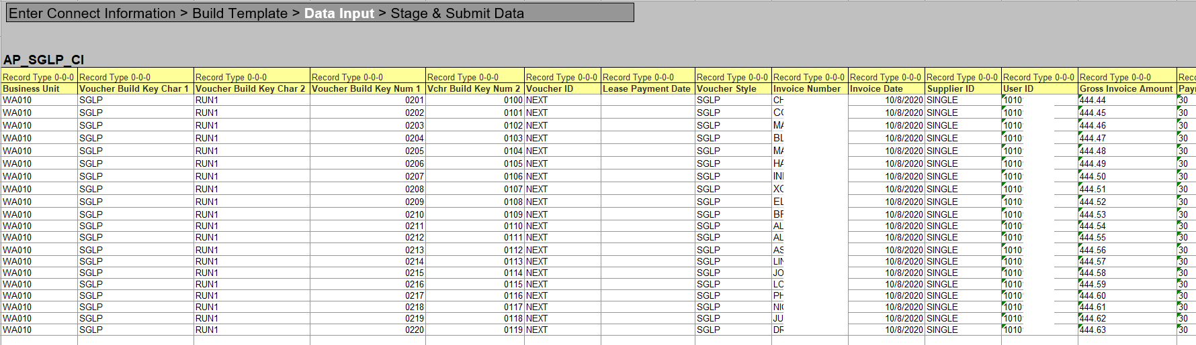

#### Image: Staging & Submission Sheet

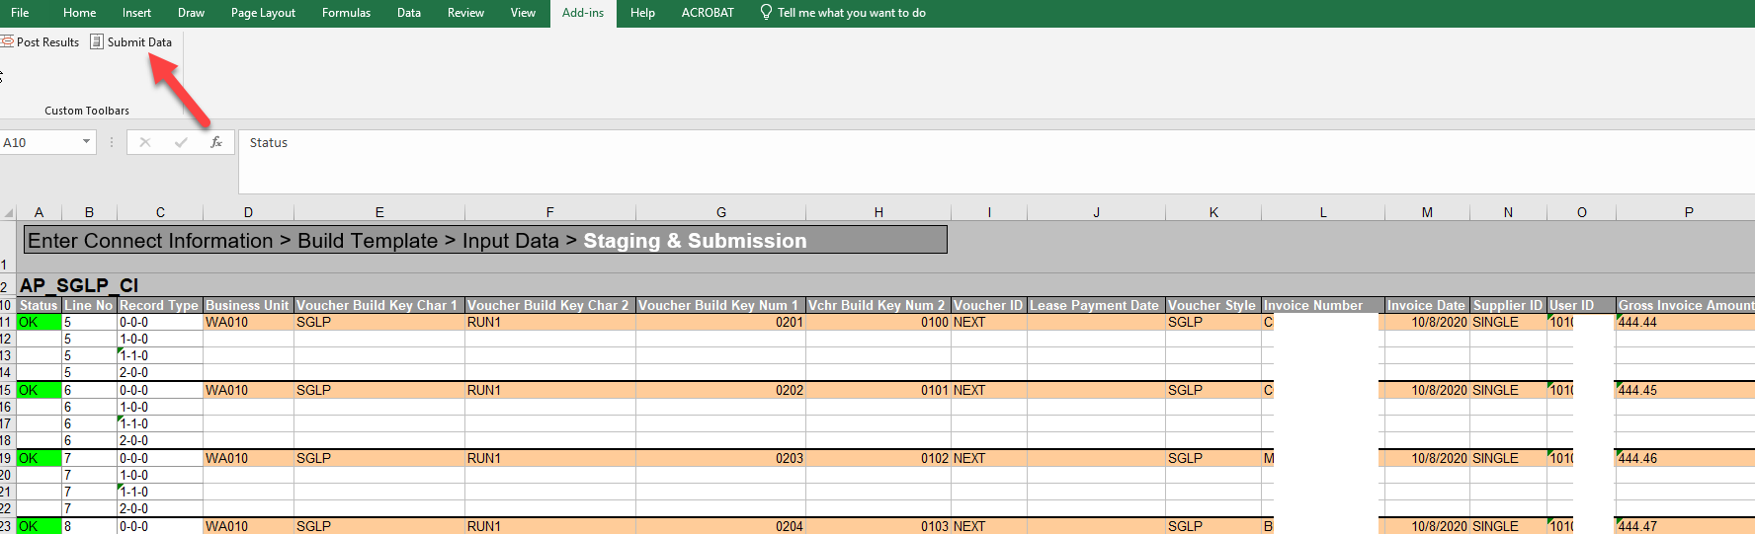

#### Image: PeopleSoft Login

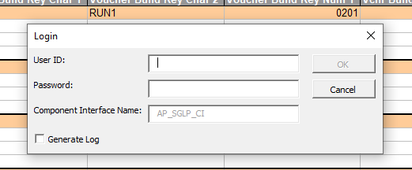

After clicking on the Submit Data button, the Login window opens and the user enters their PeopleSoft credentials. The single payment voucher data is moved to the Voucher Staging table and will be pulled in to AP during the Voucher Build process

#### Navigation

NavBar > Navigator > Accounts Payable> Batch Processes > Vouchers> Voucher Build

#### Image: Voucher Build Page

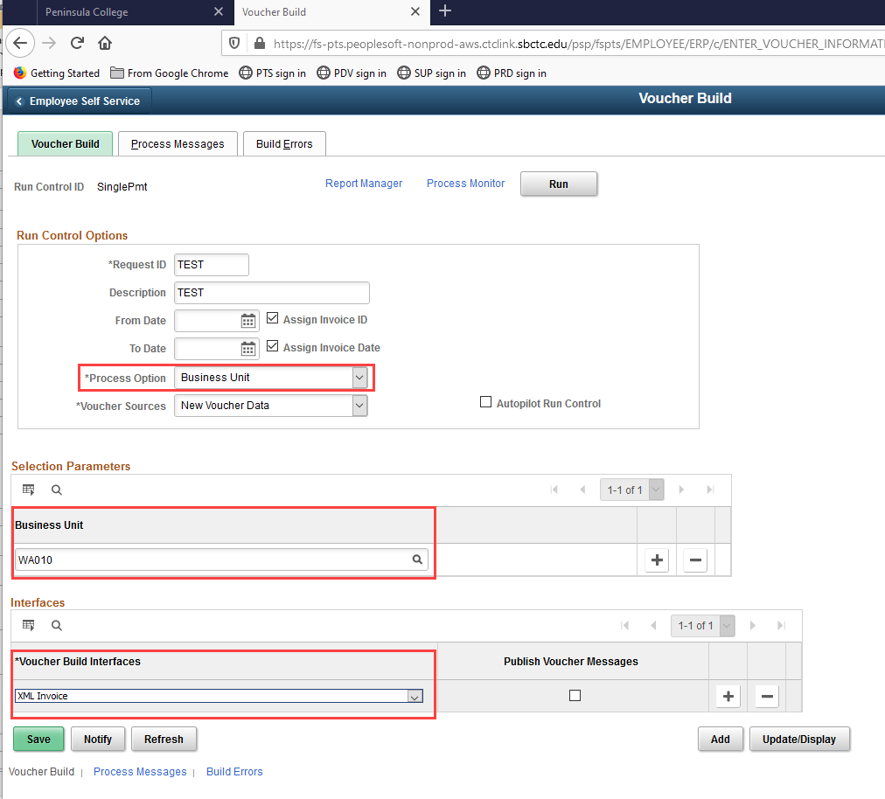

#### Image: Voucher Search Results

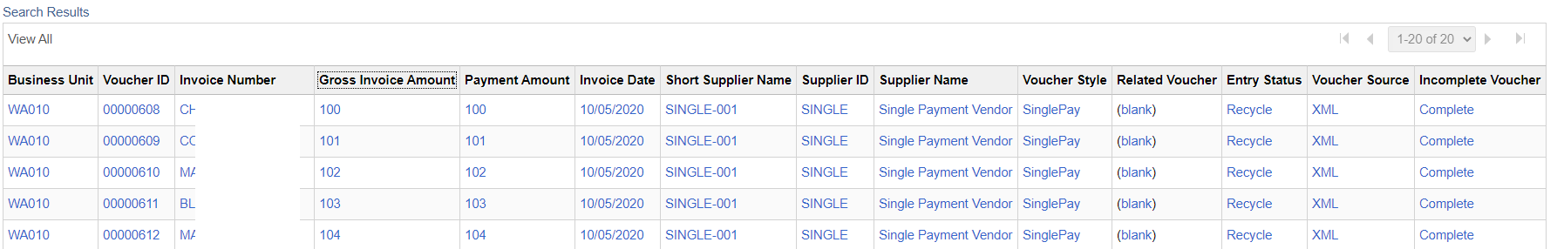

#### QRG

[9.2 Performing Voucher Build](http://ctclinkreferencecenter.ctclink.us/m/72571/l/1070853-9-2-performing-voucher-build)

### 1099-NeC IRS Reporting Requirements for 2020 Reporting

In November 2019, the IRS released new forms 1099 MISC and 1099 NEC. Starting with the 2020 1099 Year-End reporting, Non-employee Compensation is no longer reported on the 1099 MISC form - box 7.  Instead, it is reported on form 1099 NEC (Non-Employee Compensation).  In addition, the 2020 1099 MISC form layout has changed with several boxes being in different positions.

PeopleSoft Accounts Payable released an Oracle patch to assist with preparing for the change. This includes reports, queries and scripts to configure and test the process of updating Supplier 1099 withholding information and existing vouchers. SBCTC’s ctcLink 1099 Processing User’s Guide will be updated to reflect the 2020 reporting changes.

#### QRG

[1099 Processing User's Guide](http://ctclinkreferencecenter.ctclink.us/m/72571/l/1235804-1099-processing-user-s-guide)

## Travel and Expense

### Expense Report

The view expense report page has been updated to fluid with color changes.

#### Navigation

Nav Bar > Navigator > Employee Self-Service > Travel and Expenses > Expense Reports > View

Image: Expense Report Search Page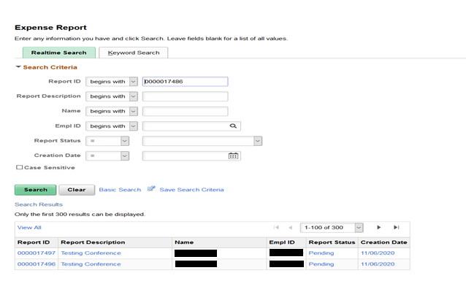Image: View Expense Report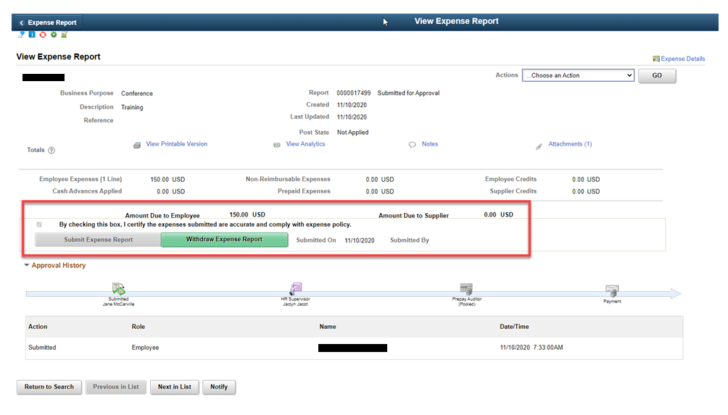

##### QRG

[9.2 View and Modify Expense Reports](http://ctclinkreferencecenter.ctclink.us/m/79738/l/985011-9-2-view-and-modify-expense-reports)

## Accessibility

### Asset Management – Search for an Asset

The search for an asset page was modified so that the fields are labeled correctly, specifically the asset id field.

#### Navigation

Nav Bar > Navigator > Asset Management > Search for an Asset > Select the Search Button

#### Image: Search for an Asset

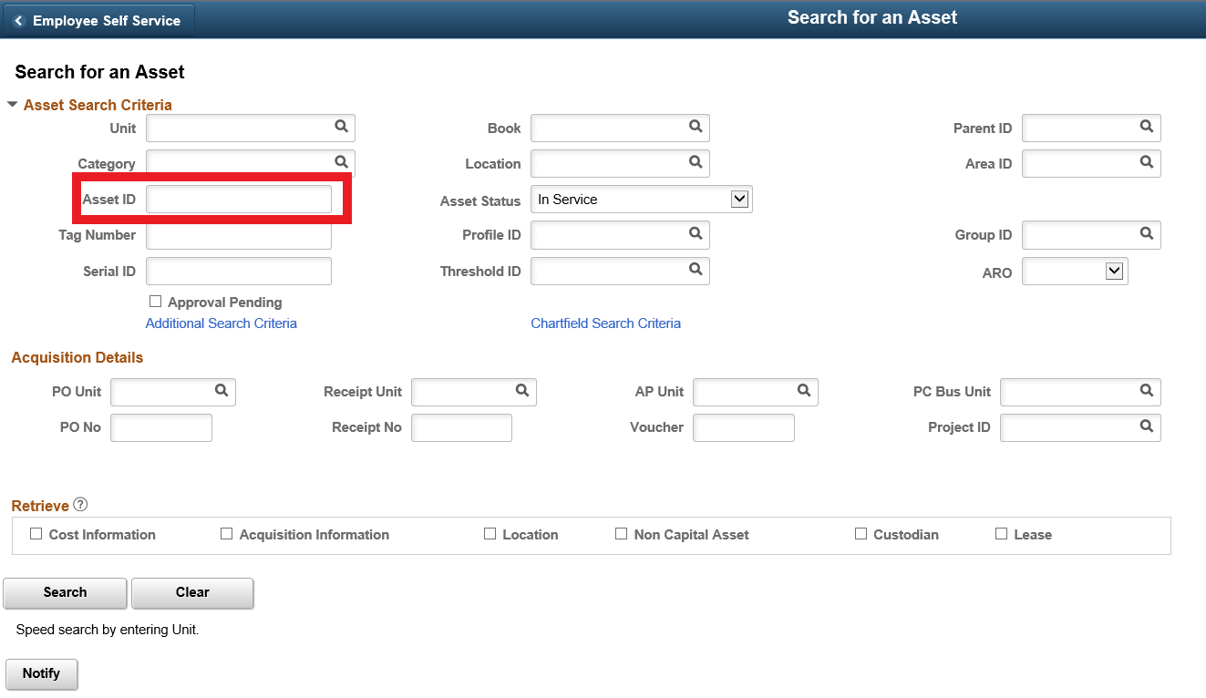

#### QRG

[9.2 Using the Asset Search Page](http://ctclinkreferencecenter.ctclink.us/m/79729/l/928499-9-2-using-the-asset-search-page)

### Asset Management – Interface Transactions Review Page

The tab order was corrected on interface transaction review page so the column headers and values are no longer skipped in the distribution grid.

#### Navigation

Nav Bar > Navigation > Asset Management > Send/Receive Information > Interface Transactions > Review

#### Image: Review Transactions Page

#### Review transactions page imageQRG

[9.2 Review and Load AM Interface DataBilling – Express Bill](http://ctclinkreferencecenter.ctclink.us/m/79729/l/928537-9-2-review-and-load-am-interface-data)

### Billing – Express Bill Page

The tab order has been corrected on the AR header distribution tab of the express bill page so that it goes to the icon on the upper right corner and then the distribution page and the links.

#### Navigation

NavBar > Navigator > Billing > Maintain Bills > Express Billing

#### Image: Express Billing AR Distribution Page

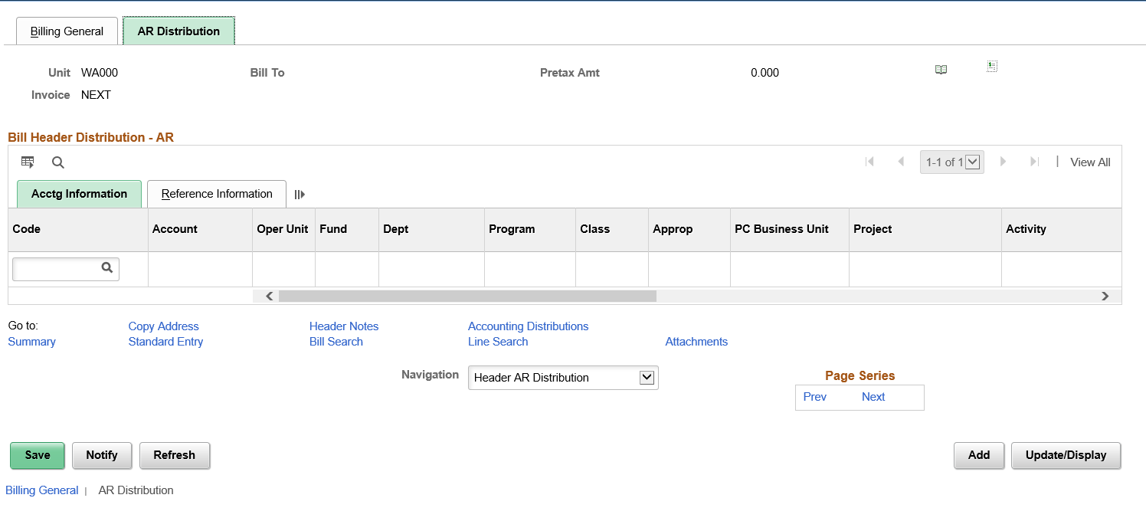

#### QRG

[9.2 Create an Express / One-Time Bill](http://ctclinkreferencecenter.ctclink.us/m/79734/l/1111079-9-2-create-an-express-one-time-bill)

### Billing – Choose Accounting – AR Offset Page

The tab order has been corrected so it goes through the main page for accounting details and then to the links.

#### Navigation

Nav Bar > Navigator > Billing > Maintain Bills > Standard Billing

#### Image: Acctg – AR Offset Page

#### Accounting - AR Offset page imageQRG

[9.2 Create a Standard Bill](https://fs-pts.peoplesoft-nonprod-aws.ctclink.sbctc.edu/psp/fspts/EMPLOYEE/ERP/c/ENTER_BILLING_INFORMATION.BI_ENTRY.GBL)

### Billing – Correct Budget Check Errors

The tab order has been corrected so that it goes through the apply correction button then the correction for line grid and it fields and then the bill line inquiry hyperlink.

#### Navigation

Nav Bar > Navigator > Billing > Maintain Bills > Correct Budget Check Errors (Discount/Surcharge Tab)

#### Image: Correct Budget Check Error (Discount/Surcharge Tab)

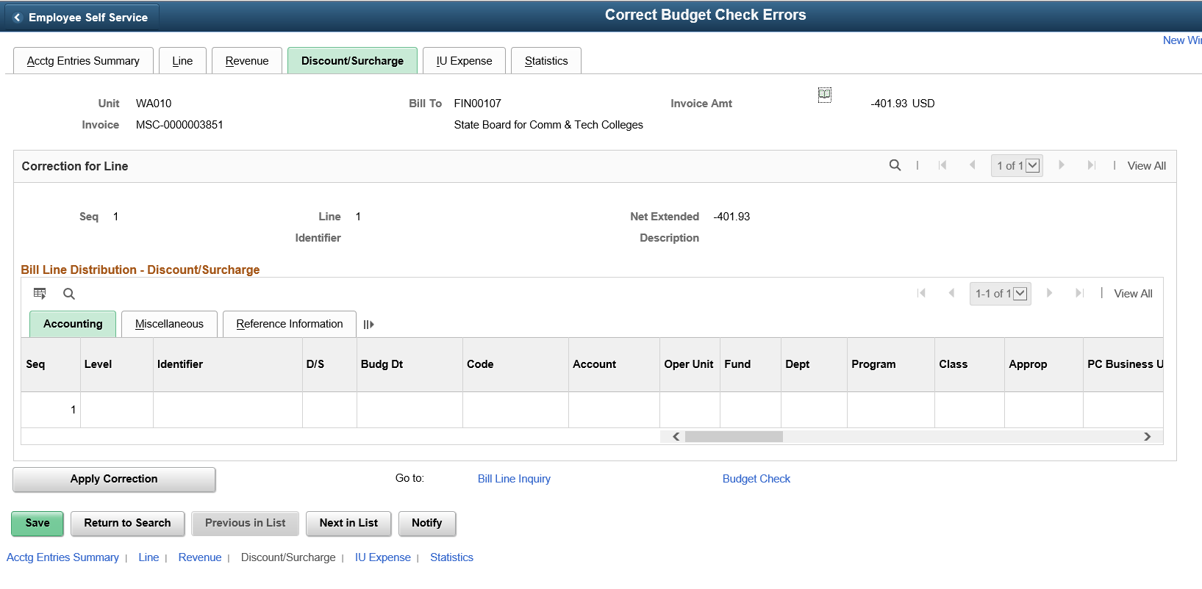

#### QRG

[9.2 Common Budget Exceptions and Corrective Actions](http://ctclinkreferencecenter.ctclink.us/m/79735/l/1046699-9-2-common-budget-exceptions-and-corrective-actions)

### Travel and Expenses –Expense Report

Users will no longer receive an error when an expense report is submitted.

#### Navigation

Employee Self Service > Travel and Expenses > Expense Reports > View and Open any submitted Expense Report

#### Image: View Expense Report

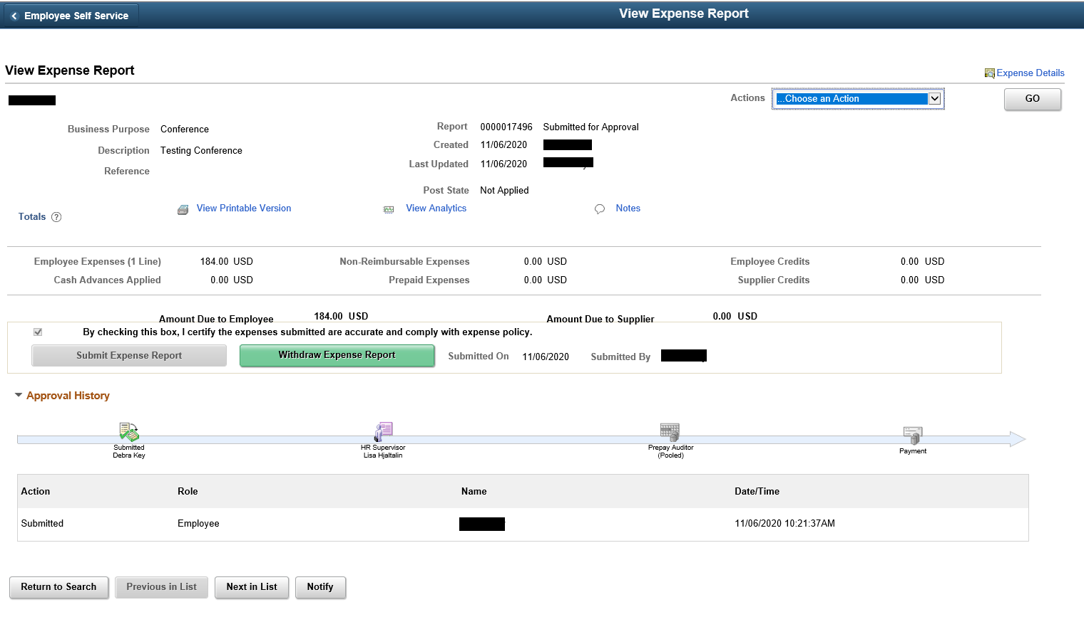

#### QRG

[9.2 View and Modify Expense Reports](http://ctclinkreferencecenter.ctclink.us/m/79738/l/985011-9-2-view-and-modify-expense-reports)

#### Navigation

Employee Self-Service > Travel and Expenses > Expense Reports > Create /Modify and Submit a new Expense Report

#### Image: Submit a New Expense Report

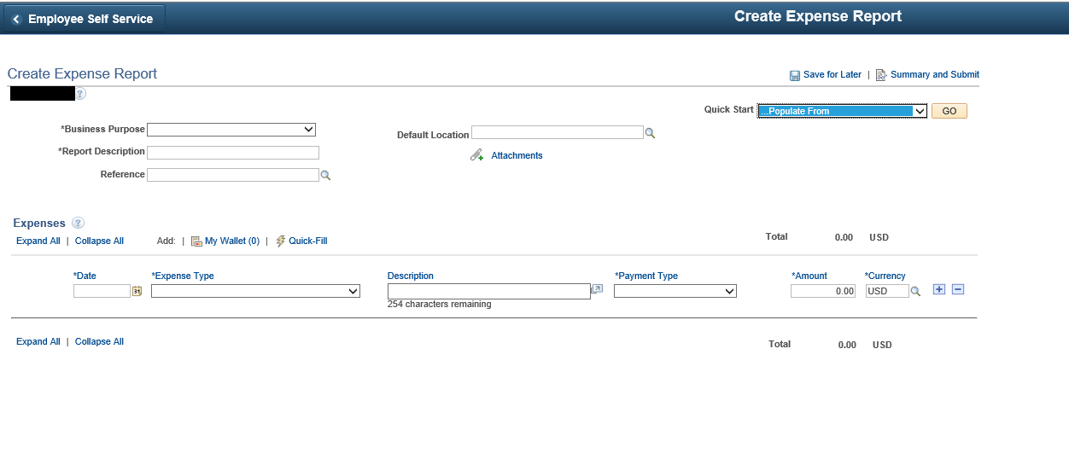

#### QRG

[9.2 Creating Expense Reports](http://ctclinkreferencecenter.ctclink.us/m/79738/l/928838-9-2-creating-expense-reports)

#### Navigation

Employee Self-Service > Travel and Expenses > Expense Reports > Create /Modify withdraw and resubmit the Expense Report and click on Refresh Approval

#### Image: Withdraw Expense Report

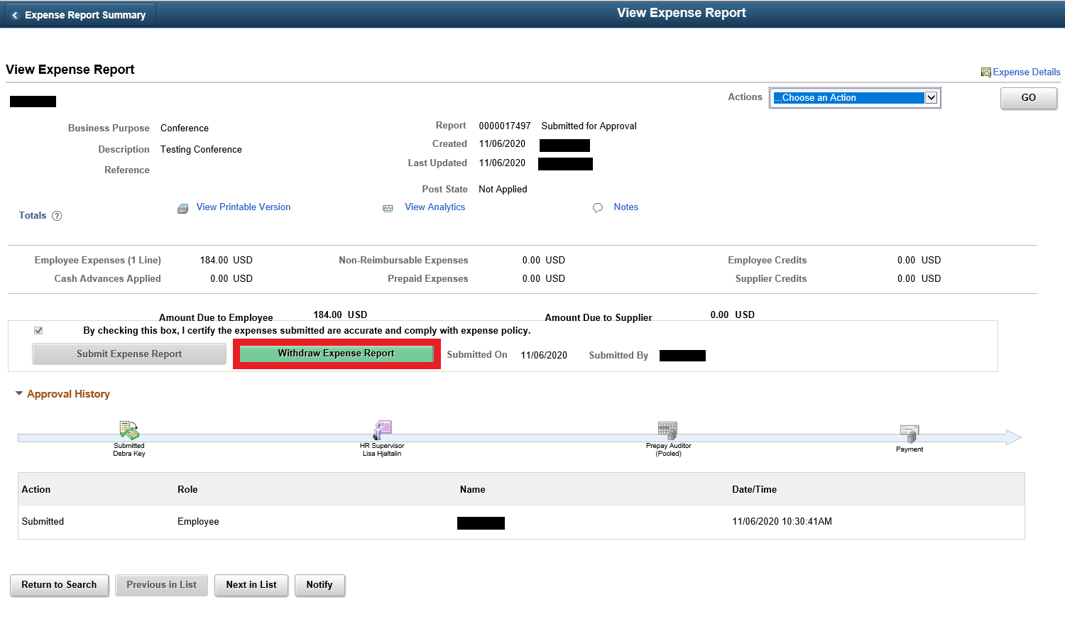

#### Image: Refresh Expense Report Approval Status

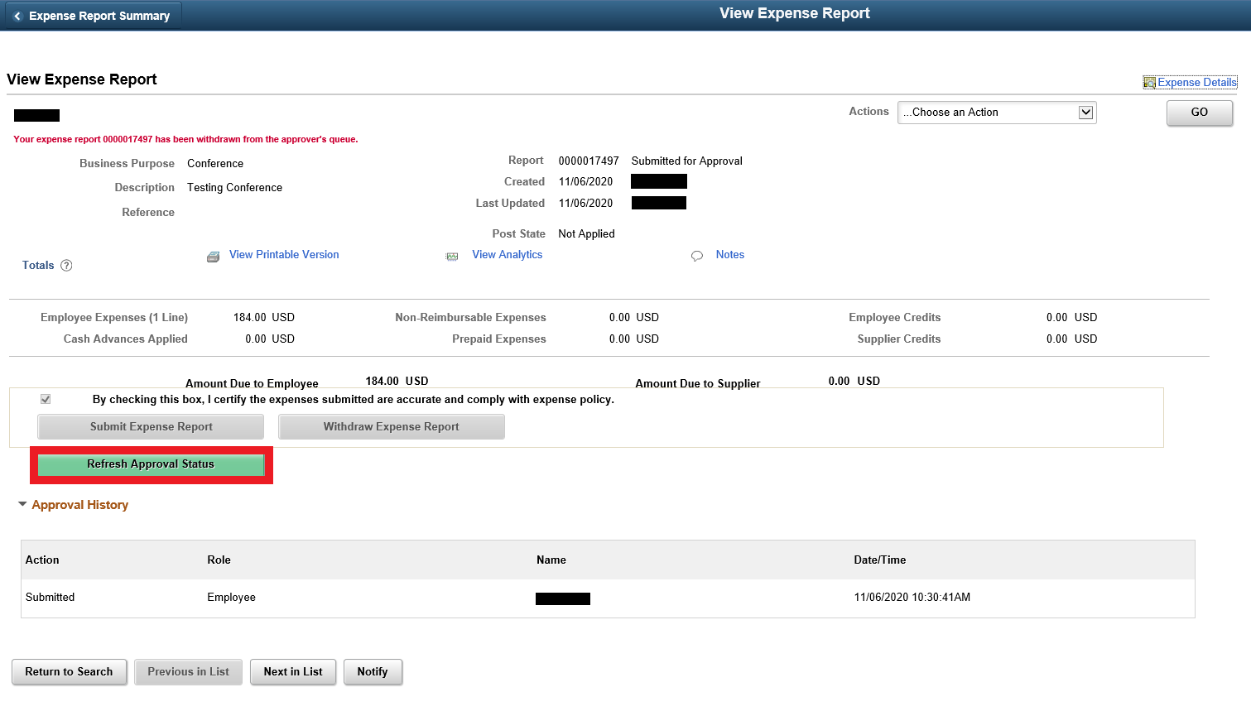

#### QRG

[9.2 Withdrawing an Expense Report before Approval](http://ctclinkreferencecenter.ctclink.us/m/79738/l/1069869-9-2-withdrawing-an-expense-report-before-approval)

### Travel and Expense – Copy Expense Report

The select label has been added to the first column listed on the copy expense report options page, in the base expense reports grid.

#### Navigation

Employee Self-Service > Expense Tile > Create Expense Report Tile

#### Image: Create Expense Report

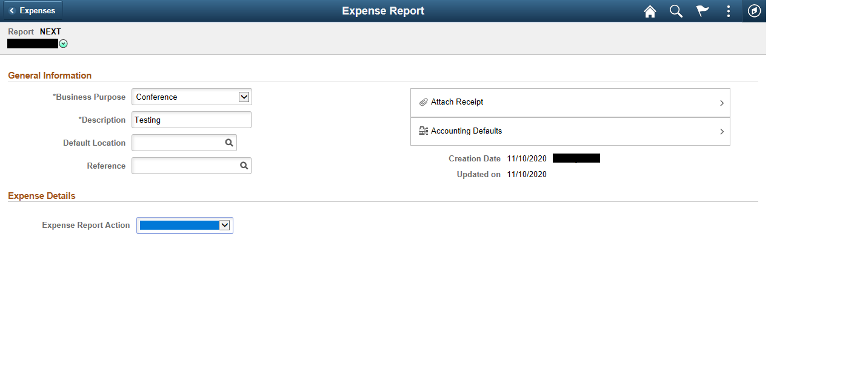

#### Image: Copy Expense Report Options

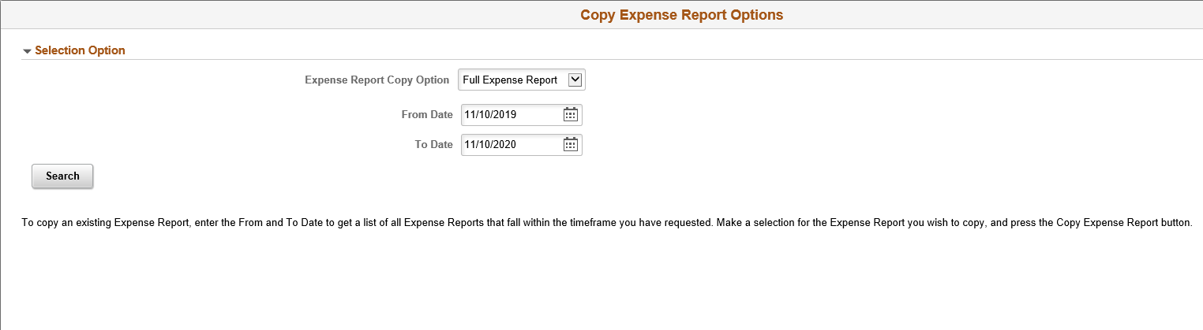

#### Image: Copy Expense Report Options Base Expense Reports Grid

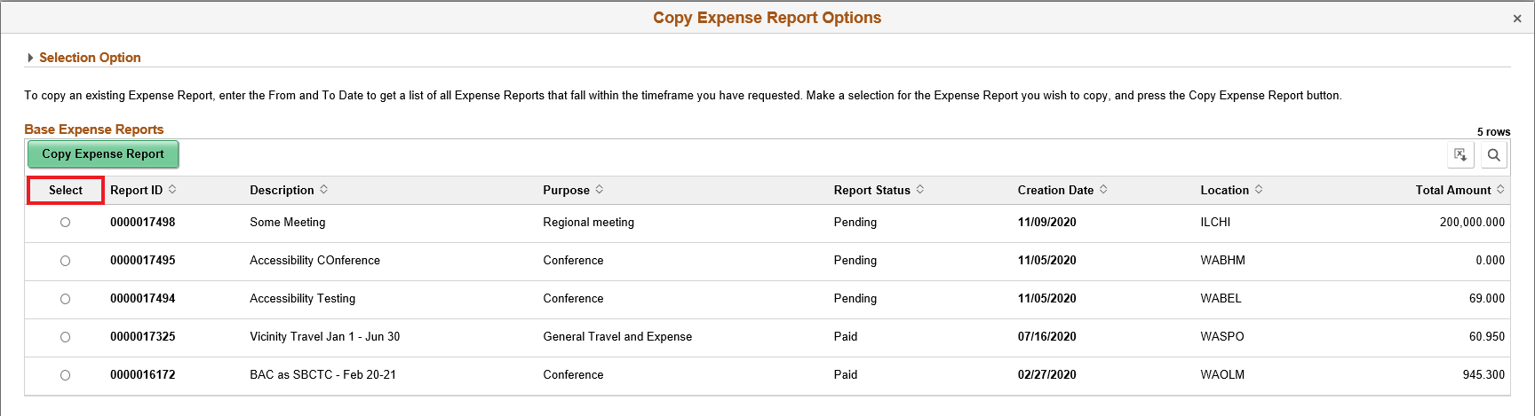

#### QRG

[9.2 Creating a New Expense Report from an Existing Expense Report](http://ctclinkreferencecenter.ctclink.us/m/79738/l/928839-9-2-creating-a-new-expense-report-from-an-existing-expense-report)

### Travel and Expenses – Expense Report History

The expense history page has been modified so that the data table headers are no longer blank and that the cells are properly associated.

#### Navigation

Employee Self Service -> Travel and Expenses -> Review Expense History

#### Image: Employee Expense History

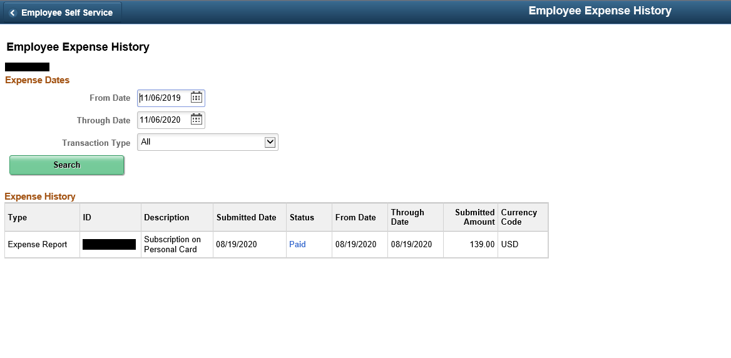

#### QRG

[9.2 View and Modify Expense Reports](http://ctclinkreferencecenter.ctclink.us/m/79738/l/985011-9-2-view-and-modify-expense-reports)

### Travel and Expenses – Travel Authorizations

The following accessibility issues were resolved in travel authorizations.

* The attachments image link has an adjacent link text with the same name and target, which is redundant
* Multiple tables are being used for layout without role = "presentation"
* The delete button for a projected expense row is labelled "DEL" which is not a meaningful button label
* The color is the only means of indicating Error Messages

#### Navigation

Employee Self Service > Travel and Expenses > Travel Authorization > Create/Modify

#### Image: Create/Modify Travel Authorization – Attachments Link

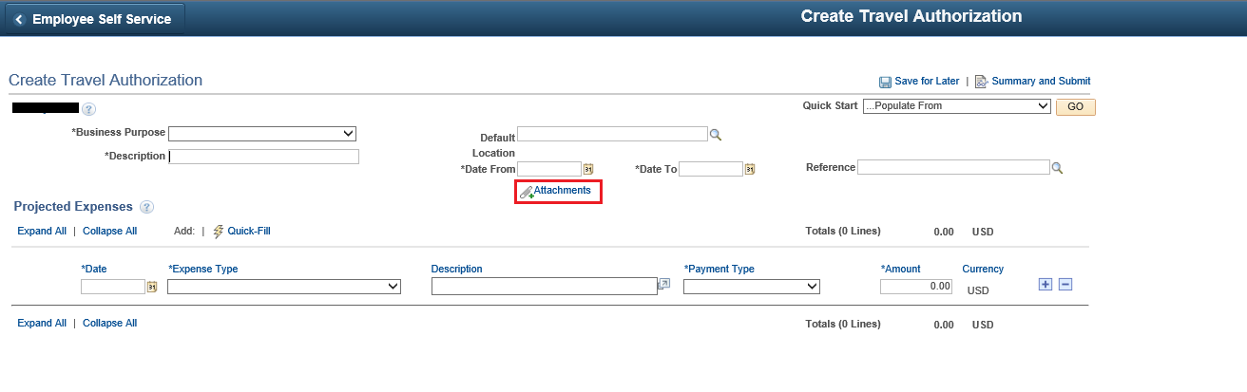

#### Image: Create/Modify Travel Authorization – Error Message

#### cid:image001.jpg@01D6BE8F.E9EC8140QRG

[9.2 Creating Travel Authorizations](http://ctclinkreferencecenter.ctclink.us/m/79738/l/928840-9-2-creating-travel-authorizations)

### Grants – Maintain Proposal

The maintain proposal page tabbing sequence has been corrected and fields are no longer be skipped.

#### Navigation

Grants > Proposals > Maintain Proposal

#### Image: Maintain Proposal

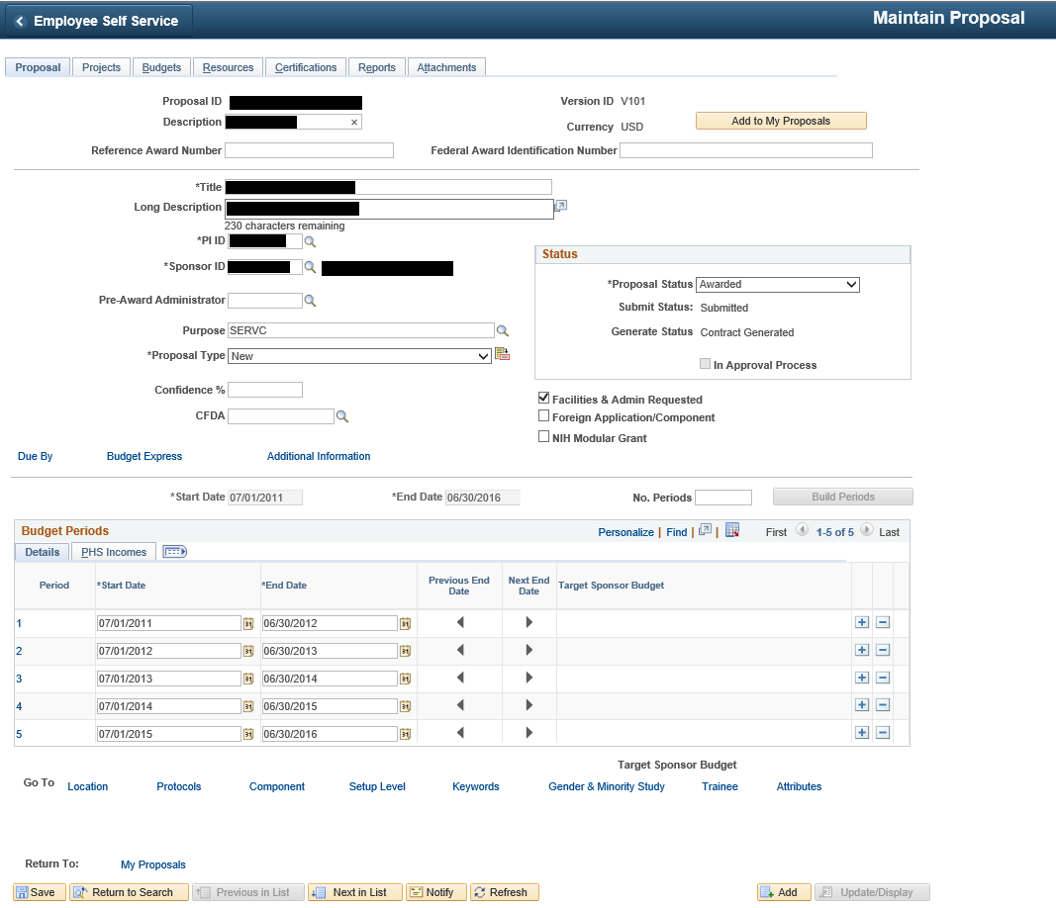

#### QRG

[9.2 Establishing the Proposal Budget](http://ctclinkreferencecenter.ctclink.us/m/79740/l/928935-9-2-establishing-the-proposal-budget)

### Purchasing – Procurement Contracts

The tabbing order in the category section of the add/update contracts page has been corrected.

#### Navigation

Procurement Contracts > Add/Update Contracts

#### Image: Add/Update Contracts

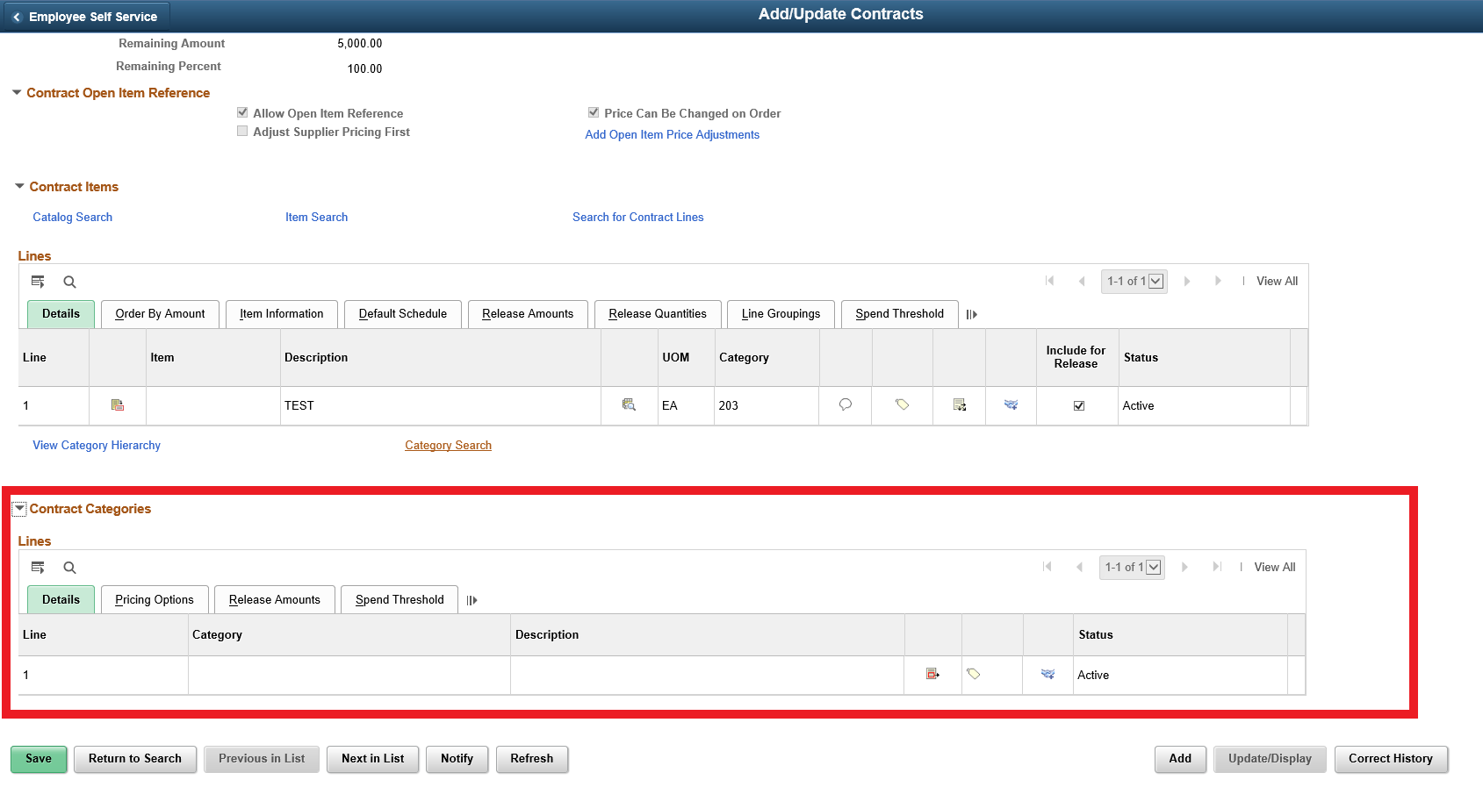

#### QRG

[9.2 Creating Procurement Contract](http://ctclinkreferencecenter.ctclink.us/m/79740/l/1066081-9-2-creating-procurement-contract)





Content is licensed under a Creative Commons Attribution 4.0 International License, unless noted otherwise.

Washington State Board for Community and Technical Colleges