





**Campus Solutions Image 18 Overview**

Table of Contents

Contents

Introduction 3

Financial Aid 3

FISAP Processing 3

COD Pell 4

Student Financials 5

Tax Processing 5

Academic Advisement 5

Self-Service 5

Campus Community 6

Student Services Center 6

Recruiting and Admissions 7

Bio/Demo 7

Student Records 8

Enrollment – Class Details Page 8

Enrollment – Service Indicators 9

Self Service – Fluid Planner 10

Self Service – View My Classes Print-Friendly 10

Self-Service – Browse Course Catalog 11

Self-Service – Class Search 12

Accessibility 13

Self-Service – Tile Headers 13

Self-Service - Incorrect aria attributes fixed 13

Mobile 13

Course Catalog 13

Class Details 15

Schedule 15

To Do 16

View Financial Aid 16

## Introduction

The Image/Upgrade Overview Document is intended to provide ctcLink users with a summary of the changes that will be made in the system as a result of the upcoming image or PeopleTools upgrade implementation. Oracle releases multiple PeopleSoft updates, called images, for each pillar every year. Each Image contains bug fixes and features that are important for PeopleSoft to work well. PeopleTools upgrades update the underlying framework of the system. There are minimal changes that are noticeable to the end users. Below is an overview of the changes that you can expect to see as part of this upgrade.

## Financial Aid

### FISAP Processing

This Financial Aid (US) update enables reporting of 2019-2020 aid year data in order to apply for campus-based funds for the 2021-2022 aid year. A link has been created under Fund Management for FISAP 22.

#### Navigation

Main Menu > Financial Aid > Fund Management > Generate FISAP Reports > FISAP Report 2021-2022

#### Image: Generate FISAP Report Menu

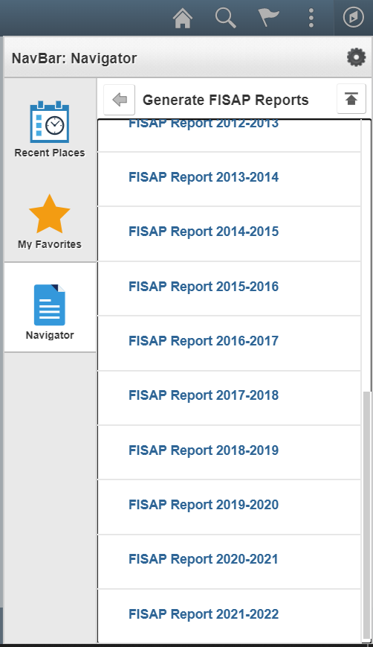

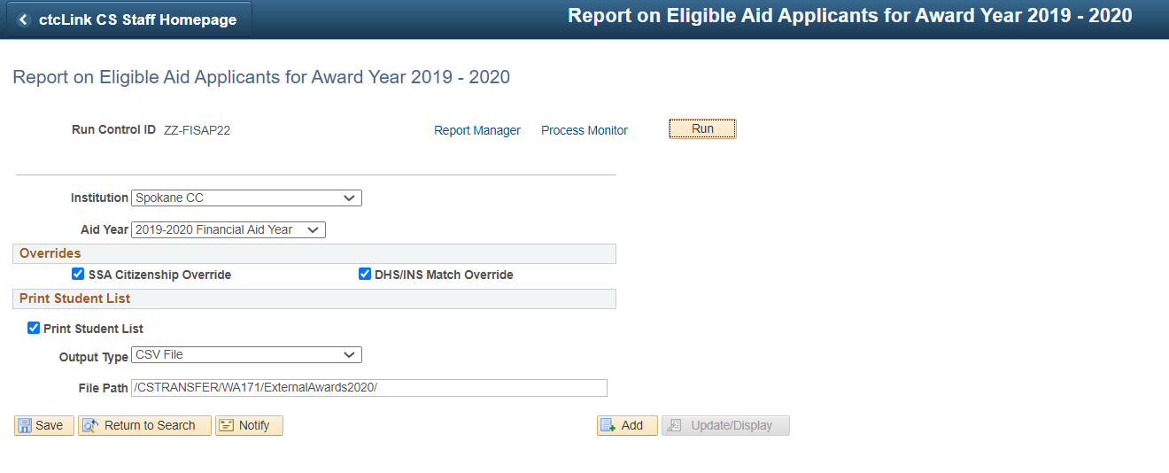

#### QRG

[FISAP PROCESSING Business Process Guide](http://ctclinkreferencecenter.ctclink.us/m/92436/l/798224-fisap-processing-business-process-guide)

### COD Pell

Included the CIP Code Year field to PELL YTD Disbursement Record Layout. Records and pages were modified to accommodate this change.

#### Navigation

Main Menu > Financial Aid > File Management > COD Full Participant > Pell Data

#### Image: Pell Outbound

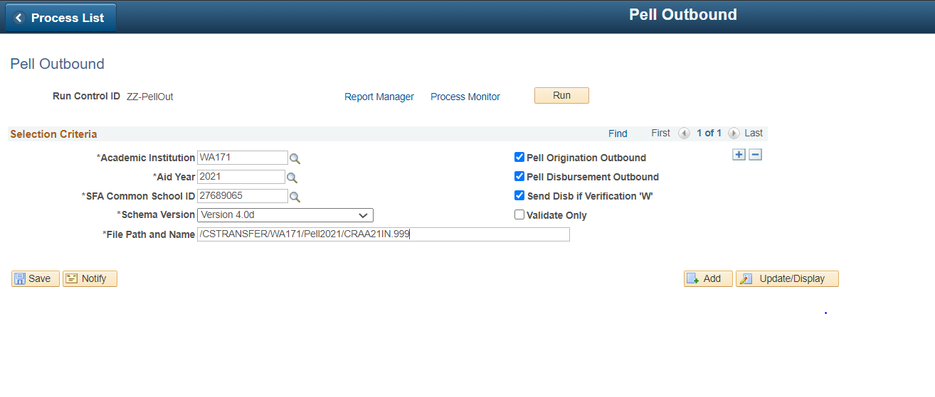

#### QRG

[Pell Processing Business Process Guide](http://ctclinkreferencecenter.ctclink.us/m/92436/l/798577-pell-processing-business-process-guide)

## Student Financials

### Tax Processing

Delivered new template for 2020 1098-T tax form.

#### Navigation

SACR > Product Related > Student Financials > Taxes > TIN Table > Template

#### Image: 1098-T Template is Available

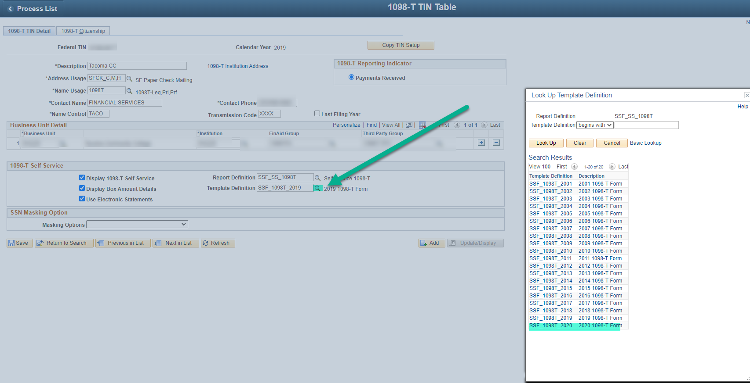

## Academic Advisement

### Self-Service

User will no longer get stuck in the search page when they enroll by my requirements and academic progress.

#### Navigation - Fluid

Student Homepage > Manage Classes > Enroll by My Requirements

#### Image:

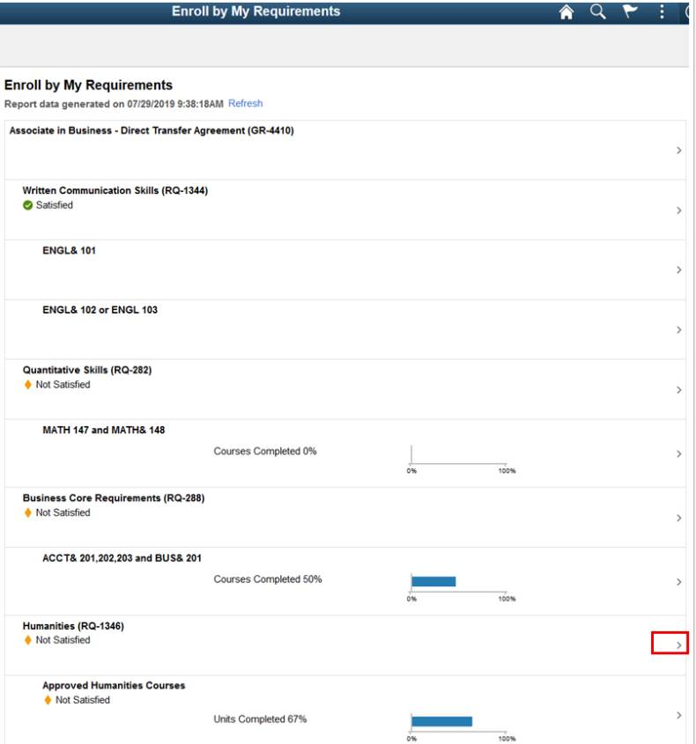

#### QRG

[Enroll by My Requirements](http://ctclinkreferencecenter.ctclink.us/m/79750/l/1102425-9-2-enroll-by-my-requirements-fluid)

## Campus Community

### Student Services Center

The return to search from the student services center general info tab will no longer display the previous student data.

#### Navigation

NavBar > Navigator > Campus Community > Student Services Center (Student)

#### Image: Student Services Center (Student)

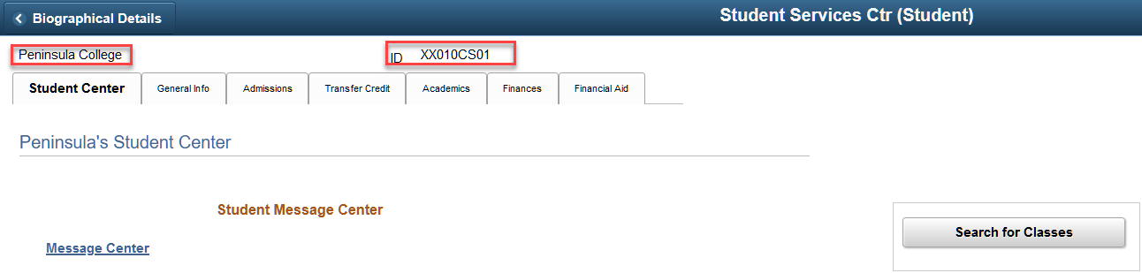

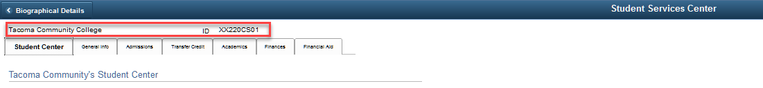

#### QRG

[Viewing Student Information](http://ctclinkreferencecenter.ctclink.us/m/79545/l/1031167-9-2-viewing-student-information)

## Recruiting and Admissions

### Bio/Demo

When changes are made to birth country via the birth information link, the birth state field will now reset (blank out).

#### Navigation

NavBar > Campus Community > Personal Information > Add/Update a Person

#### Image: Add/Update a Person

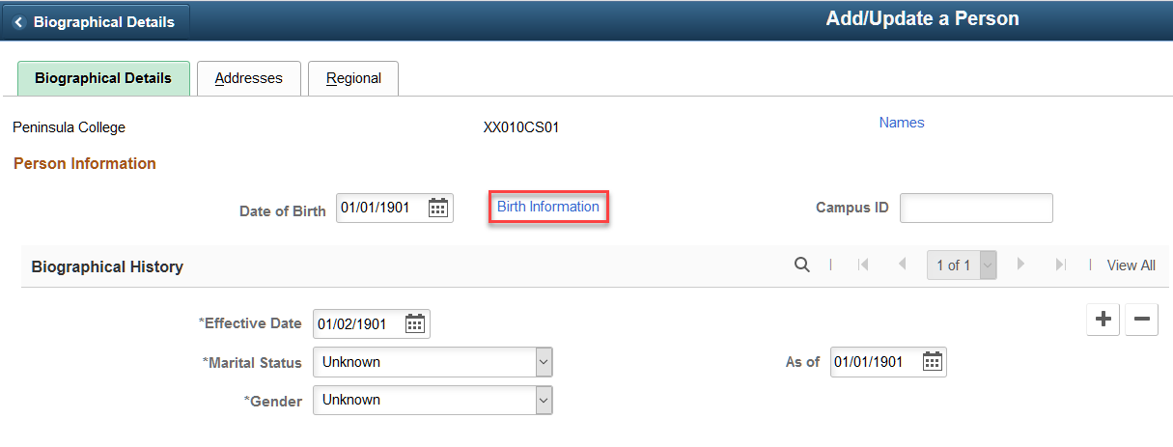

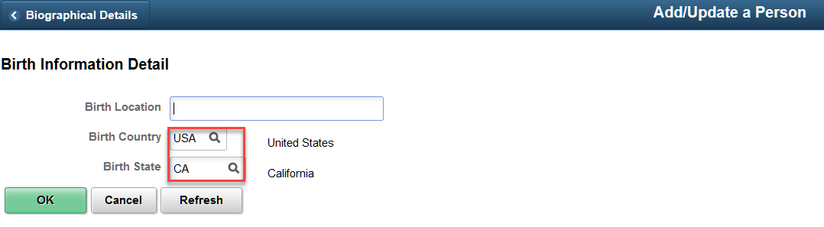

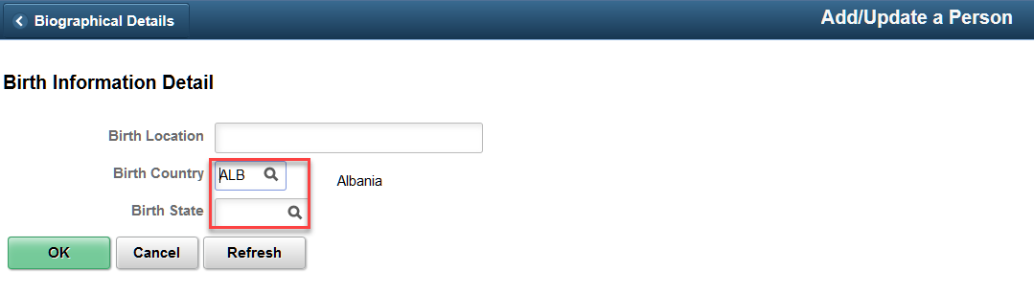

#### QRG

[Adding an Individual to the System](http://ctclinkreferencecenter.ctclink.us/m/79545/l/953296-9-2-adding-an-individual-to-the-system)

## Student Records

### Enrollment – Class Details Page

Updated the system so that clicking on the Next button on the Class Details page will redirect you to the Add Shopping Cart page, and allow you to properly add the Class to the Shopping Cart.

#### Navigation - Fluid

Student Homepage > Manage Classes > Planner

#### Image: Planner

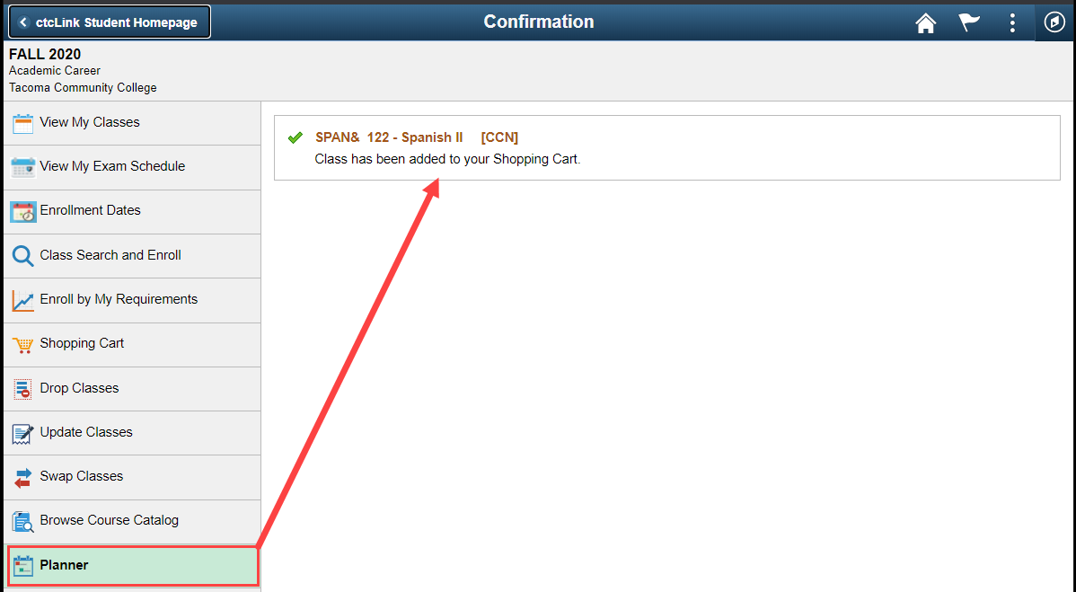

#### QRG

[Enroll by Planner to Shopping Cart](http://ctclinkreferencecenter.ctclink.us/m/79750/l/1102426-9-2-enroll-by-planner-to-shopping-cart-fluid)

### Enrollment – Service Indicators

Modified the system to validate service indicators with holds on drop.

#### Navigation

ctcLink CS Staff Homepage > Campus Community Tile > Manage Service Indicators

#### Image: Service Indicator

#### Service indicator image

#### Navigation

NavBar > Records and Enrollment > Enroll Students > Enrollment Request

#### Image: Enrollment Request

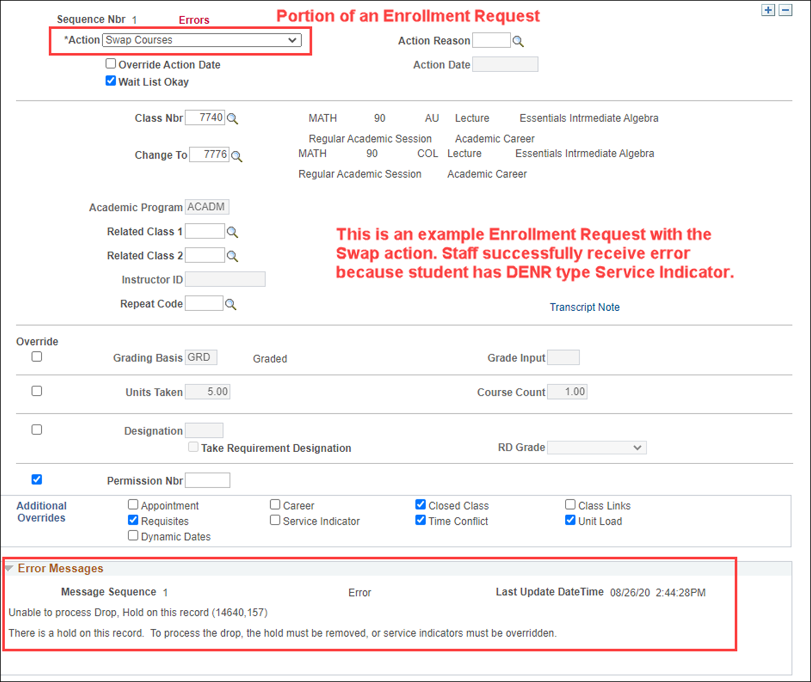

#### QRG

[Entering Service Indicator Data](http://ctclinkreferencecenter.ctclink.us/m/92555/l/1030579-9-2-entering-service-indicator-data)

[Quick Enrolling a Student](http://ctclinkreferencecenter.ctclink.us/m/79553/l/925292-9-2-quick-enrolling-a-student)

### Self Service – Fluid Planner

Made adjustments to the system to remove the blank row that remains after you delete a row in Fluid Planner.

#### Navigation - Fluid

Student Homepage > Manage Classes Tile > Planner

#### QRG

[Add Courses to Planner](http://ctclinkreferencecenter.ctclink.us/m/79750/l/1102432-9-2-add-courses-to-planner-fluid)

### Self Service – View My Classes Print-Friendly

Modified the Printable page so that checkbox filter options will work properly. Also added hover text to print button for accessibility requirement.

#### Navigation

Student Homepage > Manage Classes Tile > View My Classes

#### Image: Print-Friendly Page Responds when Dropped Classes is Unselected

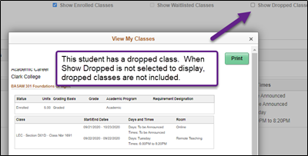

#### Image: Print Button has Hover Text

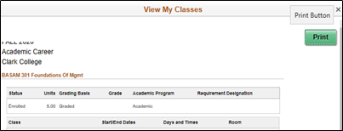

#### QRG

[Print-Friendly Student Schedule (Fluid)](http://ctclinkreferencecenter.ctclink.us/m/79750/l/1284452-9-2-print-friendly-student-schedule-fluid)

### Self-Service – Browse Course Catalog

Under Available Ways to Search, Available Subjects results are limited to subjects that are active.

#### Navigation - Fluid

Student Homepage > Manage Classes Tile > Browse Course Catalog

#### Image: Additional Ways to Search, Available Subjects

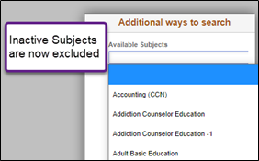

#### QRG

[Browse Course Catalog](http://ctclinkreferencecenter.ctclink.us/m/79750/l/1102431-9-2-browse-course-catalog-fluid)

### Self-Service – Class Search

* In Fluid, the area for class notes allows text to wrap and the full note to be visible.
* Meeting topics (those applied to a meeting pattern), are visible on the Class Information details

#### Navigation - Fluid

Student Homepage > Manage Classes Tile > Class Search and Enroll

#### Image: Class Notes Wrap and Display

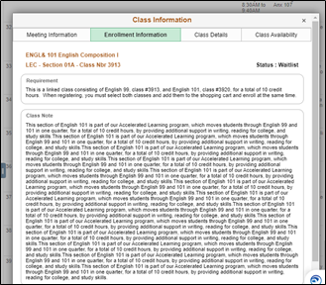

#### Image: Meeting Pattern Topic Visible

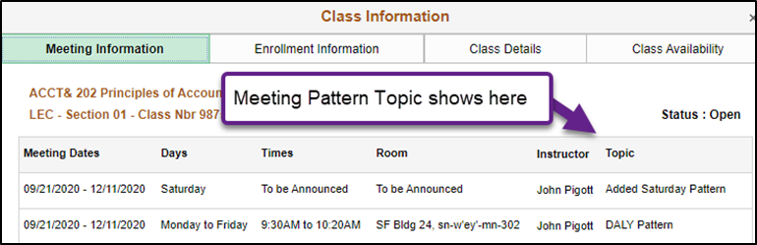

#### QRG

[Class Search](http://ctclinkreferencecenter.ctclink.us/m/79750/l/1102424-9-2-class-search-fluid)

## Accessibility

### Self-Service – Tile Headers

When Accessibility mode (screen reader mode) is selected at login, the following tile headers on the self-service pages will now be announced appropriately to screen readers such as NVDA and JAWS.

* Personal Details
* Contact Details
* Address
* Emergency Contacts
* Ethnicity
* Privacy Restrictions

#### Navigation

Student Homepage > Profile Tile

#### Image: Profile Page Menu

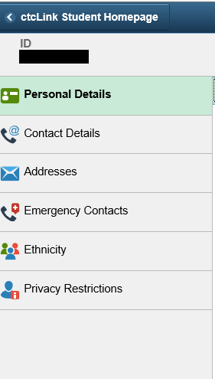

### Self-Service - Incorrect aria attributes fixed

When Accessibility mode (screen reader mode) is selected at login, the personal details page ARIA tags have been updated to remove conflicting ARIA tags.

#### Navigation

Student Homepage > Profile Tile > Personal Details

#### Image: Personal Details Page

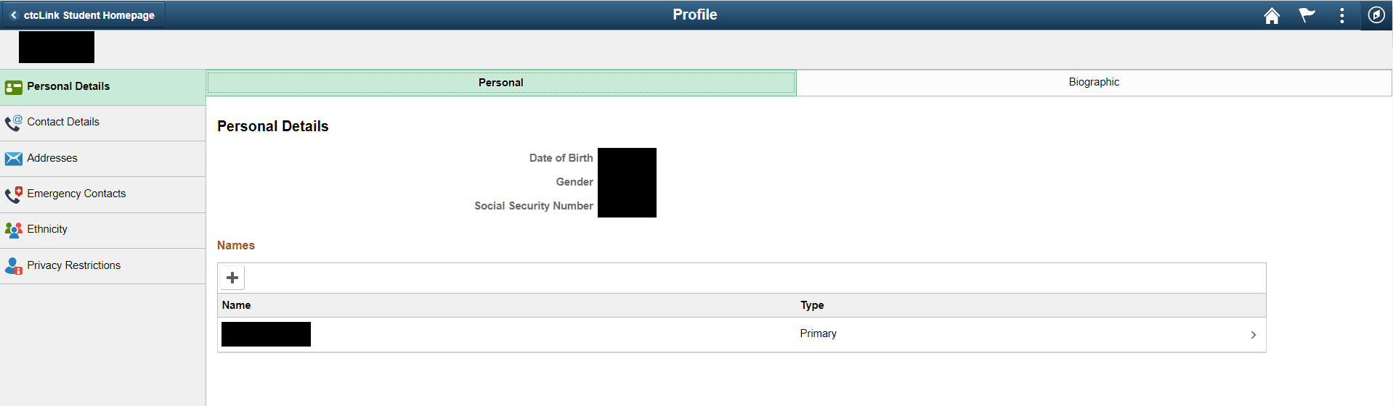

## Mobile

### Course Catalog

When looking at the course catalog a course will now display when it is typically offered.

#### Image: Course Catalog

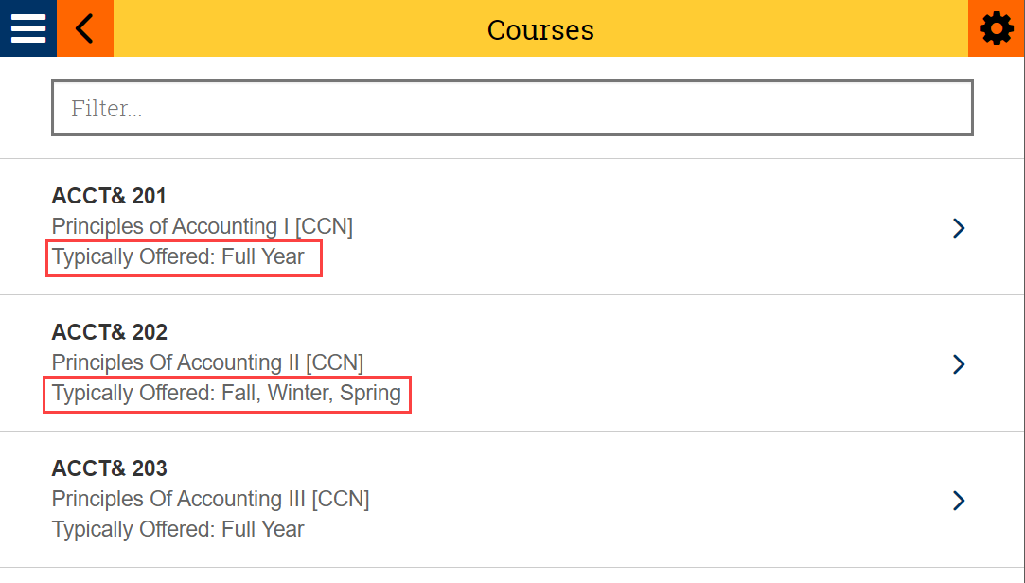

#### Image: Course Details

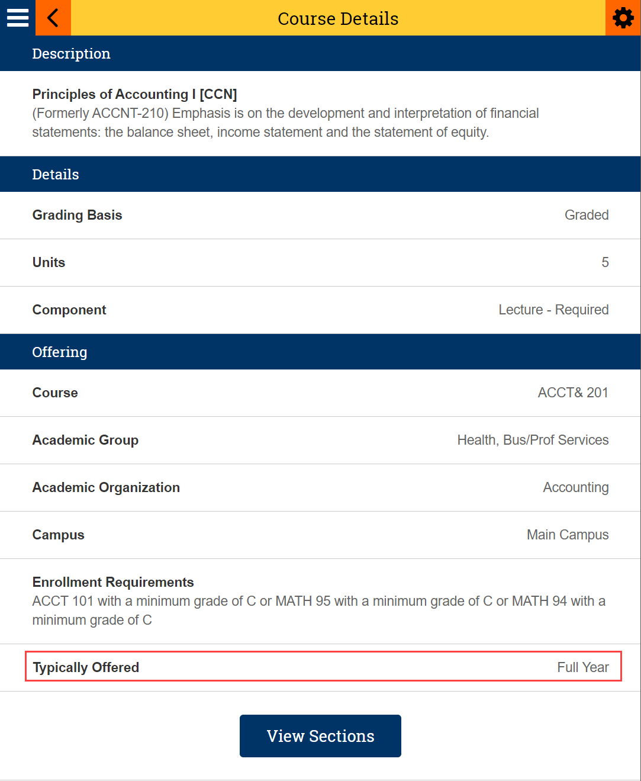

#### QRG

[Mobile – Course Catalog](http://ctclinkreferencecenter.ctclink.us/m/69799/l/758370-mobile-course-catalog)

### Class Details

The Class Details page will now show Meeting Dates

#### Image: Class Details

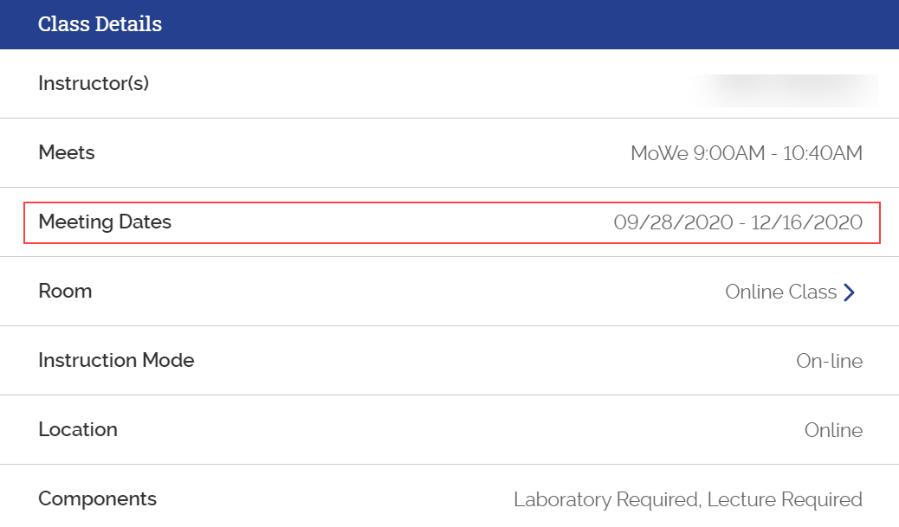

### Schedule

Resolved an issue with the start date for classes that don’t meet on a particular day of the

week.

#### Images: Schedule

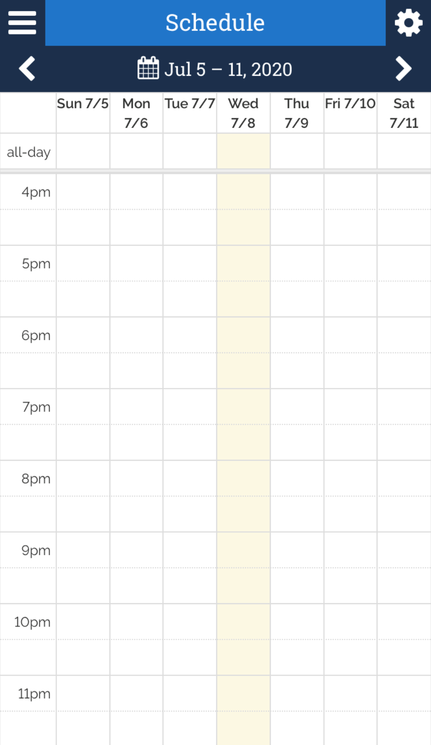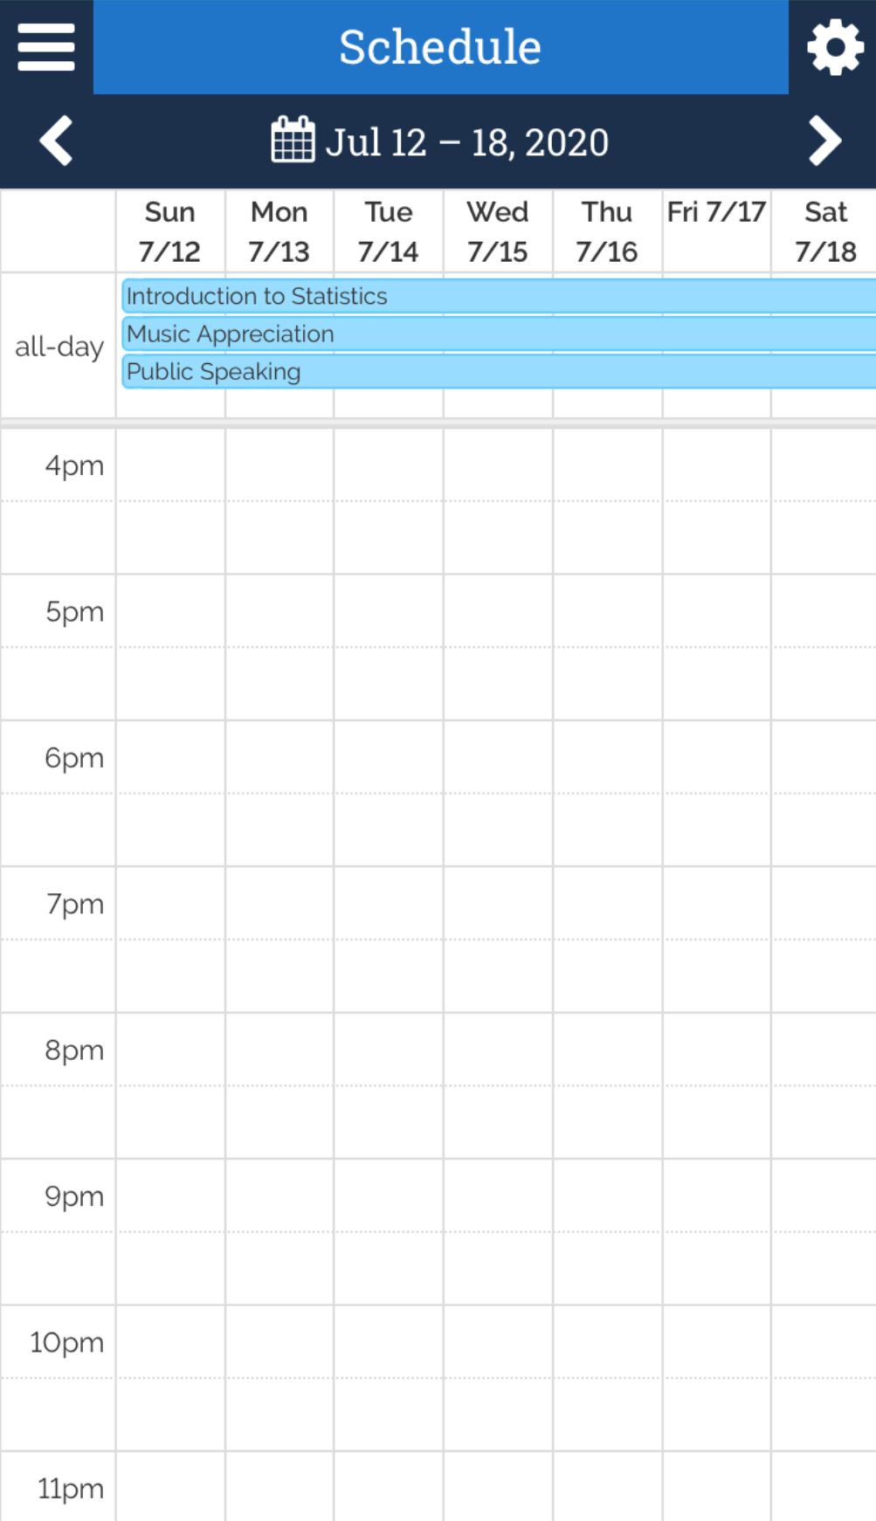

#### QRG

[Mobile - Schedule](http://ctclinkreferencecenter.ctclink.us/m/69799/l/764011-mobile-schedule)

### To Do

Empty task list items will no longer be displayed.

#### QRG

[Mobile – To Dos (aka Checklists)](http://ctclinkreferencecenter.ctclink.us/m/69799/l/750386-mobile-to-dos-aka-checklists)

### View Financial Aid

View Financial Aid will now display the 2021 College Financing Plan

#### QRG

[Mobile - View Financial Aid](http://ctclinkreferencecenter.ctclink.us/m/69799/l/761455-mobile-view-financial-aid)





Content is licensed under a Creative Commons Attribution 4.0 International License, unless noted otherwise.

Washington State Board for Community and Technical Colleges