





**Campus Solutions Image 19 Overview**

Table of Contents

Contents

Introduction 3

Student Records 3

Transfer Credit 3

Self-Service – Class Search & Enroll 4

Self Service – Evaluate My Transfer Credits 5

Honors and Awards 6

Financial Aid 7

2021-2022 Aid Year ISIR Updates 7

Accessibility 8

Student Record – Class Roster 8

Student Records - Setup 8

Student Records – Student Program Page 9

Student Records – Student Attributes Page 10

Student Records – Student Sub-Plan Page 11

Financial Aid - Direct Lending 12

## Introduction

The Image/Upgrade Overview Document is intended to provide ctcLink users with a summary of the changes that will be made in the system as a result of the upcoming image or PeopleTools upgrade implementation. Oracle releases multiple PeopleSoft updates, called images, for each pillar every year. Each Image contains bug fixes and features that are important for PeopleSoft to work well. PeopleTools upgrades update the underlying framework of the system. There are minimal changes that are noticeable to the end users. Below is an overview of the changes that you can expect to see as part of this upgrade.

## Student Records

### Transfer Credit

Modified the Other Credits Manual page to prevent a section from being shifted to the right when being viewed using Firefox or Chrome browsers.

#### Navigation

Main Menu> Records and Enrollment> Transfer Credit Evaluation> Other Credits-Manual> Other Credit By Term

#### Image: Transfer Credit Model

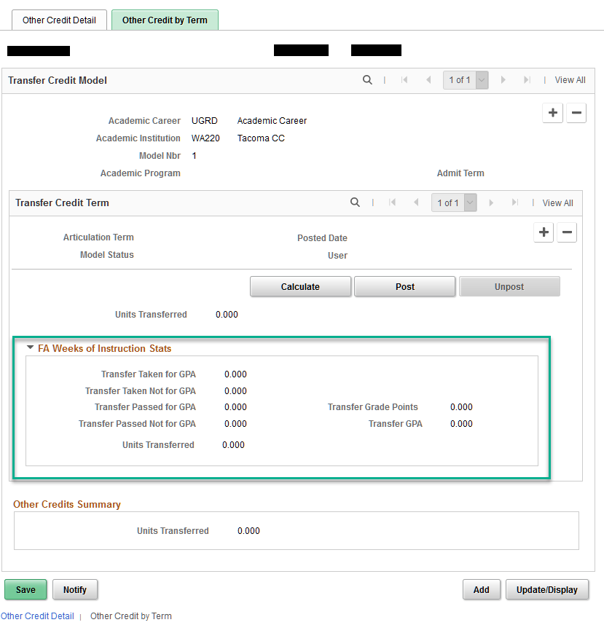

#### QRG

[9.2 Processing Other Transfer Credit - Manual](http://ctclinkreferencecenter.ctclink.us/m/79558/l/1025766-9-2-processing-other-transfer-credit-manual)

### 

### Self-Service – Class Search & Enroll

When a class has multiple meeting patterns, the meeting patterns were not sorting correctly. This has been corrected.

#### Navigation

Manage Classes Tile > Class Search & Enroll

#### Image: Production View Showing Current Sort Order

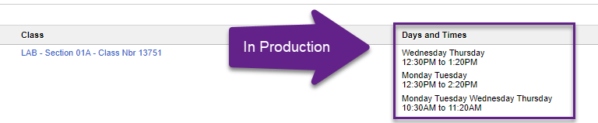

#### Image: Corrected View Showing Corrected Chronological Sort Order

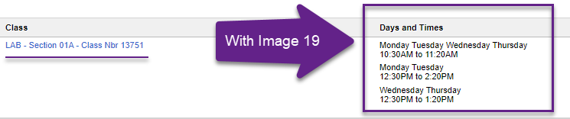

#### QRG

[9.2 Class Search Fluid](http://ctclinkreferencecenter.ctclink.us/m/79750/l/1102424-9-2-class-search-fluid)

### Self Service – Evaluate My Transfer Credits

The size of the yes button on the evaluate my transfer credit confirmation page was corrected.

#### Navigation

Student Homepage> Academic records> Evaluate My transfer Credits

#### Image: Yes – Delete Button

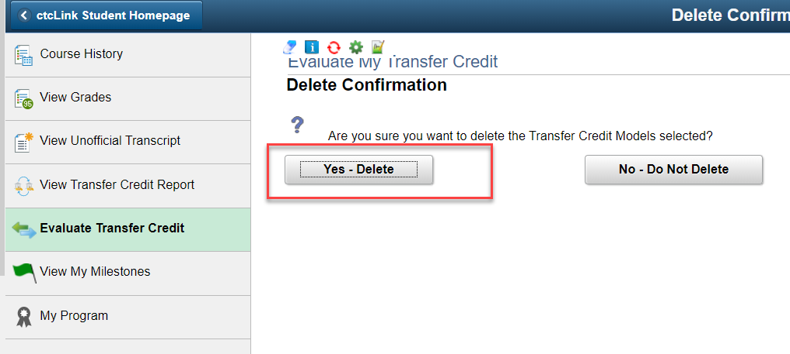

#### QRG

[9.2 Evaluate My Transfer Credit (Fluid)](http://ctclinkreferencecenter.ctclink.us/m/79750/l/1102562-9-2-evaluate-my-transfer-credit-fluid)

### Honors and Awards

The honors and awards label no longer overlaps in Internet Explorer.

#### Navigation

**NavBar > Navigator > Campus Community > Personal Information (Student) > Participation Data (Student) > Accomplishments > Honors and Awards**

#### **Image: Production View Showing Overlap**

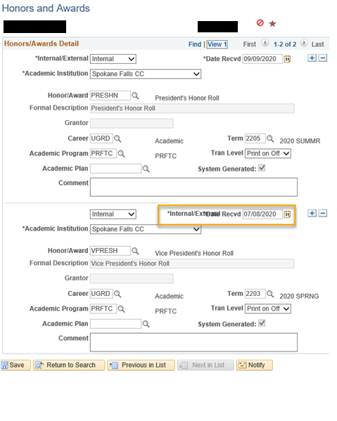

#### Image: Corrected View with Adjusted Fields

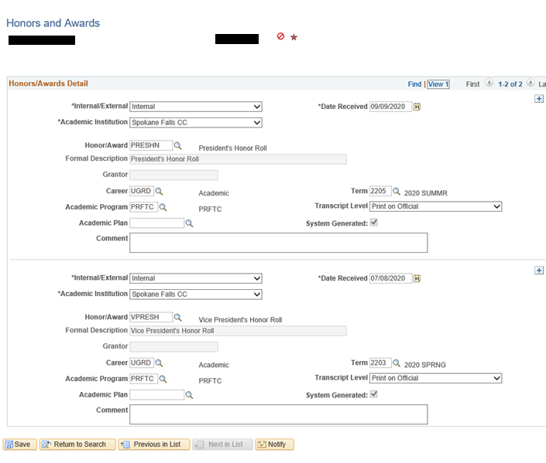

#### QRG

[9.2 Entering Honors and Awards](http://ctclinkreferencecenter.ctclink.us/m/79545/l/972043-9-2-entering-honors-and-awards)

## Financial Aid

### 2021-2022 Aid Year ISIR Updates

These new fields are added:

* Student IRS Schedule 1 data flag
* Parent IRS Schedule 1 data flag

#### **Navigation**

Main Menu > Financial Aid > Federal Application Data > Correct 2021-22 ISIR Records > Assumptions/School Codes tab

#### **Image:  Correct 2021/22 ISIR Records**

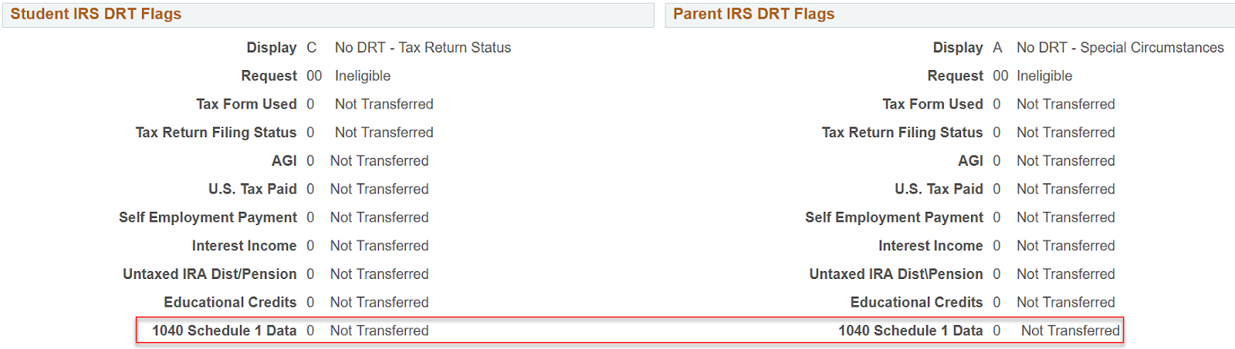

#### QRG

[FA Business Flow](http://ctclinkreferencecenter.ctclink.us/m/92436/l/794730-9-2-fa-business-flow)

## Accessibility

### Student Record – Class Roster

Modified the my schedule page to correct the Accessibility and display help text issues.

#### Navigation

ctcLink CS Staff Homepage > Faculty Center Image: My Schedule

#### faculty center my scheduleQRG

[9.2 View My Schedule - Staff (Fluid)](http://ctclinkreferencecenter.ctclink.us/m/88854/l/1103487-9-2-view-my-schedule-staff-fluid)

### Student Records - Setup

The CIP code page has been modified to correct valid SEVIS CIP code radio buttons.

#### Navigation

NavBar > Navigator > Campus Community > SEVIS > F/M Alerts > Process SEVIS F/M Alerts-F/M

#### Image: Valid SEVIS CIP Code Radio Buttons

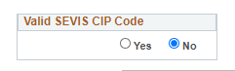

#### QRG

[9.2 Run the SEVIS Alerts Process](http://ctclinkreferencecenter.ctclink.us/m/79545/l/1031183-9-2-run-the-sevis-alerts-process)

### Student Records – Student Program Page

Adjusted the student program page layout to fix accessibility issues. There are now more details and the formatted speech is clearer.

Adjusted field placements to minimize empty spaces.

#### Navigation

NavBar > Navigator > Records and Enrollment > Career and Program Information > Student Program/Plan

#### Image: Student Program

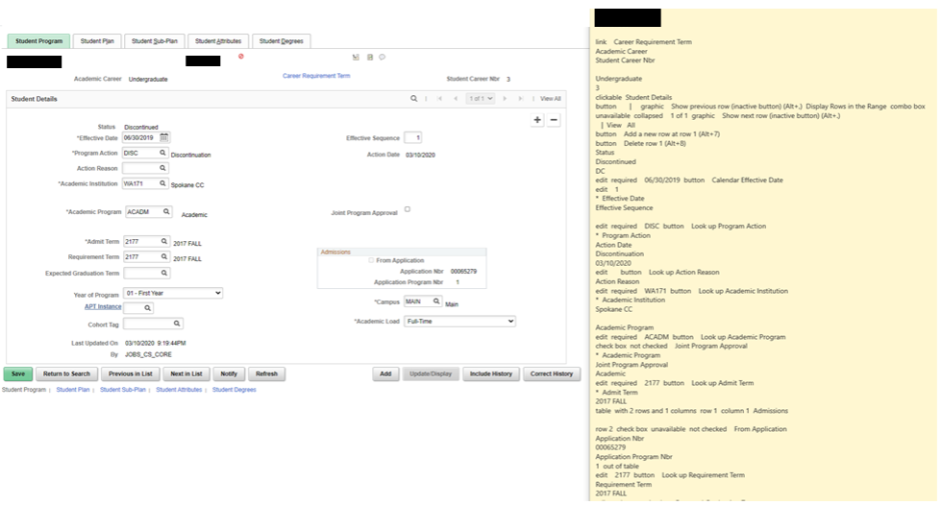

#### Image: Student Program Page – Minimize Empty Spaces

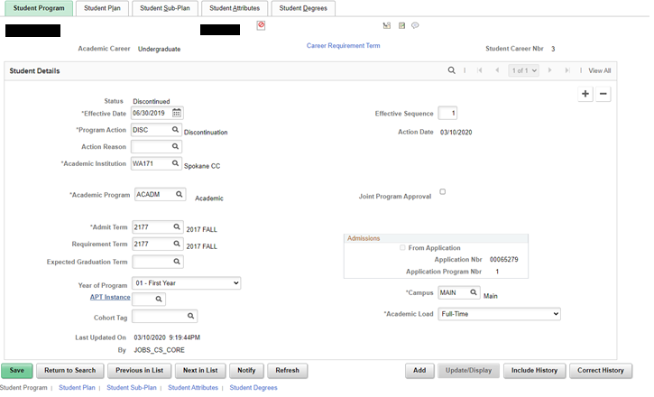

#### QRG

[9.2 Maintaining Student Program/Plan Stacks](http://ctclinkreferencecenter.ctclink.us/m/79558/l/1023073-9-2-maintaining-student-program-plan-stackshttp:/ctclinkreferencecenter.ctclink.us/m/79558/l/1023073-9-2-maintaining-student-program-plan-stacks)

### Student Records – Student Attributes Page

Adjusted the student program page layout to fix accessibility issues. There are now more details and the formatted speech is clearer.

#### Navigation

NavBar > Navigator > Records and Enrollment > Career and Program Information > Student Program/Plan

#### Image: Student Attributes

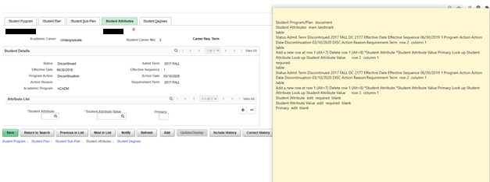

#### QRG

[9.2 Managing Student Attributes](http://ctclinkreferencecenter.ctclink.us/m/79558/l/1022906-9-2-managing-student-attributes)

### Student Records – Student Sub-Plan Page

Adjusted page fields and labels on the student sub-plan page to fix accessibility issues.

#### Navigation

NavBar > Navigator > Records and Enrollment > Career and Program Information > Student Program/Plan

#### Image: Student Attributes

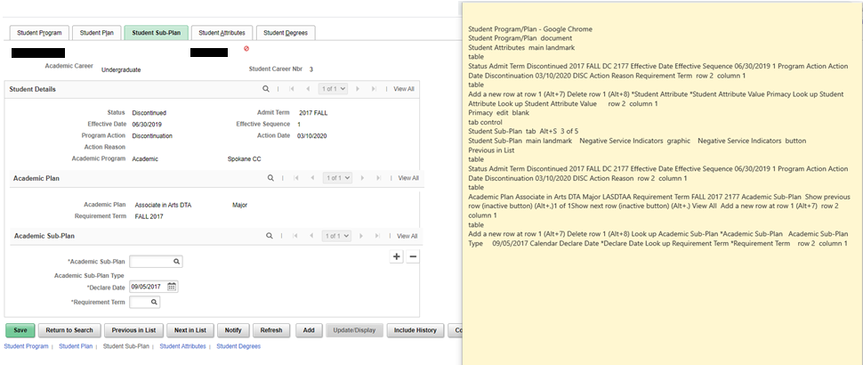

#### QRG

[9.2 Maintaining Student Program/Plan Stacks](http://ctclinkreferencecenter.ctclink.us/m/79558/l/1023073-9-2-maintaining-student-program-plan-stackshttp:/ctclinkreferencecenter.ctclink.us/m/79558/l/1023073-9-2-maintaining-student-program-plan-stacks)

### Financial Aid - Direct Lending

The following changes were made we in accessibility mode:

* All labels are now read.
* A tool tip now appears when you hover over the response information link.
* Added new field labels for supporting the Validated and Transmitted fields on the SULA distribution page.

#### Navigation

Main Menu>Financial Aid>Loans>Direct Lending Management>Override Loan Application Data

* Detail into record and then click on the Informed Borrower Override Tab

#### Image: Informed Borrowing

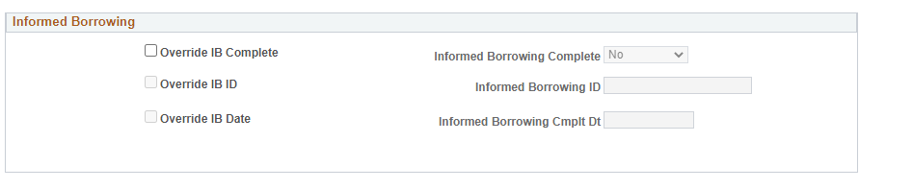

Image: Response Information Tool Tip

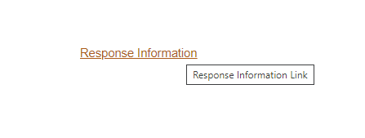

Navigation:

Main Menu>Financial Aid>Loans>Direct Lending Management>Manage Direct Loan Application>

* From the Application Financial Tab, select any SULA Disbursement Field link

Image: SULA Disbursement Field Detail

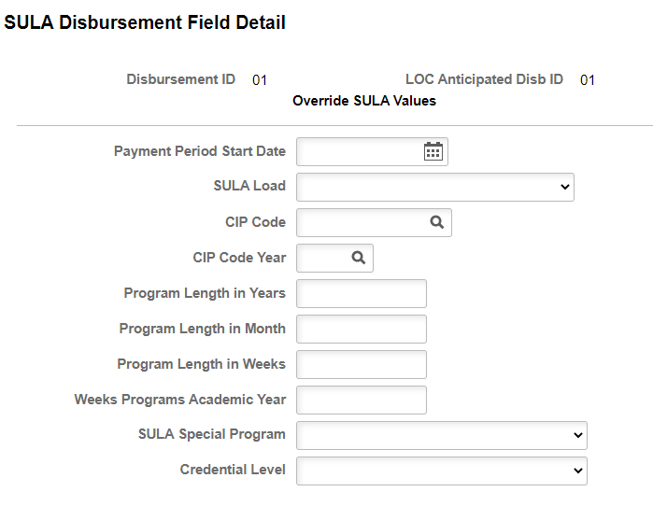

#### QRG

[9.2 Direct Loan Management Page](http://ctclinkreferencecenter.ctclink.us/m/92424/l/932258-9-2-direct-loan-management-page)





Content is licensed under a Creative Commons Attribution 4.0 International License, unless noted otherwise.

Washington State Board for Community and Technical Colleges