Affirmative Action Report Instructions

BHC_HR_EEO

The Affirmative Action report is based on a connected query and so cannot be ran in Query Report Viewer. Instead it must be scheduled in Query Report Scheduler.

To Schedule the Report:

* Go to Query Report Scheduler - Main Menu 🡪 Reporting Tools 🡪 BI Publisher 🡪 Query Report Scheduler

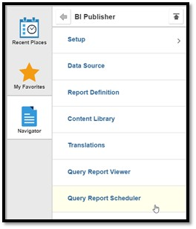

* Click “Add New Value” and enter in a Run Control ID
  + NOTE: you will only add a new value the FIRST time you run the report, thereafter, search for the Run Control ID you created the first time.

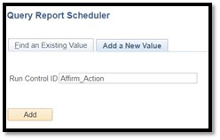

* Enter in the Data Source Type of Connected Query
* Enter the Report Name of BHC_HR_EEO
  + A pop-up window will appear asking for the college code – enter your code.

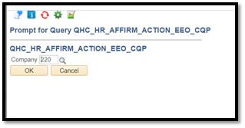

* Click on Run in the upper right-hand corner

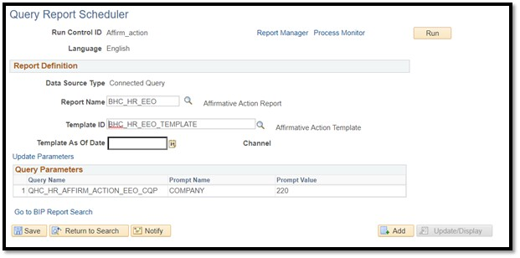

* Select Type and Format
  + Recommended selections are Web and PDF
* Click OK

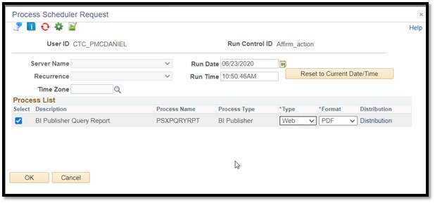

* Click on the Report Manager hyperlink that appears in the top of the screen.

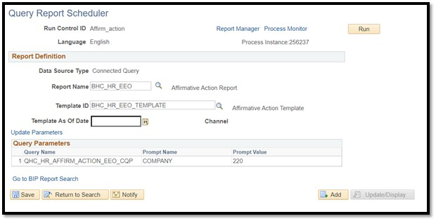

* Click on the hyperlinked name of the report
  + It may take a few minutes for the report to process and appear

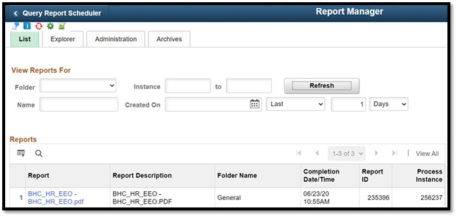

* Click on the hyperlinked report name

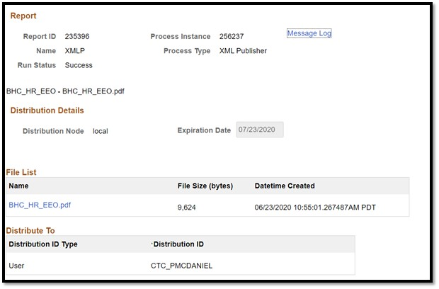

* View the report

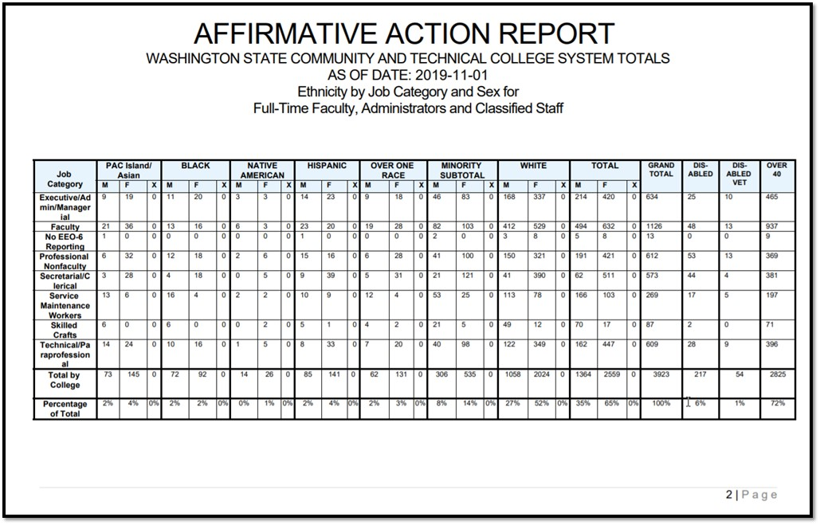

Services